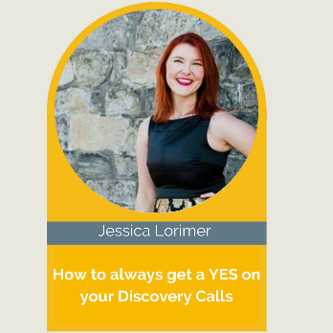

Jessica Lorimer is a Sales Coach and Leadership Expert, specialising in teaching service based business owners how to sell successfully with integrity and ease. Hers just a taste of what you will learn…

Here’s just a taste of what you will learn…
How to always get a YES on your Discovery Calls

👉 Understand how to pre-qualify your prospects.
👉 Understand the structure behind a successful discovery call.
👉 Understand how to handle objections.

The Speaker Goody Bag Downloads 👉 speaker-goodie-bag
Supersize Your Sales Guide 👉 https://jessicalorimer.com/supersize-your-sales

My Top Three Takeaways

Connect with Jessica
- E-mail - Jessica@JessicaLorimer.com
- Website - www.JessicaLorimer.com

