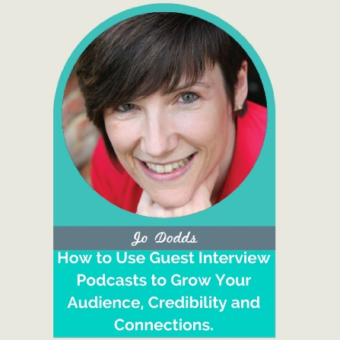
In these days of portfolio careers I have two, quite different, businesses, both involving speaking, training, consultancy and coaching.
In POWER to Live More, I work with home-based business owners to enable them to ‘Live More’ by improving their Productivity, Organisation, Wellbeing, Energy and Resilience (POWER).
Life feels so overwhelming nowadays with our busy lives, all the digital technology and that seemingly ‘always on’ culture. I’m on a mission to help solopreneurs and home based business owners to be more organised, productive, healthy and happy doing what they want to do, rather than what they feel they should or need to do.
I host and publish a weekly POWER to Live More podcast, host the Engage for Success and Digital and Social Media Leadership Forum podcasts and co-present on two internet business radio shows, Business Bunker and Money Talk, on ChannelRadio.co.uk.

Here’s just a taste of what you will learn in…

How to Use Guest Interview Podcasts to Grow Your Audience, Credibility and Connections

👉 How to determine a theme / format / questions for the interviews
👉 How to find the best guests and get them to agree to be interviewed
👉 How to produce and promote your podcast

The Speaker Goody Bag Downloads 👉 speaker-goodie-bag
Learn the 7 Common Podcasting Hazards to Avoid to Podcast with POWER 👉 https://virtualspeakingpros.com/professional-speaking-online-courses/

My Top Three Takeaways

Connect with Jo here…
- E-mail - jo@jododds.com
- Website – www.jododds.com

