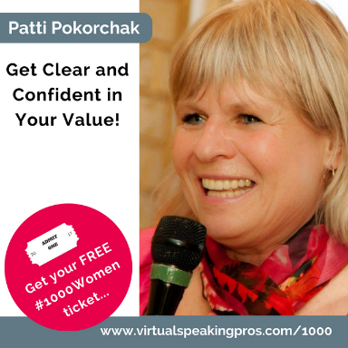

MBA has the usual awarding-winning author, speaker, coach, consultant credentials but more importantly 30+ years of hands-on sales and marketing experience and helping small businesses grow fast and profitably.
As a serial entrepreneur, she has started 11 businesses over the past 25 years AND has worked with hundreds of other business to help them grow.
Her motto is to “have fun and make money" and if you’re not having fun, then who cares about the money. The more fun you have, the more money you will make.
She loves to help make your passion profitable with her proven practical advice.
Her book “The Accidental Farmer” is NOT about farming, though she was one. It’s about an entrepreneurial life well-lived and wacky ideas that worked to build a $1 million+ software business as well as a thriving destination garden centre and hobby farm.

Here’s just a taste of what you will learn…
Get Clear and Confident in Your Value!
👉 Confused Buyers Do Not Buy
👉 Unique Sales Proposition has to flow from the heart!
👉 Follow-up and don't fall down in prospecting
👉 Why silence IS golden when selling!

The Speaker Goody Bag Download’s 👉 speaker-goodie-bag
A free month of coaching in my *NEW* Entrepreneurs Success Circle 👉 http://smallbizsalescoach.ca/coaching/entrepreneur-success-circles/

My Top Three Takeaways

Connect with Patti here…
- E-mail - Patti@SmallBizSalesCoach.ca
- Website – http://SmallBizSalesCoach.ca

