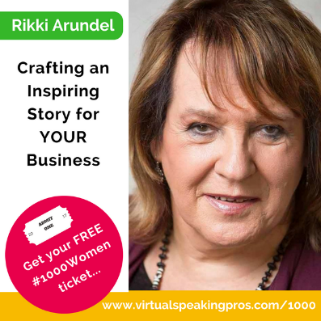
Rikki Arundel is a speaker, coach and diversity expert. The founder of the UK Professional Speaking Association, her career as a sales and technology speaker ended when she changed gender. Facing considerable discrimination, she completed a masters in gender and established herself as a gender and diversity expert delivering keynote presentations and workshops.
More recently as a result of improving public attitudes to trans people, Rikki has returned to her passion for technology, developing her skills and expertise as a virtual speaker, delivering workshops, speaker coaching and keynote presentations online. She has particularly built a reputation for engaging audiences through her entertaining and inspiring use of stories.

Here’s just a taste of what you will learn in…

Crafting an Inspiring Story for YOUR Business
👉 To simplify your MISSION
👉 To clarify your WHY
👉 To construct YOUR compelling business STORY.

The Speaker Goody Bag Downloads 👉 speaker-goodie-bag
How to engage the power of YOUR STORY when speaking online 👉 https://virtualspeakingpros.com/professional-speaking-online-courses/

My Top Three Takeaways

Connect with Rikki here…
- E-mail - rikki@arundel.com
- Website - www.rikkiarundel.com

