    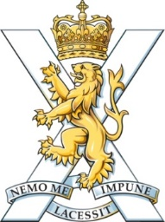 | 2nd Battalion The Highlanders ACF  Battalion Training Officer  Cadet Training Centre  Rocksley Drive  Boddam  Aberdeenshire  AB42 3BA 16-JUL-2023
YOU ARE CORDIALLY INVITED . . .
. . . to attend our Celebration Event at the Cadet Training Centre in Boddam on SUNDAY 27th AUGUST 2023.
2nd Bn The Highlanders ACF (2HLDRS) had a split Camp this year. Whilst most of our cadets made their way to the CTC in Boddam, a number also went down south to join our friends from the Argyll & Sutherland Highlanders Battalion ACF in Chickerell, Dorset. Usually we would have a day on Camp where we would present awards and recognise the achievements of the various cadres over the preceding two weeks but as we were not a complete unit this year we decided to hold separate day in which to do this. But not only that – we will also have the formal opening of the Ken Masson Learning Centre, drill square and tube range which was part of the £1.8m improvement project recently completed in time for this year’s Camp.
All cadets who were at Camp are invited to attend and they are able to have two guests come along on the Sunday to watch them march up for their presentation and to learn more about what they do here in the Army Cadet Force. While cadets will be accommodated over the full weekend so they can practice on the Saturday, friends and family are to arrive between 1000 and 1030 hours on Sunday 27-AUG-2023 for an 1100 start with expected departure after 1600 hours. Parking is available by the Buchan Braes Hotel (as marked on the map attached) – the gate marshals will be able to advise you on arrival. For cadets who may not have been accommodated over the weekend, please have them report in on the Sunday morning from 0830 so they can begin set up activities from 0900 hours. Priority for accommodation will be given to cadets living further away from CTC Boddam.
The event will include presentations for various cadres and star levels, static stands to display what we do and the formal inauguration event with an invited dignitary. Food will be available for purchase from concession stalls on the premises throughout the day (cadets will be catered for as part of the weekend accommodation). If you wish to take your young person away after the event rather than use the arranged transport, please indicate this on the confirmation slip attached. You may also advise us of any accessibility issues that you need taken into account and we will make suitable arrangements to accommodate where practical.
Please return the conformation slip as soon as possible – you can post to the address above but email notification is acceptable so please send to:
hi-2hldrs-ao@RFCA.ORG.UK

We look forward to seeing you there!

LOCATION FOR PARKING
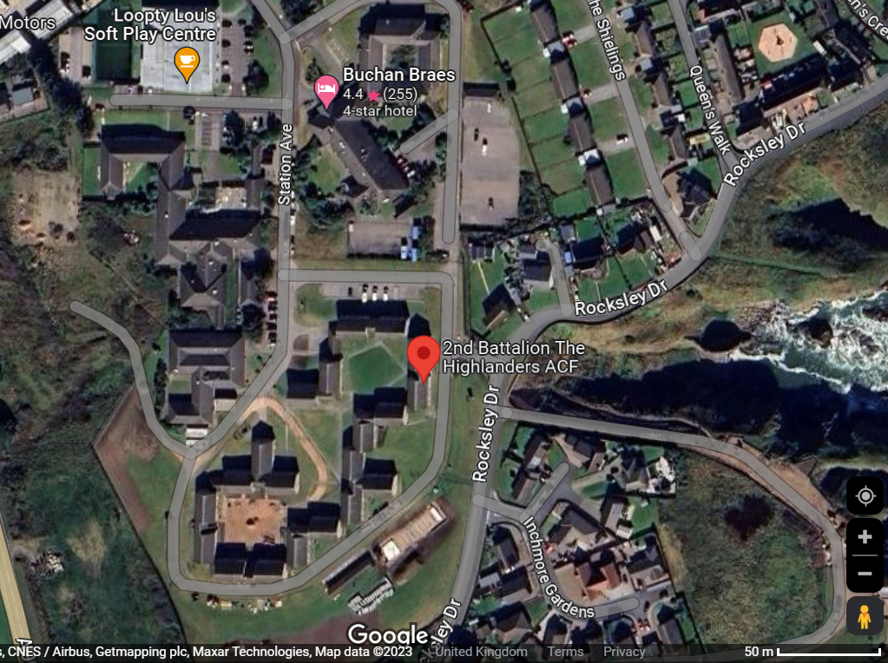
CTC Boddam main gate entrance
Buchan Braes Hotel parking area

Yours sincerely,
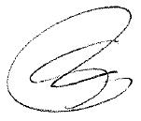

Major Sean Fraser
2nd Battalion The Highlanders ACF

CONFORMATION SLIP

CELEBRATION EVENT – 27th AUGUST 2023

Cadet Name(s):

Detachment:

As the parent / guardian of the above, I am confirming that the following two persons will be attending the above event on the date shown:

GUEST 1 :

GUEST 2 :

The cadets are being transported to and from the event but if you wish them to leave with you on the day, please tick the box below as conformation:

I will take the cadet(s) named above with us on the day so do not require return transport

