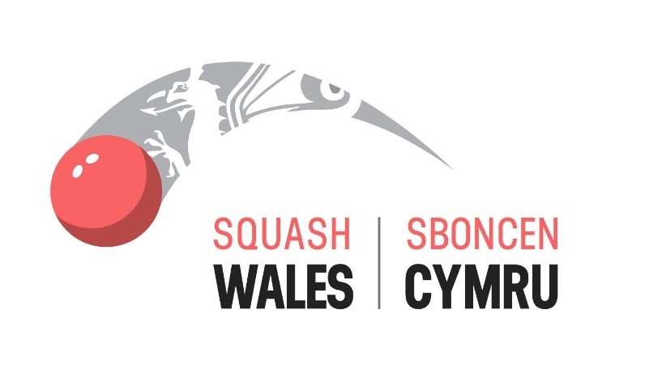

SQUASH WALES
NATIONAL SQUAD SELECTION CRITERIA

Document Control

Document created | Author
June 2020 | Dave Evans

Version | Date | Description of Change | Changed by
V2 | June 2020 | Personnel Changes | DE
V2 | July 2023 | Personnel Changes | DE
V2 | Feb 2026 | Personnel Changes | DE

Action Required

Version | Date | Description of Change | Requested by

Board Agreement

Version | Date  Agreed | Comments

Next review date

Version | Next Review Date
V2 | June 2021
V2 | October 2023
V2 | October 2024
V3 | October 2026

Selection CRITERIA & Procedure for JUNIOR National Squads

Criteria

Players must:

- Eligible to represent Wales as outlined in the Welsh Nationality protocol.
- Be an Academy member of Squash Wales, for which they are selected.
- Attained the minimum commitment criteria set out by Squash Wales in the information sheet.
- Have signed and returned the Squash Wales Code of Conduct Form.

Selection Factors

Individual performances and results during:

- National Squads that the player has been invited to attend.
- Welsh Jnr Open, Welsh Jnr Closed, North Wales Jnr Open.
- Welsh Regional tournaments.
- Regional Academy Day Squads and weekly Academy Training Night.
- English Inter-County Championships (if selected).
- English Gold & Silver Events
- British Closed and Open and European Tournaments.
- Referral from Squash Wales Performance Team.
- Benchmark scores from the Player Performance Profile Chart.

Selectors for National Squads

- Squash Wales Head of Performance/Participation
- Squash Wales National Junior Coach.

The selectors will meet prior to the first National Squad date to select players. Performances will be reviewed regularly to ensure that the inclusion and exclusion flexibility of the Squad structure is complied with.

The Selectors will place emphasis on individual performance, behavior, commitment and attitude at every stage of the Junior Development Pathway as defined in the Squash Wales Code of Conduct and Commitment for Home & Away Events.

aPPEALS PROCEDURE

Appeal Panel Members

- Tom Edwards Board member – Lead on Performance
- Two Independent Board members of Squash Wales

Appeal Process

An appeal must:
- Be addressed to and received by Tom Edwards Board Director for Performance of Squash Wales tom.edwards@squashwales.com in writing or email 14 days prior to the squad/event
- Contain the facts plus supporting evidence

The Panel will meet as soon as conveniently possible after receipt of an appeal. The decision of the Panel will be final and binding on the appellant and will be communicated in writing within 10 days.

