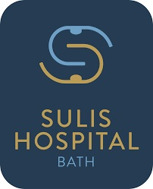

Working Towards a Greener More Sustainable Future
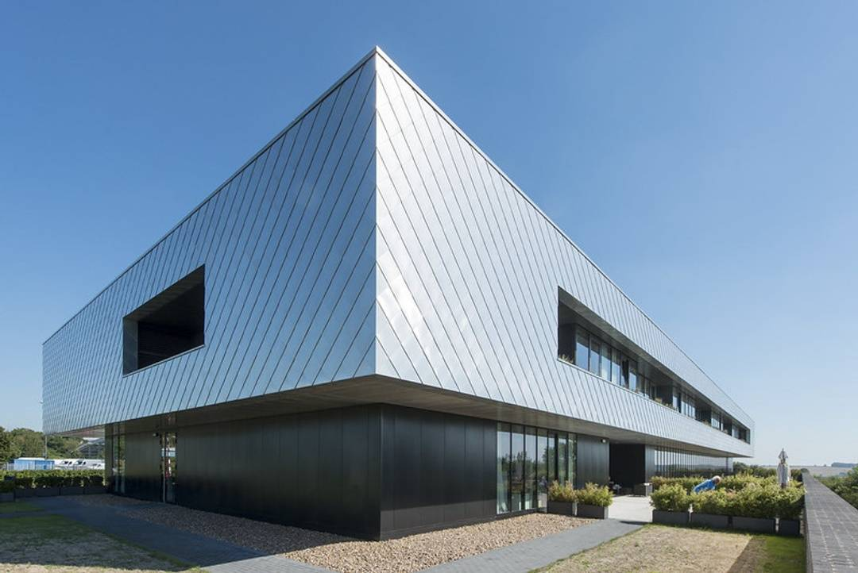
2025 – 2030

The Green Plan

Contents
03 Foreword
04 Introduction
05 Our Organisation
06 Key Drivers for Change
07 Our Green Plan
08 Our Hospital Goal and Objectives
09 Governance
10 Green Plan – Key Actions and Progress to Date
11 Areas of Focus
12 Climate Adaptation
13 Digital Transformation
14 Estates & Waste Management
15 Food and Nutrition
16 Green Space and Biodiversity
17 Medicines and Medical Gases
18 Net Zero Clinical Transformation
19 Supply Chain and Procurement
20 Travel and Transport
21 Workforce and System Leadership
22 Mapping Ambition to Action
23 How can you help

Foreword
Climate change is undoubtedly affecting all aspects of healthcare and, as a relatively new site, Sulis is in a good place to contribute to the reduction of its carbon footprint quickly and effectively
There are already a few initiatives underway to reduce waste, and pollution, most notably in the Endoscopy suite and theatres. However, there is a need to roll out across the organisation a concerted programme to not only continue the good work, but include all clinical and support service areas
This document is a welcome addition to the programme and sets out what and how Sulis will play our part in the nation’s strategy to achieve Net Zero in the coming years
Investment in time, people and infrastructure will be foremost in Sulis’ decision-making to achieve our goals

Simon Milner Hospital Director

Introduction
Whilst Sulis is a Private Hospital, we are solely owned by the Royal United Hospital Bath and as such aim to align our plan with the ‘NHS Net Zero’ sectors and targets.
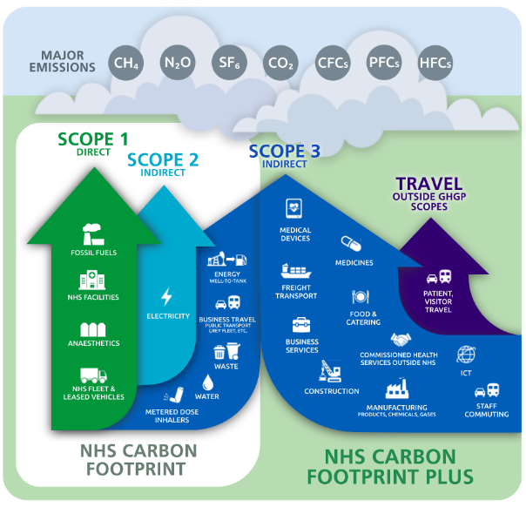
Acting responsibly and reducing the impact we have on our environment is an important consideration for Sulis, from the way we care for our patients, to ensuring we have a strong, financial, and sustainable system in place. As a healthcare organisation, we are committed to actively delivering our contribution to reduce carbon emissions and embed sustainability into everything we do. Climate change is globally recognised as the greatest environmental and economic threat faced by the national governments and individuals. It is also an opportunity for us to make those sustainable improvements, ensuring we use resources responsibly.
Based on the findings of the ‘Delivering a ‘Net Zero’ National Health Service’ report, the NHS has formally adopted two targets, set as the earliest possible credible dates for the NHS to achieve net zero emissions:
• for the NHS Carbon Footprint (emissions under NHS direct control), net zero by 2040, with an ambition for an interim 80% reduction by 2028-2032.
• for the NHS Carbon Footprint Plus, (which includes our wider supply chain), net zero by 2045, with an ambition for an interim 80% reduction by 2036-2039.

With the introduction and publication of the Hospitals Green Plan, we are taking steps to embed sustainability into Sulis culture and operations. Our initial focus will be on engaging our staff and seeking views as to how we can become a more sustainable organisation. A governance structure will be set up with a dedicated Sustainability Sub-Committee, and specific working groups whose purpose will be to drive the aims and objectives set out in the Green Plan.
This Green Plan will be published in 2025 and sets out targeted aims and objectives to ensure that we align with those of the National Greener NHS. It also sets out our plan to meet the NHS Long Term Plan, ‘Delivering a Net Zero National Health Service’ report and subsequent guidance documents focuses on reducing carbon.
Figure1: Greenhouse Gas Protocols (GHGP) scopes in the context of the NHS
This Green Plan will guide and develop future services in line with national and local policies and to ensure we embed sustainability in all services across the Hospital.

Our Organisation
Sulis Hospital is an independent, award-winning hospital owned by the Royal United Hospitals Bath NSH Foundation Trust. It expands the Trust’s capacity to deliver high quality elective care for NHS patients and provides private healthcare. Since becoming part of the Trust in 2021, Sulis operates as the UK’s first fully-operational private hospital wholly-owned by an NHS Trust – meaning surplus income generated through private care is reinvested into NHS services for the benefit of all patients.

The wider Trust serves a population of roughly 500,000 people across Bath, North East Somerset, parts of Wiltshire, Somerset and South Gloucestershire – as well as visitors, students and tourists to the area.

Sulis employs 548 staff and provides a broad range of diagnostic, outpatient and surgical services, delivered by world-class consultants and clinical experts. Its modern facilities include four operating theatres, an endoscopy suite, advanced imaging and dedicated inpatient and day-case units. It’s also home to the new Sulis Orthopaedic Centre with two additional operating theatres, a ring-fenced elective hub designed to deliver orthopaedic surgery with minimal disruption from emergency pressures for the system.

Working in close partnership with the RUH Bath, Sulis supports efforts to reduce waiting times, increase planned care capacity and improve patient flow across the region. The hospital plays a key role in delivering safe, efficient and patient-centred care across a mixture of NHS and private pathways.

The Hospital is aligned with the Bath, Swindon and Wiltshire (BSW) Integrated Care System (ICS), whose long-term vision is to support healthy, independent living, and is part of the BSW Hospitals Group, alongside Royal United Hospitals Bath NHS Foundation Trust, and Great Western Hospitals NHS Foundation Trust and Salisbury NHS Foundation Trust.

Key Drivers for Change
A sustainable health and care system delivers high quality care and improved public health without exhausting natural resources or causing ecological damage. Sustainable development is based on the principle that our actions today should not negatively impact on the future of people, wildlife and our planet.
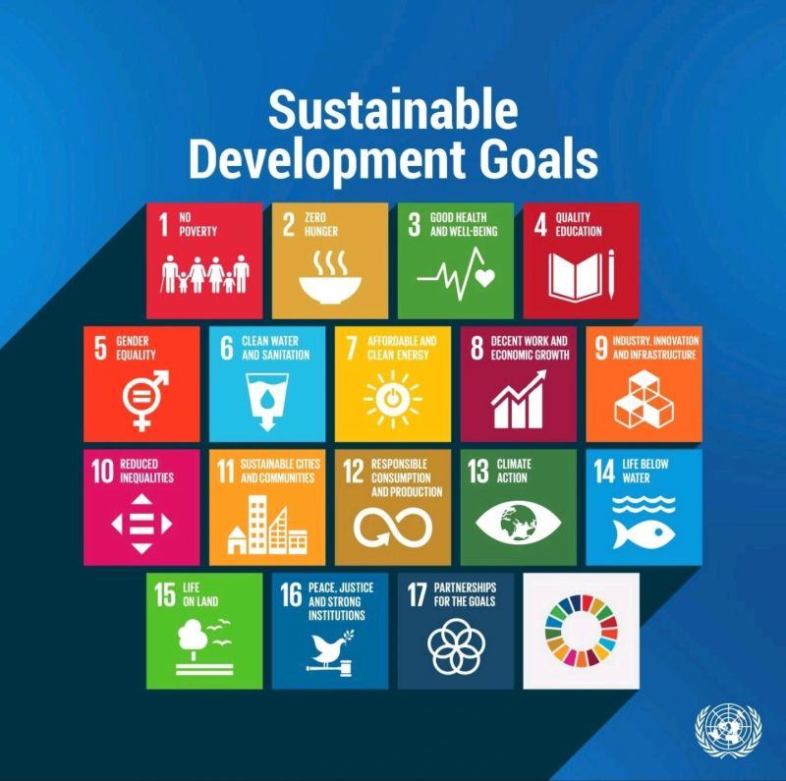
This is achieved by balancing economic, environmental, ethical and social considerations in everything we do. The United Nations developed 17 Sustainable Development Goals (SDGs), shown in Figure 3, which recognise that ending poverty and other deprivations must go hand-in-hand with strategies that improve health and education, reduce inequality, and spur economic growth – all while tackling climate change and working to preserve our oceans and forests. As a Hospital, we have a responsibility to adhere to this and ensure long term financial, environmental, and social sustainability within the organisation, as well as across the healthcare system.
There are several key drivers for change, which have informed this Green Plan and its direction of travel.
- Climate Emergency – Health emergency
- Climate Change Act 2008
- Delivering a ‘Net Zero/ NHS
- NHS Long Term Plan
- Estates Net Zero Carbon Delivery Plan
- NHS Net Zero Building Standard
- Clinical Waste Strategy
- Management and Disposal of Healthcare Waste (HTM 07-01)
- Net Zero travel and Transport Strategy
- Sustainable IT and Digital services Strategy
- Care Quality Commission Assessment (Environmental Sustainability) Fig: 2 Drivers for Change
- BANES Climate Emergency Planning Statement (2019)
- Green Plan Guidance

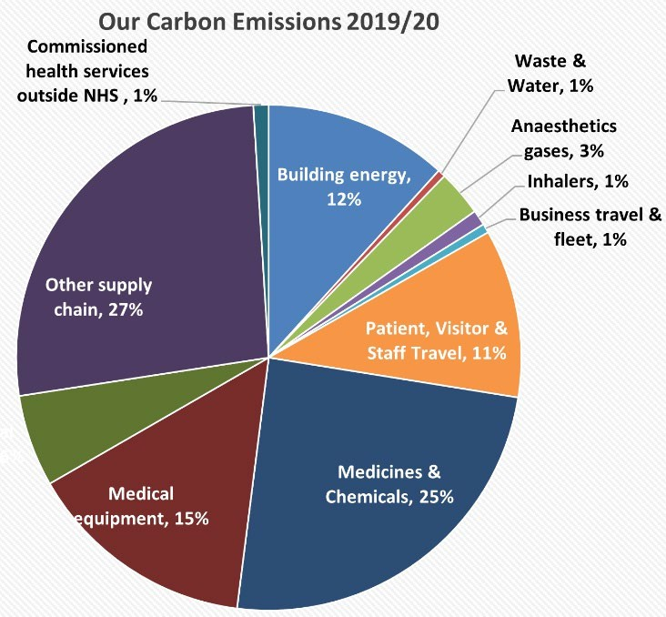
Our Green Plan
To plan our pathway to net zero carbon emissions, we must first understand the areas responsible for those emissions. Figure 4 identifies the key sources of emission by activity for a typical NHS Trust such as RUH. We must now review our own activities to develop a true understanding of our carbon Emissions. Whilst the chart makes clear that the area around medicines, medical equipment and other supply chain, gives us the greatest opportunities for positive change, the small changes each individual member of staff can make will contribute significantly to the overall picture.
At present Sulis does not have a definitive measure of its carbon footprint. Estimates of Sulis contributions to the NHS Carbon Footprint Plus emissions have not been calculated by the Greener NHS team. The latest available data is for the 2019/20 base year (Figure 4). The NHS Carbon Footprint Plus are calculated using expenditure data, supplemented with staff and patient travel data. These spend based estimates of the NHS Carbon Footprint are less suitable for tracking year-on-year changes in emissions and are best used for baselining, identifying emissions hotspots at a point in time, and understanding NHS organisations’ contributions to the national emissions set out in the Delivering a Net Zero NHS report. Estimates of the contributions to the national NHS Carbon Footprint and NHS Carbon Footprint Plus, and the targeted reductions required, will be revised as data and modelling continue to improve over time, with improvements particularly focused on bringing in more granular data that allows active monitoring and verification of progress at hospital level
Fig:4 NHSCarbon Footprint

Sulis Goal and Objectives
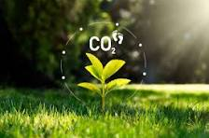
Our goal is to lead in sustainable health and care, in partnership with RUH Bath, our community and planet.
Our key Green Plan objectives are as follows:
Reduce our Carbon Footprint by 80% by 2032 and achieve Net Zero by 2040
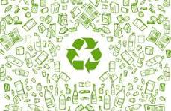
Reduce our Carbon Footprint Plus (including wider supply chain) by 80% by 2039 and achieve Net Zero by 2045


Achieve 10% net biodiversity gain by 2030, across the Sulis estate



Adopt the Clean Air Hospital Framework to achieve excellent score of 70% by 2029


Adopt a sustainable model of care for each clinical pathway by 2030

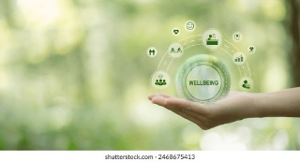
Support Staff Wellbeing

Governance
The Hospital recognises the need for sustainable development and the focus for long term improvements. Therefore, it is essential that the Hospital is accountable for delivering the Green Plan, and that policies, procedures, business cases and processes reflect this. The governance structure to deliver the Green Plan needs to be established to engage all relevant parts of the organisation to take a coordinated approach to the implementation of the Green Plan.
It aims to ensure that sustainability is embedded within the organisation, including its strategies and processes, and for the Sulis to continue to become a safe, caring and efficient hospital within a high-quality hospital environment, built on clinical and financial sustainability. The next stage of this is to embed sustainability within departments so they are also accountable for the delivery of this Green Plan. This will be explored in the coming
year.
Trust Board
Finance Investment &
Infrastructure Committee

Sustainability
Sub-Committee
Environment
Group
Departmental
Working Groups

Sustainability Sub-Committee
Led by the Associate Director of Finance and Associate Director of Estates, our Hospital Sustainability Sub Committee should comprise of a representative from targeted corporate functions and clinical service lines with decision making authority, together with a representative from each of the groups that sit underneath. In addition, a clinical lead with oversight of net zero clinical transformation, with formal links into board-level leadership and governance, will be identified (Head of Nursing?).

Environment Group
The group will focus on improving wildlife, biodiversity and the natural environment across owned or leased facilities. This group will continue to be the ‘social conscience’ of the organisation on environmental matters.

Departmental led working groups
Departmental led focused groups, such as pharmacy, theatres and procurement, will focus on more specific objectives outlined in the Green Plan.

Green Plan – Key Actions and progress 2025 to date

Whilst this is the first Green Plan for Sulis Hospital. There have been some previous, positive highlights that will add to the outcomes and achievements of the plan as we move forward.
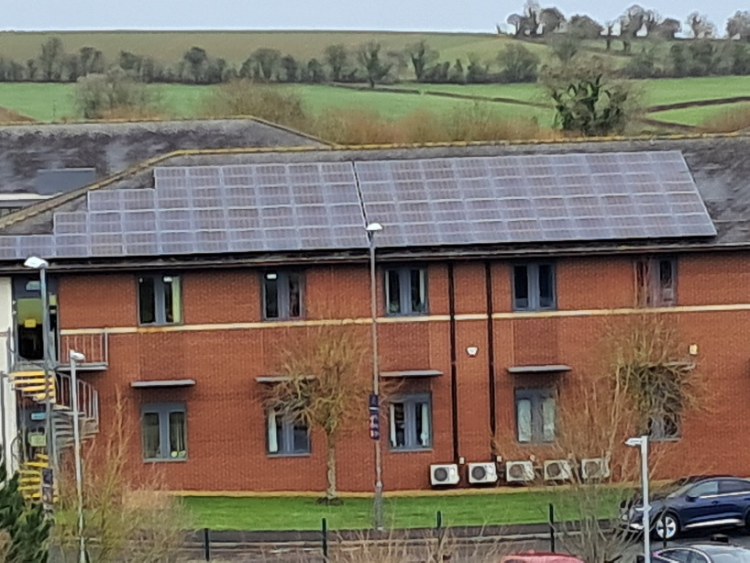
Solar panel arrays on SOC and Unit 1
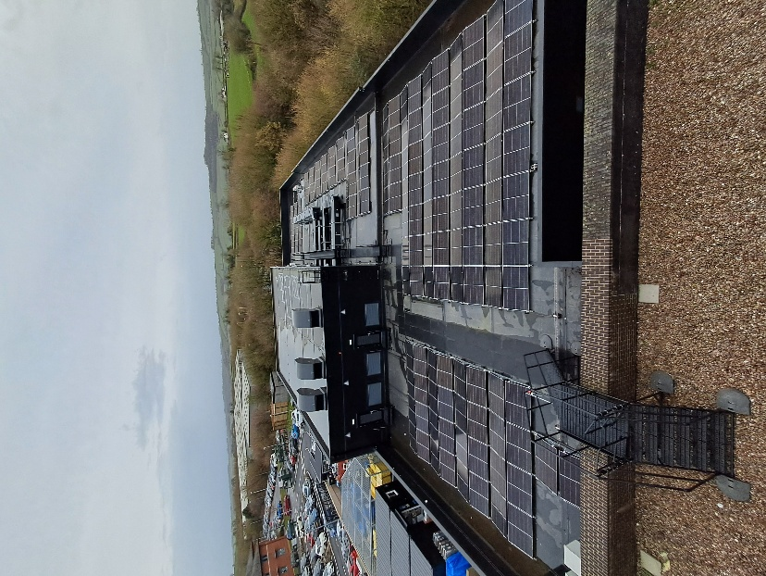
6 x Air Source Heat Pumps installed on SOC

4 X Air Source Heat Pumps CDC (CT)

Herb Garden

Theatre Med gas Reductions

Theatre material reductions

Our Areas of Focus
In line with NHS England’s Green Plan framework, we have structured this plan around nine recommended Areas of Focus, which ensure action across both clinical and non-clinical domains. In addition, recognising the health and wellbeing value of the natural environment, we have introduced a 10th area of focus, Green Spaces: Biodiversity and Community Wellbeing.

Climate Adaptation Digital Transformation Estates and Waste Management
Food and Nutrition Green Spaces: Biodiversity and Community Wellbeing Medicine and Medical Gases
Net Zero Clinical Transformation Supply Chain and Procurement Travel and Transport
Workforce and System Leadership

For each of the focus areas, we have identified headline actions and measurable outcomes. We will promote the use of A3 Thinking as part of the Improving Together methodology, encouraging individuals and teams to contribute to continuous improvement through small, measurable actions, recognising the power of 1% gains across all areas of focus.
Monitoring and Delivery Framework
The SMART actions and KPIs presented, are a selection of key priorities. To ensure transparency and accountability, delivery will be supported by a dedicated tracker document. This will contain the full set of SMART actions, timelines, responsible leads, and performance metrics across all areas of focus. While the plan highlights key priorities, the tracking document will be regularly updated to monitor progress, inform reporting, and support decision-making at both operational and board levels. Our Board-level Executive Lead for Net Zero and Sustainability will continue to provide strategic oversight and ensure accountability for the delivery of this plan

Climate Adaptation
As the impacts of climate change become more evident, it is essential to ensure that our healthcare system remains resilient and adaptable. From extreme weather events to changing health risks, hospitals must be prepared to respond while maintaining high-quality care. By integrating climate adaptation strategies – such as sustainable infrastructure, efficient resource management, and proactive risk planning – we can protect patient wellbeing and ensure the long-term sustainability of our services. Through innovation and strategic action, we will build a future-proof healthcare system that can withstand environmental challenges.

Vision: To build a resilient healthcare system that adapts to climate challenges, protects patient wellbeing, and ensures sustainable, future-proof hospital operations.
SMART actions and KPI’s 2025 – 2028
Steps to make it happen | Measures
Produce Climate Risk Assessment and add to hospital Assurance Framework | - Risks identified and added to hospital Risk Register  - Overall risk rating in climate change risk assessment
Integrate our Adaptation Plan into business continuity strategies. Ensuring that our emergency plans for extreme weather consider support for vulnerable communities. | - Testing of business continuity and extreme weather plans.
Collaborate with external stakeholders to support local adaptation plans where appropriate and to learn and share beyond our boundaries. | - Feedback or recognition from external networks.  - Increase in external collaborations leading to joint initiatives/learning opportunities.

Digital Transformation
Digital transformation plays a crucial role in advancing sustainable healthcare by reducing carbon emissions, optimising efficiency, and improving patient care. By embracing smart technologies, paperless systems, and data-driven decision-making, we can minimise waste, lower energy consumption, and streamline operations. Virtual clinics, remote monitoring, AI-driven resources management, empower patient self-care, reduce reliance on hospital visits, and support a shift toward user self-service. Through digital innovation, we will not only enhance patient experience but also ensure that sustainability remains at the core of our net-zero transition.

Vision: Leveraging digital innovation to create smarter, more sustainable healthcare – reducing carbon emissions, optimising resources, and enhancing patient care while driving our transition to a net-zero future
SMART actions and KPI’s 2025 – 2028
Steps to make it happen | Measures
Reducing environmental impact of digital services. Circular economy models - device lifecycle management, reuse models. | - Items monitored (new, reused, recycled/disposed of) by category.
Energy efficient IT systems. And work to ensure AI use is optimised with sustainability in mind. | - % of energy-efficient assets sourced.
80% of hosting to be in low carbon data centres by 2028, using best-available estimates and provider disclosures | - RAG rating providers.
Increase/introduce solutions to improve utilisation of office space. | - % of rooms in system, and number of bookings.
Electronic Patient Record (EPR) project. | - Full EPR implementation by October 2026.
Digitalisation of paper-based processes and publications. | - % of paper v digital systems.
The BSW Hospitals Group to bring together technologies used and maximise existing digital technologies to reduce the need to invest in further solutions that increase our carbon footprint. | - Reduction in applications e.g. server rooms, single cyber tooling.

Estates and Waste Management
Sustainable estates, incorporating any development of the wider site, are key to reducing the environmental impact of healthcare facilities ensuring they are efficient, resilient, and fit for the future. By incorporating energy-efficient design, renewable energy sources, and green building principles, we can lower carbon emissions, improve resource efficiency, and create healthier environments for patients and staff. Investing in sustainable infrastructure and modernising hospital estates will support our journey to net-zero, ensuring that our facilities are not only environmentally responsible but also equipped to meet the evolving needs of healthcare.

Vision: To create sustainable, energy-efficient, and future-ready healthcare facilities that minimise environmental impact while enhancing patient care and staff wellbeing.
SMART actions and KPI’s 2025 – 2028
Steps to make it happen | Measures
Identify available energy/net zero training to upskill our staff to be more ‘energy aware’, and conscious of their contribution to our Green Plan. | - HDP plan established.
Undertake energy audits to identify high usage areas to focus on reducing consumption by end of 2026. | - Number of areas audited.  - Energy consumption of systems (kWh)
Increase on-site renewable energy generation by 2028. | - Increase in renewable energy production.
Better utilisation of Building Management Systems | - Energy consumption of systems (kWh).
Support the NHSE 20-20-60 clinical waste segregation initiative. | - % of Highly Infectious-InfectiousOffensive Waste disposal.
Increase the activity of Sustain & Reclaim to promote reuse of resources | - Increase in cost avoidance and tCO2e saved.
A Heat Decarbonisation Plan (HDP) by 2028, targeting fossil-fuel phase-out by 2032. | - HDP plan established.
A formalised Net Zero Estates Strategy by the end of 2025. | - Published strategy.
Ensure all applicable new building and major refurbishments projects are compliant with the NHS Net Zero Building Standard. E.g. Elective Care Centre | - BREEAM rating. Assessment over life of design and subsequent construction.
100% LED lighting across the estate. | - % of LEDs installed on site.
Replacement of energy-inefficient windows unit 1 | - Number of windows replaced.

Food and Nutrition
Sustainable food and nutrition are essential components of a greener healthcare system. By prioritising locally sourced, seasonal, and plant-based options, we can reduce the environmental impact of hospital food services while helping to improve the health and wellbeing of patients and staff. Minimising food waste, optimising procurement, and promoting responsible sourcing will help lower carbon emissions and support our commitment to a net-zero future. Through a sustainable approach to food and nutrition, we can create a healthier environment for patients, staff, and the wider community.

Vision: To promote sustainable, nutritious, and locally sourced food choices that enhance patient health, reduce waste, and minimise the environmental impact of hospital food systems.
SMART actions and KPI’s 2025 – 2028
Steps to make it happen | Measures
Focus on reducing single-use plastics by 20% in 2026. | - Reduction in items procured.
Increase the use of organic and locally sourced products by 2027. | - Achieving Food for Life Silver
Introduce electronic patient meal ordering by end of 2026 reducing paper and supporting a reduction in food waste. | - Food waste disposal reported using the ERIC system.  - Reduction in paper.
Increase plant-based meals, reduce meat and dairy (dietitian led) in 2026. | - Carbon emissions reduction.
Improve energy efficiency and reduce energy consumption of catering activities by 2028, through behaviour change and ensuring any equipment replaced is energy efficient. | - Energy consumption kWh
Develop supplier sustainability maturity programme driving Environmental, Social & Governance within the supply chain | - Number of suppliers taking up sustainability programme.

Green Spaces: Biodiversity and Community Wellbeing
In a healthcare environment, access to quality green spaces supports physical healing, mental wellbeing, and environmental resilience. At Sulis we have very limited outdoor and green space. However, preserving and increasing biodiversity; enhances air quality, provides therapeutic landscapes for patients and staff, and creates habitat for native wildlife. This area of focus commits to integrating nature into the hospital environment by protecting existing green areas, introducing biodiversity-supporting features, and encouraging engagement through education and community participation.

Vision: To create a healing environment where people and nature thrive together, fulfilling the Hospital responsibilities.
SMART actions and KPI’s 2025 – 2028
Steps to make it happen | Measures
All accessible green space locations will be communicated to public and staff e.g. maps, posters. | - Number of maps downloaded/handed out.  - Count Staff badge access to areas.
Implement ten biodiversity initiatives e.g. pollinator gardens, green roofs, bird boxes, or insect hotels by end of 2026. | - Number and type of features installed.  - Records of usage by wildlife.
Conserve, enhance and extend where possible, areas of existing habitat e.g. unimproved land/species-rich areas. | - Number and variety of key indicator species recorded.
Staff engagement activities e.g., nature walks, exhibitions. | - Number of participants/feedback.
Baseline biodiversity survey by end of 2027. | - % surveyed. New species observed and location/estimate of abundance.
Develop supplier sustainability maturity programme driving Environmental, Social & Governance within the supply chain | - Number of suppliers taking up sustainability programme.

Medicines and Medical Gases
Medical gases and medicines play a vital role in patient care, but their production, use, and disposal contribute significantly to healthcare-related emissions. By adopting sustainable procurement practices, optimising usage, and exploring lower-carbon alternatives, we can minimise their environmental impact whilst maintaining high-quality care. Reducing waste, improving efficiency, and implementing greener solutions for anaesthetic gases and pharmaceuticals will support our transition to net-zero healthcare.

Vision: To reduce the environmental impact of medical gases and medicine through sustainable procurement, responsible usage, and innovative alternatives – ensuring high-quality patient care while supporting our journey to a net-zero healthcare system.
SMART actions and KPI’s 2025 – 2028
Steps to make it happen | Measures
To phase out the use of nitrous oxide by end of 2026 | - Reduction carbon emissions.  - £ savings made.
Reduce medicine waste from wards and pharmacy by 20%, by 2028. | - Progress reviewed through periodic sampling and available data where feasible.
Reduction in medical gases through the Elective Care Centre. | - Reduction in associated carbon emissions.

Net Zero Clinical Transformation
As healthcare evolves to meet the demands of the 21st century, it is essential to integrate sustainability into care delivery. The NHS Long Term Plan emphasises the need for innovative models of care that not only improve patient outcomes but also reduce carbon emissions. By considering environmental impact in care design and implementing sustainable practices, we can create a healthcare system that is both resilient and environmentally responsible. This approach ensures that quality care and sustainability go hand in hand, benefitting both patient and the planet.

Vision: To transform healthcare delivery by integrating innovative, sustainable models of care that enhance patient outcomes while minimising environmental impact, ensuring a greener and more resilient future for all.

SMART actions and KPI’s 2025 – 2028
Steps to make it happen | Measures
Focus on reducing emissions and improving the sustainability of the Hospital, establishing a working group to support this, by mid-2026. | - Establishment of Emergency dept. working group, and identification of initiatives.
Empower clinicians to improve the sustainability of their models of care by embedding Sustainability and Quality Improvement in their working methods, and any other available tools and resources, by end of 2026. | - % of Quality Improvement projects with sustainability impacts identified
Ensure business development and investment decisions undertake a formal Sustainability Impact Appraisal (SIA) by 2028 using available tools | - Number of SIAs completed.
Identify more efficient work processes to reduce the use of paper, gloves, and couch paper rolls. | - Cost reduction from previous fiscal year
Identification of Clinical Sustainability Leads across areas by mid-2026. | - Number of Clinical Leads.

Supply Chain and Procurement
A sustainable supply chain and procurement strategy are essential for reducing the environmental impact of healthcare operations, by prioritising ethical sourcing, low-carbon alternatives, and circular economy principles, we can minimise waste, lower emissions, and enhance resource efficiency. Embedding sustainability into procurement decisions across the BSW Hospital’s Group ensures that the products and services we use align with our commitment to a net-zero future. Through collaboration with suppliers, innovation, and responsible purchasing, we can create a greener, more resilient healthcare system that benefits both people and the planet

Vision: “By 2045, to see Suli and the wider NHS with a net zero, fair, and transparent supply chain free of modern slavery” through building a sustainable, ethical, and low-carbon supply chain that supports high-quality patient care while reducing environmental impact.
SMART actions and KPI’s 2025 – 2028
Steps to make it happen | Measures
Engagement with suppliers to shape our approach and provide them opportunity to align with our supplier sustainability maturity programme driving Environmental, Social & Governance within the supply chain, focusing initially on our >£10k p.a. suppliers | - Initial sign-up numbers to programme  - Annual update report from supplier
All suppliers, by April 2027, will be required to publish a Carbon Reduction Plan (CRP) for global emissions aligned to the NHS net zero target Scope 1, 2 and 3 emissions | - % of >£10k suppliers with CRP measured year on year
Working with Salisbury (BSW) procurement. To explore and implement (2025-26) methodology to quantify delivered social value through tendering. Year on year reporting | - Record social value creation and associated number of contracts.
Supplier Day for local SME suppliers across BSW by March 2026. | - Supplier event held.
Work with NHSSC through BSW to implement sustainable product choices | - Number of products moved to a more sustainable option.

Travel and Transport
Reducing travel emissions is crucial, as vehicle pollution negatively impacts local air quality and public health. NHS England has set an ambitious target to transition to a net-zero fleet, including emergency and patient transport vehicles. Whilst at present we do not have any fleet vehicles, we are committed to playing our part in this journey by supporting the use of low and zero-emission vehicles. Shifting towards cleaner transport alternatives, including active travel options, not only supports environmental goals but also enhances staff wellbeing by promoting physical and mental health.

Vision: To create a sustainable future where zero-emission transportation is seamlessly integrated across our fleet, business travel, and staff commutes for all essential travel needs.
SMART actions and KPI’s 2025 – 2028
Steps to make it happen | Measures
Understanding barriers and motivations to sustainable travel Annual staff travel survey, and visitor travel survey by 2027. | - % of survey participants.
SMART actions added to Sustainable Travel Plan by end 2026. | - Refreshed plan published.
Reducing unnecessary patient travel. | - Number of remote appointments and patient miles avoided.
Introduction of cycle to work scheme by 2027 | - Appointment of a cycle to work provider that meets staff needs and/or other opportunities to acquire a bike.
Working with internal and external partners to learn and share beyond our boundaries by 2028 and collaborate to increase patient access to public transport to attend hospital. | - Increase in external collaborations for joint initiatives or funding opportunities.
Promote the Sulis E-Bike hire scheme – available Jan 2026 | - Measure uptake of hires  - Survey for reduction in car mileage

Workforce and System Leadership
A sustainable healthcare future depends on strong leadership and an empowered workforce. Embedding sustainability into everyday practices requires a collective commitment from leaders, staff, and system partners. By fostering a culture of environmental responsibility, providing education, and training, and integrating green principles into decision-making, we can drive meaningful change. Our workforce is at the heart of this transition, and through collaboration, innovation, and leadership, we will build a resilient, net-zero healthcare system that supports both people and the planet.

Vision: To inspire action, share knowledge, and empower change for a more sustainable healthcare system. And to broaden our impact by inspiring action among our wider stakeholders, including patients.
SMART actions and KPI’s 2025 – 2028
Steps to make it happen | Measures
Senior leadership and Board specific training by end of 2026. | - % of leadership/Board completing training.
Annual staff survey for understanding sustainability engagement, motivators, barriers, challenges. | - % of staff participating in survey.
Include Sustainability and Quality Improvement (SusQI) in appraisals by the end of 2026. | - % of staff incorporating SusQI goals into their appraisal plans.
Expand the Sustainability Champions network to ensure representation in every ward and department by 2028. | - Number of Sustainability Champions and initiatives undertaken.
Engage with local, regional, and national networks to learn and share beyond our boundaries, 2025-2028. | - Feedback or recognition from external networks. Increase in external collaborations leading to joint initiatives or funding opportunities.
Mandatory Net-Zero Training Module for all staff 2026 | - % completion on mandatory training audit
Sustainability included in Hospital Induction 2026 | - Attendance at Hospital Induction

Mapping Ambition to Action
This section illustrates how our six strategic objectives (page 8) – the ‘why’ behind our sustainability journey – are delivered through the 10 Areas of Focus of our Green Plan – the ‘how’. By making these connections explicit, we can better track progress, ensure our actions remain purposeful and impactful, and highlight how each operational area contributes to our overarching goals.

Areas Of Focus
Goals & Objectives | Adaptation | Digital Transformation | Estates & Waste Management | Food & Nutrition | Green Spaces Biodiversity and community wellbeing | Medicines & Medical Gases | Net Zero Clinical Transformation | Supply Chain & Procurement | Travel & Transport | Workforce & System Leadership
Carbon Footprint reduction by 80% | 
Carbon Footprint (Plus) reduction by 80%
Achieve 10% net Biodiversity
Adopt Clean Air Hospital Framework & achieve Excellent
Adopt sustainable model of care for each clinical pathway
Support staff wellbeing and retention
We have set ambitious but achievable goals under this Green Plan, aligned to national NHS net zero targets. We recognise, however, that the scale and pace of our progress is influenced by the fact that we are starting our journey five years later than the RUH, BSW group and wider NHS, we will also be impacted by, external factors, including capital funding and increasing hospital activity levels and patient demand. Overall, our confidence in achieving most of our aspirations by 2028 is positive, with some areas already embedded into our ways of working. The major area where we need immediate focus is calculating our overall carbon footprint and knowing the levels and action required to reduce our scope 1, 2, and 3 emissions. We will continue to monitor and prioritise actions based on impact, feasibility, and available resources, maintaining a clear direction of travel towards our long-term net zero goals while being transparent about the challenges ahead.

How you can help
- Spread the word
  - Start the conversation! Talk to your colleagues, friends, and family about sustainability. Every discussion helps drive awareness and positive change – let us get everyone thinking (and talking) green
- Get Involved
  - Share your ideas, ask questions, or reach out for support by emailing:
- Become a Sustainability Champion!
  - Be a leader in inspiring change – whether you are enthusiastic about making bold, sustainable moves or simply want to start with small everyday actions, there is a place for you in our team.
Interested? Email david.hughes@sulishospital.com to find out more and get involved.

