Motor Vehicle

Research Task

NAME:

Date:

Score:

1). If a tyre has a sidewall marking of 225/45 ZR17 91W, what does the ‘91’ indicate?

A. Width of the Tread in mm
B. Height of the sidewall
C. Speed Rating
D. Load Index

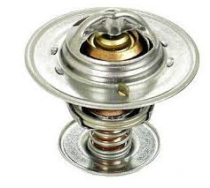
2). Identify the component shown in this image:

A. Oil pressure switch
B. Radiator core
C. Coolant sensor
D. Thermostat

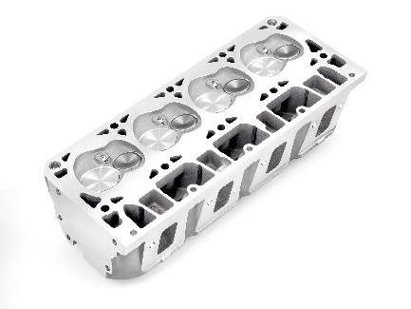
3). Identify the component shown in this image:

A. Crankshaft
B. Radiator
C. Cylinder Head
D. Thermostat

4) It is recommended that brake fluid be changed periodically because it

A Absorbs moisture
B Loses its viscosity
C Causes seals to swell
D Becomes too thick

5). What item is indicated by the letter L in the diagram shown here?
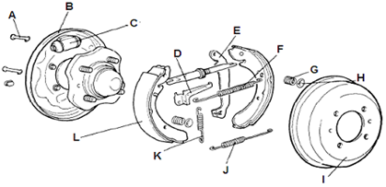
A Brake disc
B Brake drum
C Brake pad
D Brake shoe

5). In the space below, name and describe the four strokes of a Spark Ignition and a Compression Ignition engine. Draw a sketch for each stroke, show the piston direction and valve position, and describe what is happening in each stroke. Also, describe the differences between the four-stroke cycle of the Spark Ignition engine and that of the Compression Ignition engine.

