 

**Level 1/ Level 2 Diploma in Art & Design**

|  |  |
| --- | --- |
| **Assignment Title** | **Summer Project Brief / Make Your Mark** |
| **Level** | Level 1/ Level 2 |
| **Assignment Leader** | Charlotte Dawson and Francesca King |
| **Start Date** | June 2021 |
| **Assessment Date** | September 2021 |

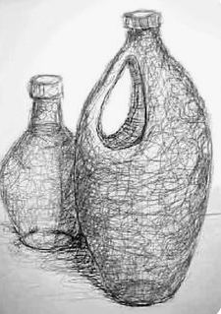 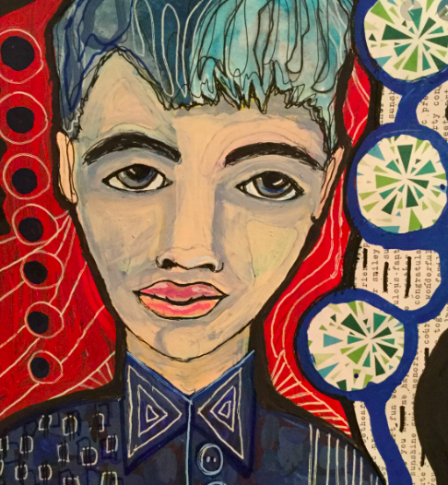

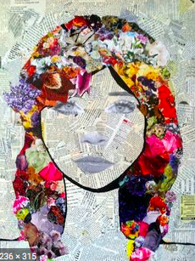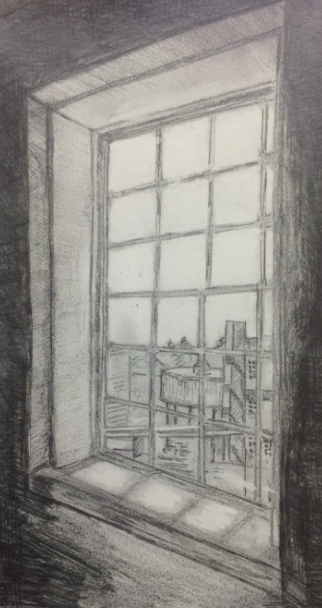

|  |
| --- |
| **Content** |
| During the Summer holidays we would like you to explore drawing. We have devised a variety of drawing /mark making activities for you to complete over the Summer Holidays. These tasks which will allow you to experiment with observation, scale and hand & eye co - ordination whilst allowing you to reflect on yourself and the world around you. Practice makes perfect, if you take your time with these activities and repeat them you will start to feel more confident and drawing will start to feel more natural to you. Have fun with these activities and keep all of your drawings together, even the ones that you may not like very much, they are still valid. **Materials needed**  * General art equipment – whatever you have to hand is great. * You can use a sketchbook or separate sheets; any size format is fine. * Collect together any materials you have and use separately or together. |
|  |
| **Activity 1 - Invisible Objects** |
| Ask someone to put three objects into a bag, they mustn’t tell you what they are. Then you must put your hand into the bag and draw them, even if you guess what they are, don’t draw what you know, draw what you feel, i.e. take note of the texture and shape.  It may be that you draw a recognisable object, but alternatively you might have a more conceptual response, drawing simply the lines of what you feel. You can choose to draw all or one of the objects, or simply parts of them. |
|  |
| **Activity 2 - Draw without looking at your page** |
| A simple blind drawing, choose some household objects, cans, and food packaging are great for these.  Using colour, produce a few simple sketches –these rules apply: 1. Keep your eyes on the object 2. DO NOT look at the paper 3. Don’t lift your pen from the page  The trick is to ‘draw with your eyes’ and let your hand follow. |

|  |
| --- |
|  |

|  |
| --- |
| **Activity 3 -Sound** |
| Make a series of marks based on your response to sound – does what you hear sound warm, cold, angry, exciting? How do you represent this in terms of line, media, colour and scale? Your response may be to make marks, or you may visualise a scene/characters.  Produce three drawings in response to what you’re listening to, you can select your own music or choose from some of those listed below (just copy the titles below in to the YouTube search bar to listen:  Antonín Dvořák – Dvorak – String Serenade in E, Op.22 / Wind Serenade in D minor 1 Hour Birdsong Sounds on a Spring Morning in English Countryside |

|  |
| --- |
| **Activity 4 – Create your own portrait** |
| The last 3x activities were quite loose and expressive which is great practice but you may want to draw a bit more traditionally for this one. Take a selfie of yourself and draw yourself from a photograph or even better look in the mirror as you draw yourself. You could even add colour and pattern using collage materials like old magazines or paint if you have it at home. If not then maybe check the spice jar. Turmeric, paprika make good washes when you add some water and stir up. Or pop a tea bag in a cup and fill the cup half full of hot water, let it cool down and stew then the tea will be ready to wash the paper with and add colour. You can also use coffee. |

|  |
| --- |
| **Activity 4 – Draw a view from your window** |
| Have a look out of a window in your house. What can you see? Trees, telegraph poles, cars, brick walls? Draw a sketch of what you can see outside of your own window. You may want to take a photograph of the view and draw from that. You may also want to try a few different windows in your house so you can experiment with a range of different views. |

|  |
| --- |
| **Activity 5 – Check out Art Gallery Websites** |
| We would really like you to make yourself familiar with some of the more well-known art galleries out there. Check out the galleries websites and get a feeling for what the gallery offers and what kind of artists they represent. Once you start the course we will ask you to visit and check out art gallery websites when you are discovering different artists for research. So why not get a head start and have a browse before? Maybe make some notes of what you thought of the websites and other points of interest. Here is a small a selection of galleries for you to check out but why not try and find some of your own? Could you perhaps search and find out if your local art gallery have its own website?  [https://baltic.art](https://baltic.art/)  <https://www.tate.org.uk/>  <https://hepworthwakefield.org/>  <https://ysp.org.uk/> |

|  |
| --- |
| **Useful links -** |
| <https://www.studentartguide.com/articles/line-drawings> - various types of line drawing  <https://www.pinterest.com/pin/324540716876383741/> - portrait drawings  <https://www.channel4.com/programmes/graysons-art-club> - Grayson’s Art Club |