Health & Social Care
Activity Booklet

Student Name:……………………………………………………………………....

Contents

Section 1 Learning styles Page 3

Section 2 Active engagement in learning Page 4

Section 3 Working with others Page 4

Section 4 Action Planning Page 5

Section 5 Problem solving Page 6

Section 6 Plan & structure the content of a piece of work Page 8

Learning styles questionnaire Page 11

Learning styles tally chart Page 17

Section 1: Describe personal learning styles and preferences and how to meet own learning needs

Complete the Learning Styles Questionnaire on pages 12 to 18 of this booklet.
Use the tally chart on page 18 of this booklet to complete the questionnaire selecting the answer that best suits you. Choose ONE answer for each question.

Then record your preferred learning style here:

…………………………………………………………………………………………………………………………………………..

Describe the strengths associated with your preferred learning style

Describe the weaknesses associated with your preferred learning style:

What types of activity would best suit your preferred learning style? (list a minimum of 3

Section 2: Active engagement in learning

What does active engagement mean? Give 2 examples (listening, asking questions, doing group tasks, completing an exercise/activity)

Explain the benefits of each of these to your learning.

Section 3: Working with others

I have worked well with others doing…….and the benefits of this were….
(minimum 2 examples)
activity | benefits

Section 4: Create and monitor an action plan to complete set work on time.
Create an action plan with a minimum of 5 things that you would like to achieve during your course next academic year, including key dates.
for example
Action: Date to be achieved

Get a part time job 01/01/18
Buy course text book 01/10/17
Pass theory test 31/10/17
Pass driving test 01/03/18
Attend 2 university open days 30/06/18

My Action Plan
Actions/Targets | Dates to be achieved

Section 5: Describe ways to resolve a problem.

Describe ways that you could resolve a problem that you may have or have had in the past.

Describe the situation, say why the problem occurred, what actions were taken to resolve it, final outcome and how you will make sure it doesn’t happen again.

You could consider:
- You have missed the bus and will be late for work.
- You have been invited for a job interview on a date that you cannot attend.
- You have lost your timetable and don’t know where your first lesson is.
- You are ill (in hospital) and your coursework is due in tomorrow.
- You have lost your work ID badge.

Problem

Actions to resolve it

Outcome

How will you make sure this does not happen again?

Section 6: Plan and structure the content of a piece of work.

Your subject: Why have you chosen to take a health & social care course?

Use a Mind Map to show how you would plan and structure this piece of written work.

Career Experience

What I will learn about
Why it fits my skills/qualities/personality

This is your first assignment – list everything you will do before you start. If the piece of work is an essay, how will you structure it?

Now use this mind map to structure a short essay, about 500 words, explaining your choice of course. Your essay should be structured and contain:
- introduction
- main content of topic
- conclusion

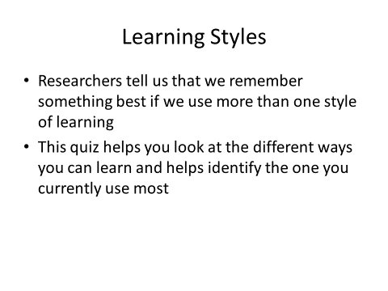
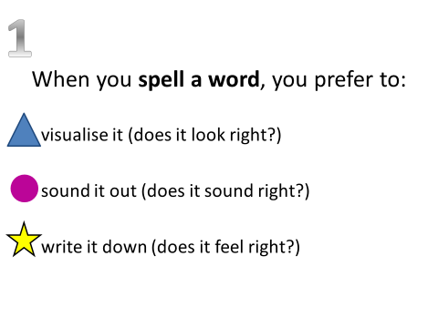
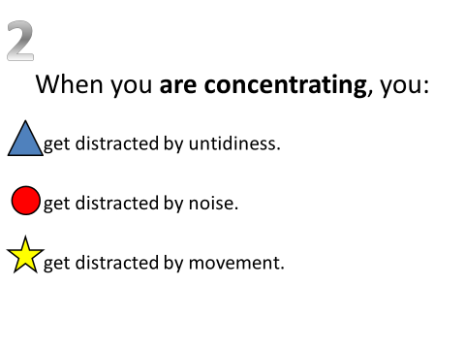
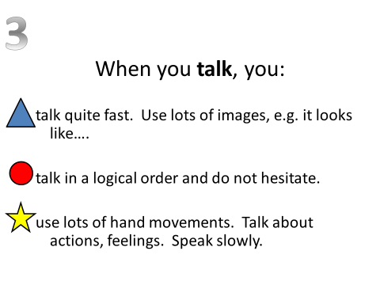
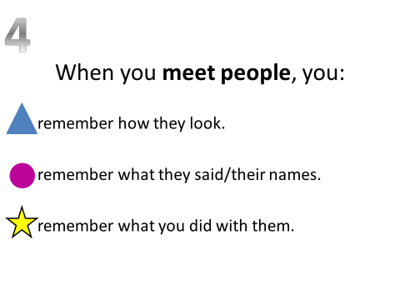
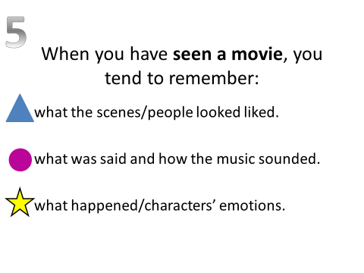
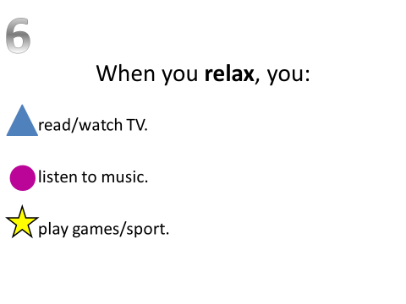
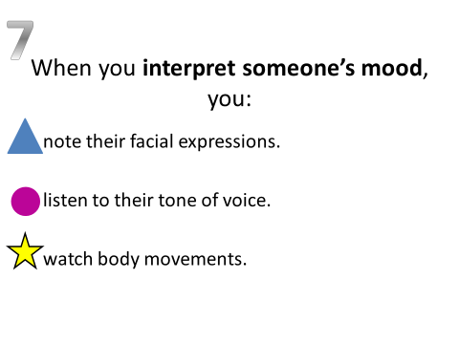
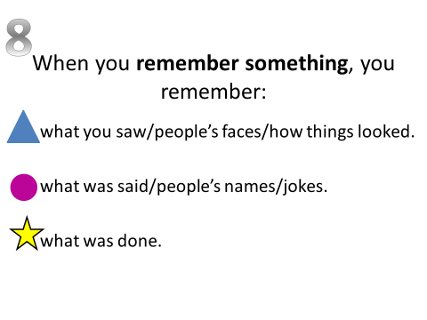
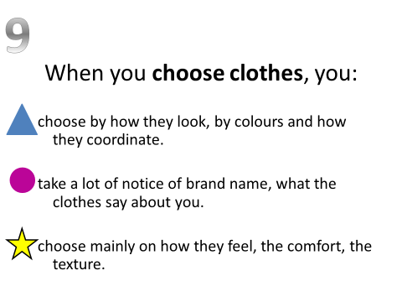
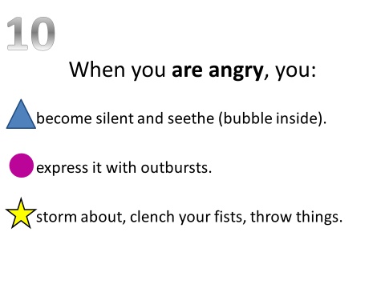
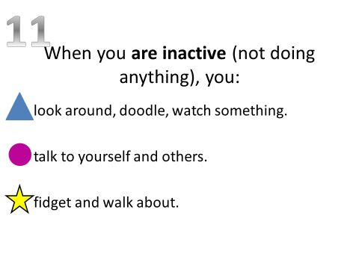

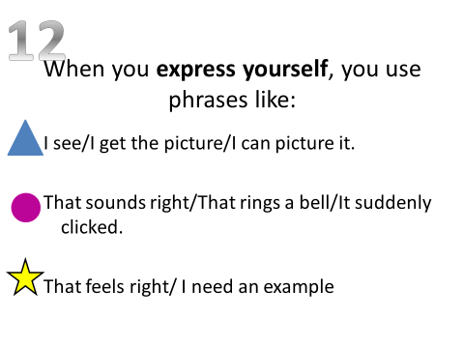
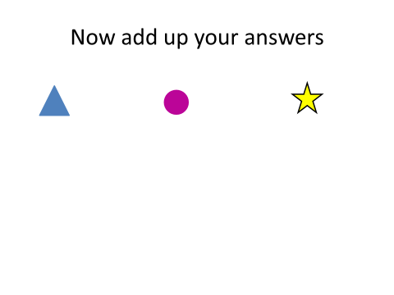
1
2
3
4
5
6
7
8
9
10
11
12
total

