Biology Ideas of interest 1

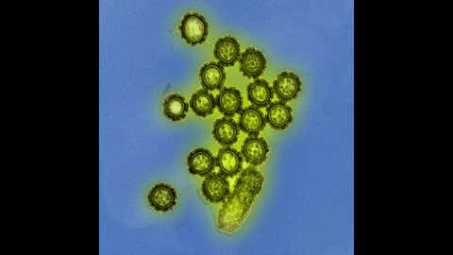

https://weather.com/health/cold-flu/news/2019-01-30-stunning-microscopic-images-viruses-bacteria

Bacteria and viruses are some of the last things you hope to encounter on a day-to-day basis. After all, they're what make you sick. Yet, if you look at bacteria, viruses and the cells they infect in electron micrographs, or images captured through microscopes, they can be quite fascinating to look at.
Electron microscopes, which capture these images, allow for greater magnification and resolution than standard microscopes because they use electron beams instead of light to capture the images we see. Then, with coloured dyes and photographic colour treatment, individual cells, viruses and bacteria can be easily identified — creating these almost surreal images.
Click through the slideshow above to see 50 striking electron micrographs of some of the world's most dangerous and deadly disease-causing viruses and bacteria.

