MY SUMMER WORK

With a track record built over 30 years of learner success, BTEC Nationals are widely
recognised by industry and higher education as the signature vocational qualification. They provide progression to the workplace either directly or via study at a higher level.

This Summer Project is a taster of what you will study in September 2021 with the Travel and Tourism Team at Stafford College.

There are 4 parts to the Summer Project please try and complete them as best you can but, more importantly, enjoy it!

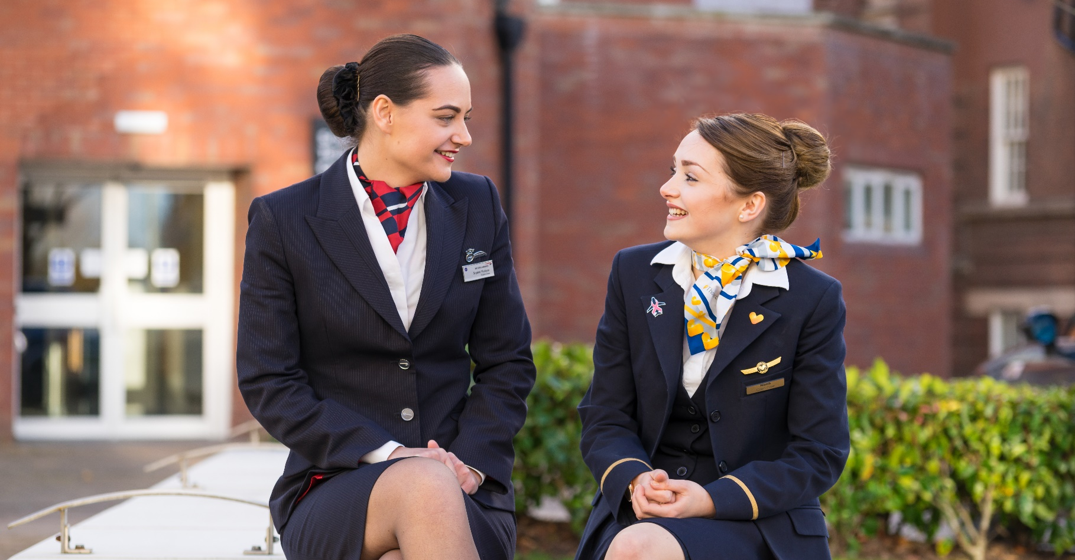

EXTRA INFO

For any help and guidance please contact the staff members below.

For any support:
graeme.haigh2@nscg.ac.uk
Liam.clarkson@nscg.ac.uk

MY SUMMER WORK

PART 1: Let’s see what you already know…POP QUIZ! Try and complete the quiz with no help (i.e. google!).

 | Question | Answer
1 | What country does this flag belong to?
2 | What is the capital of Spain?
3 | What are the 4 capital cities of the UK?
4 | What and where is this famous landmark?
5 | How many continents are there?
6 | Name them…
7 | What country does this flag belong to?
8 | What is the famous theme park on the outskirts on London?
9 | Which island sits in the middle of the Pacific Ocean?
10 | What and where is this famous landmark?

PART 2: A good starting point is to look at some of the key words that are used within the Travel and Tourism
Industry on a daily basis. Complete the table below and record where you got the information from:
Key Word/Term | Definition (write a short definition of the key word) | Where did you get this definition from i.e. website, book, own knowledge
Inbound Tourism
Outbound Tourism
Domestic Tourism
VFR
Appeal
FCO
ABTA
UNWTO
Butlers Tourist Area Life Cycle (TALC)
PART 3: The Travel and Tourism Industry is made up of multiple ‘elements’ and you will learn about these whilst
studying with us at Stafford. In the Travel and Tourism Industry we research different elements to gain a better
understanding and knowledge of them. One of these elements is the Event, Conference and Exhibitions element. Thinking this element of the industry, try and answer the below questions, carrying out research to support your
answers. Make a note of where you got this information from i.e. website, book (this is called a resource or ‘source of information’).

Question | Answer | Resource/Source of Information
Name three types of venues used for events, conferences and exhibitions. | 1.  2.  3.
What is a ‘product launch’
Give examples of two other travel and tourism industries that the events, conferences and exhibitions industry works with. | 1.  2.
What health and safety factors would the management of a hotel need to consider when staging a wedding fair?
Name two purpose-built exhibition centres in the UK. | 1.  2.
PART 4: Now, a little bit about you! We would like you to write no more than 250 words on your favourite
holiday destination/attraction and why this is. This could be in the UK or Overseas or could be a particular
attraction you have visited. This should be supported with an explanation of why so, provide detail and reasons and/or evidence to support your opinion/view of why the destination/attraction is a favourite of yours.

Please type here...

