**USEFUL LINKS**

**Practical Activities**

**MY SUMMER WORK**

https://www.youtube.com/watch?v=vhO5MK0tQQI

During your Practical lesson you participated in various outdoor sports and activities.

Your summer task is split into two parts.

**Part 1** is to complete a SWOT analysis of your performance during the lesson.

**Part 2** is to complete the two questions to the best of your ability.

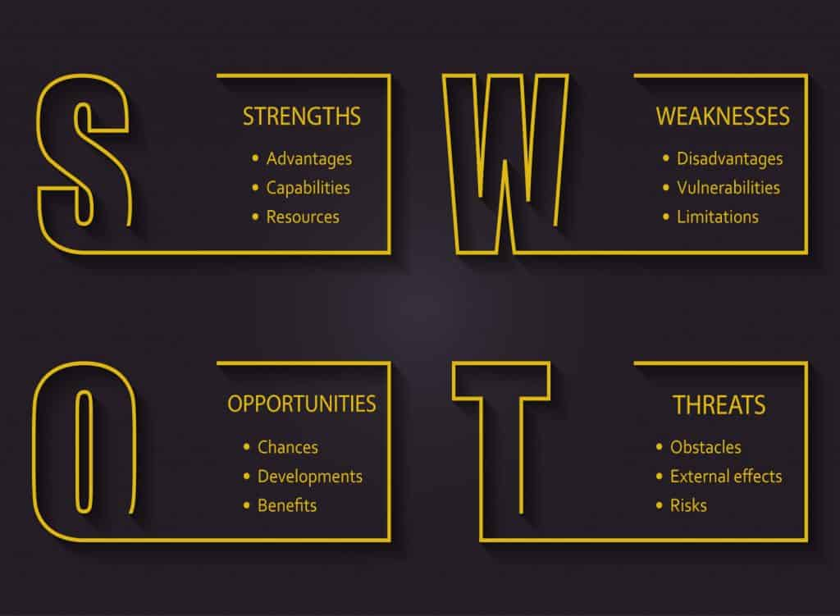

**EXTRA INFO**

For any help and guidance please contact the staff members below.

For any support:

Liam.clarkson@nscg.ac.uk

Graeme.haigh2@nscg.ac.uk

**MY SUMMER WORK**

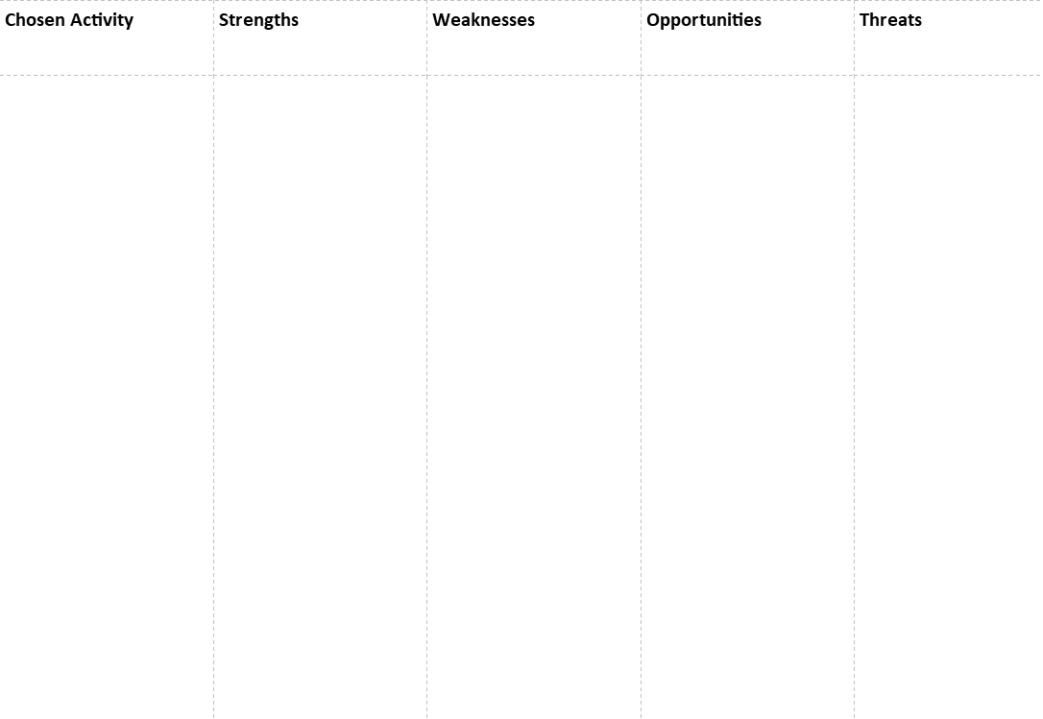

**Part 2. Why is it important to stay active?**

____________________________________________________________________________________________________________________________________________________________________________________________________________________________________________________________________________________________________________

**What is your favourite sport?**

____________________________________________________________________________________________________________________________________________________________________________________________________________________________________________________________________________________________________________