**USEFUL LINKS**

**Fitness and Physical Preparation Task**

**MY SUMMER WORK**

<https://www.fitnessvenues.com/uk/british-army-fitness-tests.html>

<https://www.assessmentcentrehq.com/prison-officer-assessment-day/>

<https://www.college.police.uk/support-forces/health-safety-welfare/job-related-fitness-standards>

<https://www.avonandsomerset.police.uk/apply/jobs-and-volunteering/fitness-test/>

<https://www.raf.mod.uk/recruitment/fitness-in-the-raf>

 During the fitness session you completed a variety of tests and recorded your score.

This task links to what you need to do with this score.

In a table laid out like the one below you need to answer the following three questions:

1. **What is the requirement for your chosen service (put NA if this does not apply)**

2. **What is the difference between the two scores.**

3. **What will you do to improve the score you achieved**

This information will be used for your fitness assignments and your ability to analyse is vital for the grades

A larger editable document is on the second page.

**EXTRA INFO**

For any help and guidance please contact the staff members below.

For any support:

Marie.myatt@nscg.ac.uk

Graeme.haigh2@nscg.ac.uk

Liam.clarkson@nscg.ac.uk

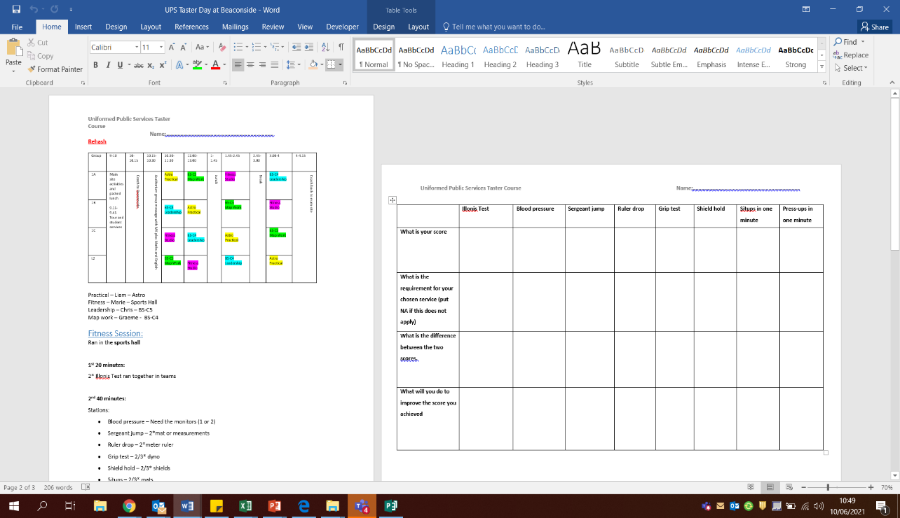

**MY SUMMER WORK**

