USEFUL LINKS

Land Navigation
MY SUMMER WORK

https://oscompass.com/GPSorCompass.htm
https://techdaring.com/the-pros-and-cons-of-satellite-navigation/
During the Land Navigation lesson you participated in various expedition based topics.
This task links to what you did during your lesson. PLease answer the following question.

What are the benefits and drawbacks of the following three navigation tools?
1. Compass
2. Phone
3. Sat Nav

A larger editable document is on the second page.

EXTRA INFO
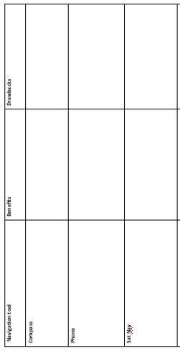
For any help and guidance please contact the staff members below.
For any support:
Chris.holloway@nscg.ac.uk
Marie.myatt@nscg.ac.uk
Graeme.haigh2@nscg.ac.uk
Liam.clarkson@nscg.ac.uk

MY SUMMER WORK

Navigation tool | Benefits | Drawbacks
Compass
Phone
Sat Nav

