

**Welcome to Health and Social Care…**

With Stafford College

NSCG

WELCOME to our Health & Social Care home pack.

We are excited to welcome you to the Health & Social Care department and supporting you on an exciting journey into a Health and Social Care career.

Our home learning pack will support and prepare you for your studies with us in September.

Enjoy and any questions please contact

the staff team,

Thanks

*Meryl*

Meryl

I know



CONTENTS



MEET the team

Course overview

Entry requirements

Fun tasks to have a go at

Why do you need Maths & English in Health & Social Care?

Opportunities/Awards

Placement

Career prospects

(What can I do with my qualification?)







Meet the team

**Meryl Cotton**

(Curriculum area manager) EY& H&SC

[meryl.cotton@nscg.ac.uk](mailto:meryl.cotton@nscg.ac.uk)

**Louise Finney**

**Level 2 & Level 3 Health & Social Care Lecturer**

[**Louise.finney@nscg.ac.uk**](mailto:Louise.finney@nscg.ac.uk)

**Zoe Pickard**

Level 3 Health & Social Care Course leader

[zoe.pickard@nscg.ac.uk](mailto:zoe.pickard@nscg.ac.uk)

**Layla Mountford**

Level 2 Course Leader

[layla.mountford@nscg.ac.uk](mailto:layla.mountford@nscg.ac.uk)

**Harriet Hornett**

Level 3 and Level 4 Health & Social Care lecturer

[**Harriet.hornett@nscg.ac.uk**](mailto:Harriet.hornett@nscg.ac.uk)

**Ellie Finch**

Health & Social Care lecturer

[ellie.finch@nscg.ac.uk](mailto:ellie.finch@nscg.ac.uk)

**Laura Whitehead**

Health & Social Care lecturer

[laura.whitehead@nscg.ac.uk](mailto:laura.whitehead@nscg.ac.uk)

**Sarah Hicks**

Student Welfare officer

[sarah.hicks@nscg.ac.uk](mailto:sarah.hicks@nscg.ac.uk)

**Claire Turner**

H&SC & EY Placement Officer

[claire.turner@nscg.ac.uk](mailto:claire.turner@nscg.ac.uk)

**Penny Lugg**

H&SC & EY Placement Officer

[penny.lugg@nscg.ac.uk](mailto:penny.lugg@nscg.ac.uk)

Please return the packs by **the 1st July** to Michelle Grocott ; [michelle.grocott@nscg.ac.uk](mailto:michelle.grocott@nscg.ac.uk)

## 

## LEVEL 2 COURSE OVERVIEW

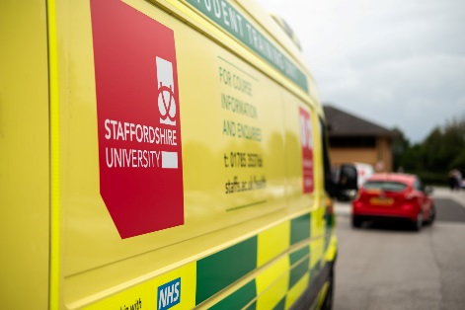The Edexcel BTEC Level 2 Extended Certificate in Health and Social Care course is designed to give you the underpinning knowledge, understanding and skills that you will need to prepare for employment within a wide range of caring services. It also provides you with the opportunity to potentially progress onto the Edexcel BTEC Level 3 Extended Diploma in Health and Social Care. The Level 2 course takes one year to complete. You will learn about many aspects of caring for others and may have the opportunity to carry out a week’s work experience within a care setting towards the end of your course. This will enable you to put the learning you have gained in the classroom into practice in a relevant workplace.

Modules include:

* Health and social care values
* Effective communications
* Healthy living
* Impact of nutrition on health
* Human body systems and care of disorders,
* Creative and therapeutic activities in a health and social care setting.



The study programme will also incorporate a range of work related experience activities to ensure that you have the breadth of skills required to progress to further/higher education, employment or an apprenticeship.

**Maths and English**

Alongside your course you will study maths and/or English to improve your skills in these vital subjects by attending structured weekly sessions as part of your timetable. Maths and English development is also integrated in practical assignments.



**Level 3 COURSE OVERVIEW**

The aim of this course is to provide knowledge, understanding and skills in health and social care learning environment leading to a widely recognised national qualification for those who wish to work in a caring career or progress into higher education. In year 2 learners are able to transfer to the Health Studies pathway that is often preferred by universities for learners wishing to progress to midwifery, children’s nursing, physiotherapy. Alternatively the Social Care pathway will offer further studies onto programmes such as adult nursing, social work, youth work, psychology and health related degrees.

The study programme will also incorporate a range of work related experience activities to ensure that you have the breadth of skills required to progress to further/higher education, employment or an apprenticeship.  
Alongside your course you will study maths and/or English to improve your skills in these vital subjects by attending structured weekly sessions as part of your timetable. Maths and English development is also integrated in practical assignments.

**What else do I need to know?**

On a Level 3 Health and Social Care course you are expected to complete work placement experience over the duration of the 2 year programme. You will be supported on your course by a personal tutor who will meet with you regularly to discuss your targets for achievement. Throughout your course there will also be opportunities to get involved in extra activities and organised trips that will support your learning. Many of our resources can be accessed both at College and from home using our intranet service and well equipped Learning Resource Centre.

**Level 2 Entry Requirements:**

You will have a minimum of 4 GCSEs at Grade 3 or above.

**Level 2 Units:**

|  |  |
| --- | --- |
| **Unit No.** | **Unit Title** |
| 1 | Human Lifespan Development **Exam** |
| 2 | Health and Social Care Values |
| 3 | Effective Communication in Health and Social Care |
| 9 | Healthy Living **Exam** |
| 4 | Social Influences on Health and Wellbeing |
| 5 | Promoting Health and Wellbeing |
| 6 | The Impact of Nutrition on Health and Wellbeing |
| 7 | Equality and Diversity in Health and Social Care |
| 10 | Human Body Systems and Care of Disorders |
| 12 | Creative and Therapeutic Activities in Health and Social Care |

**Level 3 Entry Requirements:**

Usually a minimum of four high grades at GCSE (4-9) in subjects that are relevant to the course you’d like to study, including maths and/or English. Alternatively, you’ll need a Level 2 Diploma with overall Merit in a relevant subject and maths and English at appropriate levels.

**Units Year 1**

|  |  |
| --- | --- |
| **Unit No.** | **Unit Title** |
| 1 | Human Lifespan Development **Exam** |
| 2 | Working in Health & Social Care **Exam** |
| 5 | Meeting Individual Care and Support Needs |
| 11 | Psychological Perspectives |
| 19 | Nutritional Health |

**WORKING IN HEALTH & SOCIAL CARE**

**Welcome to Health & Social Care**

Working for the Health & Social Care Sector is a fantastic, exciting and extremely rewarding experience!

When working in Health & Social Care, you will be supporting individuals & families to maintain their independence, dignity & safety. You will also be providing a personal approach for people within your care.



**What Job roles are there in Health & Social Care?**

* Nurses
* Midwives
* Radiologist
* Paramedic
* Physiotherapist
* Healthcare assistants
* Social workers
* Occupational therapists
* Youth workers
* Care managers/assistants
* Support workers

… And many more!

If you would like some more information, please visit: <https://www.jobs.nhs.uk/xi/browsejobs/>

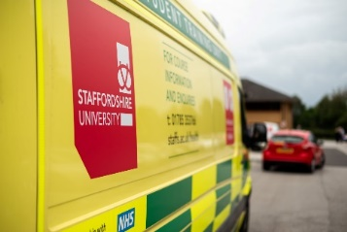

**Please go to the next page for more information and fun tasks to complete!**

***Join us in Health & Social Care***



**WHAT DO WE LEARN?**



* The roles of people who work in health and social care setting
* The roles of organisations in the health and social care sector
* Working with people with specific needs in the health and social care sector

**LET’S GET STARTED**

* Nurses
* Midwives
* Radiologist
* Paramedic
* Physiotherapist
* Healthcare assistants
* Social workers
* Occupational therapists
* Youth workers
* Care managers/assistants
* Support workers

Task 1

Choose **1** of the health & Social Care job roles below and answer the questions on the next page.

You will need to research your answers.

**Job Role: \_\_\_\_\_\_\_\_\_\_\_\_\_\_\_\_\_\_\_\_\_\_\_\_\_\_\_\_\_\_\_**

**Q.1. List 3 responsibilities of your chosen job role**



**Q.2. List 3 other health and social care professionals your chosen job role may work with on a day to day basis**



**Q.3. In your own words, describe why you would like to follow a career in this profession**

**………………………………………………………………………………………………………………………………………………………………………………………………………………………………………………………………………………………………………………………………………………………………………………………………………………………………………………………………………………………………………………………………………………………………………………………………………………………………………………………………………………………………………………………………………………………………………………………………………………………………………………**

QUESTIONS CONTINUED

**There are also many qualities that NHS England expect to see in professional working for The Health & Social Care Sector, please see below.**

**Q.4. Explain the importance of demonstrating ALL of the above 6C’s/ qualities in your chosen job role.**

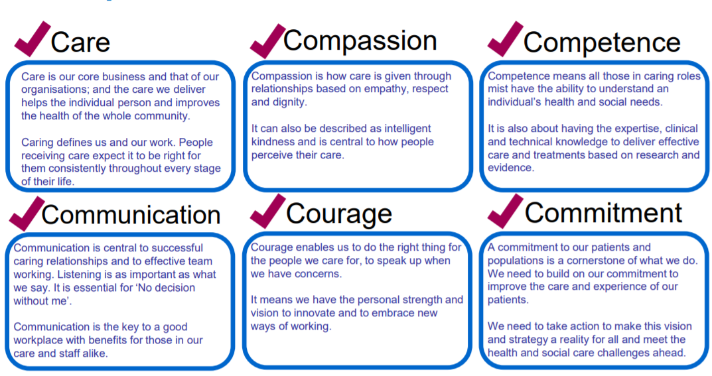

**Q.5. Assess how demonstrating the above qualities can have positive effect on the service provided by you as the professional. Think about a an environment you may be working in with a particular service user, you may also want to think about how not demonstrating the above qualities could have a negative effect on the service provided.**

**Q.6. Find a news article where your chosen job role has received positive feedback in the media, e.g. BBC news story. Once you have found a story, summarise the main points and provide a conclusive paragraph explaining how this job role helped & supported an individual (s).**



Nutrition

**What is nutrition?**

Nutrition is the science that interprets the nutrients and other substances in food in relation to maintenance, growth, reproduction, health and disease of an organism. It includes food intake, absorption, assimilation, biosynthesis, catabolism and excretion.

**Why do we learn about nutrition for Health & Social Care?**

All job roles in Health & Social care require a basic understanding of nutrition to enable us to ensure our patients and/or clients are meeting their basic nutritional needs, to empower individuals to live a healthy lifestyle, and to allow ourselves to be as healthy as we possibly can be.

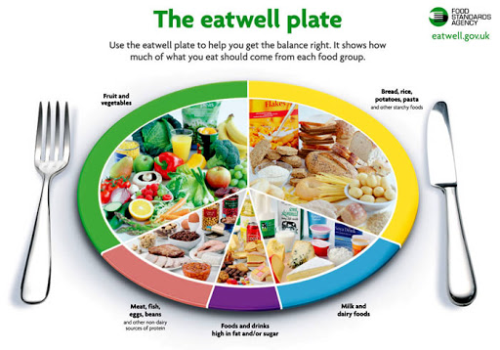

**We start with the basics:**

**Macronutrients:**

* Carbohydrates
* Protein
* Fats

**Micronutrients**

* Vitamins and minerals

**We learn:**

* What these do for the human body?
* How much of each we should eat each day
* What foods we can find these in
* What lifestyle factors can influence our diet and nutritional intake
* What health factors can influence dietary requirements
* What recommendations we can give to an individual to improve their diet and nutritional health

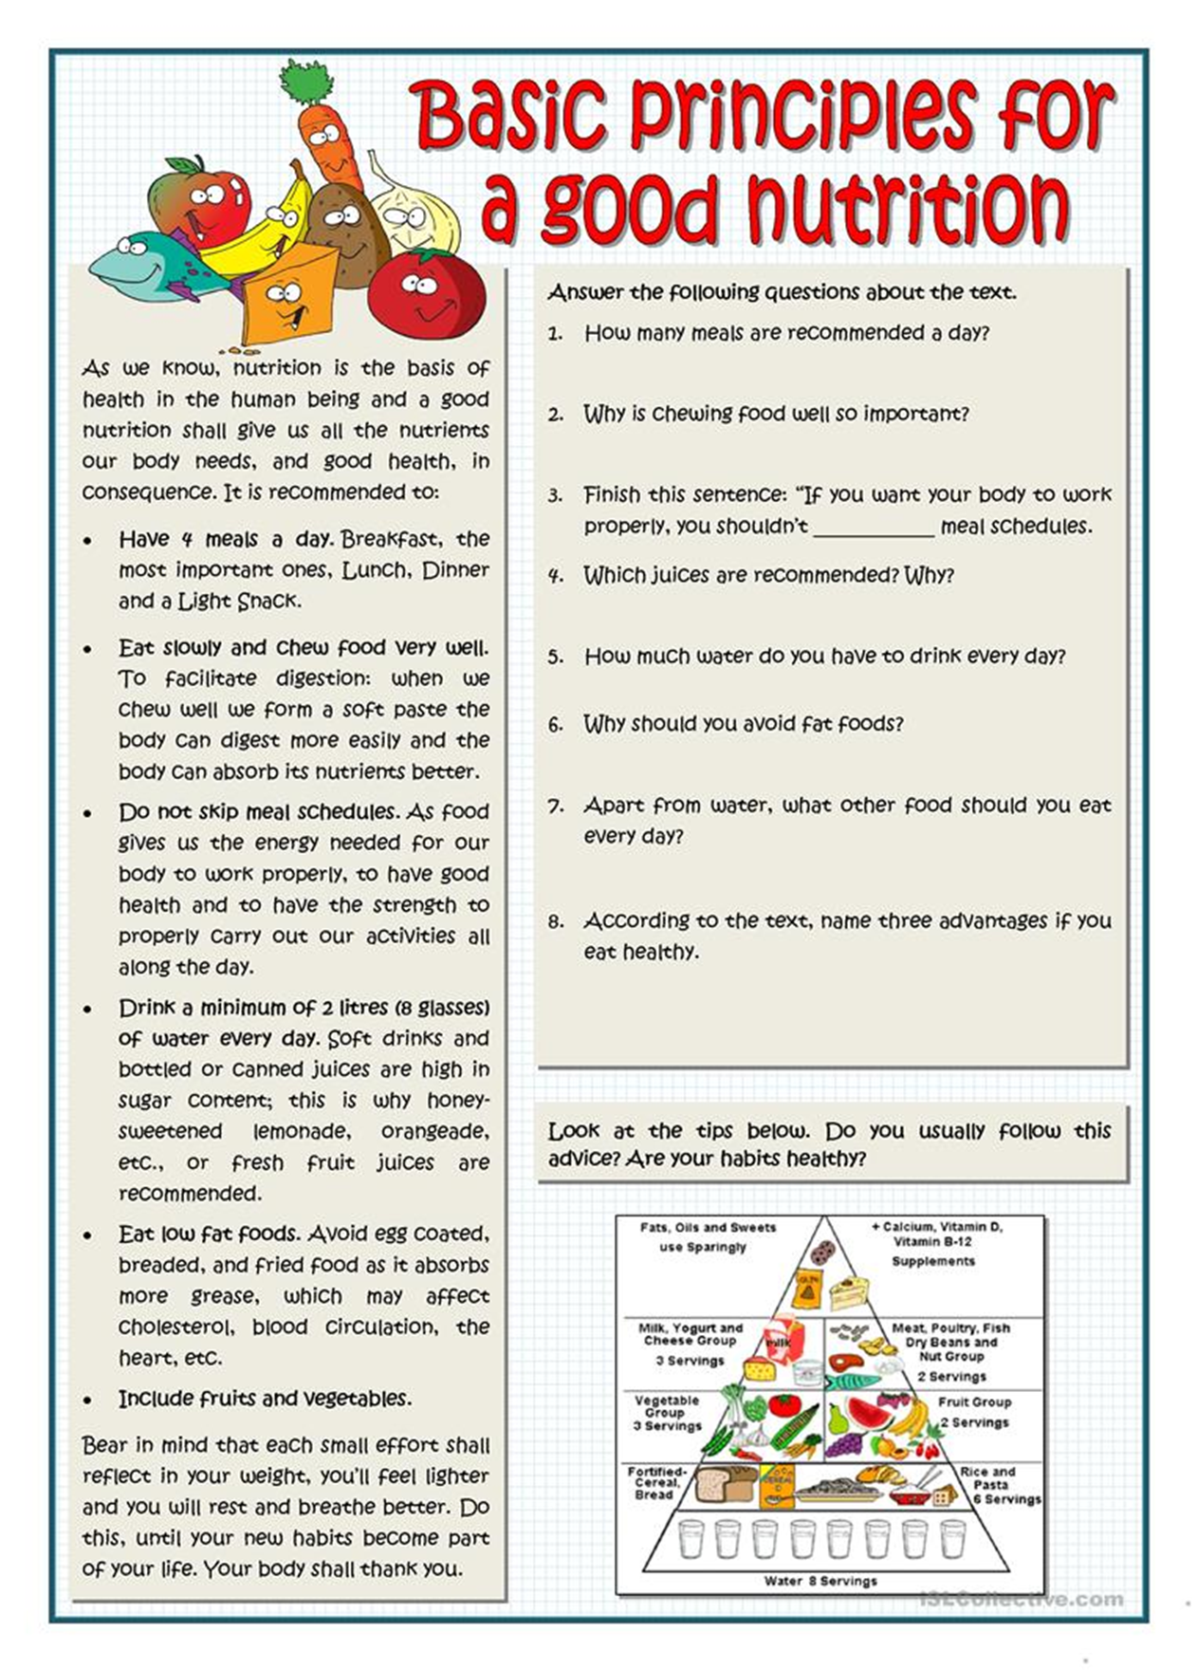



Task 1

1. Find a healthy recipe that uses 5 ingredients that you already have at home.
2. Identify the macronutrients and micronutrients in this recipe.
3. What meal would this recipe be good for?
4. Research the ingredients and work out how much this meal would cost per portion.

Task 2



Cook or bake this recipe for a family member, and ask the family member to critique your finished product.

Write a report

* Describe what you did to succeed with the task.
* Assess the finished product
* Evaluate the critique you received from your family member
* Upload a picture of your nutritional meal to our Instagram page which is nscgstafford.hsc







HUMAN LIFESPAN & DEVELOPMENT

**Human growth and development occurs in stages. A person’s stage of growth and development affects their health, care and support needs. Learning about the patterns of human growth and development in each life stage is important in HSC. There are also major life events that can affect the personal development of an individual.**



**Key terms**

***Life stages:*** ‘These are the different points that individuals pass through during the process of normal development. Each stage has significant key developmental stages within it, which can identify it as part of the life stage.’ (Hetherington. A, 2013)

***Growth:*** ‘This can refer to size and weight.’ (Hetherington. A, 2013)

***Development:*** ‘This relates to acquiring skills and knowledge to perform tasks.’ (Hetherington. A, 2013)

**Activity 1**

**There are six life stages.**

**Can you identify all six?**

**Categorise the ages for these**

**Activity 2**

**In relation to development, can you define PIES?**

**For each part, describe what that means.**

**Activity 3**

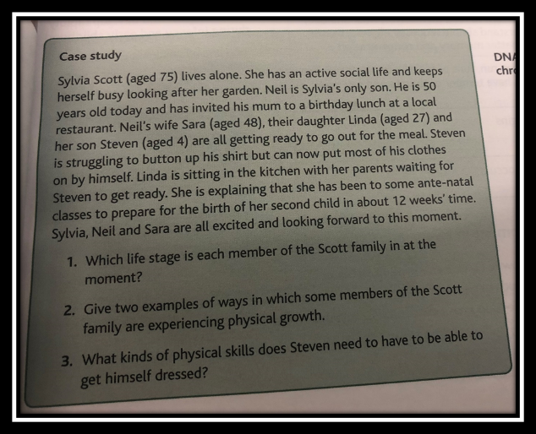

**Activity 4**

**Complete the milestones task below**

|  |  |  |  |  |
| --- | --- | --- | --- | --- |
| **Developmental Milestones Independent Study Task**  **(1 example for each)** | | | | |
| **Life stage** | Physical Milestones | Intellectual Milestones | Emotional Milestones | Social Milestones |
| **Birth & Infancy**  **O -2yrs** |  |  |  |  |
| **Early Childhood 3-8 Years** |  |  |  |  |

# **Reading List**

# **BTEC National Health and Social Care Student Book 1**

Part of the [**BTEC Nationals Health and Social Care 2016 series**](https://www.pearsonschoolsandfecolleges.co.uk/FEAndVocational/HealthAndSocialCare/BTEC/BTECNationalsHealthandSocialCare2016/BTECNationalsHealthandSocialCare2016.aspx)

Unit 1: Human Lifespan Development

For further information on the health & social care course, please use the information provided below for wider reading.

Unit 2: Working in Health and Social Care

Unit 3: Anatomy and Physiology for Health and Social Care

Unit 5: Meeting Individual Care and Support Needs

Unit 7: Principles of Safe Practice in Health and Social Care

Unit 10: Sociological Perspectives

Unit 11: Psychological Perspectives

Unit 14: Physiological Disorders and their Care

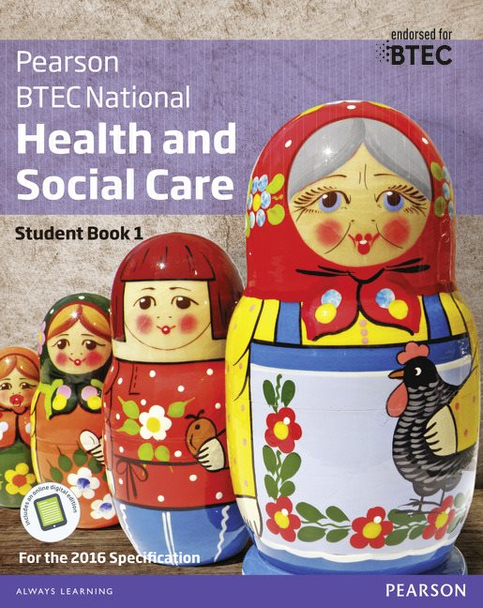

AN00790_

# **BTEC National Health and Social Care Student Book 2**

Part of the [**BTEC Nationals Health and Social Care 2016 series**](https://www.pearsonschoolsandfecolleges.co.uk/FEAndVocational/HealthAndSocialCare/BTEC/BTECNationalsHealthandSocialCare2016/BTECNationalsHealthandSocialCare2016.aspx)

Unit 4: Enquiries into Current Research in Health and Social Care

Unit 6: Work Experience in Health and Social Care

Unit 8: Promoting Public Health

Unit 12: Supporting Individuals with Additional Needs

Unit 13: Scientific Techniques for Health Science

Unit 15: Microbiology for Health Science

Unit 17: Caring for Individuals with Dementia

Unit 18: Assessing Children’s Development Support Needs

Unit 19: Nutritional Health

Unit 24: Biochemistry for Health

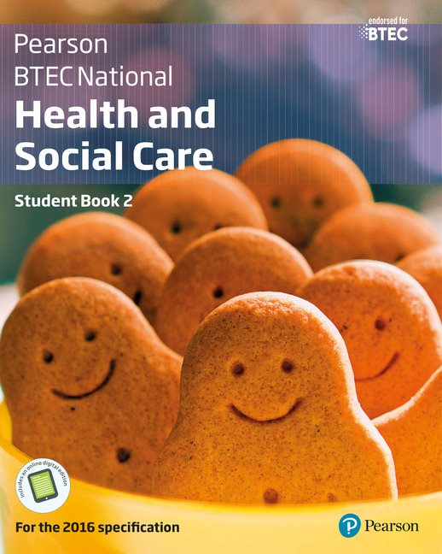



**Where should you get your information from?**

Make sure you get your information from trustworthy sources…

Wikipedia is not a trustworthy source, as anyone with an account can edit the information!

**Some examples of trustworthy sources are:**

* The NHS website <https://www.nhs.uk/>
* BBC Bitesize <https://www.bbc.co.uk/bitesize>
* Journal Articles – you can search for journal articles on virtually every topic on Google. They look a little like this on the search results, based on a search of ‘journal article importance of multidisciplinary approach’:
* Dorling Kindersley (DK) <https://www.dkfindout.com/uk/human-body/>
* Encylopedia Brittanica <https://www.britannica.com/>
* NICE (National Institute for Health and Care Excellence) <https://www.nice.org.uk/>
* BBC Good Food (to link in with Nutrition) <https://www.bbcgoodfood.com/>

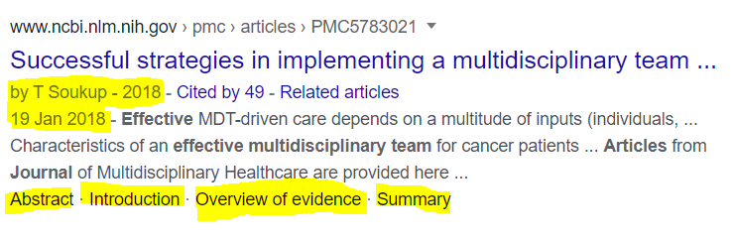

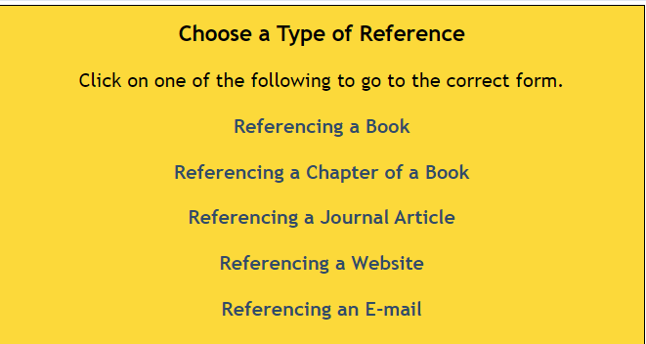

Remember; always show your sources of information. The best way is through Harvard Referencing. Below are links to a guide and a Harvard Reference generator:

* <https://www.canterbury.ac.uk/students/docs/study-skills/resource-1-Harvard-Referencing-Guide.pdf>
* <http://www.neilstoolbox.com/bibliography-creator/>

**MATHS AND ENGLISH**

It is important that you focus on your Maths GCSE should you be retaking it. You may benefit a few resources such as:

* BBC Bitesize <https://www.bbc.co.uk/bitesize/subjects/z38pycw>
* Maths Watch <http://www.mathswatch.co.uk/>

You will also be doing maths tasks in class that are relevant to the units you learn. Have a go at the example below:

According to Rolewicz and Palmer (2019), the NHS employs 1.5 million people. If 77% of employees are women, how many women work in the NHS?

**Extension**

What percentage of employees are men? How many men does the NHS employ?

It is important that you focus on your English GCSE should you be retaking it. You may benefit from resources such as:

* BBC Bitesize is a very useful resource for this <https://www.bbc.co.uk/bitesize/subjects/zr9d7ty>

You will also be completing tasks in class, which link to English. Have a go at one of these now:



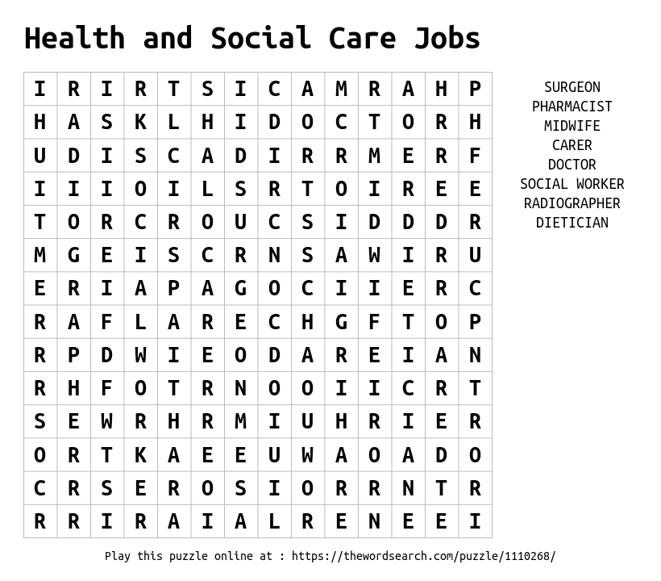



# **Opportunities**

**A T S T A F F O R D C O L L E G E - H E A L T H A N D S O C I A L C A R E**

TRIPS AND VISITS

### Making learning more fun

We want you to enjoy your time at Stafford College, and we recently went to Disneyland Paris for one of our trips.

The students loved it, and got to experience a seminar on

Equality in Disney before exploring the park! We also have University

trips where you can experience each profession during the day!

GUEST SPEAKERS …such as Dementia Friends

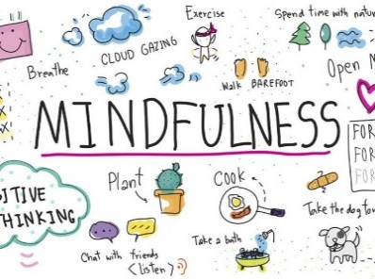

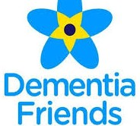

Our students get to experience a variety of Guest Speakers, such as Dementia Friends, NSPCC, and

University related professionals.

This allows you to develop your knowledge on what career you might want to

choose in the future. Our students also got to become a Dementia

Friend, an additional skill to add to their CV.

**AND MANY MORE!**

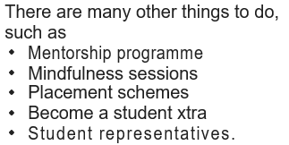

# **Award Ceremonies**

**C E L E B R A T I N G Y O U R A C H I E V E M E N T S**



# Career Prospects

W H A T J O B S C A N T H I S Q U A L I F I C A T I O N L E A D T O ?

