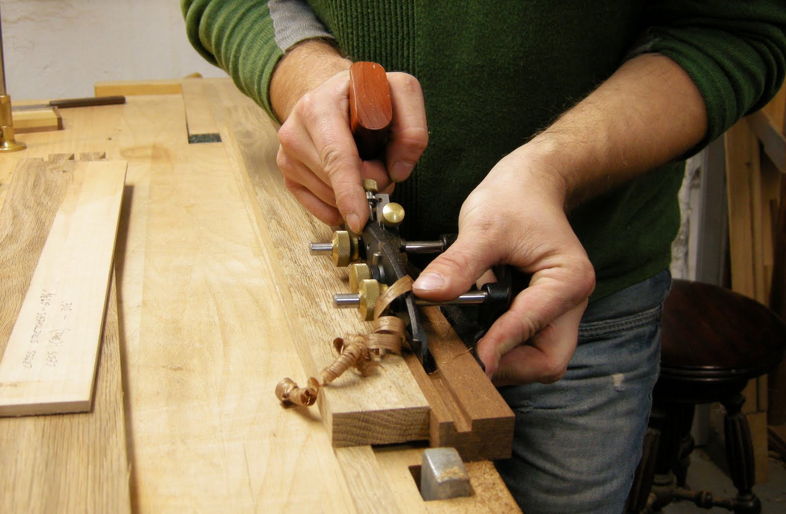

**Administrator**

**Tracy Taylor**



[tracy.taylor@nscg.ac.uk](mailto:tracy.taylor@nscg.ac.uk)

**Administrator**

**Amy Sparkes**



[amy.sparkes@nscg.ac.uk](mailto:amy.sparkes@nscg.ac.uk)

**Lecturer**

**Garry Pritchard**



[garry.pritchrd@nscg.ac.uk](mailto:garry.pritchrd@nscg.ac.uk)

**Lecturer**

**Martin Lester**



[martin.lester@nscg.ac.uk](mailto:martin.lester@nscg.ac.uk)

**Lecturer**

**Dominic Cooper**

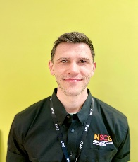

[dominic.cooper@nscg.ac.uk](mailto:dominic.cooper@nscg.ac.uk)

[martin.lester@nscg.ac.uk](mailto:martin.lester@nscg.ac.uk)

**Technician**

**Graham Pimblott**

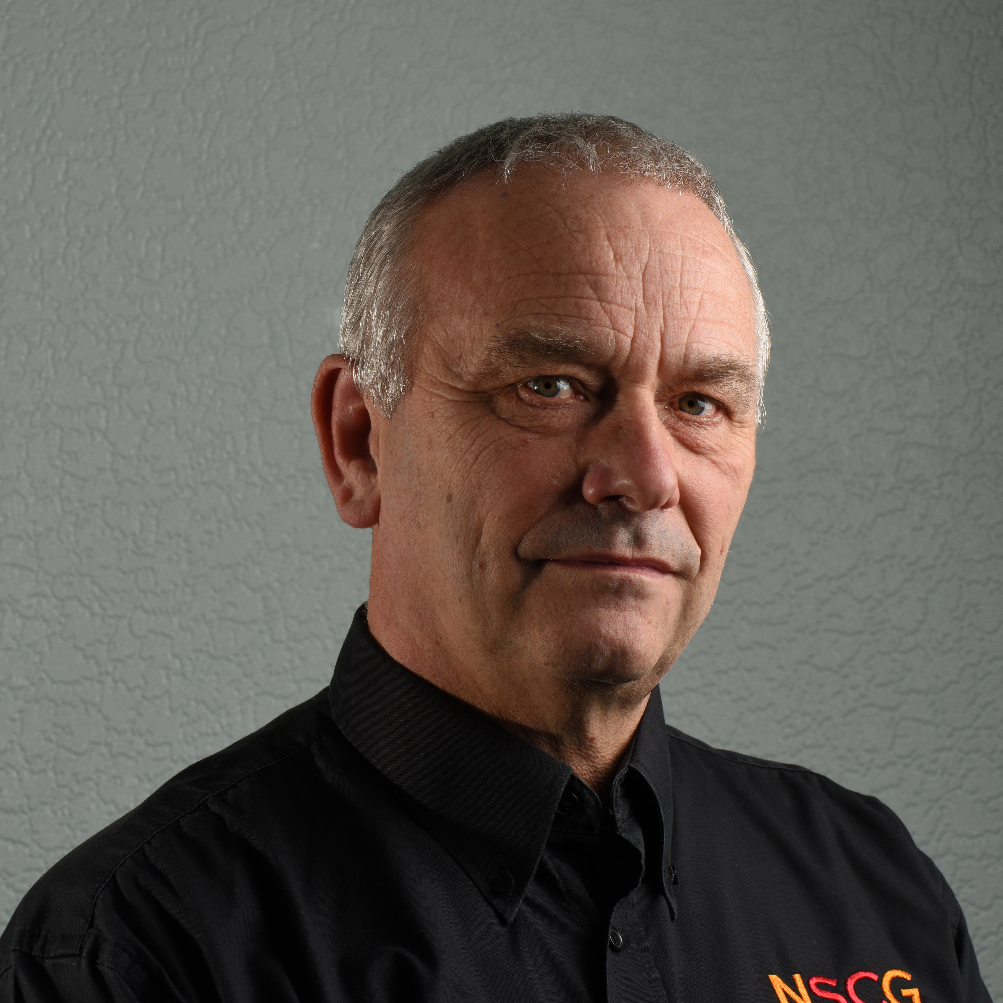

[graham.pimblott@nscg.ac.uk](mailto:graham.pimblott@nscg.ac.uk)

**Apprentice Assessor**

**Dave McIlwrath**

[david.mcilwrath@nscg.ac.uk](mailto:david.mcilwrath@nscg.ac.uk)

**Curriculum Manager - Construction & Engineering**

**Steven Michael**



[steven.michael@nscg.ac.uk](mailto:steven.michael@nscg.ac.uk)

**Curriculum Leader and Lecturer**

**Wayne Cotton**



[wayne.cotton@nscg.ac.uk](mailto:wayne.cotton@nscg.ac.uk)

**Welcome to our Joinery Courses**