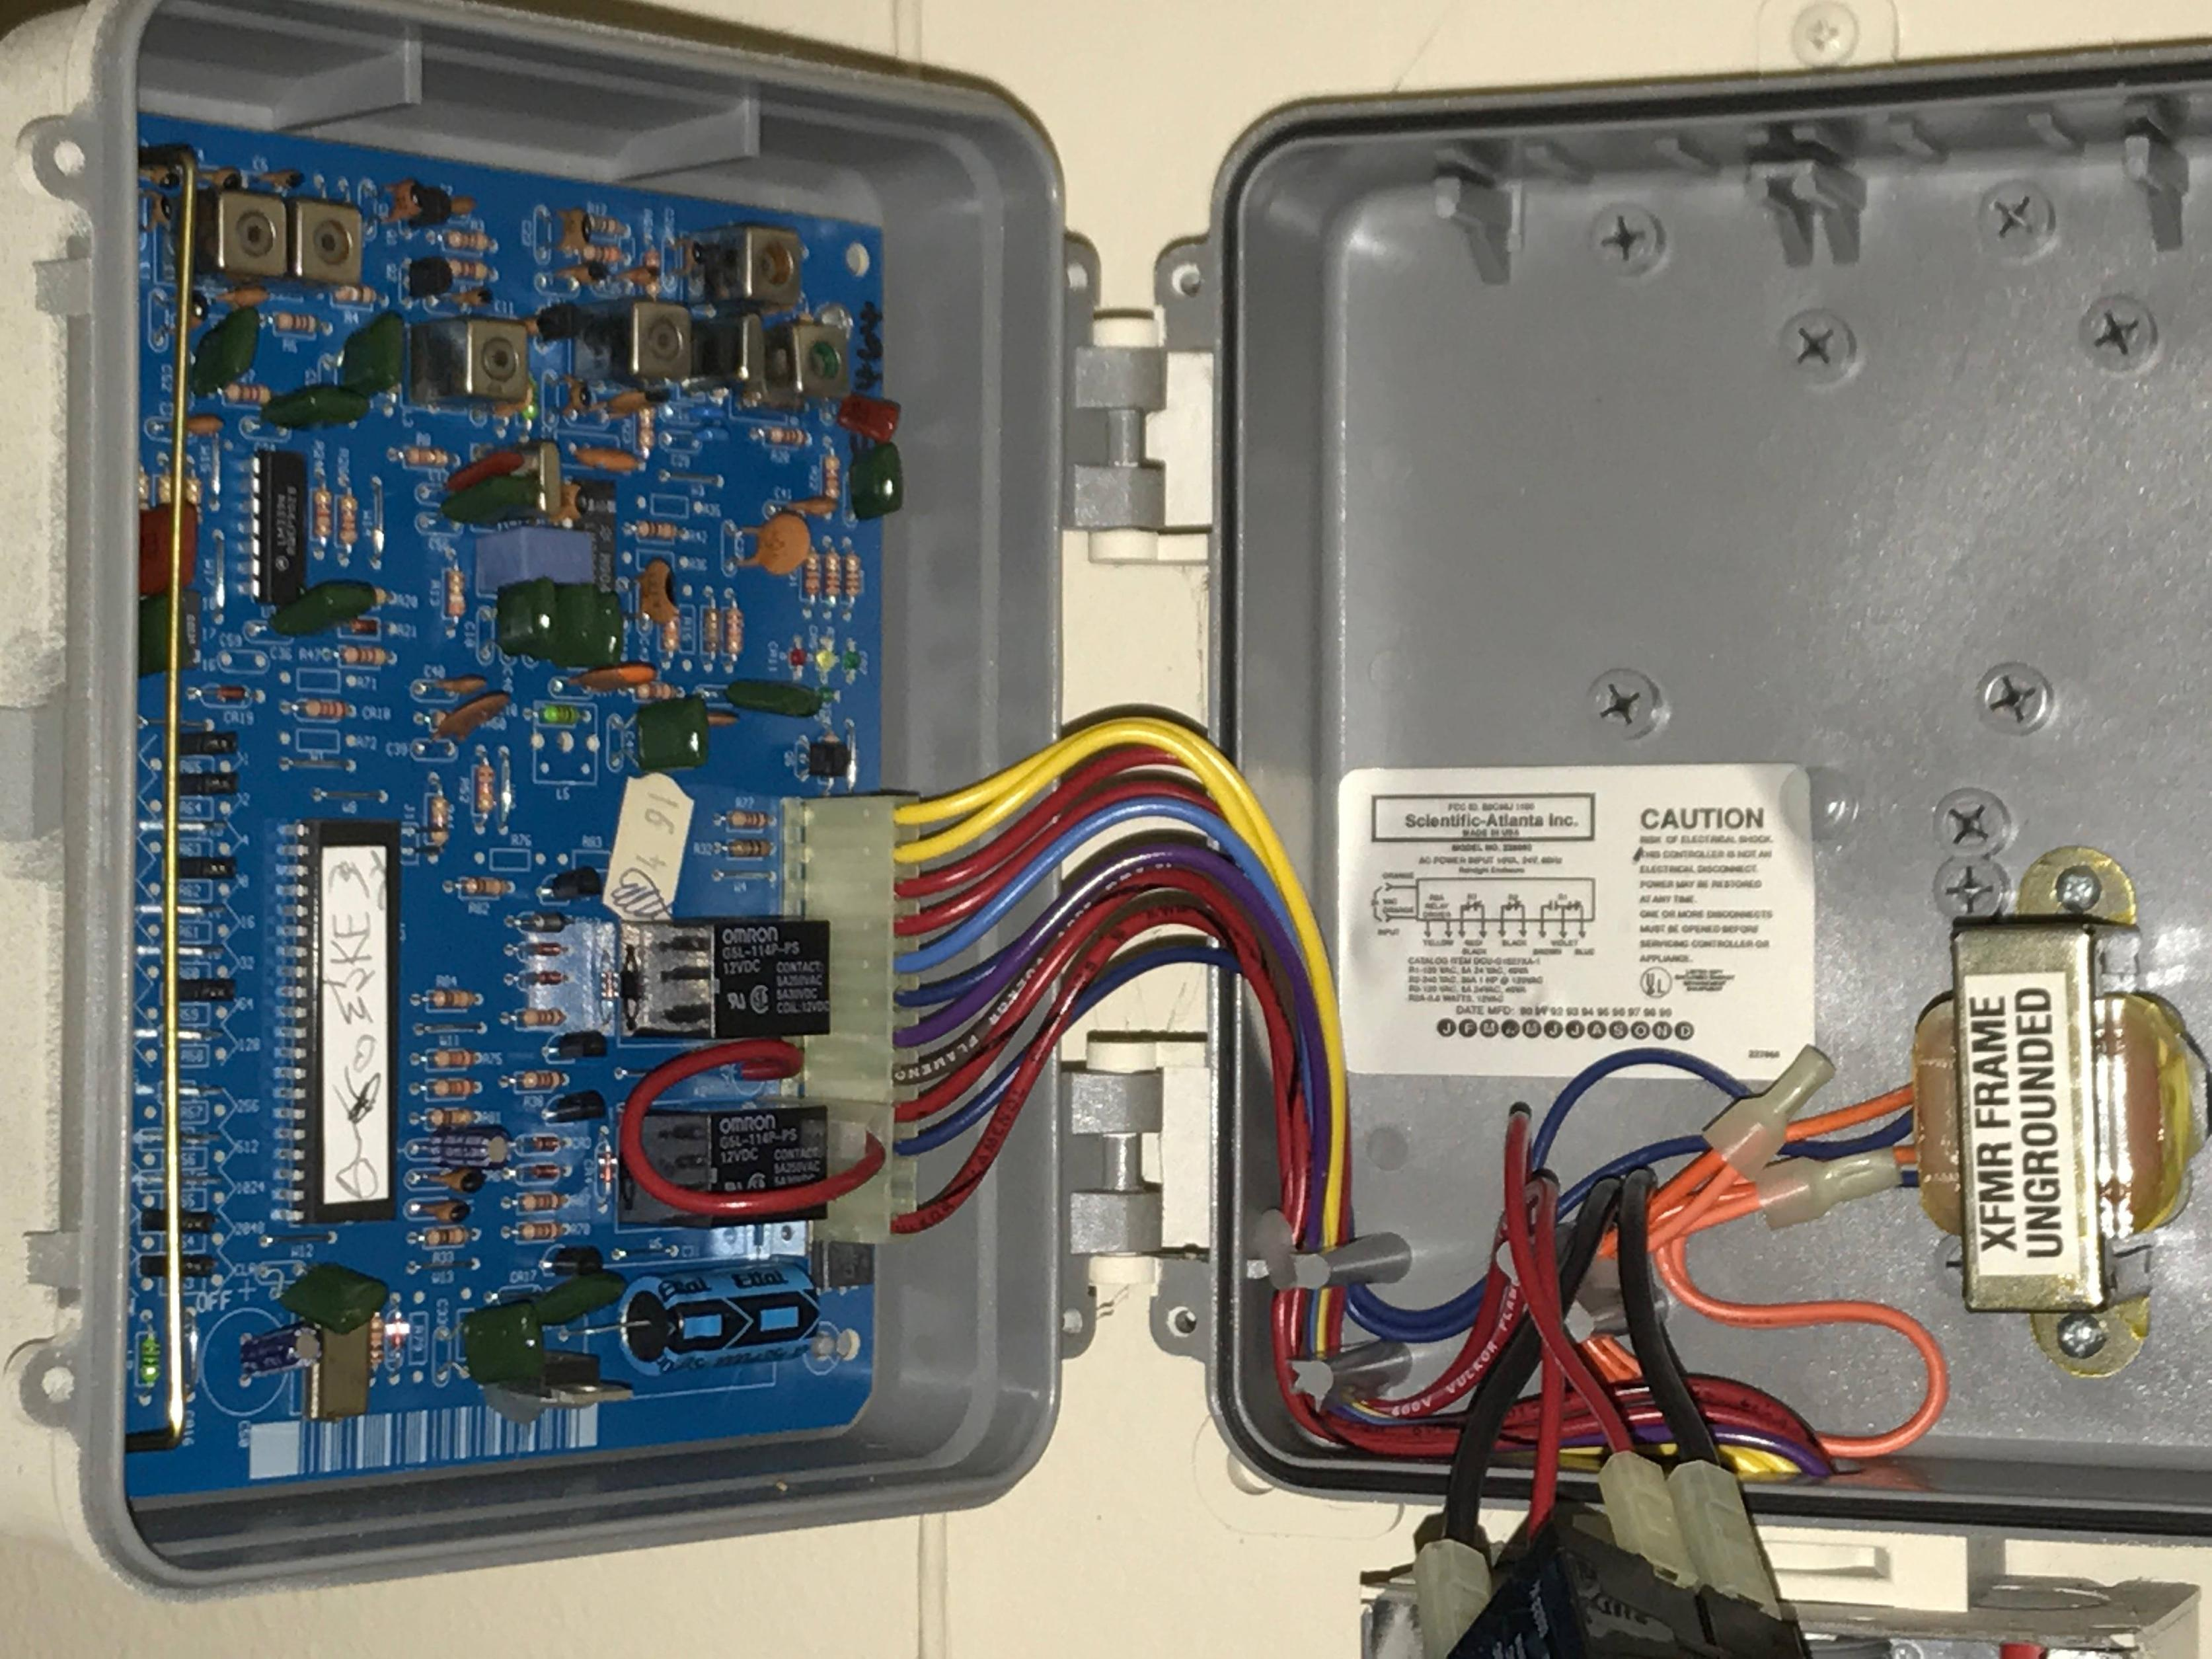

**Administrator**

**Amy Sparkes**



[amy.sparkes@nscg.ac.uk](mailto:amy.sparkes@nscg.ac.uk)

**Administrator**

**Tracy Taylor**



[tracy.taylor@nscg.ac.uk](mailto:tracy.taylor@nscg.ac.uk)

**Curriculum Leader**

**Ross Cooper**

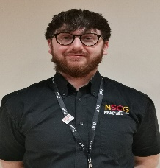

[ross.cooper@nscg.ac.uk](mailto:ross.cooper@nscg.ac.uk)

**Lecturer**

**Paul Glover**



[paul.glover@nscg.ac.uk](mailto:paul.glover@nscg.ac.uk)

**Apprentice Assessor**

**Myles Hanlon**



[myles.hanlon@nscg.ac.uk](mailto:myles.hanlon@nscg.ac.uk)

**Lecturer**

**Richard Wells**

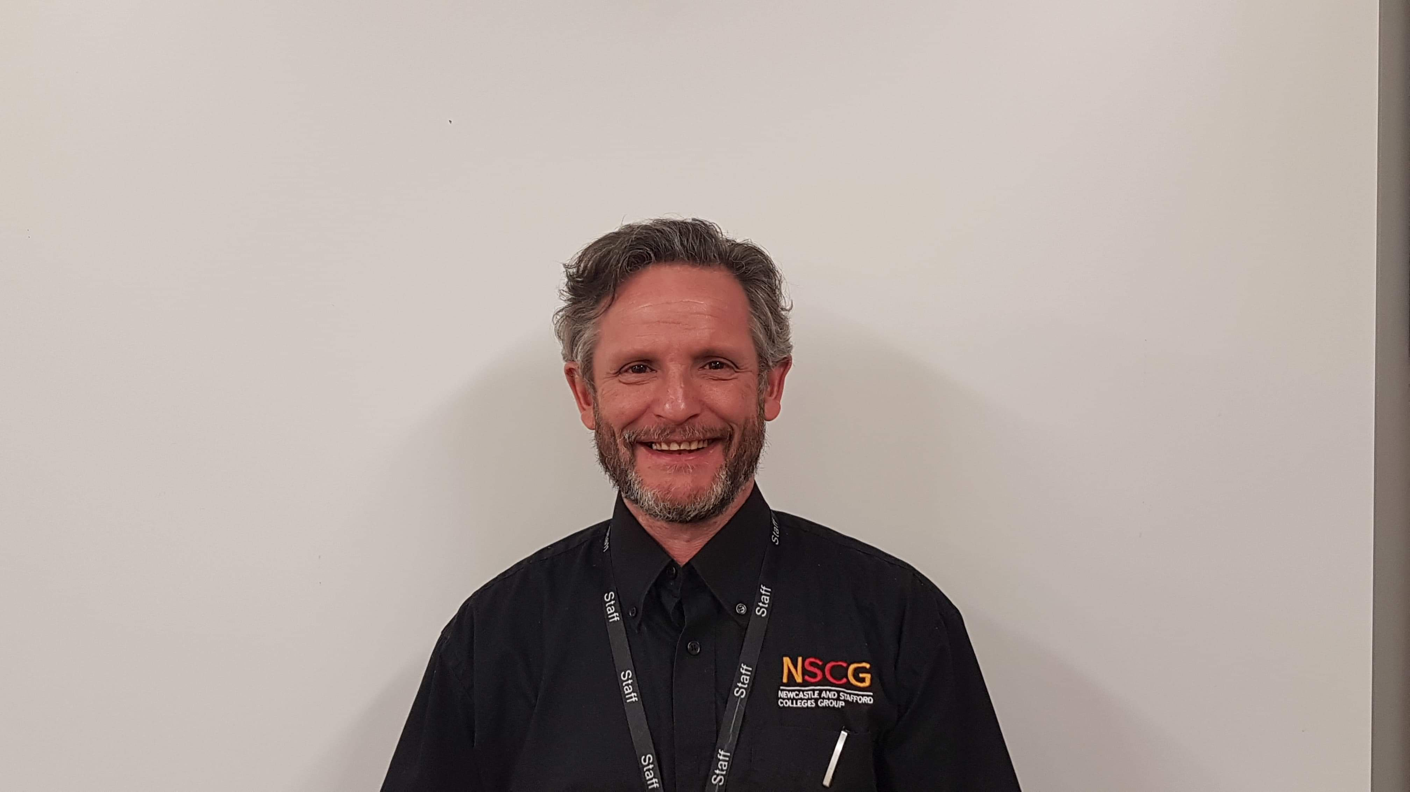

[richard.wells@nscg.ac.uk](mailto:richard.wells@nscg.ac.uk)

**Lecturer**

**Dave Eccleston**

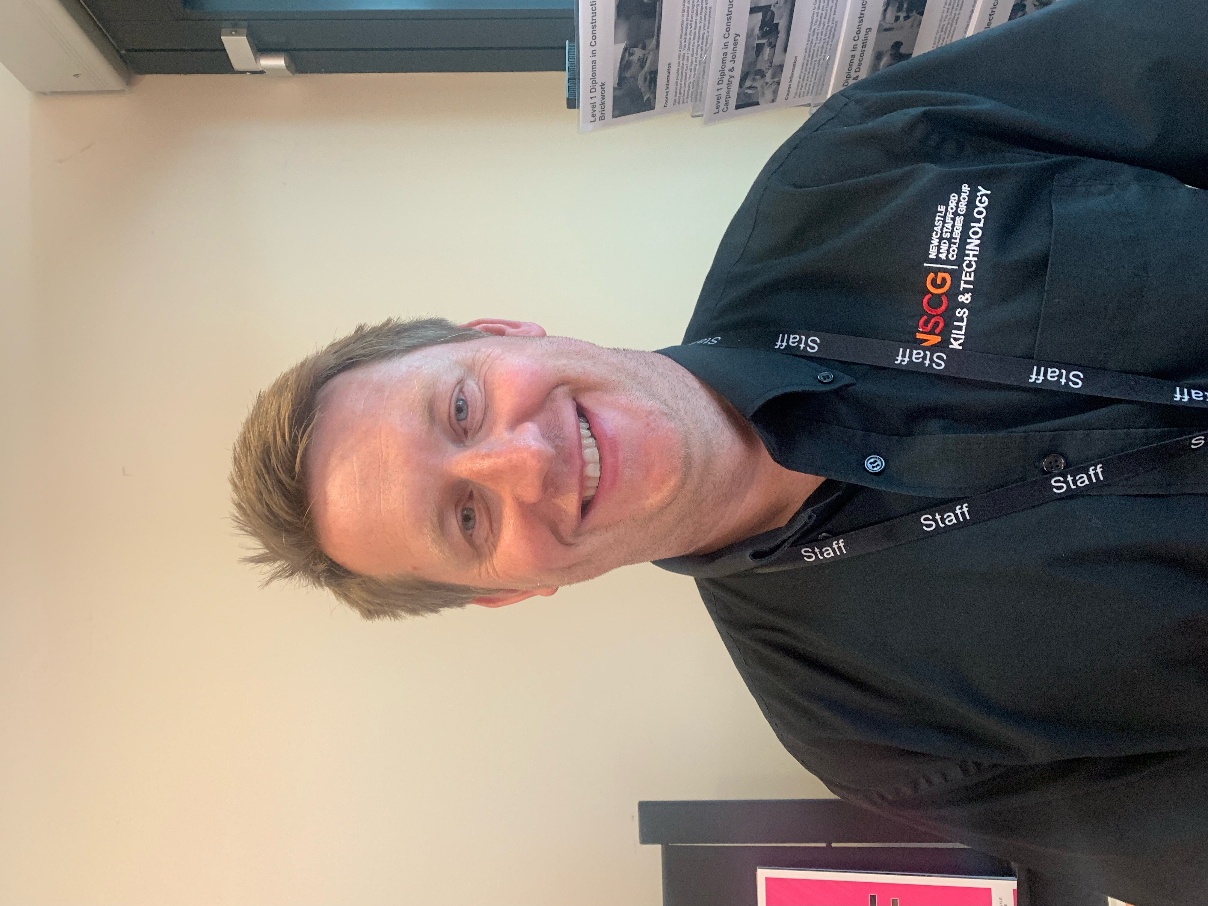

[dave.eccleston@nscg.ac.uk](mailto:dave.eccleston@nscg.ac.uk)

**Lecturer**

**Stuart McLean-Inglis**

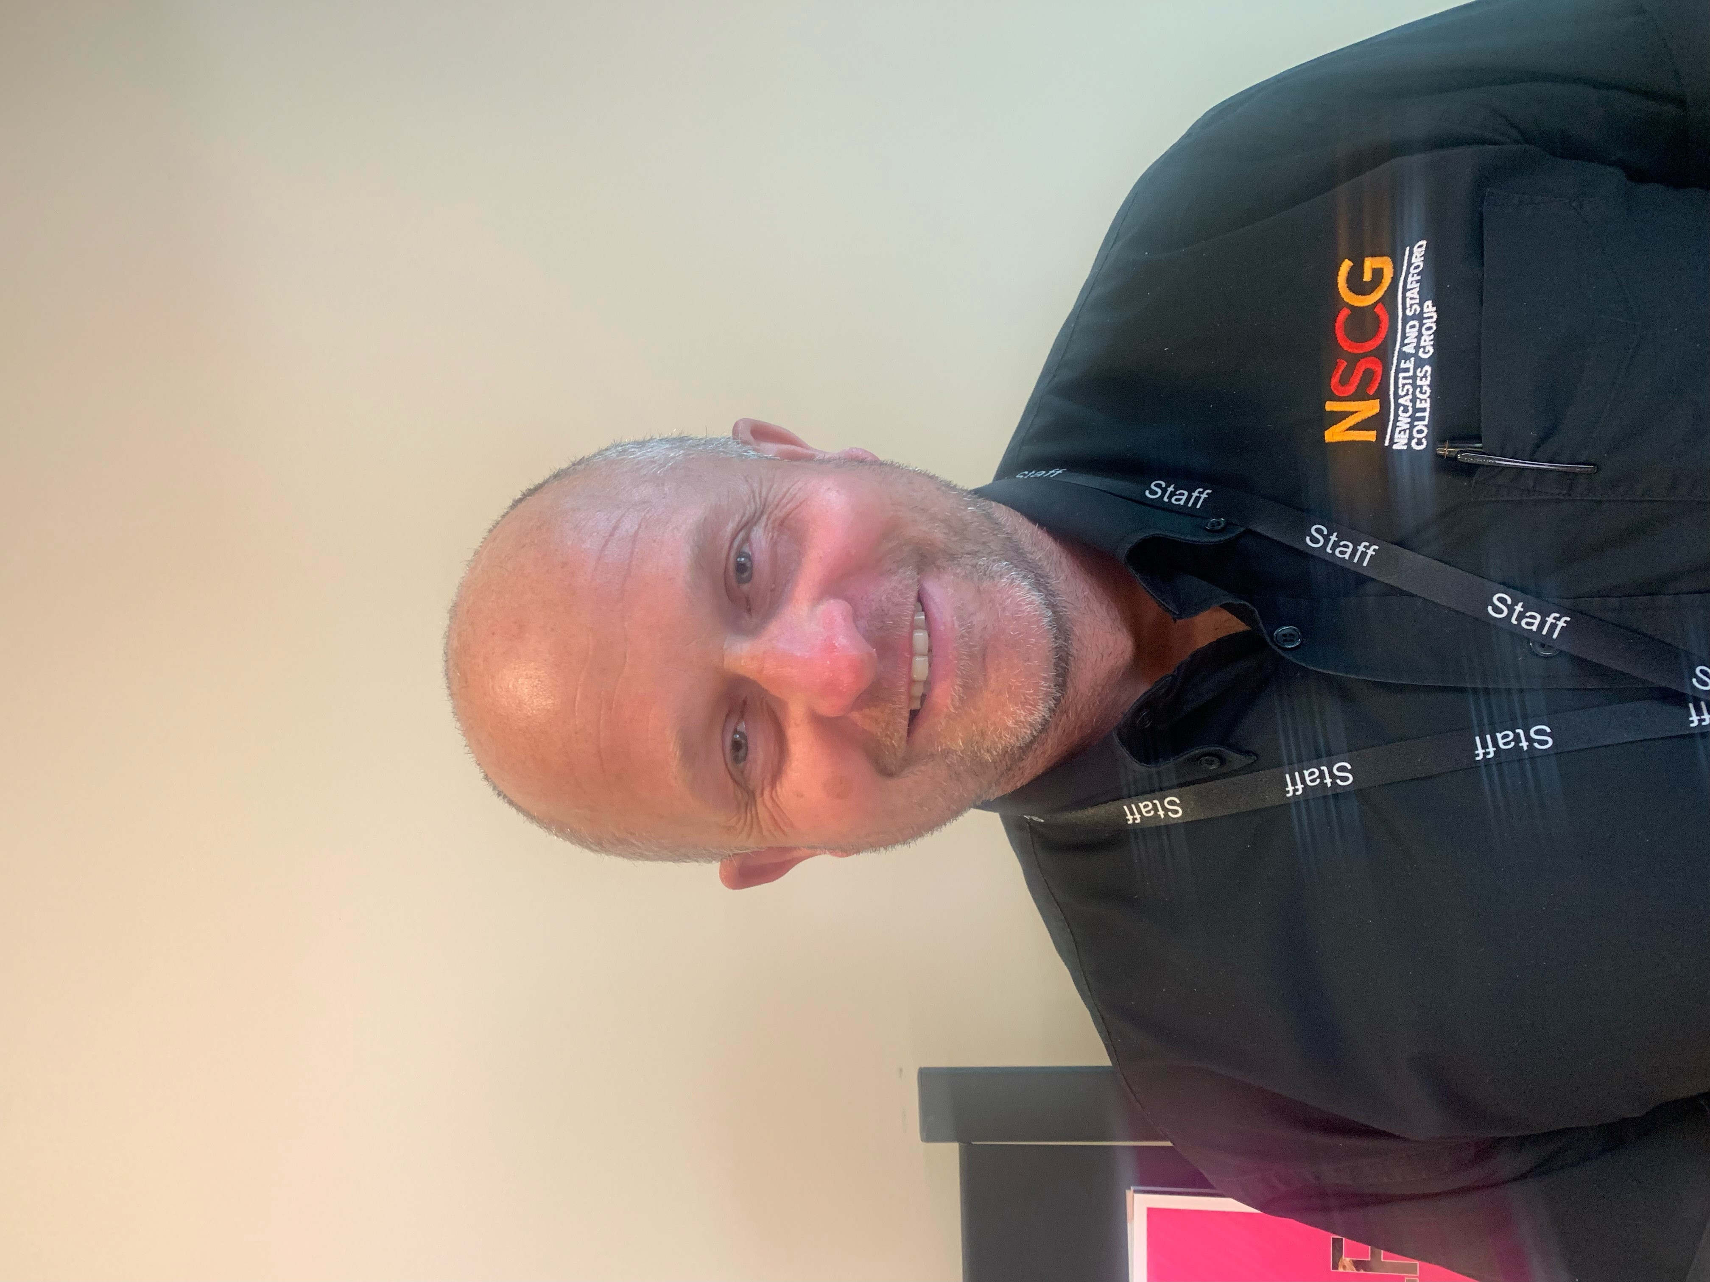

[stuart.mclean-ingli@nscg.ac.uk](mailto:stuart.mclean-ingli@nscg.ac.uk)

**Apprentice Technician**

**Riley Potts**

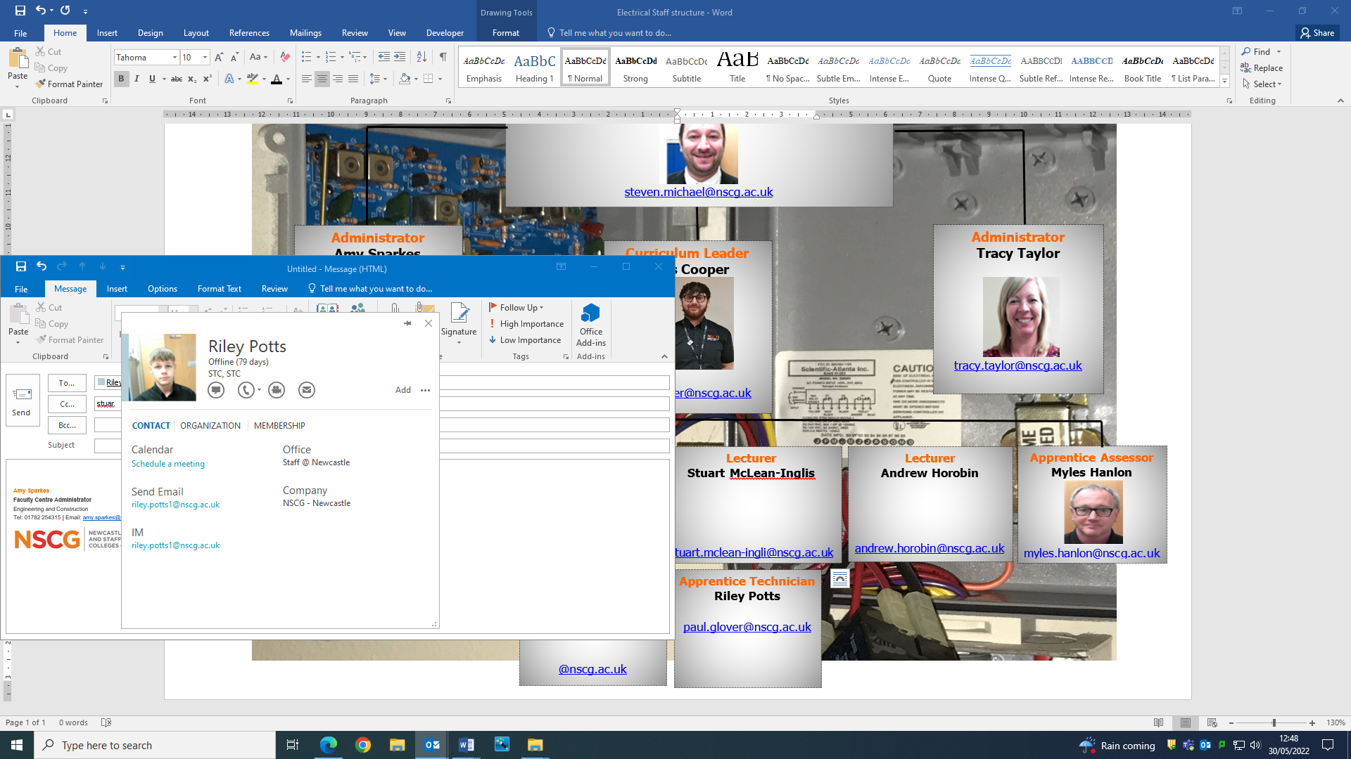

[riley.potts@nscg.ac.uk](mailto:riley.potts@nscg.ac.uk)

**Curriculum Manager - Construction & Engineering**

**Steven Michael**



[steven.michael@nscg.ac.uk](mailto:steven.michael@nscg.ac.uk)

**Welcome to our Electrical Courses**