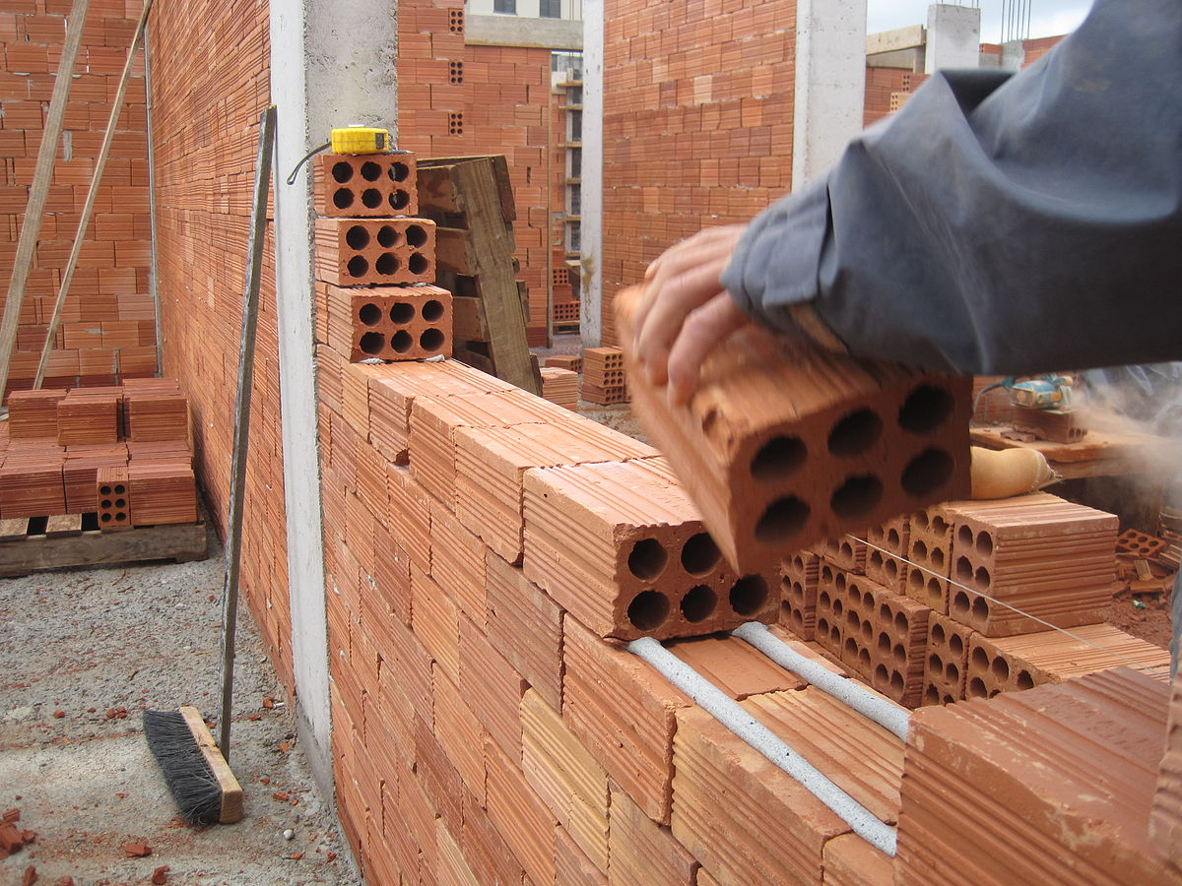

**Lecturer**

**Robbie Legg**

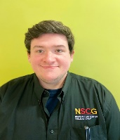

[robbie.legg@nscg.ac.uk](mailto:robbie.legg@nscg.ac.uk)

**Lecturer**

**Gareth Dawson**

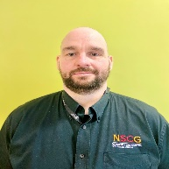

[gareth.dawson@nscg.ac.uk](mailto:gareth.dawson@nscg.ac.uk)

**Technician**

**Dave Clarke**



[dave.clarke@nscg.ac.uk](mailto:dave.clarke@nscg.ac.uk)

[dave.clarke@nscg.ac.uk](mailto:dave.clarke@nscg.ac.uk)

**Apprentice Assessor**

**Dave Ratcliffe**



[david.ratcliffe@nscg.ac.uk](mailto:david.ratcliffe@nscg.ac.uk)

[david.ratcliffe@nscg.ac.uk](mailto:david.ratcliffe@nscg.ac.uk)

**Administrator**

**Tracy Taylor**



[tracy.taylor@nscg.ac.uk](mailto:tracy.taylor@nscg.ac.uk)

**Curriculum Manager - Construction & Engineering**

**Steven Michael**



[steven.michael@nscg.ac.uk](mailto:steven.michael@nscg.ac.uk)

**Curriculum Leader**

**Wayne Cotton**

[wayne.cotton@nscg.ac.uk](mailto:wayne.cotton@nscg.ac.uk)

**Administrator**

**Amy Sparkes**



[amy.sparkes@nscg.ac.uk](mailto:amy.sparkes@nscg.ac.uk)

**Welcome to our Bricklaying Courses**