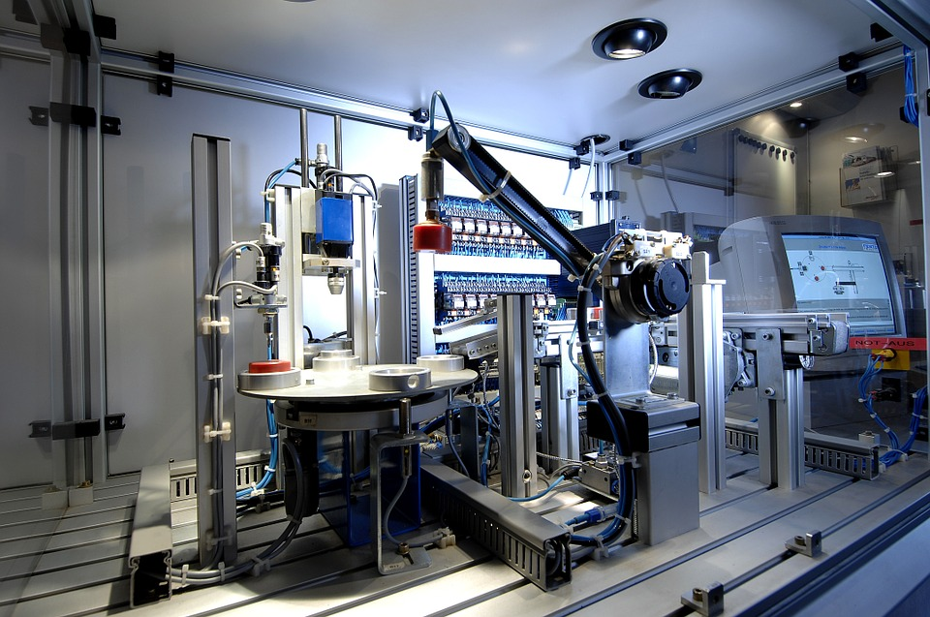

**Administrator**

**Tracy Taylor**



[tracy.taylor@nscg.ac.uk](mailto:tracy.taylor@nscg.ac.uk)

**Curriculum Manager - Construction & Engineering**

**Steven Michael**



[steven.michael@nscg.ac.uk](mailto:steven.michael@nscg.ac.uk)

**Lecturer**

**Roger Sharman**

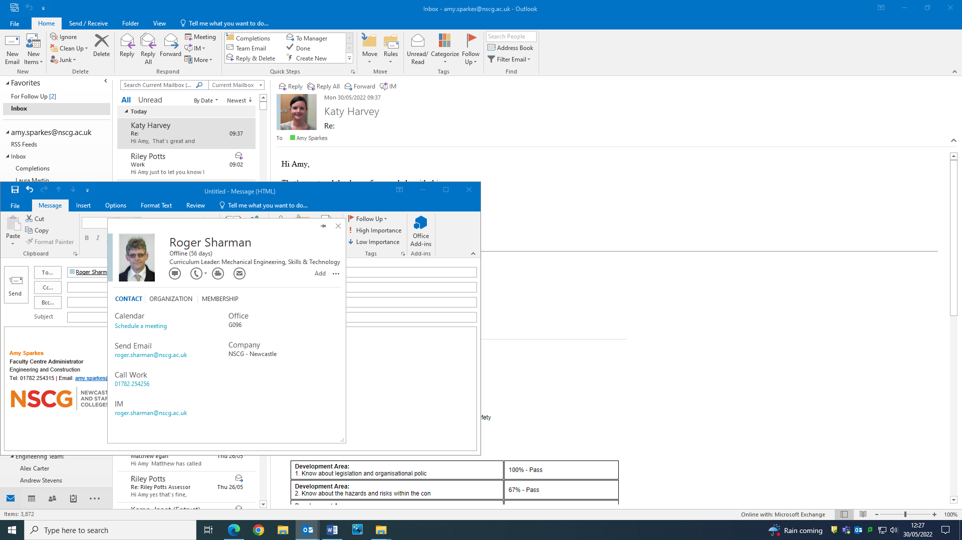

[roger.sharman@nscg.ac.uk](mailto:roger.sharman@nscg.ac.uk)

**Curriculum Leader for Full Time courses and Lecturer**

**Ian Clarkson**

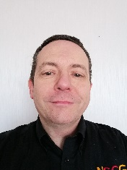

[ian.clarkson@nscg.ac.uk](mailto:ian.clarkson@nscg.ac.uk)

**Curriculum Leader for Part time & HE courses and Lecturer**

**Dave Halliwell**

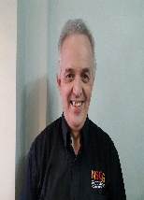

[dave.halliwell@nscg.ac.uk](mailto:dave.halliwell@nscg.ac.uk)

**Administrator**

**Amy Sparkes**



[amy.sparkes@nscg.ac.uk](mailto:amy.sparkes@nscg.ac.uk)

**Lecturer**

**Alexandra Carter**



[alex.carter@nscg.ac.uk](mailto:alex.carter@nscg.ac.uk)

**Lecturer**

**Michele Robinson**

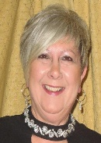

[michele.robinson@nscg.ac.uk](mailto:michele.robinson@nscg.ac.uk)

**Lecturer**

**Stephen Gage**

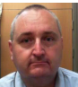

[stephen.gage@nscg.ac.uk](mailto:stephen.gage@nscg.ac.uk)

**Lecturer**

**Ovidiu-Stefan Gogu**



[ovidiustefan.gogu@nscg.ac.uk](mailto:ovidiustefan.gogu@nscg.ac.uk)

**Lecturer**

**Simon Bowyer**



[simon.bowyer@nscg.ac.uk](mailto:simon.bowyer@nscg.ac.uk)

**Welcome to our BTEC Engineering Courses**