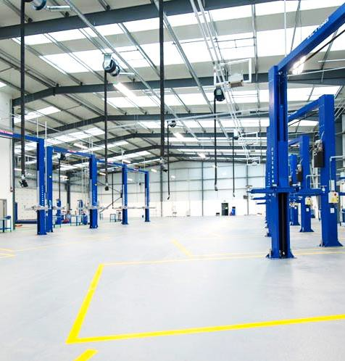
0

HUMBERSIDE FIRE & RESCUE SERVICE and HUMBERSIDE POLICE JOINT ESTATES STRATEGY & ASSET MANAGEMENT PLAN 2019 – 2024

Part B
JOINT ASSET MANAGEMENT PLAN 2019 – 2024
HUMBERSIDE FIRE & RESCUE SERVICE AND
HUMBERSIDE POLICE

CONTENTS
Joint Asset Management Plan – Part B

Introduction | ……………………….. | 2
OVERVIEW OF THE ESTATE | ……………………….. | 3
Humberside Police Estate | …………………..…… | 3
Humberside Fire & Rescue Service Estate | …………………..…… | 4
6 Facet Survey | ……………………..… | 5
Condition Category Scoring & Weightings | ……………………….. | 5
Visibility and Accessibility – Survey | ……………………….. | 6
Survey Findings | ……………………….. | 7
Six Facet Survey Result | ……………………….. | 8
Sustainability, Carbon Mgt and Environment | …………........…….. | 9
Waste and Recycling | ……………………….. | 11
Display Energy Certificates | ……………………….. | 12
Carbon Offsetting | ………............……. | 12
Spatial Standards for the Estate | .......................... | 13

OVERVIEW OF THE ESTATE IMPROVEMENT PROGRAMME ............... 15
Governance Arrangements .......................... 18
Review Process .......................... 19
RISK ASSESSMENT .......................... 20
APPENDIX A - Six Facet Survey, Assessment Criteria …………………..…… 21
APPENDIX B - Visibility & Accessibility .......................... 23
APPENDIX C - Carbon Emissions ………………………. 24
APPENDIX D - Display Energy Certificates ………………………. 25

JOINT ASSET MANAGEMENT PLAN

Introduction
Following the merger of the Police and Fire Service Estates Teams into a joint service, we have prepared this Joint Asset Management Plan to ensure that the management of both estates can be aligned. We are seeking to apply the same property management processes, maintenance regimes, contracts and resourcing to make economies and efficiencies whilst improving our business resilience. Importantly, our intention is to apply the same standards to our collective building assets and provide accommodation which enables our services to be delivered effectively to the communities we serve.
There will always be changing demands on the emergency services which, together with workforce orientated needs such as ‘Dignity at Work’, ‘Wellbeing’, ‘Equality and Diversity’ and ‘Flexible Working’, means that must ensure we not only operational requirements but that the asset base reflects the future needs of modern Policing and Fire & Rescue services for the future.
We firmly believe that the basis of good asset management is to have a full understanding of the estate and the services needing to be provided. By achieving this, we can establish and review our priorities for change, not only to clearly align the estate with operational delivery, but also to include an element of flexibility to mitigate the effect of any future change. It is a fact that property is always one of the slowest resources to respond to change for any organisation, and if we rely on responding reactively where an asset no longer meets service need, that service can be compromised. That situation often leads to the asset base underperforming, both financially and practically.
The indicators of poor asset management are considered to be:
- Having a large ‘backlog maintenance’ requirement.
- Poor fit between service requirements and available property – ‘fit for purpose’.
- Poor accommodation impacting on the workforce and their productivity.
- Limited flexibility for change and opportunity for collaboration.
- Inefficient planning of planned maintenance and capital works.
- Inadequate control of property related revenue budgets.
- Isolated and unplanned decisions.

The Asset Management Plan is therefore in place to enable a structured and programmed approach to maintenance and change, and should bring about the benefits of:
- Supporting service delivery and corporate objectives.
- Improving satisfaction with the working environment and built infrastructure.
- Ensuring that property assets are efficiently run and cost effective.
- Estate work (both revenue and capital) can be well planned to maximise benefits and reduce disruption to building users.
- Demonstrating clear performance management methodologies to ensure continuous improvement and efficiency of the estate.
We have established the principles for achieving our required standards for the estate through our 6 Facet Model of assessment. This is detailed fully on the following pages and is essentially the ‘design guide’ which both Humberside Police and Humberside Fire & Rescue Services will adopt throughout the life of the Estates Strategy & Asset Management Plan.

OVERVIEW OF THE ESTATE

Humberside Police Estate

There are currently 62 premises within the estate which accommodates over 3,340 officers and police staff, including PCSOs. For the purpose of benchmarking Estate, it has been classified according to a 5- tier hierarchy used by the National Police Estates Group (NPEG), as follows:

Level 1 | Force Headquarters
Level 2 | Operational and Organisational Support
Level 3 | Divisional Headquarters
Level 4 | Local Policing Team Bases
Level 5 | Community Offices

The estate contains a significant number of older buildings which require a disproportionate amount of higher priority repairs year on year. The backlog maintenance requirement is substantial but has been reducing year on year because of the ongoing planned maintenance programme and also the delivery of capital works, including the new Clough Road Police Station and the Operational Support Building at Melton. However, the condition of a number of properties and infrastructure does pose a risk of building failure which could lead to disruption and unplanned costs at a time when there is pressure to limit repairs and maintenance budgets.
It is not possible to accurately quantify the extent of the backlog as condition data is in need of a full review, which will be implemented in conjunction with the data migration to our new asset management system. It is expected to have the system, including the new ‘Helpdesk’, in operation by April 1st 2019, with additional modules and processes developed throughout the first 12 months. This will provide all premise related data for both police and fire services, necessary to monitor performance, place orders, store comprehensive building related data, and revise and update condition information through a quinquennial inspection programme. The system will enable more effective management of the estate and assist in prioritising planned maintenance, capital works and associated funding.
On the basis of ‘what we don’t have, we don’t pay for’, the amount of space we intend to provide per person has been reduced. This links directly with improvements in I.T. equipment and changes in working practices to allow agile working, which have reduced the demand for space and the number of workstations required. A reduction of floor area by 10% would, in theory, reduce heating and lighting bills alone by 10%. Based on current energy consumption it is estimated that this could potentially save circa £90,000 per year at current prices.

Utilities Cost 2017 - 18 | Budget | Outturn | Per M²
Electricity | £700,000 | £684,510 | £11.25
Gas | £315,520 | £251,003 | £4.12
TOTAL | £1,015,520 | £935,513 | £15.37

In 2010/11 Humberside Police was the 12th highest spend per m² on electricity. Our current spend now equates to £11.25/m² which puts us as the 9th lowest spender, per m², of the 42 Forces. This clearly demonstrates our commitment to reducing our energy consumption. (Available through the NPEG Benchmarking data 2016).

Humberside Fire & Rescue Service Estate
There are currently 34 premises within the estate which accommodates 1054 officers and fire staff. We currently undertake CIPFA ‘value for money’ benchmarking on an annual basis to measure the estate’s performance against other public sector organisations. This splits the estate into all buildings and admin buildings only for comparison purposes. However, this does not provide enough meaningful data to enable us to develop a detailed improvement plan. Therefore, we will be seeking to adopt the NPEG Benchmarking criteria in line with the police estate. However, it is accepted that the ‘Fire estate’ has different operational needs to police and is therefore constituted differently.
The Proposed Fire Estate 5-tier classification hierarchy will be as follows:

Level 1 | Service Headquarters
Level 2 | Operational and Organisational Support
Level 3 | Fire Stations
Level 4 | Training Facilities
Level 5 | Community Offices (Safety)

The estate is a mix of older and new fire stations, many of which are in need of further modernisation to respond to the requirements of ‘dignity at work’, access and general wellbeing. There has been a programme of new buildings (Central (Hull), Brough and Clough Road), which have improved overall condition and reduced total backlog maintenance requirements, although further significant works are planned to a number of sites, noted in the Fire Estate Delivery Plan – Part C.
The extent of the backlog maintenance requirement is currently being refreshed and costs recalculated. This work will also be implemented in conjunction with the data migration to our new joint asset management system as noted above. The new ‘Helpdesk’, in operation by April 1st 2019, will be a joint provision for both fire and police services, and will operate in conjunction with a joint Request for Service (RFS) process which will allow building users to monitor progress of their RFS.
Using the same premise, as with the police estate, of ‘what we don’t have, we don’t pay for’, the amount of space we intend to provide per person in office accommodation has also been reduced. The same improvements in I.T. equipment and changes in working practices to allow agile and flexible working, also apply. Similarly, this should reduce the demand for space and the number of workstations required.
The Fire Service estate also provides opportunities to collaborate with police and other partners to share accommodation. This has already been explored, with the vehicle maintenance workshop at Melton being a good example of where this has been successful and helped drive revenue savings and estate rationalisation. Further projects at Driffield, Pocklington and Bransholme, amongst others, will be progressed during 2019/20 with the intention to improve overall services to the public and make efficiency savings.

Utilities Cost 2017 - 18 | Budget | Outturn | Per m2
Electricity | £250,000 | £258,642 | £8.24
Gas | £150,000 | £114,843 | £3.66
TOTAL | £400,000 | £373,485 | £11.90
Current HFRS spend on electricity equates to £8.24/m² which appears low compared to other public sector bodies, but is skewed because of the inclusion of appliance bays, training towers and gyms within the area data. (CIPFA VfM Benchmarking data 2016/17).

Six Facet Survey
An important part of the Joint Estate Strategy and Asset Management Plan development was to develop a full understanding of the current condition of both Police and Fire Estates. To assist us in this process, we will be using a 6 Facet Survey approach which assesses each site and its buildings, considering the following criteria:

1 | Physical Condition
2 | Function Suitability
3 | Space Utilisation
4 | Quality
5 | Compliance with Fire, Statutory and Non-Statutory Standards
6 | Energy (Utilities & Display Energy Certificates)
This process will continue to be used by the Joint Estates Service in the future and integrated into the Asset Management database. Accommodation

Condition Category Scoring & Weightings
For each of the Categories within the Six Facet Survey the point scores below will be allocated. The maximum score for all Six Facets is 24. The banding for each Facet category is detailed in Appendix A.

Category A | = | 4 Points | Category B | = | 3 Points
Category C | = | 2 Points | Category D | = | 1 Point
Each Facet is considered in terms of contribution to satisfy the Estate Objectives. The key drivers for the Estate Objectives focus particularly on suitability of the estate, flexibility and compliance with standards. Therefore, for those facets which have a greater contribution to the objectives, a weighting has been applied. In addition, for each Facet, a Target Score of 3 for each facet is considered to be a challenging but achievable target (as set out below). The purpose of this is to define the minimum overall score required to satisfy the Estate Objectives.
Facet

- Physical Condition
- Functional Suitability
- Space Utilisation
- Quality
- Statutory Compliance
- Energy TOTAL
Min. Target
Score
3
3
3
3
3
3
18
Weighting
x 0.9
x 1.0
x 0.9
x 0.8
x 1.0
x 0.8
Min. Weighted Max. Weighted
Score Score
2.7 3.6
3.0 4.0
2.7 3.6
2.4 3.2
3.0 4.0
2.4 3.2
16.2 21.6

Buildings scoring 16.2 or more should be considered a viable asset. Maintenance should be applied accordingly to keep or improve the current condition. Those scoring less than 16.2 will be carefully considered for improvement, rationalisation or disposal, as they do not represent a viable future asset.
It is possible for a building to achieve the target score but fail to achieve the minimum required standard in one or more of the facets. Therefore, actions will be planned to ensure all facets meet the minimum standard required. Table 1 highlights example scores for a range of larger buildings in police and fire estates. Those in red or orange need review. This process has been applied to all buildings within the police and fire estates. Full details on each building are held with the Joint Estates Service.

Examples of high and low performing buildings within the estate
Shelford House, Scunthorpe, and Peaks Lane Fire Station, Grimsby. Two of our lowest rated buildings.
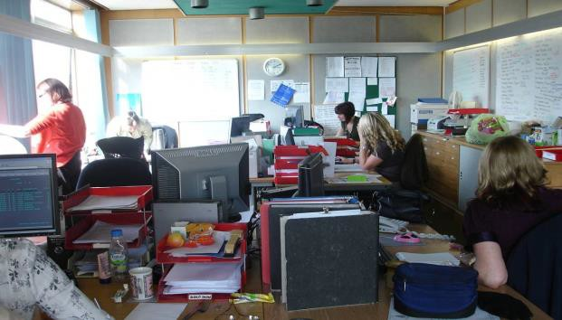
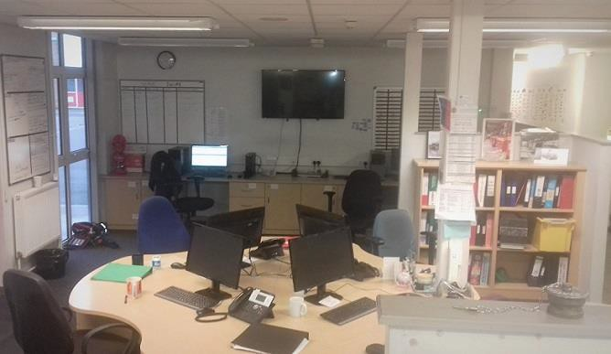

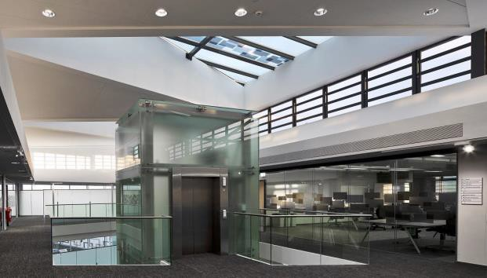
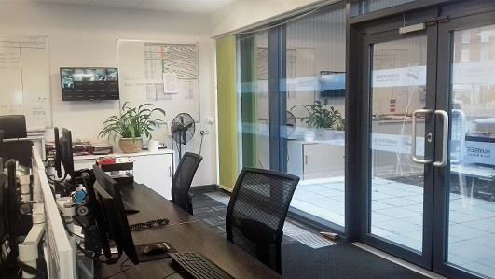
Clough Road, Hull, and Central Fire Station, Hull. Two of our highest rated buildings.

Visibility and Accessibility - Survey
Featuring in our strategic objectives, and a priority for the PCC, is to improve the visibility and accessibility of the police estate during and after rationalisation. This not only includes the physical access and signage, but also the appearance of the building which should be a reflection of a quality policing organisation and thereby assist in maintaining, or improving, public confidence in SYP.
In order to assess the standard of visibility and access to our sites, a Visibility and Accessibility Survey was undertaken on the 13 key buildings in the estate. The remaining sites will be surveyed as part of a rolling programme of re-surveying. This approach will identify where improvements can be made either through minor physical improvements, improved signage and lighting, to road signage in conjunction with local authorities and partners.
The following criteria are considered (during daytime and night time):

1 | Visibility of building (at set distances) | 6 | Clarity and visibility of access
2 | Visibility of Signage (at set distances) | 7 | Maintenance of the site and buildings
3 | Adequacy of directional highway signs | 8 | Accessibility by disabled people
4 | Quality of lighting to signs | 9 | Parking for visitors and disabled
5 | Quality of lighting to the building | 10 | Adequacy of public transport links
Each criterion is scored from 1 to 3 to give an overall score and grade as follows:
A = Complies well with all criteria B = Reasonable compliance with all criteria C = Compliance with most criteria D = Poor or no compliance with criteria.
The aim is to have all buildings achieving a grading of A or B. The grading will be used as a standard when acquiring sites, facilitating relocations or when considering sharing alternative premises with partners. An example of the Visibility and Accessibility Survey scoring sheet is included in Appendix B.

Table 1: Survey Findings
A summary of the facet survey findings is presented below:

 | Priory Road Headquarters  Grimsby Police Station  Scunthorpe Police Station  Beverley Police Station  Hessle Road Police Station |  |  |  |  | Clough Road Police Station  Training Centre, Courtland Road  HFRS HQ  (excludes OTC)  Peaks Lane Fire Station. |  |  |  | Central Fire Station  Beverley Fire Station
Physical Condition | Cat A | Cat B | Cat A | Cat B Cat B |  | Cat A | Cat B Cat B Cat B |  |  | Cat A | Cat B
Functional Suitability | Cat A | Cat B Cat B |  | Cat C | Cat B | Cat A Cat A |  | Cat B Cat B |  | Cat A | Cat B
Space Utilisation | Cat B | Cat C Cat C |  | Cat A | Cat C | Cat A | Cat B Cat B |  | Cat D | Cat A | Cat B
Quality | Cat A | Cat C | Cat B Cat B |  | Cat C | Cat A | Cat B Cat B Cat B |  |  | Cat A | Cat B
Statutory Compliance | Cat A | Cat B Cat B |  | Cat C Cat C |  | Cat B Cat B Cat B Cat B |  |  |  | Cat A | Cat C
Energy (Utilities)  Display Energy Certificate Rating (DEC)  Visibility Rating | Cat C Cat C Cat C Cat C |  |  |  | Cat D | Cat B | Cat C Cat C |  | Cat D | Cat B Cat B
 | Cat E Cat C Cat D Cat B Cat D |  |  |  |  | Cat C Cat E Cat D Cat B |  |  |  | Cat D Cat C

Table 2: Six Facet Survey Result
Using the scoring matrix in Table 1, the results of the 6 Facet Survey are presented below:
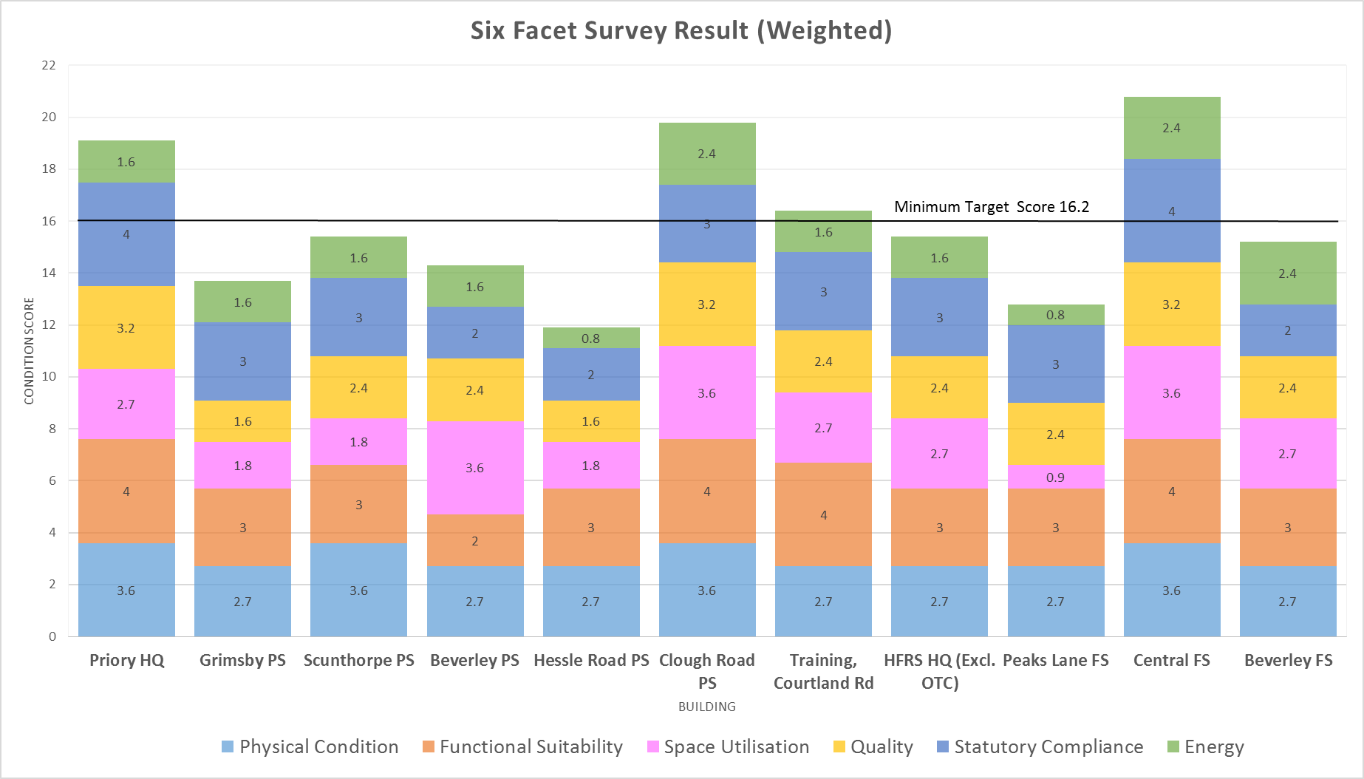

Sustainability, Carbon Management and Environment

Both Humberside Police and Fire & Rescue Service take our response to the environment seriously and have taken different approaches to this aspect of our work. It is recognised that it would be advantageous if both took a similar approach and adopt a holistic methodology in managing ‘Sustainability’ in its widest sense.
HFRS is currently maintaining accreditation for ISO 14001 as a framework for environmental management. This process is robust but requires consider able input to maintain and is only part of the full sustainability management approaches used by many organisations, including the police.
The Strategic Plan (HFRS) commits the Service to implementing measures to ensure environmental sustainability but doesn’t specify the approach to be taken. It is also considered that HFRS carries out a lot of work which could be considered a ‘sustainability action’ but is not recorded under the specific focus of the ISO 14001 format.
Since the National Police Estates Group (NPEG) formed a Sustainability Group with the intention of sharing best practice for sustainability across the police forces. This has evolved to include members from other Emergency Services and the group has now re-titled itself as ‘Emergency Services Environment and Sustainability Group’, to be inclusive of all the blue light community. It now includes members from London, Essex, Avon, Hereford & Worcester, Manchester and South Yorkshire fire and rescue services.
In January 2018 the National Fire Chiefs Council circulated the group’s National Sustainability Charter, which considers the wider ‘sustainability’ rather than the narrower field of environment, with the view the UK fire and rescue services could adopt the approach. Humberside Police are already signed up to the Charter and has a joint Sustainability Strategy with South Yorkshire Police.
It is our intention as a collaborative estate service, to adopt the police estate approach and work to the parameters of the existing Sustainability Strategy. Hopefully this will be adopted across all HFRS in the near future. The Sustainability Strategy covers 9 sustainability related areas. These are:
- 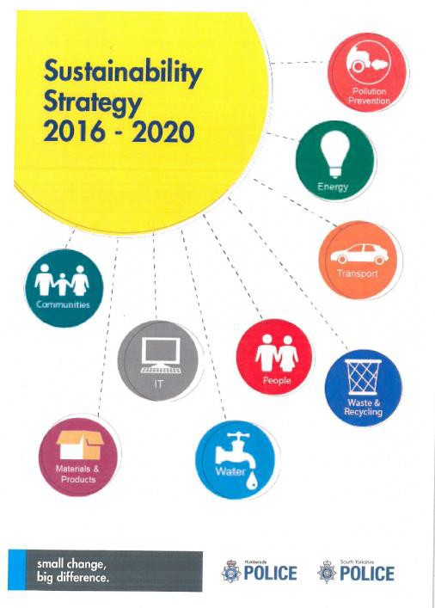Communities
- Materials & Products
- Information Technology
- Water
- People
- Waste & Recycling
- Transport
- Energy
- Pollution Prevention

Energy Performance
Humberside Police and HFRS combined estates currently produce 5,270 tonnes of carbon each year. This is around 62% of our total carbon emissions and equates to an annual carbon footprint of 1.17 tonnes per FTE. The police estate has reduced emissions by 46% since 2010/11, whilst HFRS estate has reduced emissions by 16.4% since 2014/15.

Estates Carbon Emissions – Police and HFRS

2015/16 | 2016/17 | 2017/18
7,253 tonnes | 6,352 tonnes | 5,270 tonnes
4,714 FTE | 4,496 FTE | 4,518 FTE
1.54 tonnes/FTE | 1.41 tonnes/FTE | 1.17 tonnes/FTE

Total Carbon Emissions – Police and HFRS

2015/16 | 2016/17 | 2017/18
11,296 tonnes | 9,743 tonnes | 8,492 tonnes
4,714 FTE | 4,496 FTE | 4,518 FTE
2.40 tonnes/FTE | 2.17 tonnes/FTE | 1.88 tonnes/FTE

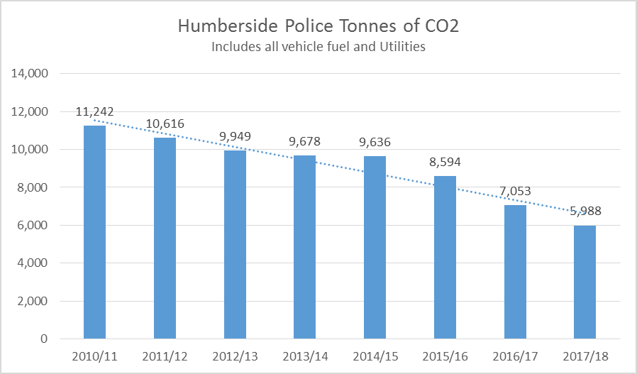Following the 2008 Climate Change Act, Government committed the UK to reduce carbon emissions by 80% (from 1990 levels) by 2050. Humberside police have already made good progress in contributing towards this requirement, having already achieved a reduction in carbon emissions by 46% since 2010/11, as indicated on the graph.

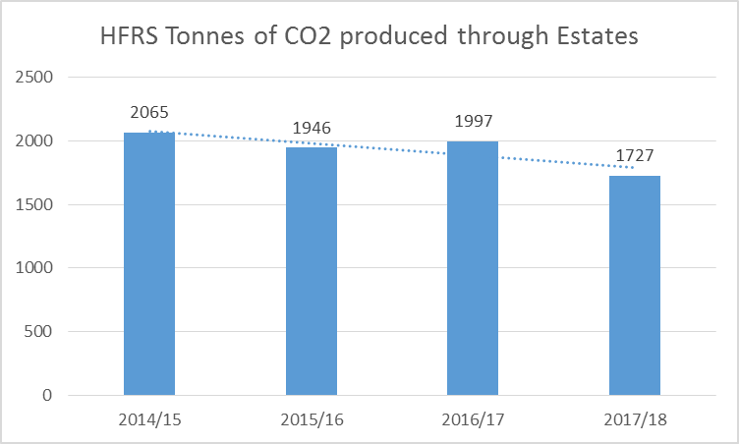HFRS carbon emissions data for the estate indicates a gradually decreasing trend. Reductions will continue to be made through capital investment and planned maintenance improvement schemes, more efficient use of facilities and introduction of technologies, e.g. boiler monitoring, lighting controls, smart metering and mobile equipment.

Our new target, throughout the life of this Joint Estates Strategy and Asset Management Plan, will be to achieve a carbon emission reduction (from 2010/11 levels) of 60% by 2024 for the police estate. The target for HFRS estate will be a reduction of at least 30% (from 2014/15 levels), also by 2024. Longer term planning on carbon emission reduction will be achieved through the joint implementation of the Sustainability Strategy.

Sustainability and energy use reduction is always considered as part of the capital or major planned maintenance projects and programmes of work. These will continue to be designed and specified to a high sustainability standard, including the use or generation of renewable energy where financially viable. It is our intention to achieve a BREEAM (environmental assessment method) rating of ‘very good’, as a minimum standard, for all new build and major refurbishment projects. It is accepted that it may sometimes not be possible to achieve this due to site constraints or specialist requirements.
Examples of some of our successful work achieved over the last 5 years are:
- A series of new LED lighting schemes already completed and a number currently being introduced throughout the police estate has reduced energy demand and improved lighting levels. The Estates Strategy includes LED replacements as a standard for all lighting schemes.
- The police estate has increased from 3% of sites (freehold) incorporating sustainable technology in 2010, to over 17% of the sites incorporate wind turbines, solar photo-voltaics, solar thermal units and ‘free cool’ units instead of air cooling. It is envisaged that, by 2024, the Force will have over 25% of police buildings using new sustainable technology. A similar target has been set for the Fire & Rescue Service estate.
- Additional works are being planned as viable ‘spend to save’ projects. These include additional on-site renewable technologies such as heat pumps, more photo-voltaics arrays and voltage optimisation/power factor correction. All will make significant savings in energy costs as well as reducing carbon emissions.
- At present the police estate generates over 120,000 kWh of electricity from sustainability technology. This production saves the equivalent cost of the total power usage for Bridlington Police Station each year, or 3 buildings the size of Barton Police Station. The fire estate generates 57,000kWh of electricity per year, enough to power the equivalent of 3 buildings the size of Pocklington Fire Station.
- Prior to merging the two estate teams, HFRS had already begun a programme of general lighting replacements, boiler upgrades (converting from oil to gas usage) and the construction of new buildings incorporating sustainable technology at Clough Road, Brough and Central.

The Sustainability Strategy will continue to be used to support the Estates Strategy and our ambition to reduce our carbon footprint further. Much of that will be achieved by continuing to reduce energy requirements, but we will also continue incorporating sustainable construction practices within our building construction works, such as the use of recycled materials, local employment and skills requirements in contracts and use of the Considerate Constructor scheme where possible.
The more holistic approach of the Sustainability Strategy will detail the Police and HFRS’s approach to environmental and carbon management. From an estates perspective, this will require our best use of current assets and the development of more sustainable new assets as the estate is improved through planned works and the capital programme.

Waste and Recycling
The other key supporting policy for the Estates Strategy will be a new Waste and Recycling Policy. This will link directly to facilities management functions and will be developed during the early summer 2019. We recognise the importance of recycling and will endeavour to establish a much improved recycling culture with realistic performance targets which will be monitored and reviewed. It is also recognised that this will come at a revenue cost which will have to be considered for ‘value for money’ before implementation.

Display Energy Certificates
The Energy Performance of Buildings Directive (EPDB) 2002/91/EC was introduced to facilitate improvements to the energy performance of buildings. The Directive is an important driver towards reducing carbon dioxide emissions as part of the UK Climate Change Strategy.
The regulations include all public buildings with a total useful floor area of 1000m², to have an annual report highlighting energy usage together with and an advisory report which lasts for 7 years. Amendments in 2017 now include buildings that exceed 250m² and up to 1000m², which are accessible to the public, needing to display a Display Energy Certificate (DEC) in a prominent place visible to the public, However, these buildings only require a certificate every decade. The fines for failing to display a valid certificate are £500, and failing to have a valid advisory report is £1000.
Humberside Police and Fire & Rescue Service currently have 14 buildings which require an annual DEC. A further 20 buildings require a 10 year DEC and are listed in Appendix D.

BUILDING (Annual) | ENERGY SCORE | ENERGY RATING
Beverley Police Station | 29 | B (Main building only)
Clough Road Police Station | 59 | C
Bransholme Police Station | 62 | C
Grimsby Police Station | 64 | C
Goole Police Station | 74 | C
Scunthorpe Police Station | 82 | D
Bridlington Police Station | 87 | D
Hessle Police Station | 99 | D
Courtland Road, Training Centre | 124 | E
Priory Road Police Station | 125 | E
Peaks Lane Fire Station | 50 | B
Beverley Fire Station | 56 | C
Summergroves Way, SHQ | 82 | D
Central Fires Station | 83 | D

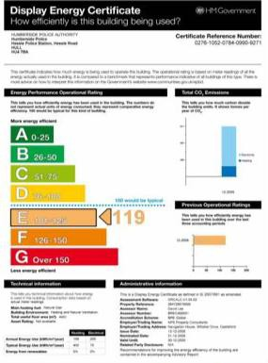The scores from the DECs completed to date indicates that 50% of the buildings surveyed fall below the expected rating threshold, having been assessed to fall into bands D, E or F. This indicates that these buildings create higher levels of CO2 emissions when measured against a hypothetical “standard” building of the same type.
Poor performance is addressed, where possible, by improvement works and raising the awareness of energy issues with building users. The DECs make recommendations in this regard which are fed into existing building performance data. This is then used to inform future decision making on rationalisation of assets, planned maintenance or refurbishment.

Carbon Offsetting
A further way to reduce our carbon footprint is by offsetting emissions against the use of ‘green’ energy which is produced from renewable sources, e.g. wind farms. The electricity is still purchased through the grid but comes at a premium. The drawback is that this approach fails to address the underlying issue of reducing emissions in the first place. This is not an option that Humberside Police wishes to pursue at this point in time. The premium from our supplier is yet to be agreed.

Spatial Standards for the Estate
Within the combined estate there are currently 96 premises with a combined gross internal area (GIA) of 98,420m². This is made up of 62 police premises totalling 67,020m2 and 34 HFRS premises totalling 31,400m².
It is difficult to accurately benchmark space data because of the diverse use of different buildings, working practices and shift patterns. In the case of the Fire and Rescue Service, a high percentage of the built estate comprises appliance bays which therefore skews spatial data per office workstation. In order to develop meaningful space data for our services, appliance bays have been excluded from calculations, as has the Emergency Services Fleet Maintenance workshop at Melton. Ancillary spaces such as plant rooms, property stores, conferencing, kitchens and dormitories, for example, are included in the GIA calculations.
There are standards for workstations and office space in the Workplace Health, Safety & Welfare Regulations 1992, which require 11 cubic metres of 3D space per person, equating to about 2.0 x 2.3 metres of floor area in a modern building with a ceiling height around 2.4 metres. It is not clear on whether this includes furniture or equipment, however, there should be sufficient floor area, height and unoccupied space for purposes of health, safety & welfare.
Workstations have to be suitable for both people and the work being done. Any person working at the workstation should be capable of leaving it swiftly, or should be able to be assisted in the event of an emergency. Seats have to be suitable for the person for whom it is provided, and any reasonable adjustments to enable anyone to work effectively will be provided. There should be sufficient clear and unobstructed space to enable work to be undertaken safely. The 2013 Occupier Density study published by the British Council for Offices (BCO) found '…a mean density of 10.9 m² to be a reasonable space per workplace.
In terms of an individual work space, the previous Humberside Police Estates Strategy set a target figure of 7.5m² based on a review of office layouts and benchmarking data from other public sector organisations. This has worked well in more ‘open plan’ environments, such as Clough Road Police Station but not so well in refurbishing older accommodation, often with cellular floor plans. In order to establish new standards for this current Estates Strategy, research on standards applied by others has been researched and highlighted a diverse range, as noted in the table below.

Body | Approaches to spatial standards
National Police Estates Group | Recommended good practice guide (2011) indicates 9m² as target per workspace (excludes garages, conference etc.). Also an average of 8 desks per 10 FTE.
Dept. for Business, Enterprise and Reg. Reform (DBERR) | The DTI introduced recommended standard for workspace of 10m²/FTE for all new office buildings and major refurbishments of existing office buildings. This is still the standard advised by the DBERR.
Ministry of Housing, Communities and Local Government | OGC Publication “Working beyond walls - The government workplace as an agent for change”, used as target for London HQ workspace of 6.7m²/FTE.
York City Council | Revised workspace standards for office accommodation with average workspace (desk area) of 7m²/FTE. (Excludes significant storage, conferencing, public areas).
British Council for Offices (BCO) | The 2013 Occupier Density Study indicates '…a mean density of one workplace per 10.9m² net internal area (NIA). 58% of sample fall in range of 8-12 m².
Workplace H, S & Welfare Regs. 1992 | Minimum standard of 11 cubic metres of 3D space per person, equating to approx.  2.0 x 2.3 metres floor area with a ceiling height of 2.4 metres

Based on the current average workspace across the estate and the standards being used by other public bodies, a target of 12m2 per workplace will be implemented across the respective estates. If this could be achieved, the total area of state could be reduced by approximately 12%.
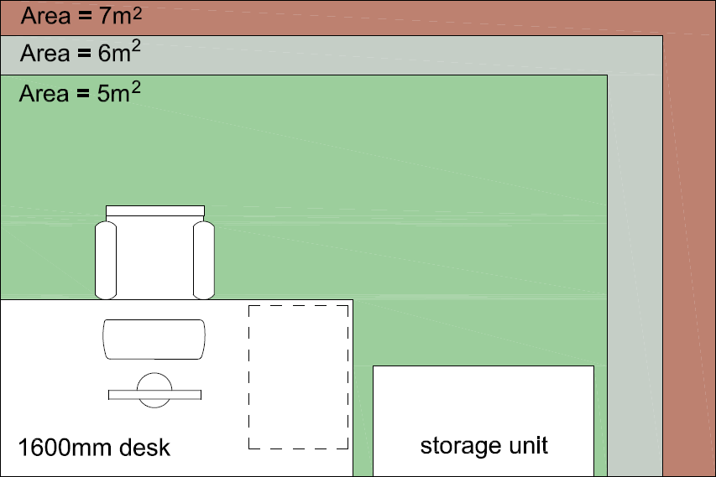As a point of visual reference, the following adjacent plan depicts a typical desk space layout ranging from 5m² to 7m², including an area for individual storage. It is recognised that specific workspaces will, by function, require additional space, for which there is Home Office guidelines, e.g. Chief Officers, Heads of Service, specialist functions. Our target area for desk space in general office areas will be a minimum of 5m², subject to specific use and operational requirements such as additional I.T. /monitors and printers.

In developing any future accommodation, the use of agile working practices will also be considered, based on the working practices of the user service. This can range from ‘hot desking’, clear desk working, utilising flexible working arrangements and collaboration arrangements. There is a need to review working practices and potential efficiencies to be gained by reducing workspace provision to, for example, 8 spaces to every 10 staff where functionally possible. To support this a space utilisation study will be undertaken during 2019. This will give some understanding to why and where we have empty desks, whether they could be shared or reduced.

OVERVIEW OF THE ESTATE IMPROVEMENT PROGRAMME
The following overview of key estates projects is based on current capital programmes and major planned maintenance works of both police and fire & rescue services. Most of these proposals have already been developed as part of existing governance and planning arrangements. However, the additional parameters of satisfying the target standards, as set out in the Asset Management Plan, have already been incorporated into the development and briefing for each project. By this method we expect to extend the working life of the buildings, improve sustainability performance, reduce energy and maintenance costs, and successfully satisfy the key objectives of the Estates Strategy. Detailed implementation of each project will use an accepted project management approach.

Summary of Key Building Project Proposals

Humberside Police HQ Priory Road | The site will continue to be the Force HQ. The building is in good condition and the site has full flood protection. HQ facilities have been modernised with office remodelling and the previous public enquiry entrance has been remodelled to form an open HQ reception.  Work is planned to complete the remodel, improve parking and reduce energy use on the site. The Custody suite will remain mothballed for the short term. | 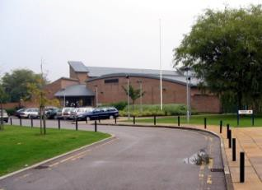
Humberside Fire & Rescue Service HQ Summergroves Way | The site will continue to be the Fire & Rescue Service Headquarters. Plans to relocate existing conferencing facilities have currently been placed on hold.  Planned works include: Remedial/improvement works to car parks, accessibility works to ground floor to be completed during 2019, and boiler replacement and heating improvements. An upgrade/refurbishment of OTC facility is also planned during 2019. | 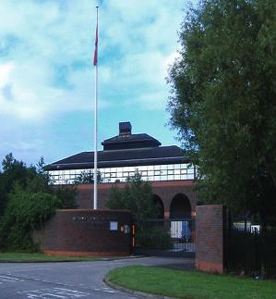
Bridlington Fire Station | Re-modelling and refurbishment of the station to improve ‘dignity’ and ‘welfare’ facilities. General maintenance improvements will be included in general works across the whole site.  Breathing Apparatus Training facilities have recently been upgraded with all works to be completed in early 2019. | 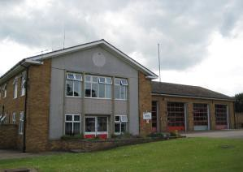
Beverley Police Station | Site is an eclectic mix of buildings. Very poor energy performance. The main building and site is a valuable asset. Options for disposal, re-modelling and possible re-provision for some services are also being explored.  The site will consolidate local provision and a number of specialist services/support (2019/20). This will require major refurbishment if existing is retained as anticipated.
Grimsby Police Station | The building is being substantially refurbished to improve health & safety and security as well as consolidate operation services. Custody will be closed (2019) post opening of Birchin Way.  Reorganisation within the secure yard, garage and annex areas will be completed, including changes to the property store provision. Wellbeing improvements will be made, including gym provision in 2019/20. | 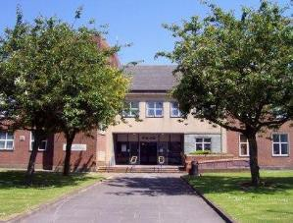

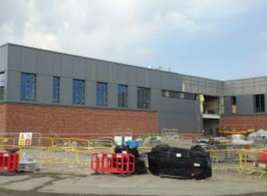
Birchin Way Custody Facility | The new £15m South bank custody facility at Birchin Way was handed over in November 2018 and will be fully operational early 2019.  Operating procedures and systems will continue to be tested through the building’s retention period up to November 2019.
Scunthorpe Police Station | Options to co-locate services with North Lincs Council have been explored and some shared provision will be progressed. Current site will be retained and consolidated over the next two years. The custody facility will be closed once Birchin Way is fully operational.  General improvement works will be implemented across the site. The internal yard will be cleared to provide more secure parking. Magistrates Courts separation to implement. | 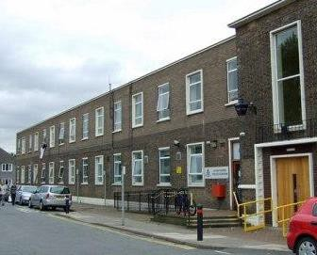
Scunthorpe Fire Station | Re-modelling and refurbishment of the station to improve ‘dignity’ and ‘welfare’ facilities. General maintenance improvements and boiler replacement will be included in general works across the whole site.  Breathing Apparatus Training facilities have recently been upgraded with all works to be completed in early 2019.  A full review of the site accommodation will be undertaken in 2019/20. | 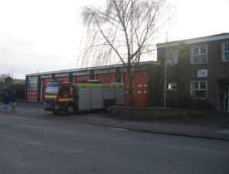
Driffield Fire Station  Pocklington Fire Station | Plans are to be progressed to re-provide facilities for the Local Policing teams in Driffield and Pocklington into the respective Fire Station sites. This will allow for disposal of the existing police stations as a contribution to the capital costs of remodelling works.  Pocklington will be implemented first. Driffield Fire Station will also include provision for Yorkshire Ambulance as a three  service collaboration, driving savings for the public purse. | 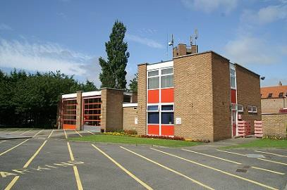  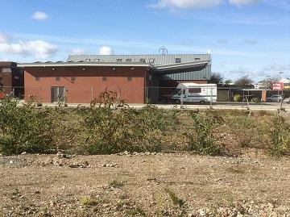
Clough Road Training Facility | Construction of new operational training facility has been designed to be sited on the land adjacent to the new fire station. This will include a training house, external Road Traffic Collision training area, and associated parking.  Charging points have also been included to enable use by Yorkshire Ambulance Service as a standby location.
Howden Fire Station | Currently undertaking an options appraisal on future provision. This ranges from remodelling existing, new build and collaborative project with police.  Temporary changing provision has been provided to address ‘dignity and privacy’ issues, and other minor improvements planned. | 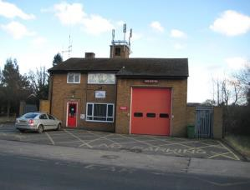
Bransholme Noddle Hill Annexe | Premise has been vacated and is now being considered for use as a collaboration project with Yorkshire Ambulance Service as a local base, and with Police as a Local Policing base.  Proposals will be presented during 2019 with a possible implementation date later in 2019/20. | 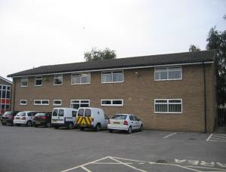

Calvert Lane Fire Station | The building is in need of extensive maintenance works and improvements to meet ‘dignity and privacy’ requirements.  Maintenance will include works to the appliance bay roof, heating system (replacement), re-decorations and review of appliance bay doors/windows.  Works will be planned over two financial years. | 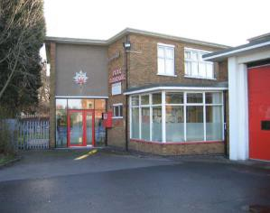
Hessle Police Station | The building has been extensively remodelled but is still in need of more improvements to the services and roof. Further remodelling to the control room and wellbeing improvements are planned.  The movement of some services currently housed in the building is being considered as part of the development of the Melton 2 project. The site still has limited parking provision and is reliant on on-road parking. | 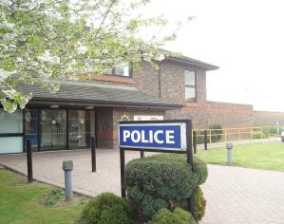
Training Centre – Courtland Road, Hull | The internal areas have been remodelled, with further minor improvements to be implemented. Energy use is high despite renewables on site and the building is thermally poor, with solar gain issues to the southern elevation. Further external works planned include improvements to cladding/insulation, replacement of fencing and main entrance gates, signage and lighting. | 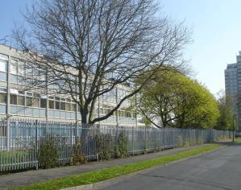
Melton 2 Facility | This project is to provide a second operational support building adjacent to the existing building on Wyke Way, Melton. It is intended to provide accommodation for specialist services, special operations training, conferencing, data resilience and control facilities.  Progression of the project will be subject to affordability and approvals, with completion anticipated in 2020-21. | 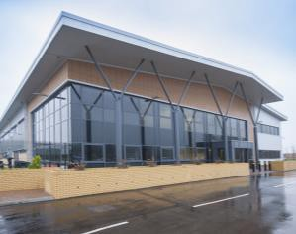
East Hull Fire Station at Jean Bishop Centre | Existing Fire Station on Southcoates Lane will be retained until 2020, allowing for a public consultation exercise on future use of the site. Site will be used in short term for training and limited operational use.  New Fire Station at Jean Bishop Centre is fully operational. | 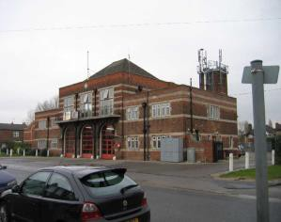
Minor Improvement Works and Sustainability Projects | General capital and planned maintenance works to remainder of the estate will include ‘Spend to Save’ projects to: Rationalise workspace, Develop renewable technology,  Improve building fabric, Reduce carbon footprint, rationalise Property Stores, install further Environmental controls.  Projects to be identified with short pay back periods, i.e. 5 – 7 years. | 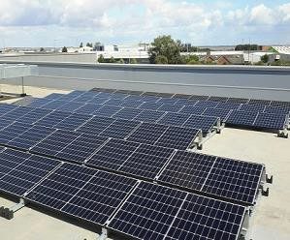

Governance Arrangements
The Joint Estates Board (JEB) will assume the role of overseeing Corporate Asset Management on behalf of both police and fire services. The Board comprises key users from across both estates who are best informed to provide recommendations as to how the buildings can be improved and the operational implications for doing so.
The Chair of the Board is rotated between the Assistant Chief Officer, Resources (HP), and the Director of Service Support (HFRS). They represent the executive management of their respective organisations, answering to the Chief Constable and Chief Fire Officer. As the estate sits under the ownership of the Police and Crime Commissioner, the JEB has representation from the Office of the Police and Crime Commissioner, through the Deputy Chief Executive (who is also the Treasurer). The JEB meets on a quarterly basis and will review Estates Strategy progress and endorse or agree amendments to project proposals within the Delivery Plans. Membership is detailed in the Joint Estate Service Terms of Reference, but includes Finance, HR, Business Change and Procurement.
The Estates Strategy will underpin the Joint Asset Management Plan to enable project development and delivery, as well as robust property management. The outputs and performance indicators contained in the Plan will be reported to the JEB on a regular basis to ensure that the agreed standards and direction of travel are being achieved.
The Head of Joint Estates Services is responsible for the co-ordination and control of all aspects of the Estates Strategies and Delivery Plans. The Project Managers will be responsible for the day to day management of individual projects and the development of project briefs, ensuring that all the works are satisfactorily completed on time and within the defined cost budget. The Project Managers will initially work with internal stakeholders and other Technical Consultants to develop project business cases prior to endorsement by the JEB, Executive Management and the OPCC, and/or Fire Authority.

To support the PCC and Fire Authority in managing the estate, the following bodies are responsible for the following decision making, prioritising and monitoring of the Joint Estates Strategy & Asset Management Plan:

  - Joint Estates Board
Chaired by Assistant Chief Officer (Resources), HP, or Director of Support, HFRS
Reviews Estates Strategy progress and endorses or agrees amendments to project proposals within the Delivery Plans.
  - Chief Officer Group (HP) and Senior Leadership Team (HFRS)
Review and agree overall Estates Strategy, project development and business cases for significant operational change leading to estate change.
  - Police and Fire Transformation Board
Membership of Executive managers from Police and Fire & Rescue Service. Review of Estate Strategy implementation in line with requirements for transformational change and collaborative work.
  - Corporate Governance Group (CGG) and Fire Authority
Membership of CGG includes PCC, and Fire Authority includes the Chair of the Fire Authority. Ratify the Estates Strategy & Asset Management Plan 2019 – 24, monitor progress and ratify key delivery projects and asset disposals.

Review Process
The Estates Strategies, Joint Asset Management Plan and Delivery Plans will be reviewed annually by the Joint Estates Board for continued relevance in the external and financial environment in which they operate. Any recommendations for change will be included in appropriate reporting to the relevant body noted in the Governance Section.
The Asset Management and Delivery Plans will also be continually monitored by the Joint Estates Board, with regular reporting to the OPCC.
An annual report will be prepared to include a full review of the Joint Estates Service’s delivery of project work, property management, sustainability works and delivery against performance requirements. This will be presented at the end of each calendar year to fit with the budget setting processes of both OPCC and Fire Authority.

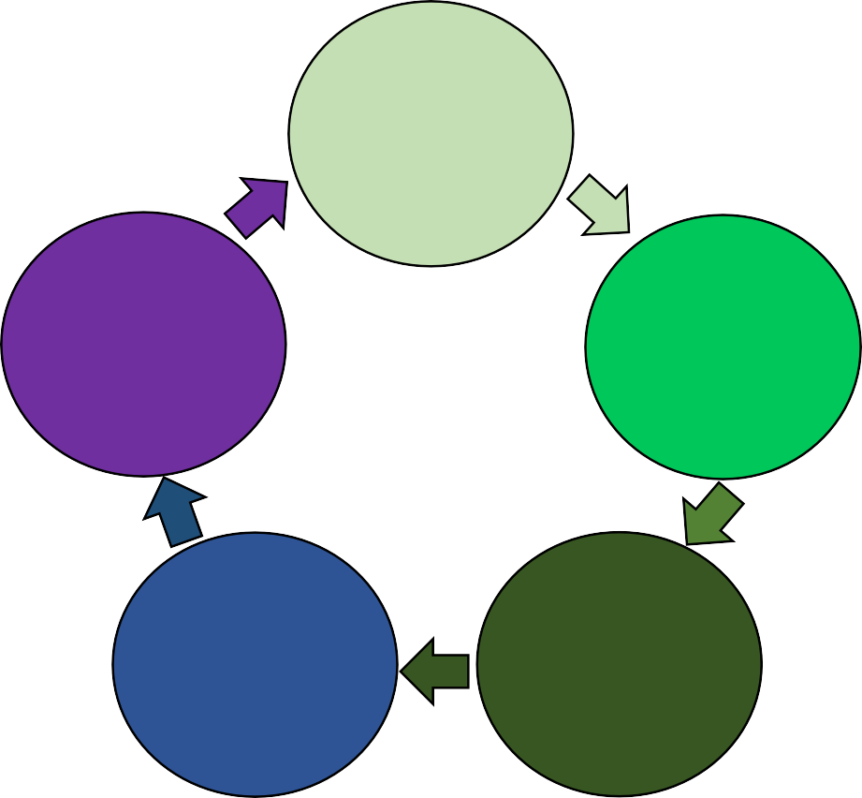Joint Estates Strategy & Corporate Asset Management Plan - Annual Reports

Changes of Programme Standards, Financing or Demands. Review Business Drivers.

ASSET MANAGEMENT
Capital works, Property Management and Facilities Management PARAMETERS
Finance, Governance, Standards, Sustainability, AM Data Quality, AM Data
Delivery Plans reviewed, Capital & maintenance budgets agreed.
New programme of works agreed.

Regular Monitoring & review of performance by JES and Joint Estates Board
Agreed estate standards, Project Management, JES Delivery of services

RISK ASSESSMENT
Preliminary assessment of risks associated with Estates Strategy delivery
Risks associated with the development, management and delivery processes established by the Joint Estates and Asset Management Plan, are set out in the table below. These are regularly monitored and form part of the annual review of the Joint Estates Service.

RISK | Risk Type | Owner | Risk Rank | Mitigation
Continuing ‘Austerity’ and reducing Capital & Revenue funding | Financial / Business / Legal | Finance | High | Prioritise work to fit benefits analysis. Value for Money.
Depressed local property markets | Financial | Finance | Medium | Programme governance. Consultation with developers. Partnership working.
Project prioritisation  /conflict between projects | Financial / Project | Joint Estates | Medium | Programme governance. Business benefits analysis.
Failure to meet sustainability targets | Reputational / Financial | JEPB | Medium | Regular review of metrics. Highlight ‘spend to save’ projects.
Climate Change Levy rises. | Statutory / Financial | JEPB | Medium | Likely to be imposed to energy bills as a levy to pay for major infrastructure projects.
Business Continuity - I.T., Custody, Operational flexibility. | Business / Reputational | JEPB | High | Build spare accommodation into capital programme. Project management.
Regional Influences | Political / Financial | ACO | Medium | Close contact with regional working, lead roles and participation. Asset Management Group.
Reduction of Revenue Budgets | Financial / Regulatory | Finance | High | Improve data quality for targeted work. Carry out high priority work only.
Contractor Management | Legal / H&S | Joint Estates | Low | Written processes in place, supporting documents. Responsible person for sites identified and trained.
Backlog Maintenance | Business / Reputational | Joint Estates | Medium | Essential repairs only. Include in capital work where possible. Quality data.
Data Quality | Project / Financial / | Joint Estates | High | Asset Management software and condition surveys to set up quality data and monitoring.
Resources | Project / Business / | Joint Estates | High | Risk based process. Overlapping roles to provide some continuity.
Statutory Obligations | Legal / H&S / Reputational | Joint Estates | Medium | Detailed knowledge of obligations. Quality data. Support of Force H&S.
Asbestos | Legal / H&S / Reputational | Joint Estates | Medium | Asbestos Register in place. Management Plan to distribute. Quality data. Support of Force H&S.
Legionella | Legal / H&S / Reputational | Joint Estates | Medium | Quality data. Support of Force H&S. Data base established.
Rising costs – materials, utilities, - sustainability | Financial / Project | Joint Estates | High | Use of alternative materials and ‘value engineering’. Prioritise projects.
Changes in key personnel | Business / Project | Force/ HFRS | High | Input from COG and OPCC at earliest. Risk assesses on regular basis.
Linking Operation Strategies with Estates Planning | Business / Project | JES / HFRS | High | JES involvement in HFRS operational plans at early stage. Ensure early consideration of estate implications.

APPENDIX A - Six Facet Survey, Assessment Criteria
Six Facets - Criteria

Physical Condition
This assessment examines the building structure and fabric, mechanical and electrical engineering installations It aims to categorise the condition of the building. The Physical Condition Categories are:
Category A: | Long-term work required outside the 5 year planning period that will prevent deterioration of the fabric or services; | Score 4
Category B: | Desirable work required within 3 to 5 years that will prevent deterioration of the fabric or services and/or address a low risk to the health and safety of occupants and/or remedy a less serious breach of legislation. | Score 3
Category C: | Essential work required within 2 years that will prevent serious deterioration of fabric or services and/or address a medium risk to health & safety of occupants and/or remedy a less serious breach of legislation. | Score 2
Category D: | Urgent works that will prevent closure of site and/or address an immediate high risk to H & S of occupants and/or remedy a serious breach of legislation. | Score 1
Function Suitability
Identifying how effectively buildings support the delivery of services. The criteria used in such assessments include: Operational relationships; Services to support operations / policing; Location; Environmental conditions; and Overall effectiveness. The categories for Functional Suitability are:
Category A: | High degree of satisfaction. | Score 4
Category B: | Acceptable/reasonable: no major change necessary. | Score 3
Category C: | Below acceptable standard. | Score 2
Category D: | Unacceptable in its present condition. | Score 1
Space Utilisation
Premises should provide sufficient space to support the provision of a first class Policing service to the public. The space analysis indicates under or over utilised floor space. The Space Utilisation categories are:
Category A: | Sufficient (the utilisation is within ±10% of available area). | Score 4
Category B: | Acceptable, however elements are under used or overcrowded (the utilisation is within ±15% of the available area). | Score 3
Category C: | Some areas are unacceptable (use ±20% of available area). | Score 2
Category D: | Unacceptable utilisation is >±20% of the available area. | Score 1
Quality
An assessment of amenities, comfort and design:
Amenities: does the building offer an attractive and pleasing area for officers/staff and the public (e.g. what the building and its environment offers in terms of privacy, dignity, comfort, working conditions and sign posting).
Comfort: does the building offer an acceptable environment (e.g. is it well lit, adequately heated and cooled, noise and odour free).
Design: is the building attractively interior/exterior designed (e.g. in terms of good quality colour schemes, is it well furnished, enhanced by art, plants, landscaping views, good connectivity etc).
Category A: | A facility of good quality. | Score 4
Category B: | A facility requiring general maintenance investment only. | Score 3
Category C: | A less than acceptable facility requiring capital investment. | Score 2
Category D: | Very poor, needs major capital investment or replacement. | Score 1

Compliance with Statutory and Non-Statutory Standards
The scope of this assessment is limited to compliance with Fire Risk, Disability Discrimination Act, General Health & Safety, Asbestos, Environmental Contamination and Flood Risk.
Category A: | Long-term work required outside the 5 year planning period that will prevent deterioration of the fabric or services. | Score 4
Category B: | Desirable work required within 3 to 5 years that will prevent deterioration of the fabric or services and/or address a low risk to the health & safety of occupants and/or remedy a less serious breach of legislation. | Score 3
Category C: | Essential work required within 2 years that will prevent serious deterioration of the fabric or services and/or address a medium risk to the health & safety of occupants and/or remedy a less serious breach of legislation. | Score 2
Category D: | Urgent works that will prevent immediate closure of premises and/or address an immediate high risk to the health and safety of occupants and/or remedy a serious breach of legislation. | Score 1
Energy
Assessment carried out by analysis of the operating costs and annual utility usages. This assessment is split into two elements, Utilities and the Display Energy Certificate rating.
Energy (Utilities) The utilities costs include gas, water, electricity and waste water. The Energy (Utilities) categories below are based on average Office Utility usages:
Category A: | £0 – £20/m2 | Score 4
Category B: | £20 – £23/m2 (increase of 15% from Category A) | Score 3
Category C: | £23.70 – £26/m2 (increase of 30% from Category A) | Score 2
Category D: | >£26/m2 (greater than a 30% increase from Category A) | Score 1
The above categories are applied to all buildings, with the exception of storage facilities which are categorised as follows:
Category A: | £0 – £15/m2 | Score 4
Category B: | £15 – £17.3/m2 (increase of 15% from Category A) | Score 3
Category C: | £17.3 – £19.5/m2 (increase of 30% from Category A) | Score 2
Category D: | >£19.5/m2 (greater than a 30% increase from Category A) | Score 1
Energy (DEC) Display Energy Certificates (DEC) have been included as a further indicator:
Category A: | DEC Energy Operational Performance Rating A & B | Score 4
Category B: | DEC Energy Operational Performance Rating C & D | Score 3
Category C: | DEC Energy Operational Performance Rating E & F | Score 2
Category D: | DEC Energy Operational Performance Rating G | Score 1

APPENDIX B - Visibility & Accessibility

Visibility and Accessibility Survey – Scoring Sheet

Site: | Date: | Surveyed by: | Day time | Night time

 | Criteria | Assessment (during day and night time) plus comments | Notes | Score  value | Score
A | Visibility of building on | Excellent at all times |  | 3
 | approaching | Good/poor - can be improved |  | 2
 |  | Poor - difficult to improve |  | 1
B | Visibility of Signage on | Excellent at all times |  | 3
 | approaching | Good/poor - can be improved |  | 2
 |  | Poor - difficult to improve |  | 1
C | Directional highway | Excellent in all approaches |  | 3
 | signs (where | Good/poor in all/some directions |  | 2
 | appropriate) | Poor - limited chance to improve |  | 1
D | Quality of lighting to | Well lit to good standard |  | 3
 | the signs | Adequate - can be improved |  | 2
 |  | Limited/restricted |  | 1
E | Quality of lighting to | Well lit to good standard |  | 3
 | the buildings | Adequate – can be improved |  | 2
 |  | Limited opportunity to improve |  | 1
F | Clarity and visibility of | Good and safe access at all times |  | 3
 | access | Good/poor - can be improved |  | 2
 |  | Poor - difficult to improve |  | 1
G | Appearance of the site | High quality and professional |  | 3
 | and buildings | Good/poor - can be improved |  | 2
 |  | Poor – difficult to improve |  | 1
H | Accessibility by | Excellent at all times |  | 3
 | disabled people | Good/poor - can be improved |  | 2
 |  | Poor - difficult to improve |  | 1
I | Parking for visitors and | Excellent |  | 3
 | disabled | Limited |  | 2
 |  | None |  | 1
J | Adequacy of public | Excellent |  | 3
 | transport links | Limited |  | 2
 |  | None |  | 1
Total
Grading Values

Total Score | Grading
26-30 | A | Good levels of compliance with all criteria
20-25 | B | Good or reasonable levels of compliance with all criteria
16-20 | C | Compliance with most criteria
Below 15 | D | Poor or no compliance with criteria

Site Visibility & Accessibility Grading |  | Potential for:

APPENDIX C - Carbon Emissions
Estates Carbon Emissions - Police

2010/11 | 2015/16 | 2016/17 | 2017/18
6,586 tonnes | 5,307 tonnes | 4,355 tonnes | 3,543 tonnes
4317 FTE | 3489 FTE | 3344 FTE | 3464 FTE
1.53 tonnes/FTE | 1.52 tonnes/FTE | 1.30 tonnes/FTE | 1.03 tonnes/FTE
Total Carbon Emissions - Police

2010/11 | 2015/16 | 2016/17 | 2017/18
11,242 tonnes | 8,536 tonnes | 7,012 tonnes | 5,988 tonnes
4317 FTE | 3489 FTE | 3344 FTE | 3464 FTE
2.60 tonnes/FTE | 2.45 tonnes/FTE | 2.09 tonnes/FTE | 1.74 tonnes/FTE

Estates Carbon Emissions - HFRS

2014/15 | 2015/16 | 2016/17 | 2017/18
2,065 tonnes | 1,946 tonnes | 1,997 tonnes | 1,727 tonnes
1280 FTE | 1225 FTE | 1152 FTE | 1054 FTE
1.61 tonnes/FTE | 1.59 tonnes/FTE | 1.73 tonnes/FTE | 1.64 tonnes/FTE
Total Carbon Emissions - HFRS

2014/15 | 2015/16 | 2016/17 | 2017/18
2,868 tonnes | 2,760 tonnes | 2,731 tonnes | 2,504 tonnes
1280 FTE | 1225 FTE | 1152 FTE | 1054 FTE
2.24 tonnes/FTE | 2.25 tonnes/FTE | 2.37 tonnes/FTE | 2.37 tonnes/FTE

Estates Carbon Emissions – Police and HFRS

2015/16 | 2016/17 | 2017/18
7,253 tonnes | 6,352 tonnes | 5,270 tonnes
4,714 FTE | 4,496 FTE | 4,518 FTE
1.54 tonnes/FTE | 1.41 tonnes/FTE | 1.17 tonnes/FTE
Total Carbon Emissions – Police and HFRS

2015/16 | 2016/17 | 2017/18
11,296 tonnes | 9,743 tonnes | 8,492 tonnes
4,714 FTE | 4,496 FTE | 4,518 FTE
2.40 tonnes/FTE | 2.17 tonnes/FTE | 1.88 tonnes/FTE

APPENDIX D - Display Energy Certificates
Full list of DECs for Police and Fire & Rescue Service estates, annual and 10 yearly.
Building (Annual) | Energy Score | Energy Rating
Beverley Police Station (Main) | 29 | B
Clough Road Police Station | 59 | C
Bransholme Police Station | 62 | C
Grimsby Police Station | 64 | C
Goole Police Station | 74 | C
Scunthorpe Police Station | 82 | D
Bridlington Police Station | 87 | D
Hessle Police Station | 99 | D
Courtland Rd, Training Centre | 124 | E
Priory Road Police Station | 125 | E
Peaks Lane Fire Station | 65 | C
Beverley Fire Station | 56 | C
Summergroves Way, SHQ | 82 | D
Central Fire Station | 83 | D
Building (Every 10 years) | Energy Score | Energy Rating
Driffield Police Station | 66 | C
Pickering Rd Police Station | 68 | C
Brough Police Station | 77 | D
Scunthorpe North PS | 82 | D
Grimsby North Police Station | 84 | D
Preston Road Police Station | 86 | D
Scunthorpe East PS | 98 | D
Withernsea Police Station | 112 | E
Pocklington Police Station | 119 | E
Pocklington Fire Station | 47 | B
Barton Fire Station | 57 | C
Beverley Fire Station | 56 | C
Market Weighton FS | 62 | C
East Hull Fire Station | 72 | C
Goole Fire Station | 74 | C
Immingham East Fire Station | 78 | D

Scunthorpe Fire Station | 79 | D
Brigg Fire Station | 89 | D
North Hull Fire Station | 96 | D
Grimsby FS – Cromwell Rd | 101 | E
West Hull Fire Station | 102 | E
Immingham West FS | 102 | E
Bransholme Fire Station | 115 | E
Cleethorpes Fire Station | 135 | F
Bridlington Fire Station | 139 | F
Driffield Fire Station | 144 | F
Brough Fire Station | - | tbc
Central Fire Station | - | tbc
Kirton Lyndsey | - | tbc

