Health Fact Sheet
Glyphosate & Health

Glyphosate is familiar to most people in the form of the weed killer Roundup, which is widely advertised as making your life easier by killing those pesky weeds ‘right down to the roots’!

And that’s not the only thing its killing! It would seem that its toxic effects are hitting human health as well.

Based on the initial data provided by the manufacturer, Monsanto, this nasty weed killer has been deemed to be safe to use not just on the food we eat, but in our gardens (beware pets and children!), parks, playing fields, golf courses, and public spaces.

Information uncovered since suggests that Monsanto were being less than honest when they claimed it was ‘environmentally friendly’ and ‘biodegradable’ and safe for human health - and the cost has been paid by the public with a wide range of health issues linked with glyphosate exposure.

And glyphosate is not just used on GM Round Up Ready crops – it is being used on a host of non-GM crops as well – wheat, barley, oats, canola, flax, peas, lentils, soyabeans, dry beans and sugar cane to name a few. In fact, the latest advice from the manufacturers to farmers is to spray their crops with glyphosate just before harvest so that it will kill and dry the crop and remove the weeds, making it easier to harvest!

Also, despite the initial claim by Monsanto that it would reduce pesticide and herbicide use, in fact, usage of these chemicals has shot up – by 527 million pounds between 1996 and 2011. In fact, research shows that despite the dangers of glyphosate becoming more and more clear over the years there has been a 400% increase in its use in the last 20 years.
And if this wasn’t shocking enough two papers published in August 2015 which monitored the effects of glyphosate and Roundup in doses many thousands of times LOWER than the regulatory so-called ‘safe’ limits, and found that long term, ultra-low dose exposure can result in both kidney and liver damage, which has serious health implications.

And recent European studies show just how pervasive this chemical is – 7/10 city dwellers show traces of it in their urine, and it is has also been found in breast milk. The implications are huge….

This is just the latest in a long line of warnings about how unfriendly glyphosate is to human health – and yet it still continues to be used. And, shockingly, farmers I talk to are totally unaware of the health implications of what they are doing, and are indignant at the efforts of ‘those who know nothing about farming’ to get it banned!!!

So what are some of the health issues that exposure to glyphosate causes?

There has now been somewhere in the region of 20 years of data gathered and it does not make good reading. Glyphosate is in the food we eat, the water we drink, the air we breathe, and where our children play.

One of the striking things noticed by the scientists is that people who are sick or unwell have a higher level of glyphosate in their body than healthy people do – that alone should be enough to hae regulatory authorities paying closer attention. But it has also been implicated in a wide range of other health issues – so let’s look at some of them:

ADHD There is a strong correlation between glyphosate and ADHD, thought to be
due to its ability to disrupt thyroid hormone functions.
Alzheimer’s Glyphosate dysregulates an enzyme, CaMKII, as well as causing oxidative
stress and neural cell death consistent with Alzheimer’s.
Birth Defects Pregnant women living within 1,000 metres of where this pesticide is
applied showed higher levels of encephalopathy, affecting the development of the brain, skull and scalp. Glyphosate can also affect the Vitamin A
signalling pathway vital for foetal development. Birth defects quadrupled in one area in South America monitored after the introduction of Roundup Ready Crops.
Autism Glyphosate has a number of known biological effects that align with the known pathologies associated with autism, including gut dysbiosis and the promotion of aluminium accumulation in the brain.
Brain Cancer The chance of brain cancer in a child doubles if either parent has been exposed to Roundup in the two years prior to a child’s birth.
Breast Cancer In laboratory tests glyphosate induces the growth of human breast cancer cells via the oestrogen receptors.
Cancer Where surveys have been carried out the rates of cancer are 2 – 5 times higher in farming communities using Roundup versus those not using Roundup. Glyphosate is known to induce DNA damage which can lead to cancers.
Coeliac Exposure to glyphosate in laboratory tests have led to digestive problems similar to that of coeliac disease. The known effects of glyphosate parallel the characteristics of coeliac disease – including gut imbalances, enzyme impairment with detoxifying environmental toxins, amino acid depletion, mineral deficiencies.
Chronic Kidney In countries using glyphosate there has been a big increase in farm workers Disease with chronic kidney disease. Scientists think that it forms complexes with hard
water and nephrotoxic metals causing kidney tissue to be destroyed.
Colitis Overgrowth of clostridia bacteria is a causal factor in colitis and there is a causal link between glyphosate and destruction of beneficial bacteria leading to clostridia overgrowth.
Depression Glyphosate disrupts chemical processes in the production of serotonin, an important neurotransmitter, a lack of which has been linked to depression.
Delayed Exposure to Roundup can lead to reduced testosterone production, sufficient Puberty to alter cell morphology and to delay the onset of puberty.
Heart Disease Enzyme disruption caused by glyphosate can lead to lysosomal dysfunction, a major factor in heart disease.
Hypothyroid Higher rates of hypothyroidism are found in communities where Roundup is used.
Leaky Gut Glyphosate can cause severe tryptophan deficiency, leading to inflammatory bowel disease, and nutrient malabsorption.
Liver Disease Even low doses can disrupt human liver cell function
Lou Gehrig’s Glyphosate disrupts sulphate transport from the gut to the liver, potentially Disease (ALS) contributing to severe sulfate deficiency, a lack of which in the brain is
associated with ALS.
Multiple It is thought that glyphosate-induced IBS triggers an immune reaction,
Sclerosis leading to the development of this immune disorder.
Non-Hodgkin B Cell lymphoma is positively associated with glyphosate exposure.
Lymphoma
Parkinson’s The onset of Parkinson’s after exposure to glyphosate has been well
Disease documented, with glyphosate inducing the cell death characteristics of the
disease.
Infertility Glyphosate has been shown to be toxic to human placental cells and many
Problems agricultural workers exposed to it experience pregnancy problems.
Obesity A shift in gut bacteria towards strains which produce endotoxins has been
shown to contribute to obesity. Glyphosate induces this shift.
Respiratory Higher rates of chronic respiratory illness are found in areas with high usage
of glyphosate.

Phew! It is quite a list isn’t it! All of it nasty. And quite enough to get anything banned immediately, you would think!

And it HAS been banned - in certain countries who put the health of their population first! But within America and the EU it seems the interests of big business always seem to take precedence over public health, the heavy lobbying of the manufacturers carries more weight than the studies which show proof of harm.

And it is not just harm to humans, it is devastating to wildlife and the environment. And that ‘biodegradability’ they claimed for the product – well, it takes at least 20 years or more before this happens, and not only poisons the soil but enters into water courses, with the problems that brings!! I’m not sure I call that either biodegradable or environmentally friendly!

So if your Government won’t take the necessary steps to protect you, and leading agencies such as the World Health Organisation are wishy-washy in their advice around this chemical, you have got to take responsibility for avoiding this extremely damaging chemical yourself!
And as food labelling laws won’t help you avoid exposure, only eating organic will. A more expensive option, I know, but what price health? You only have to ask those who have lost their health to know it is a price worth paying.

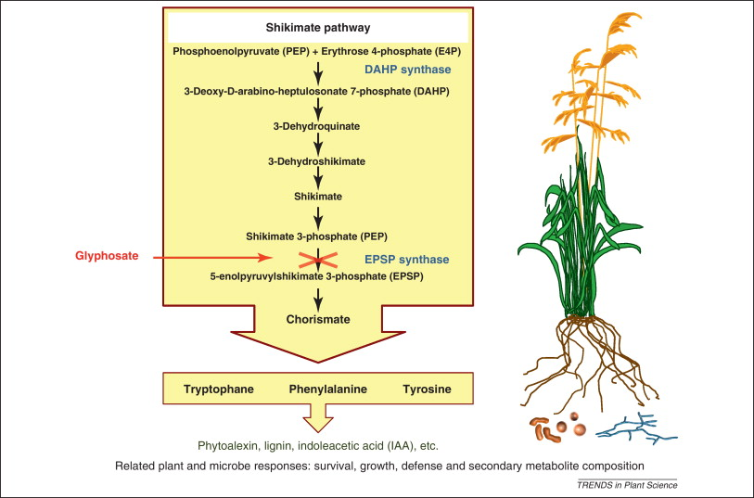
But there is more to this – as if all the foregoing weren’t bad enough! And it concerns how glyphosate damages something called the shikimate pathway.

Shikimate pathway? What’s that I hear you ask!

This is a pathway that is targeted by glyphosate within both plants and bacteria that is part of the way it works. It interrupts this pathway within both plants and bacteria, and stops it from working.

So what, I hear you say. BUT remember, we have 10 times more bacteria in our body than we do human cells. The majority of these bacteria are hugely important to us, helping to carry out numerous beneficial processes, and we are just beginning to really appreciate how truly necessary to health these bacteria are.

So whilst we don’t, as humans, have a shikimate pathway, the fact that our bacteria do and they are badly affected by exposure to glyphosate means that this also affects us, because of what they do for us.

The bacteria use the shikimate pathway to convert fructose into PEP (phosphoenolypyruvate) which is involved with the synthesis of the essential amino acids, phenylalanine, tyrosine, and tryptophan from which we make important neurotransmitters (important for feeling good, amongst other things). If we don’t make these neurotransmitter our brains don’t work as well as they could, and our mood is affected – those affected included serotonin, dopamine, melatonin, epinephrine as well as folate and Vitamin K.

But more than this, because the next step in this pathway is blocked by the action of glyphosate, PEP piles up and this suppresses the ability of microbes to convert fructose, which then ends up in the lower gut, rather than being digested, and gets processed into fat, producing wind and bloating. The fat gets taken to the liver for it to process and gets deposited in the liver causing fatty liver or lots of LDL cholesterol.

Our gut microbiome ultimately determines whether we will be healthy or not, slim or not, have strong immune function or not. As glyphosate wreaks havoc on this microbiome and all the many benefits it brings to us, impacting health in all sorts of ways.

As some researchers say:
“...Our systematic search of the literature has led us to the realization that many of the health problems that appear to be associated with a Western diet could be explained by biological disruptions that have already been attributed to glyphosate.

These include digestive issues, obesity, autism, Alzheimer’s disease, depression, Parkinson’s disease, liver diseases, and cancer, among others. While many other environmental toxins obviously also contribute to these diseases and conditions, we believe that glyphosate may be the most significant environmental toxin, mainly because it is pervasive and it is often handled carelessly due to its perceived nontoxicity.”

And in an article posted in October 2013 one of the same researchers, Stephanie Seneff stated:
“Tryptophan is the sole precursor to serotonin, and serotonin deficiency is implicated in a litany of diseases and conditions that are prevalent today, including autism, obesity, Alzheimer’s disease, depression, suicide, and homicidal behaviour. Serotonin is an appetite suppressant so it’s hard not to overeat when it is in short supply. If you are disciplined to resist these urges, then you run the risk of depression and Alzheimer’s disease, or autism in your children. Serotonin is the precursor to melatonin, the neurotransmitter that regulates the wake-sleep cycle, and melatonin deficiency is also implicated in autism. Tyrosine is the precursor to dopamine, and impaired dopamine supply is the key defect associated with Parkinson’s disease. Glyphosate activates an enzyme called phenylalanine ammonia lyase (PAL), which breaks down phenylalanine and releases ammonia as a by-product. Excess ammonia in the blood stream can trigger a cascade leading to encephalitis and seizures.”

Another issue that has been identified is that glyphosate also inhibits our ability to access certain important minerals as it acts as a chelating agent, binding and removing them from the body, and it also down regulates our ability to use Vitamin D – a vital vitamin that many, many people in the UK are already severely short of. And again, there are serious health implications associated with this.

These changes to the gut microbiome change its balance from being beneficial to you, to becoming more and more hostile – and what is more we know that these colonies of damaged bacteria get passed from generation to generation, so this will potentially be affecting not just you but reverberating down the generations into your children, your grandchildren and beyond.

Particularly important with regard to coeliac disease (allergy to wheat and gluten) is the Bifido strains of bacteria. It has been noticed that even if someone has the genetic markers for coeliac, if they have high levels of Bifido bacteria they are less likely to develop full blown coeliac, as they are integral to helping us digest grain and break down gluten. Once they have been harmed by a poison both wheat and milk become toxic to the human gut. Given that wheat and gluten intolerance is rising fast this should be taken seriously.

Not good is it!

Long story short – you don’t want this nasty chemical anywhere near your food, your house, your garden or your loved ones.

Round up the Roundup and throw it out!

Environ Health Aug 25 2015. Transcriptome Analysis Reflects Rat Liver and Kidney Damage following Chronic Ultra-low dose Roundup Exposure. www.sciencedirect.com/science/journal/aip/02786915 Potential Toxic Effects pf Glyphosate and its Commercial Formulations below Regulatory Limits.
FoE Europe. Determination of Glyphosate Residues in Human Urine Samples from 18 European Countries. 2013.
Samsel & Seneff Entropy 2013, 15(4). 1416-1463
For full article see http://www.westonaprice.org/health-topics/roundup-the-nontoxic-chemical-that-may-be-destroying-our-health/

