NATIONAL LEARNING DISABILITIES IMPROVEMENT STANDARDS SURVEY

Our hospital is taking part in a patient survey for people with learning disabilities.

We want to know what you think about the care you received from your local NHS hospital.

Information about the survey will be sent to you by post.

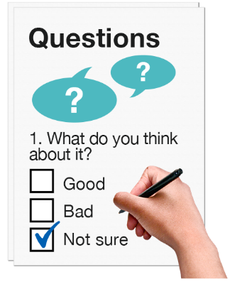

Your answers will help us to work out what was good and what needs to change.

If you want to take part in the survey, please complete the CONSENT form.

CONSENT FORM

Date:…………………………………………………………………

Name:…………………………………………………………………

Address:…………………………………………………………………………………………………………………………………………
…………………………………………………………………………………….……………………………………………………………..

Signature:……………………………………………………………

If you would like take part in the survey, please tick the box.

Please give this form back to a staff member in the hospital.

I understand the information and would like to take part in the survey.

