18 January 2017

Dear Fellow Clerk,

Monday Lunches at Ironmongers’ Hall

It was a pleasure to welcome most of you to Ironmongers’ Hall for Monday’s Clerks’ Briefing and lunch. Our Monday* lunches have been a feature of life in Ironmongers’ Hall for seven years now. As you may know, lunch is available to members of all Livery Companies and their guests. We much look forward to welcoming you, the members of your Company and their guests to our Hall. We are pleased to say that there is also a Carvery option.†

You can enjoy pre-lunch drinks in the drawing room before making your way to your table. Lunch will be served at a time of your choice between 12.00 midday and 2.00 pm. This is an ideal way of starting the week by sharing exceptional food at exceptional value with friends and colleagues.

We do ask you, please, to make a reservation beforehand. To reserve your table simply ring Paulina Sowa or Ed Bolling on 0207 776 2300. You can also make your reservation on line at www.ironhall.org

All our food is British and much of it sourced locally from the Nevill Estate in Surrey. Our menus change twice a month. Please note that a two-course lunch will cost £30.50 and a three-course lunch £34.50.

Our selection of modestly priced wines, beer and soft drinks will also be available.

As I have said, we much look forward to seeing you, your members and their guests here in Ironmongers’ Hall. I would be most grateful if you would kindly circulate this letter to your members.

With all good wishes,

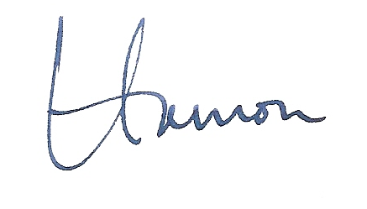

Col HPD Massey
Clerk

*Monday lunches will not be served on Bank holidays or during August
†This option carries a supplement of £3.00

