Company Name:

Contact name:
Company Address:

Website Address:

Email:

Telephone:

Product(s)
Description:

Techniques:
Images (max of 3) to include:
Individual items
Stall as laid out

Links to social media handles:

Please specify your preferred space (Images below):

Adam Hall £260

Galleries £240
Additional Exhibitor Information (if any)

Please send your completed form to thetextilefair@comptonverney.org.uk

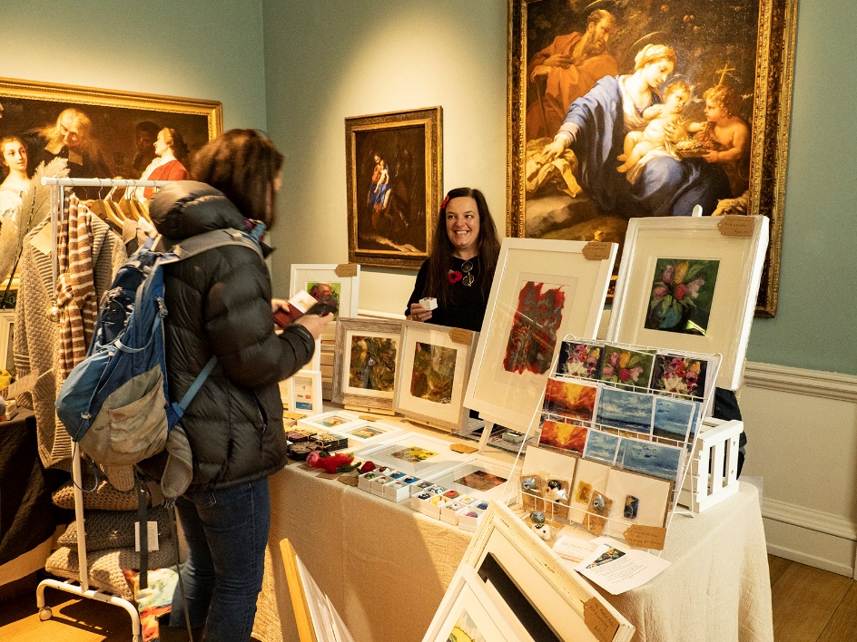
Galleries

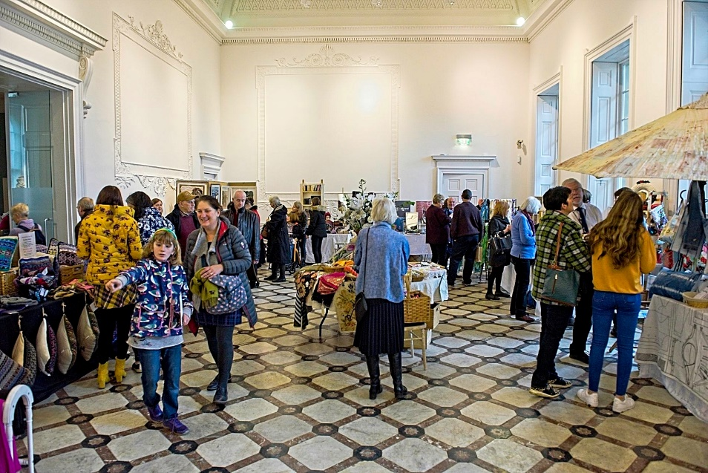
Adam Hall

