Appendix 1

PRECEPT REPORT 2019/20 and Medium Term Financial Strategy (MTFS)

The recommendations in this report are subject to public consultation closing on 28th January 2019.

1. Police and Crime Plan
1.1 The budget enables delivery of the Police and Crime Commissioner’s (the “Commissioner”) Police and Crime Plan (the “Plan”). The Plan determines, directs and communicates the Commissioner’s priorities during their period in office and sets out for the period:
- the Commissioner’s police and crime objectives for the area
- the policing of the area which the Chief Constable is to provide
- the financial and other resources which the Commissioner is to provide to the Chief Constable
- the means by which the Chief Constable will report to the Commissioner on the provision of policing
- the means by which the Chief Constable’s performance in providing policing will be measured
- the services which the Commissioner is to provide or arrange to support crime and disorder reduction or help victims of witness of crime and anti-social behaviour (crime and disorder reduction and victims’ service grants).
- any grants which the Commissioner is to make and the conditions, if any, of those grants.

1.2 The Plan’s strategic aims and objectives are set out in the diagram overleaf.

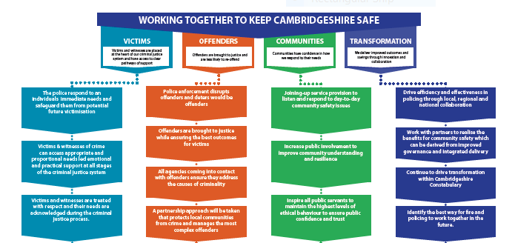

2. Budget and Medium Term Financial Strategy (MTFS) Development
2.1 During the summer and autumn 2018, the Commissioner oversaw work to update the MTFS. The Provisional 2019/20 Police Grant Settlement was announced on 13 December 2018, stating an increased grant of 1.93%. The Provisional Settlement also gave all Police and Crime Commissioners the flexibility to increase the council tax precept by up to £24 for 2019/20.
2.2 The MTFS at Appendix 2 sets out the updated budget for the period 2019/20 to 2022/23, which is based on detailed budget work undertaken by the Constabulary and the Office of the Police and Crime Commissioner (OPCC).
2.3 It also sets out the assumptions and information underpinning the budget and MTFS.
- General inflation for the period to 2022/23 will be at 2% per annum.
- Police officer and staff pay for the period to 2022/23 will increase by 2% per annum.
- The council tax base in 2019/20 is estimated to have increased by 1.5% to 284,128. At this point housing development is anticipated to continue to grow across the county. The MTFS assumes an estimated increase of 1.99% for the next three years to 2022/23, however this is subject to ongoing review.
- Victims’ Services Grant from the Ministry of Justice (MoJ) has been confirmed for 2019/20 as £979k.
- Provisional notification of Cambridgeshire’s allocation of the capital grant has been received and is the same as 2018/19 at £0.5m.

2.4 Table 1 below sets out in broad terms how the budget has been balanced and Table 2 shows a high level analysis of the total budget.

Table 1 – Budget changes 2018/19 to 2019/20

 | £m
Budget 2018/19 | 137.1
Funding Changes
Increase in Formula Grant | 1.5
Pension Grant | 1.4
Increase in Precept receipts | 7.9
Change in Net Budget requirement | 10.8
Net Budget Requirement 2019/20 | 147.9
Budget 2018/19 | 137.1
Net Revenue Expenditure Changes 2019/20:
Increased Pension Costs | 2.2
Recruitment/Increased Officers | 2.5
Inflationary Pressures | 1.2
Growth Pressures e.g. demand | 1.4
Cost Pressures | 7.3
Savings:-
Local Policing Review | -1.8
Supplies and Services | -0.8
Estates Rationalisation | -0.2
Collaboration Savings | -0.7
Total Savings | -3.5
Budget 2019/20 | 147.9

Table 2 – High Level Budget Analysis

 | £m
Policing Budget – delegated to the Chief Constable | 143.2
Office of the Police and Crime Commissioner (OPCC) | 1.2
Victim, restorative justice, and crime and disorder grants | 2.2
Capital Financing | 1.3
Net Budget Requirement | 147.9

3. Precept 2019/20
3.1 Since taking office in May 2016, the Commissioner has been ensuring that, in the face of complex economic and social pressures, the OPCC and the Constabulary think and act differently and transform the way they work through collaboration and new technology: the police never work in isolation.
3.2 The Commissioner’s guiding principle in setting the precept is to ensure services continue to be protected and to achieve value for money in policing.
3.3 The Provisional Police Grant Settlement announced a below level of inflation increase of government grant but also enabled additional funds to be raised locally by precept increases up to a maximum of £2 per month.
3.4 The Commissioner is committed to protecting, and strengthening, frontline resources as a consistent message that he receives from the public, is that they want to see more officers in local policing within Cambridgeshire.
3.5 Financial modelling indicates that due to existing cost pressures that are outside of the Commissioner or the Chief Constable’s control, a 2% rise in the local precept would lead to a reduction of around 80 frontline officers.
3.6 A £2 rise per month would generate around £7.6m of additional funding. This would enable the existing cost pressures to be met and for up to 50 officers to be recruited and deployed into local policing in Cambridgeshire. This will increase the ability of the Constabulary to protect the public and tackle crime.
3.7 A £10 per month rise would bring overall funding more in line with the national average and enable the recruitment of more than 350 frontline officers. This would substantially increase the capacity of the Constabulary and its ability to tackle crime and keep people safe.
3.8 For the above reasons, and also due to initiatives currently in place to deliver future efficiencies, the Commissioner is recommending to the Police and Crime Panel (the “Panel”) an increase of £23.94 in council tax for 2019/20. This would see the policing element of a Band D council tax property increasing from £198.72 to £222.66 per annum, an increase of £2 per month.
3.9 The Police Reform and Social Responsibility Act 2011 enables the Commissioner to obtain the views of the public before issuing a precept. As well as the Commissioner’s extensive public engagement via meetings, surgeries and his newsletter, a survey was made available from 8th January 2019 to 28th January 2019 with a link to the survey being available on the Commissioner’s website as well as being sent to eCops subscribers, which is approx. 15,000 email addresses. News of the Commissioner’s proposal was also covered by the media across Cambridgeshire and on social media. As at 18th January 2019, 1,928 survey responses were received with 85% of respondents in agreement with a proposed precept increase of £2 or more. A verbal update will be provided to the Panel with the final results.
3.10 Details of the precepts due from each collection authority net of any loss or surplus on the collection funds are set out at Appendix 1 (Annex A).

4. Workforce
4.1 Despite ongoing budget pressures, the total number of police officer posts in the Constabulary establishment is budgeted to increase by 75 local officers to 1,496 officers in 2019/20. The increase in precept will fund 50 of these. The remaining 25 were identified in the Constabulary’s Local Policing Review (LPR) in 2018 which enabled an additional 50 officers, with the first 25 recruited in 2018/19 and the remaining 25 in 2019/20.These have been included in the establishment figures below.
4.2 PCSO establishment numbers are budgeted at 80.
4.3 Police Staff budgeted numbers are estimated to remain at 873.
4.4 The target for Special Constabulary numbers continues to be 300.
4.5 The Constabulary is already collaborating in several areas. This has enabled each Force/Constabulary to have access to a greater number of resources.

Table 3 – Draft Workforce projections (establishment)
 | 2018/19 | 2019/20
Police Officers:
Local Policing | 1,175 | 1,250
Collaborated Officers | 251 | 246
Total Officers | 1,425 | 1,496
Police Staff:
Police Staff | 873 | 873
PCSOs | 126 | 80
Total | 999 | 953

5. Capital Financing
5.1 The replacement for Parkside Custody is now underway, with searches for suitable sites progressing. Detailed project plans are in the process of being drawn up.
5.2 Other than the Parkside replacement project, other Capital Programme expenditure for 2019/20 will be financed without the need for external borrowing. Financing of the programme will be through a number of different sources which include Capital Grant from Government, Capital Receipts and the use of Capital Reserves and the Budget Assistance Reserve.
  - From 2020/21, the primary source of capital financing will be borrowing as Capital Receipts Reserve will have been fully utilised by this point and it is anticipated that the current low level of Capital Grants received from central government will continue. This will have ongoing revenue consequences due to the need to budget for interest and minimum revenue provision payments.
5.4 The Capital Programme’s 2019/20 to 2022/23 revenue effects are included in the MTFS.

6. The Medium Term Outlook
6.1 As set out in the current MTFP the projected budget gap for 2019/20 to 2022/23 is a further £4.9m which will need to be met by the saving and efficiency plans that are already in place.
6.2 The Commissioner is awaiting the outcome of his proposal to take on the responsibility of governance of Cambridgeshire Fire and Rescue Service. Work is ongoing to determine the best use of the emergency service land and buildings in Huntingdon.

6.3 Eastern Region collaboration (being Bedfordshire, Cambridgeshire, Hertfordshire, Norfolk, Suffolk, Essex and Kent) is in its relatively early stages and already significant opportunities have been identified in areas such as regionalising procurement.
6.4 Transformation is crucial to enable Cambridgeshire Constabulary and partners to deliver the objectives in the Police and Crime Plan. A continual process is in place to look forward to find different ways of working which are more effective and efficient and in this way balance the budget and protect frontline policing.
6.5 This is coupled with a need to have a comprehensive understanding of demand and ways of working with partners to reduce these demands. There has been a shift in the type of demand from dealing with:
  - current crime to dealing with current and historic crime
  - public crime to dealing with public and private/hidden crime (a much greater focus on domestic abuse, child sexual exploitation, modern slavery).
  - physical crime to physical and online crime
  - simple to simple and complex (the huge increase in data associated with investigations and the disclosure burden)
  - crime to crime and social care (tackling vulnerability compounded by demand being shunted to policing by other agencies)

6.6 Over the period of the plan we will be seeking to realise additional benefits of collaboration, investment in technology, e.g. the new ABLE system which will links finance and HR system, national digital programmes and workforce productivity.

7. Robustness of estimates
7.1 Under Section 25 of the Local Government Act 2003, the Commissioner’s Chief Finance Officer (CFO) is required to report on the robustness of the estimates made for the purposes of the budget calculations.

7.2 Work on the 2019/20 budget gap started early in 2018/19, as the Constabulary identified savings during the financial year which contribute towards balancing the budgets for the next financial year. This is the established practice, which ensures that the savings and efficiencies are achievable and the Constabulary continually strives to ensure effective and efficient policing.

7.3 A sound financial strategy is the key enabler to the achievement of the pledges in the Plan, the objectives of the operational policing strategy and the protection of front-line policing. One of the best ways to keep people safe and maintain police resources and people’s confidence in the police is to place an emphasis on long-term financial and strategic management as a whole. The Commissioner and Constabulary never look at expenditure numbers in isolation.

7.4 Analysing and setting the Commissioner’s and Constabulary’s budgets is an iterative and ongoing process. Initial drafts of the following year’s budget are prepared throughout the current year. The budget setting process continues in earnest in September. The known factors including contractual commitments, cost pressures and savings identified during the current financial year, alongside assumptions relating to central government funding. These factors set the financial landscape for the coming year. The Constabulary’s Budget Managers are tasked with reviewing their budgets and recommending savings. This work is undertaken in close co-operation with the Constabulary’s Finance Team.

7.5 The Commissioner’s CFO and the Constabulary’s Director of Finance and Resources meet regularly from July to consider the draft budget and MTFP, challenging assumptions and analysing savings in order to provide a realistic and sustainable financial plan that enables the Constabulary to bring the operational policing strategy to fruition.
8. Recommendation
8.1 Taking into account all the information contained in the report the Commissioner is recommending that the Police and Crime Panel endorse his recommendation to increase the policing element of council tax by £23.94; this will increase the policing element of Band D council tax from £198.72p in 2018/19 to £222.66 per annum, an increase of £2 per month. It should be noted that this recommendation is subject to the final results of public consultation.

Appendix A

Estimated Share of Precept to be paid by each District/City Council in 2019/20

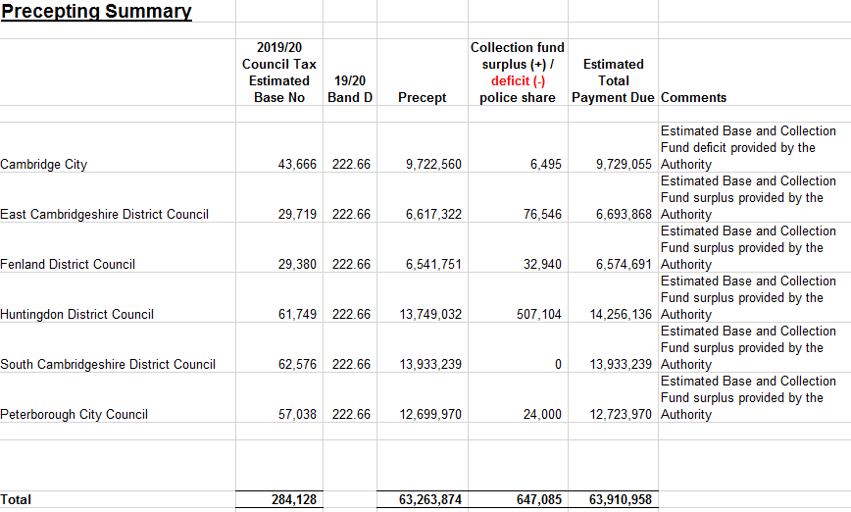

The budgeted 2019/20 Precept in MTFP is based on a Council Tax base increase of 1.5%.
The estimated Collection Fund figure is awaited from South Cambridgeshire District Council.

