This step-by-step guide will help you to book an access seat and explain how to receive a free companion ticket.
If you are not yet signed up for HYNT, please click here to find out more about the scheme which supports customers who need a companion to access our theatre and cultural events.

- Login to your account via the website’s home page by clicking the “person” icon.
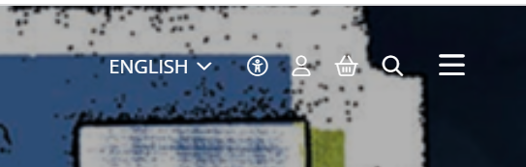
- Enter your email address or password. If you are a new customer, click the link “Register now” or if you have forgotten your password, click the link “Reset here” and email will be sent to the registered address and a link to reset it. (The email may land in your SPAM so please check here if it doesn’t arrive in your inbox.)
- Once you have logged into your account, you will land on the “DETAILS” page. Complete the fields in each link if this is a new customer account. Similarly, you can update / amend fields, e.g. contact numbers, address, surname, etc.
- If you are a HYNT card holder, there is a field at the bottom of the “DETAILS” page. Please insert the number here and “SAVE”.

- Next, go to the link “OTHER PREFERENCES”

- This link will allow you to identify your account as a HYNT Card user and to specify your access requirements. To access “wheelchair spaces” and a free companion seat, the box “I am a HYNT Card user” must be ticked. Be sure to save any updates.
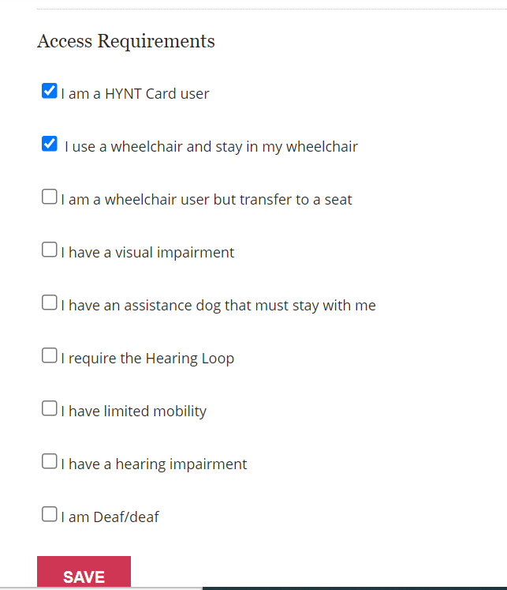

- Once these preferences have been updated, you can return to the What’s On page and book events and seats. The link is in the right-hand corner – the “three lines” icon. You can then select the relevant venue from the list.
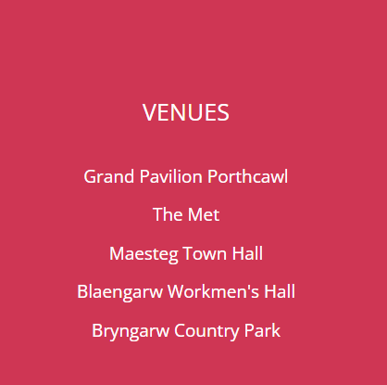
- As you are logged into your account and it’s marked as a HYNT card user, you will have access to all seats; however, areas which are suitable for wheelchair users are marked with an icon and have additional information pop up. After selecting your seats, click “CONTINUE”.
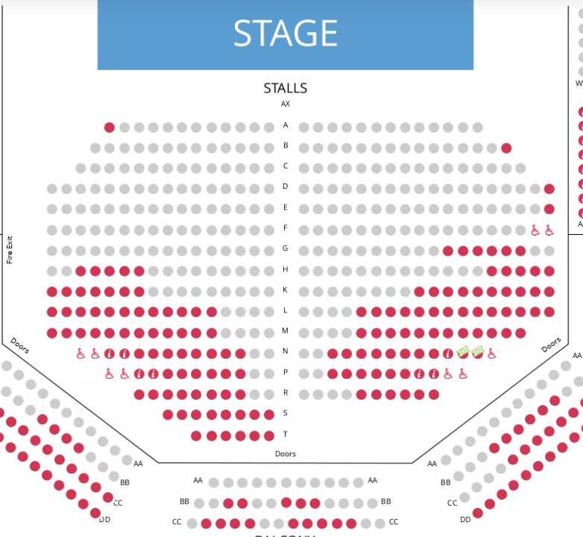

- On this page, ticket types are chosen. If you need a free companion ticket to support a HYNT card holder, select “HYNT Essential Companion”. The cost of this ticket will be discounted from your basket at checkout.
- The summary will list the total tickets and total price and identify that the Essential Companion Seat has been applied. Continue to the “Payment Page” where card details are entered.
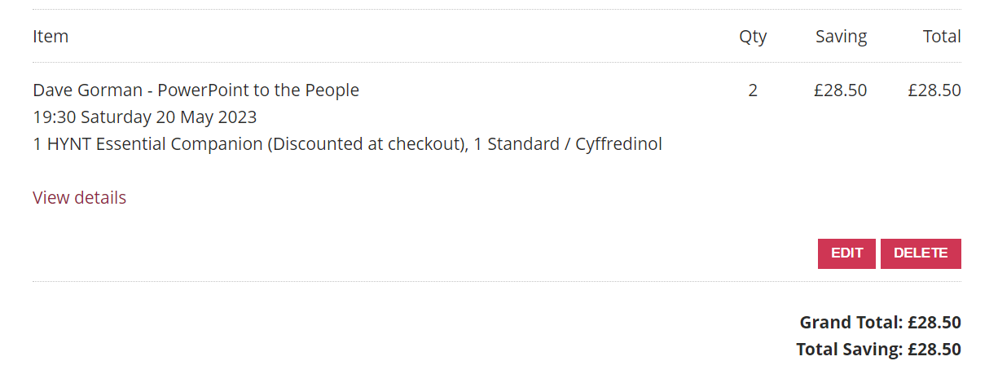
- If you forgot to login to your account whilst looking through the What’s On, there is a prompt when you hit “Buy Tickets”.
Please note: if your HYNT card allows two companions, please contact our box office. The website is not enabled to allow more than one companion seat.

