Executive Assistant (Production) Job Pack
Salary: £28,000 to £31,000 gross per year (dependent on experience)
Contract Type: Fixed-term for one year (with the possibility of extension)
Full-time, five days per week
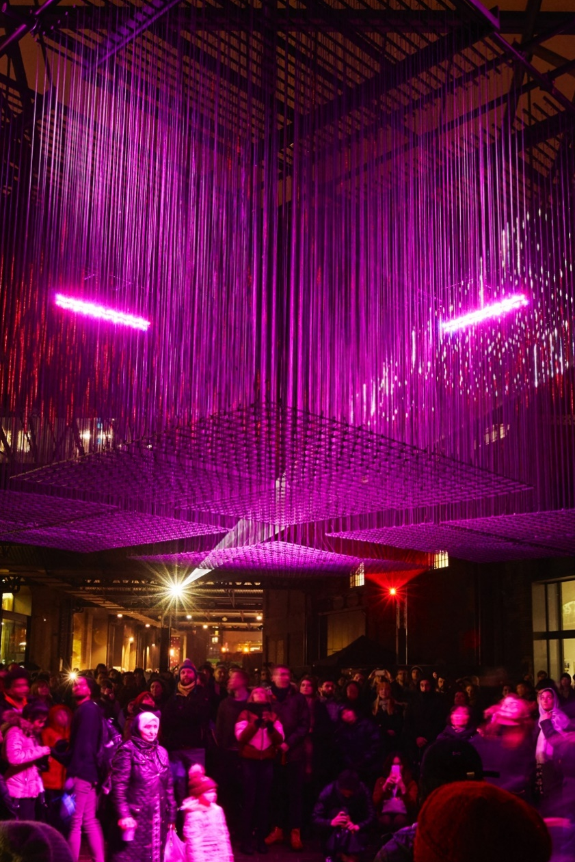

‘Aether’ by Architecture Social Club with Max Cooper, West Handyside Canopy, King’s Cross.
Lumiere London 2018, 18 - 21 commissioned by the Mayor of London. Photo by Matthew Andrews.

Summary of Terms and Conditions
Job title: Executive Assistant (Production)
Reports to: Assistant Producer
Key relationships: Artistic Director; Director of Projects; Head of Learning & Participation; Producers; Director of Operations; freelance technical staff; artists and project partners.
Contract: Fixed-term for one year (with the possibility of extension)
Probationary period: Three months
Notice period: Three months (two weeks during the probationary period)
Salary: £28,000 to £31,000 gross per year (dependent on experience)
Hours of work: 35 hours per week, Monday to Friday, with some variation according to the nature of the workload. Our standard working hours are 10am-6pm, with an unpaid lunch hour, although staff can choose any regular start time between 9am and 10am. Additional hours may occasionally be required as necessary for the successful performance of the job.
Annual leave: 25 days per year plus bank holidays
Location: London, E1. Office-based Monday to Thursday with an optional work-from-home day on Friday. Some travel around the UK required on occasion.
Physical requirements: Primarily office-based, with moderate walking expected during live project periods.

Company Background
Artichoke was founded in 2005 to bring The Sultan’s Elephant by Royale de Luxe to central London. For the first time, streets normally reserved for state occasions or sporting events were taken over by art. The Elephant changed the landscape for outdoor art forever and catapulted Artichoke into the public eye.
The company has continued to work with artists ever since, with the aim of producing unique, large-scale experiences that appeal to the widest possible audience. We don’t believe the arts should only take place behind the closed doors of theatres, concert halls or galleries. Instead, you will find our events in the street, public squares, along the coast or in the countryside.
To learn more about our past projects, visit our projects page.

Overview of the Role
Artichoke is seeking an Executive Assistant to join our Production team. This is a dual role providing executive assistance and coordination for the Artistic Director (60%) as well as the wider Production team (40%). It is a detail-focussed position requiring excellent organisation, clear communication and the ability to manage a varied and busy list of tasks.
The postholder will manage the Artistic Director’s diary, meetings, travel, and occasional correspondence. They will also provide general administrative support to the wider Production team through coordinating team meetings, taking notes and actions during meetings, and organising artist travel and accommodation.

How to Apply
- Read the information in the Job Description & Person Specification on the following pages.
- Fill out our application form. Ensure you give specific examples to support your claims in the personal statement.
Application deadline: 10am, Monday 2 March 2026
Interview dates: First-round interviews to take place in person Wednesday 11 and Thursday 12 March. Second-round interviews to take place in person w/c Monday 16 March. Both rounds of interviews will be held at Artichoke’s office in London (E1 6AB). Interview questions will be shared with candidates in advance.
Start date: Immediate start, depending on the notice period
Artichoke is an Equal Opportunities and Disability Confident Committed employer. We are committed to equality and diversity within our workforce and encourage applications from People of Colour, d/Deaf and disabled people, and those from underrepresented backgrounds. Positive action may be used in the recruitment process to select a candidate from a group that is disadvantaged or underrepresented in our workforce if the candidates in question are of equal merit.
If you require this job pack in an alternative format, please email us at recruitment@artichoke.uk.com or call on 020 7650 7611.

Job Description
The following sets out responsibilities you will hold in this position but is not a comprehensive or exhaustive list. Our projects are varied and require different ways of working, and responsibilities will adapt based on the needs of the organisation.

Artistic Director Administration
- Manage and coordinate the Artistic Director’s diary, including booking meetings, travel and accommodation.
- Manage requests for Artistic Director’s attendance at external events and meetings.
- Manage and prepare meeting documents, agendas and information in advance of scheduled meetings.
- Manage information flow in a timely and accurate manner.
- Liaise with other staff members and Trustees on behalf of the Artistic Director.
- Prepare presentations for the Artistic Director.
- Draft papers and reports on behalf of the Artistic Director.
- Draw up itineraries and schedules for business trips and site visits.
- Be available at key points to the Artistic Director to ensure travel arrangements run smoothly.
- Send correspondence on behalf of the Artistic Director when required.
- Undertake research and tasks to support the Artistic Director as required.
- Ensure all details of Artistic Director’s contacts are logged on our internal CRM database.
- Maintain and manage filing systems.
- Maintain accurate records for reporting and future planning.

Production Team Support
- Support and assist with tasks as required by line manager or Director of Projects.
- Co-ordinate and attend internal production meetings, assembling and producing agendas and notes to circulate to attendees.
- Follow up agreed meeting actions with the wider team to ensure adherence to agreed timescales.
- Assist the wider team with managing project timelines.
- Ensure all contact details for suppliers, artists and contractors are logged on our internal CRM database.
- Maintain and manage department filing systems.
- Undertake research, tasks and administrative duties to support the Producers and Production Department as required.
- Organise artists’ travel and accommodation for site visits and project delivery.
- Arrange artist travel schedules and produce artists’ information packs with key information on event delivery locations.
- Assist the producers with artist liaison during project delivery.

Financial Support
- Manage delegated areas of budget, if directed.
- Manage the reconciliation of financial paperwork on behalf of the Artistic Director, and collate expenses each month to pass on to the Finance department for payment.
- Collate financial information for the Production department and pass on to the Finance department for payment.

Research and Reporting
- Collate information relating to production-related activity to contribute to reports for funders and sponsors.
- Manage and collate information and data relating to sustainability monitoring.
- Undertake research to assist with the development of future projects as requested.

General requirements of all Artichoke Employees
- Contribute to the development of a professional working and learning environment within the organisation.
- Contribute to the organisation’s understanding of diversity and its implications for the arts and to ensure that this understanding informs all the organisation’s activities.
- Ensure adherence to the organisation’s policies and procedures with particular reference to Equal Opportunities and Health and Safety.
- Work in a flexible manner in line with the organisation’s corporate objectives and role and to be willing to undertake other duties as reasonably requested.
- Provide excellent customer care in dealings with the public.

This job description is not exhaustive, and the postholder may be required to undertake other such duties from time to time.

Person Specification
Essential | Desirable
Personal Approach
Dynamic and proactive approach to problem solving
Ability to work on own initiative
Ability to relate to a wide range of people
Enthusiasm for working as a part of a team
A keen eye for detail
Ability to manage multiple work streams and prioritise accordingly with minimum supervision
Arts Industry Knowledge
2 years’ experience of working in a similar role within an arts or creative organisation | Knowledge of work in the public realm with particular reference to temporary installation
An understanding of the relationship between technical teams and artists | Experience of working directly with production managers and technical teams
Have a broad understanding of arts participation and work with communities | Knowledge of the UK arts funding environment
Administration Skills
A minimum of 1 year’s experience managing diary and undertaking tasks for a CEO or senior staff member | Working knowledge of Spektrix or other Customer Relationship Management database
Excellent computer and database skills, especially Microsoft Office | Skills in rendering and preparing visual maps and plans through AutoCAD or other software
Efficient and concise note taker
Communication Skills
Excellent written and verbal communication skills | Proficiency in another language

Additional benefits
Pension: Artichoke is enrolled in a pension scheme with Standard Life. After working for Artichoke for 3 months, payments of 3% can be made into your pension if you contribute 5% of your qualifying earnings.
Group Income Protection (GIP) Insurance: Artichoke’s GIP policy will pay employees a percentage of their salary if they can't work due to long-term injury or illness.
Employee Assistance Programme (EAP): A confidential, employer-paid benefit offering support and advice on personal and work-related issues, including stress, financial worries, legal concerns, and family matters.
Cycle to work scheme: Artichoke purchases the bike on behalf of the employee at a reduced retail price and saves the employee tax and NI. The cost of the bike is deducted from the employee’s gross monthly salary.
Season ticket loan: Artichoke offers an interest-free loan to staff who require a season travel ticket.
Eye tests and glasses: Artichoke offers to pay for an eye test every year for staff members, up to £30, and for prescription glasses up to the value of £150.
All benefits are subject to satisfactory completion of a probationary period.

If you have any questions about the role or the application process, please email us at recruitment@artichoke.uk.com or call on 020 7650 7611.

