Bike Marking Initiative

To help protect your bicycle, Police Scotland are working with BikeRegister.com providing bike marking opportunities to those working at the RIE.
Bike marking involves pasting a discrete, permanent, unique serial number on a pedal cycle’s frame which is registered to the Bike Register database together with the owner’s details. The print is normally marked on a bikes down tube and is slightly raised, making it difficult to remove by cleaning or painting over.
A visible Bike Register sticker is placed on the top tube of the cycle to act as a deterrent to thieves and as an indicator to officers that the bike is registered and owner’s details are easily obtainable.

We are also encouraging all owners to make sure their bike is secured using a good quality lock whenever unattended.

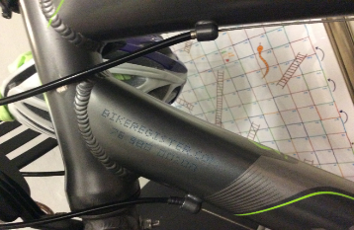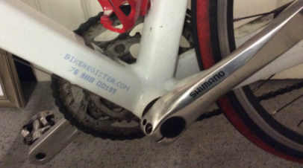

If you wish your bike to be marked please complete the attached form and thereafter email it to the mailbox of : john.ramsay1@nhs.net with the subject as RIE Bike marking.

Officers will be at the RIE Bike Shelter to the rear of the Maternity Unit between
0900 – 1200 on Tuesday 02nd June

May we ask that you provide a time which suits best to john.ramsay1@nhs.net and officers will provide a ten minute slot abiding by social distancing regulations. We will email back confirming the details. Please ensure you attach a completed form with your details.

