LYDIARD MILLICENT
NEIGHBOURHOOD PLAN
2018 – 2036

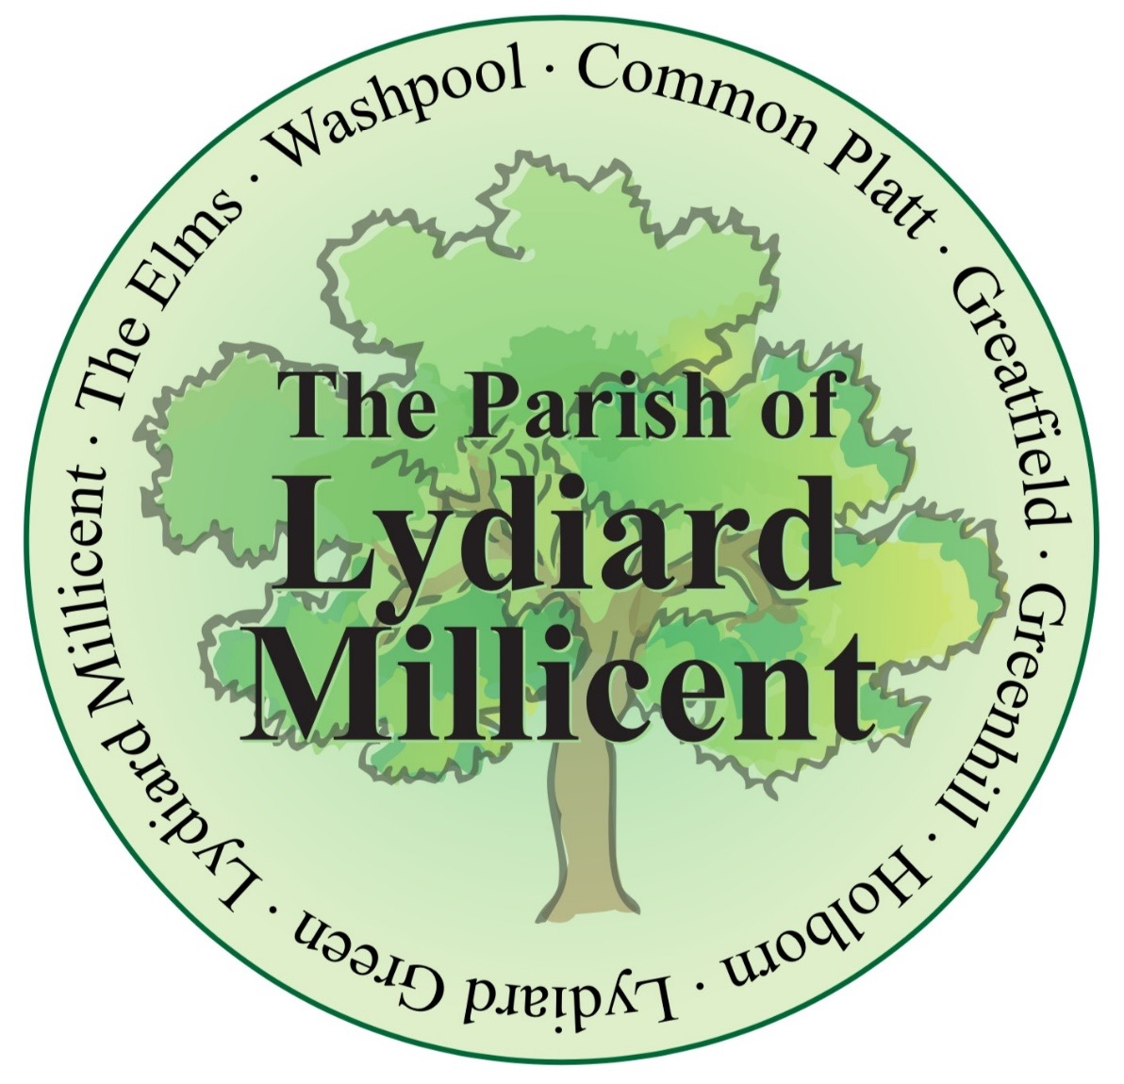

PRE-SUBMISSION PLAN

December 2018

Published by Lydiard Millicent Parish Council for Pre-Submission consultation under the Neighbourhood Planning (General) Regulations 2012 in accordance with EU Directive 2001/42

Guide to Reading this Plan

Of necessity, this Neighbourhood Plan is a detailed technical document. The purpose of this page is to explain the structure and help you find your way around the plan.

1. Introduction & Background
This section explains the background to this Neighbourhood Plan and how you can take part in and respond to the consultation.

2. The Neighbourhood Area
This section details many of the features of the designated area.

3. Planning Policy Context
This rather technical section relates this Plan to the National Planning Policy Framework and the planning policies of Wiltshire Council.

4. Community Views on Planning Issues
This section explains the community involvement that has taken place.

5. Vision, Objectives & Land Use Policies
This is the key section. Firstly, it provides a statement on the Neighbourhood Plan Vision and Objectives. It then details Policies which are proposed to address the issues outlined in the Foreword and in Section 4. These Policies are listed opposite. There are Policy Maps at the back of the plan and additional information in the evidence base to which the policies cross reference.

6. Implementation
This section explains how the Plan will be implemented and future development guided and managed. It suggests how projects might be supported by the Community Infrastructure Levy which the Parish Council will have some influence over.

LYDIARD MILLICENT NEIGHBOURHOOD PLAN 2018 – 2036

PRE-SUBMISSION PLAN

DECEMBER 2018

Contents

Foreword

List of Policies

- Introduction & Background 6

- The Neighbourhood Area 8

- Planning Policy Context 14

- Community Views 17

- Vision, Objectives & Land Use Policies 18

- Implementation 27

Policies Map and Inset

FOREWORD

Neighbourhood Plans aim to give communities the opportunity to shape their environment and have more influence over planning decisions taken which affect them.

They are developed from within the community, but provided they achieve necessary legislative milestones, they become “made” (completed) and are used by the Local Planning Authority in determining planning applications and making policy. Neighbourhood Plans must be prepared in accordance with the Local Planning Authority’s Core Strategy, in this case the Wiltshire Core Strategy, adopted in January 2015 and the reasoning and evidence base of the emerging Local Plan until 2036.

From the work done for the North East Wiltshire-Villages (NEW-V) Plan started in 2012 right the way through until now a lot of people have contributed. I would like to thank all the people that have taken part in the preparation of this plan, whether it has been in gathering data to be used in the plan, writing the plan, replying to questionnaires and turning up for the consultations that have been held. We are now not far away from submitting our plan for scrutiny and hope soon to have a positive result to enable us to bring it to referendum.

Cllr Mike Sharp
Chair, Lydiard Millicent Neighbourhood Plan Steering Group
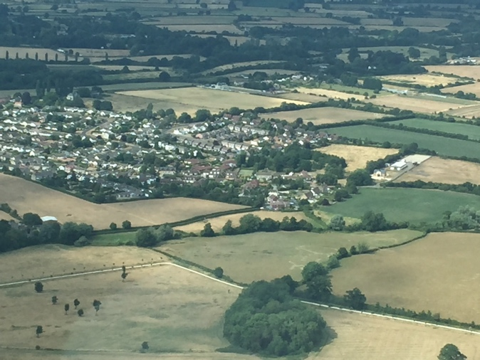

Village of Lydiard Millicent 2018 © M J Sharp
List of Policies

No. | Policy Title | Page
LM1 | Managing Design in Lydiard Millicent | 20
LM2 | Managing Design in Lydiard Green | 20
LM3 | Local Gaps | 21
LM4 | Local Views | 22
LM5 | Local Green Spaces | 23
LM6 | Local Shops and Businesses | 24
LM7 | Community Facilities | 25
LM8 | Movement routes | 25
LM9 | Developer Contributions | 26

1. Introduction & Background

1.1 Lydiard Millicent Parish Council is preparing a Neighbourhood Plan for the area designated by the local planning authority, Wiltshire Council, on 20 September 2017. The plan is being prepared in accordance with the Neighbourhood Planning (General) Regulations of 2012 (as amended).

1.2 The area coincides with the Parish boundary (see Plan A below) situated in the north eastern corner of Wiltshire. It is in the southern part of the Royal Wootton Bassett and Cricklade Community Area and lies directly to the west of Swindon with the parish of Lydiard Tregoze to the south and Purton parish to the north.

1.3 The purpose of the Neighbourhood Plan is to set out a series of planning policies that will be used to determine planning applications in the area in the period to 2036. The Plan will form part of the development plan for the Parish, alongside the forthcoming Wiltshire Local Plan and the Swindon and Wiltshire Joint Spatial Framework, which will cover the same period.
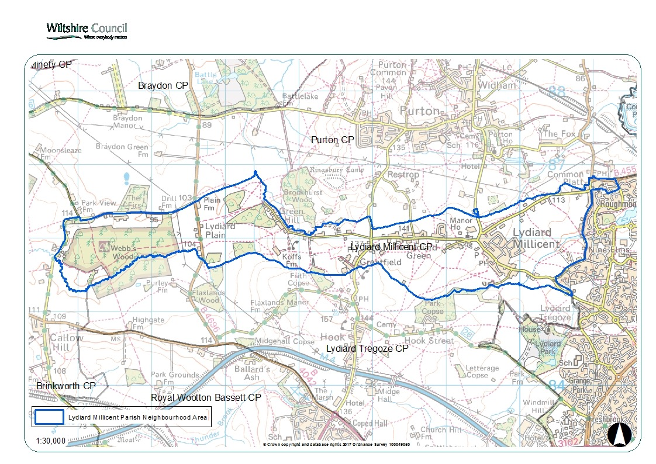
Plan A: Designated Neighbourhood Area

1.4 Neighbourhood Plans provide local communities, like Lydiard Millicent, with the chance to manage the quality of development of their areas. Although there is considerable scope for the local community to decide on its planning policies, Neighbourhood Plans must meet some ‘basic conditions’. In essence, the conditions are:

- Is the Plan consistent with the national planning policy?
- Is the Plan consistent with local planning policy?
- Does the plan promote the principles of sustainable development?
- Has the process of making the plan met the requirements of European law?

1.5 In addition, the Parish Council will need to demonstrate to an independent examiner that it has successfully engaged with the local community in preparing the Plan. If the examiner is satisfied that it has, and considers the Plan meets the above conditions, then the Plan will go to a referendum of the local electorate. If a simple majority of the turnout votes in favour of the Plan, then it becomes adopted as formal planning policy for the Parish.

The Pre-Submission Plan

1.6 The Pre-Submission Plan is the opportunity for the Parish Council to formally consult on the proposed vision, objectives and policies of the Plan. It has reviewed the relevant national and local planning policies and assessed how they affect this area. It has also gathered its own evidence examining the future of the Parish and these reports are published separately in the evidence base.

1.7 Wiltshire Council has indicated that the provisions of the Plan are not likely to have any significant environmental effects and therefore a Strategic Environmental Assessment is not required. Its formal screening opinion on this matter has been included in the evidence base. The Parish Council will set out how the Plan will contribute to achieving sustainable development in Lydiard Millicent in its final submission documents.

The Next Steps

1.8 Once the consultation exercise is complete, the Parish Council will review the comments made and prepare a final version of the Plan. This will be submitted to Wiltshire Council to arrange for a further consultation and its independent examination and then the referendum.

Consultation

1.9 If you have comments to make on this plan, please do so by 1st February 2019 at the latest in the following ways:
Email to: neighbourhoodplan@lydiardmillicent-pc.gov.uk

Post to:

Lydiard Millicent Parish Council
22 Tennyson Road
Royal Wootton Bassett
Wiltshire, SN4 8HL

The Lydiard Millicent Neighbourhood Plan website contains all the necessary background information on the Plan. Its web address is:

https://lmpneighbourhoodplan.wordpress.com/

2. The Neighbourhood Area

2.1 Lydiard Millicent is a small village with associated hamlets of Greenhill, Greatfield, Lydiard Green, Common Platt, Washpool, The Elms and Holborn, each with its own individual features and atmosphere, located in the former district of North Wiltshire, which is now part of the unitary authority of Wiltshire Council. The village has a population of approximately 1570 persons (source: 2011 Census). Based on the 2008 Strategic Housing Market Assessment (SHMA) for the Housing Market Area (HMA), the average occupancy rate for Cricklade (the nearest published village) is 2.49 persons per dwelling. This equates to their presently being approximately 630 homes in Parish.

2.2 The village’s close relationship with Swindon makes it atypical of many small villages, which are usually more remotely located. Lydiard Millicent lies on a steep scarp slope to the west of Swindon overlooking the Thames lowlands. It lies within an area described as rolling hills with the influence of Swindon being significant (North Wiltshire Landscape Character Assessment, June 2004). The ease of reach of Swindon (itself a regional centre) changes the general sustainability criteria of the village.

2.3 Swindon Town Centre is 4 miles away by road to the east. The nearest employment park is around 2 miles away in the west of Swindon at Windmill Hill. A large leisure centre and supermarket complex are less than 2 miles to the east of the site in West Swindon. This means the villages residents have access to the full panoply of day-to-day services and employment enjoyed by many Swindon residents. Swindon station offers a fast train service to London, Reading, Bristol and Birmingham which is presently being electrified.

2.4 The nearby M4 unlocks access to the Thames Valley, Aztec West, Bath and the retail and employment opportunities in the wider region.

2.5 There are 18 listed buildings in the Parish, all of which are Grade II with the exception of the Church of All Saints which is Grade II* (pictured overleaf).The Rabbit Warren, 800m east of Woodlane Farm, is a Scheduled Ancient Monument within Webb's Wood, a small but well-preserved example which provides an important insight into the economy of Bradon Forest.

2.6 There are buildings in the village that are not formally listed, including the Sun Inn, The Street (pictured overleaf), that has developed an importance as the social centre to the village and is of historic interest. The Neighbourhood Plan Steering Group are pursuing the designation of such buildings as non-designated heritage assets through a separate process with Wiltshire Council.

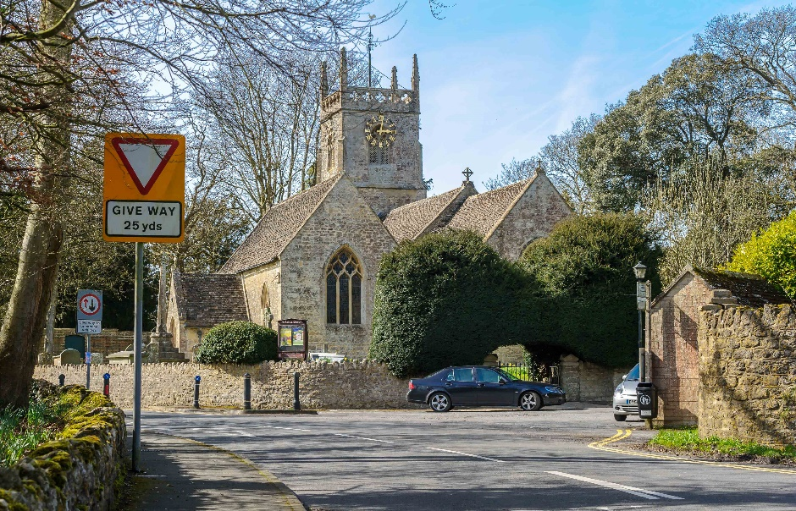
The Church of All Saints © Andrew Collett
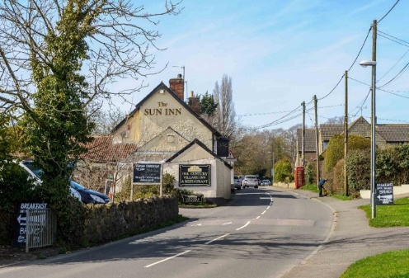
The Sun Inn © Andrew Collett

2.7 Lydiard Millicent is defined in the settlement hierarchy as a “small” village meaning it has a limited range of day-to-day services. The facilities include a pub, school, church, a good bus service, car garage, limited local employment and good sports facilities. The area is not within a landscape designation such as Green Belt or an Area of Outstanding Natural Beauty (AONB) and the Parish is located in the Wootton Bassett and Cricklade Community Area (see Plan B overleaf).

Plan B: Wootton Bassett and Cricklade Community Area

2.7 There are two Conservation Areas in the parish, one of which, centred around the Parish Church, protects the views from and to All Saints Church and the Parish Hall and was designated 18 January 1994. The other is in the adjoining hamlet of Lydiard Green designated 14 September 1993.

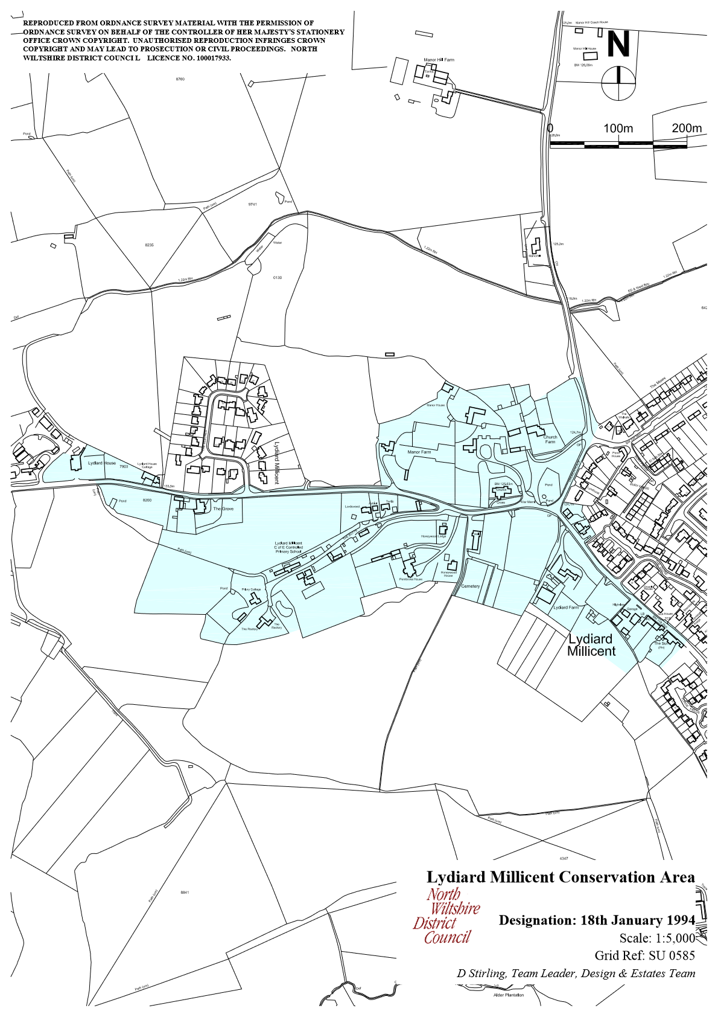
Plan C: Lydiard Millicent Conservation Area
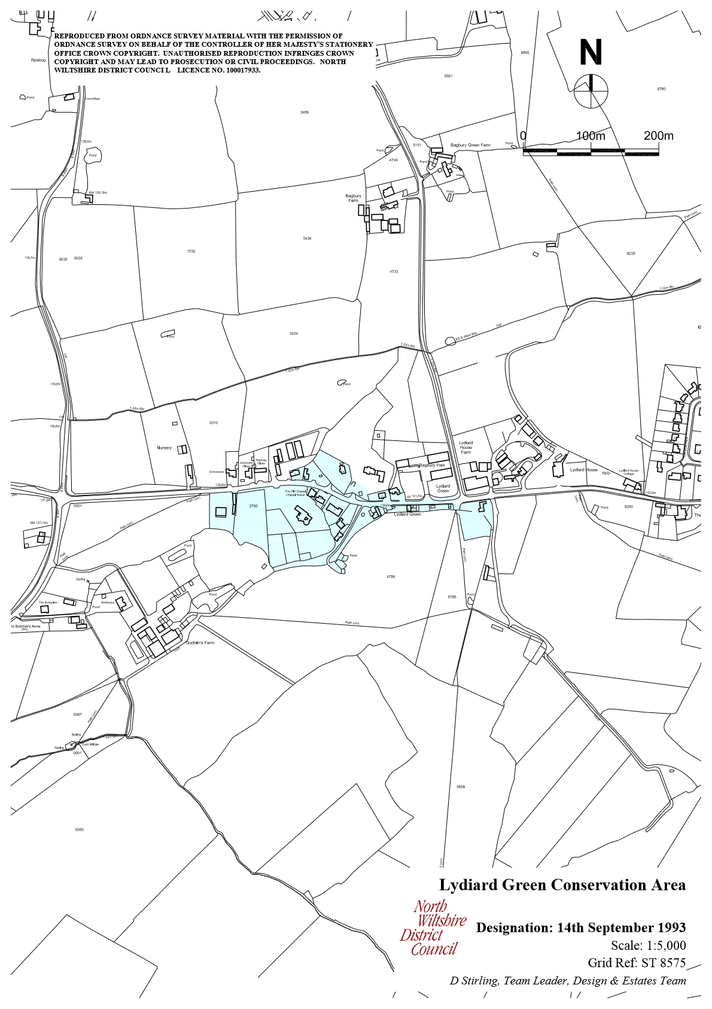
Plan D: Lydiard Green Conservation Area

2.8 There are a number of Historic Parks and Gardens in the area, the nearest being Lydiard Park, and although outside of the parish boundary, it acts as a significant visitor attraction along with the surrounding landscape.
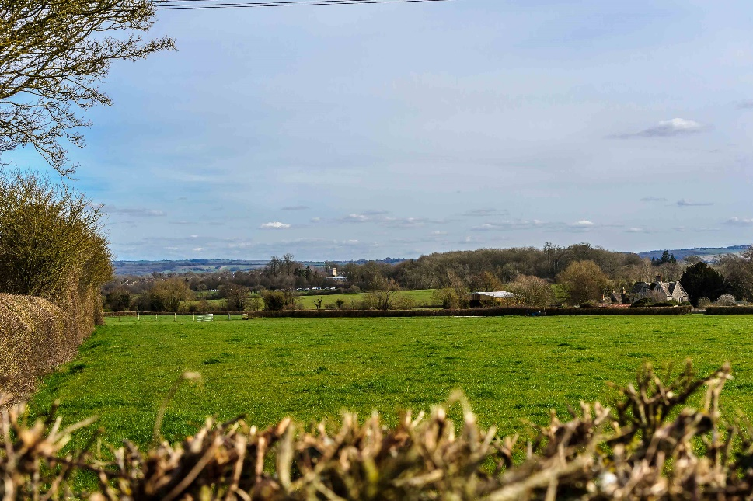
© Andrew Collett

2.9 A tributary of the River Ray, the brook running from Lydiard Park to Holborn and Washpool, to the east of the village, in the gap between the village and Swindon is prone to flooding and the areas around the tributary lies within flood zone 3 (see plan E overleaf).
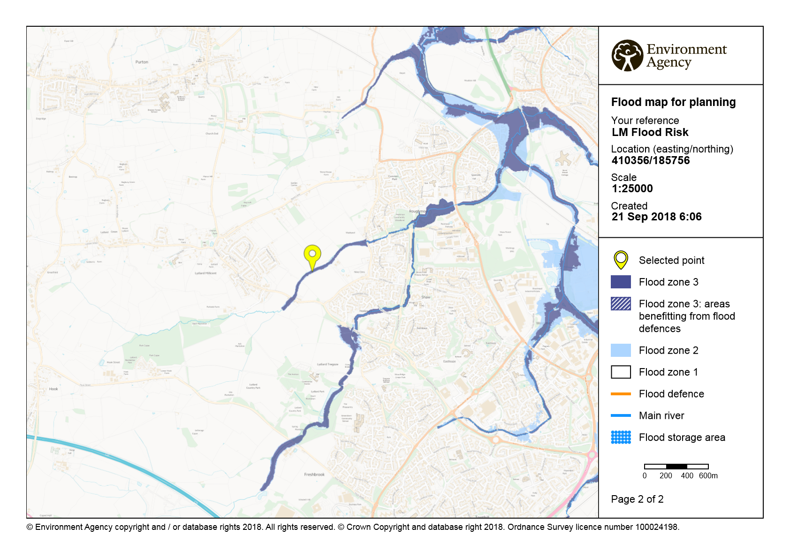
Plan E: Flood Risk in Lydiard Millicent
A Short History

2.10 Lydiard Millicent Village stands about three and a half miles west of the centre of Swindon. The name Millicent was presumably attached c. 1200 when the manor on which the village stood was held by Millicent, widow of William son of Hugh and its neighbour Lydiard Tregoze was held by Robert Tregoze. The Parish is long and narrow and adjoins Swindon. The Parish measures 6.2 miles from east to west and in places is no more than 500 yards from north to south.

2.11 Before the 20th century boundary changes it measured 2,339 a. and contained Lydiard Millicent village, Shaw village, outlying farmsteads, and Hamlets called Lydiard Green, Greatfield, Greenhill, Holborn, Nine Elms and Washpool.

2.12 In 1928 c. 22 a. was transferred to Swindon and in 1980 759 a., about a third of the Parish, was transferred to Swindon. After these boundary changes the Lydiard Millicent Parish was reduced to 1,566 a.

2.13 The population in the early 1600’s as shown by church records was about 150, and had only grown to 300 in 1881, as shown by the census. There was steady growth through the 1800’s until a surge to 564 in 1841. This has been attributed to the number of “navvies” resident temporarily in the district constructing the Great Western Railway. By 1891 the population had grown to 920, almost doubled, probably due to the close proximity of Swindon. After a fall in the first quarter of the 20th century the population recovered until 1971 when it numbered 1224. The boundary changes of 1980 when Shaw was lost to Swindon saw the population fall to 1085. The current population is about 1600, mainly centred on Lydiard Millicent village, Lydiard Green and Common Platt.

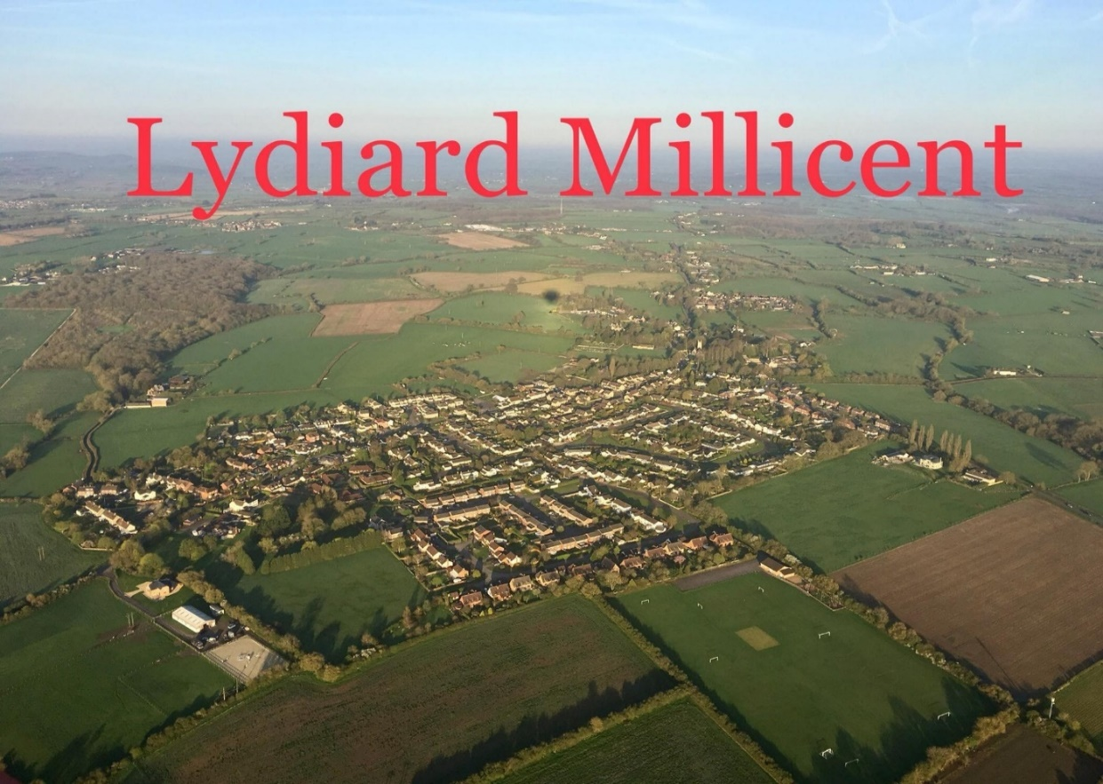
© Kelly Right
3. Planning Policy Context

3.1 The Parish lies within the Unitary Authority of Wiltshire Council.

National Planning Policy

3.2 The National Planning Policy Framework (NPPF) published by the government is an important guide in the preparation of neighbourhood plans. In July 2018 the government published an updated Framework, which sets out the transitional arrangements for Neighbourhood Plan examinations. Plans that are submitted to the Local Planning Authority after 24 January 2019 will be examined under this new Framework. The Submission version of this Plan is expected to be submitted in March 2019 and therefore reflects the provisions in this new Framework. The following paragraphs of the NPPF 2018 are considered especially relevant:

- Rural Communities (§83)
- Community Facilities (§92)
- Local Green Spaces (§99)
- Good Quality Design (§127)
- The Natural Environment (§170)
- The Historic Environment (§190)

Strategic Planning Policy

3.3 The Neighbourhood Plan must be in general conformity with the strategic policies of Wiltshire Council. The development plan primarily comprises the Wiltshire Core Strategy 2015 incorporating saved policies from district local plans, and the Chippenham Site Allocations Plan. The key policies applying to the Parish are:

- Core Policy 1 – defines Lydiard Millicent in the settlement hierarchy as a “smaller” village and limits development to that needed to help meet housing needs of the settlement and to improve employment opportunities, services and facilities.
- Core Policy 2 – limits development in Lydiard Millicent to infill within the existing built area.

3.4 There is also a wide range of development management policies covering additional employment land (including Core Policy 34 for proposals relating
to the retention or expansion of existing businesses within or adjacent Small Villages), supporting rural life at Core Policy 48 (including Core Policy 49 that seeks to protect rural services and community facilities), landscape (including Core Policies 51 and 52 that seeks to protect Wiltshire’s distinctive landscape character and green infrastructure), ensuring high quality design and place shaping (Core Policy 57), including ensuring the conservation of the historic environment (Core Policy 58).

3.5 Any development at Small Villages will be carefully managed by Core Policy 2 and the other relevant policies of the plan. At this time, the most recent Housing Land Supply Statement released in March 2017 has identified at Appendix 6 (Summary assessment of supply and remaining housing to be identified (by Community Area settlements and rural remainders) that in the Royal Wootton Bassett and Cricklade Community Area there is a 0 shortfall in dwellings in the plan period between 2006 and 2026.

3.6 Wiltshire Council is currently undertaking a Local Plan Review. The ‘Wiltshire Local Plan Review: Consultation Paper’ sets out the proposed scope of the Wiltshire Local Plan Review, which explains that the new homes, employment land and associated infrastructure needed to support growth over the period 2016 to 2026 are to be addressed in the review. This will take forward the Core Strategy to 2036.

3.7 The review will also include:
- some updating of existing Wiltshire Core Strategy development management
- policies to ensure their continued consistency with national policy;
- the introduction of additional development management policies in response to the review of the saved development management policies not replaced by the Wiltshire Core Strategy; and
- developing additional locally distinctive policies to plan positively for all town centres in Wiltshire consistent with national policy.

3.8 It will not be the purpose of the review to change or remove strategic objectives or policies that remain in accordance with national policy and support the delivery of sustainable development. The former district local plans were only originally intended to be in place until 2011. Many policies have simply been rolled forward until they are replaced by consistent policy across Wiltshire. The Wiltshire Local Plan Review will complete the review of all saved policies and ensure consistency of planning policy across Wiltshire. The review will also enable adopted local plan policies to be reviewed in the light of more recent changes to national planning policy and guidance to improve conformity.

3.9 A second document, the ‘Swindon and Wiltshire Joint Spatial Framework: Issues Paper’ has been prepared by Wiltshire Council and Swindon Borough Council and is available as a separate document. It is supported by four housing market area profiles which provide information on each of the main settlements in Swindon and Wiltshire.

3.10 The Joint Spatial Framework will guide the overall pattern of development across the wider area of the two Councils, setting out a distribution of new jobs, homes and infrastructure. It will provide evidence to inform the Councils’ individual local plan reviews. However, decisions over detailed site allocations will be made through the Councils’ individual local plan reviews.

3.11 The NPPF specifically requires that each Local Plan is based on an objective assessment of need in order to help gauge future levels of housing and employment growth. Consequently, the Councils’ have jointly prepared two evidence base reports:
- The Swindon and Wiltshire Strategic Housing Market Assessment 2017 (SHMAA)
- The Swindon and Wiltshire Functional Economic Market Area Assessment 2017
(FEMAA)

3.12 Both documents have been prepared to support this consultation on the scope of the Local Plan reviews and provide the current evidence of the need for new homes and jobs in Swindon and Wiltshire from 2016 up to 2036.

3.13 Elsewhere, the foremost priorities of the adopted Wiltshire Core Strategy and Swindon Local Plan are broadly to support rural communities by development geared towards meeting local needs or to constrain it in order to preserve the countryside and ensure a sustainable pattern of growth across the plan areas that minimises the need to travel by car.

3.14 The Neighbourhood Plan is expected to be examined prior to the adoption of these emerging documents, however its reasoning and evidence base has been taken into consideration in the preparation of the Neighbourhood Plan.

3.15 Wiltshire Council has confirmed that there is no intention to change the small village status of Lydiard Millicent. In general, therefore, the growth for Lydiard Millicent is intended to continue as in the past through the plan period, with no proposals to extend the village. The policies of this plan are therefore to guide the limited infill* within the existing built area to meet the housing needs of settlements or provide employment services and facilities as set out in Core Strategy Policy 2.

* infill is defined as the filling of a small gap within the village that is only large enough for not more than a few dwellings, generally only one dwelling.
4. Community Views

4.1 Extensive public consultation has been carried out to obtain the views of residents and other stakeholders. An event was held on the 9th November 2013 in the Lydiard Millicent Parish Hall to explain the process of Neighbourhood Planning and to gather views on the priorities for the future of the area. At the same time an online and paper-based questionnaire was widely publicised which allowed the collection of a large amount of data on the aspirations of stakeholders (Details of these events are provided in the separate Statement of Consultation, to be finalised).

4.2 Following the public engagement event and the questionnaire, Issues Reports were produced which collated and analysed all the information collected, identifying the positives and where change was needed. This data formed an important source of both qualitative and quantitative information which has underpinned the direction and vision of the Neighbourhood Plan.

4.3 A further pre- consultation event was held on 22nd June 2017 to show parishioners the latest version of the draft plan. A questionnaire was given out at the meeting and sent to parishioners who could not attend together with a copy of the plan. A sign-in sheet collected 60 names (although not all attendees signed). It is estimated that between 80-90 people attended.

4.4 The Steering Group then had regular monthly meetings, advertised on the Council website, and produced further draft plans taking account of comments from parishioners and Wiltshire Council Spatial Planning. These Drafts were available on a Neighbourhood Plan website set up in August 2017 with a link from Lydiard Millicent Parish Council website.

4.5 Further consultation was held in March 2018. Leaflets were delivered to all residents of Lydiard Millicent Parish with a questionnaire included. Post boxes were set up around the parish for replies. The results indicated that the content of the Neighbourhood Plan was on the right track.

4.6 Following a health check of the plan, the Neighbourhood Planning group sought the advice of professional planning consultants on its next steps. The outcome of this engagement and the reflection of the community in the past consultations has resulted in the policies of the Pre-Submission Plan.
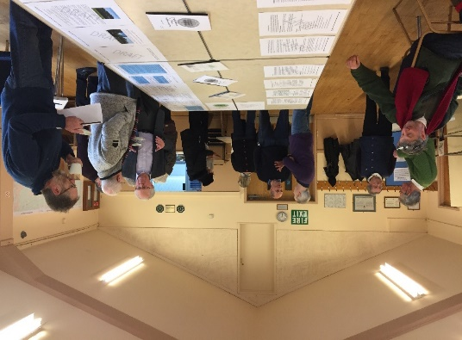
5. Vision, Objectives & Land Use Policies

Vision

5.1 The vision for Lydiard Millicent in 2036 is:

“Lydiard Millicent has remained a busy and vibrant community with a wide range of facilities. Development has been well-designed and contributed positively to the visual character of the local surrounding heritage. The gap between the Borough of Swindon and the village of Lydiard Millicent has remained and design standards of new buildings reflect the rural character of the village. The special environmental assets of the parish have been preserved and the community has benefitted from access and enjoyment of the countryside.”

Objectives

5.2 To achieve this vision a number of key objectives have been identified as follows:

- To promote high quality design and ensure the design of new development contributes positively to the visual heritage and landscape character of the local surroundings
- To sustain the range of community facilities, shops and businesses that are essential to community life
- To encourage walking in and around the village and to better manage the harmful effects of traffic and parking
- To safeguard the integrity of the gap between the Parish and Swindon

Land Use Planning Policies

5.3 The purpose of these policies is either to encourage planning applications for proposals that the local community would like to support, or to discourage applications for development that the community does not consider represent sustainable development in the Parish.

5.4 The policies avoid repeating existing national or local planning policies and therefore focus on a relatively small number of key planning issues in the Parish. For all other planning matters, the national and local policies will continue to be used. In this respect, the local community is content with the spatial strategy of the emerging Local Plan, which does not propose to release any land from the former Green Belt around the edge of the village.

5.5 Set out below are the proposed land use policies, each of which has a number and title, with the policy itself written in bold italics for ease of reference. There is also a short supporting statement explaining the intention of the policy and any other relevant background information. At the end of the document is the Policies Map – where a policy refers to a specific site or area, this is illustrated on the Map.

LM1 – Managing Design in Lydiard Millicent

Any development proposals in Lydiard Millicent, as defined on the Policies Map, must sustain and enhance the distinctiveness of the village and where appropriate the character and appearance of the Lydiard Millicent Conservation Area and its setting.

The use of building forms and materials that reflect the vernacular may be considered appropriate, provided it can be demonstrated that they adhere to the essential village character.

In these regards, infill development within the built area of Lydiard Millicent, in accordance with Core Policies 1 and 2 of the Wiltshire Core Strategy would be supported, provided it has full regard to the following design principles:

- the importance to defining the essential character of the village of stone clad buildings and lime-wash cottages throughout the area;
- the importance of the group value of heritage assets, other buildings and structures, open spaces, and mature trees to defining the important area around All Saints Church;
- the importance of a number of long views from the Church to the South;
- the importance of the view to the Church from the open fields to the South;
- the common use of lime-washed, rendered or other exteriors in the setting of listed buildings or in the Conservation Area;
- the importance of the rural outlook in the centre of the village.

5.6 This policy establishes the importance of the design of new development in the village to maintaining its essential character. In doing so, it refines the design quality principles of Core Strategy Policy 57. It also identifies the key characteristics of listed buildings and the Conservation Area for the application of Core Strategy Policy 58.

5.7 The policy highlights a series of development principles that are drawn from the Neighbourhood Plan Character Appraisal of the village. Those principles set out those features of the village that make it distinctive from its neighbouring villages and help define the significance of the Conservation Area. It therefore informs the Design & Access Statements prepared for planning applications in demonstrating that, where relevant to the nature and location of the proposal, regard has been paid to those principles. Although it allows for modern architectural responses to the vernacular, it makes clear that ‘pattern book’ housing forms that dominate urban and suburban towns will not be appropriate.

LM2 – Managing Design in Lydiard Green

Any development proposals in Lydiard Green, as defined on the Policies Map, must sustain and enhance the distinctiveness of the village and where appropriate the character and appearance of the Lydiard Green Conservation Area and its setting.

The use of building forms and materials that reflect the vernacular may be considered appropriate, provided it can be demonstrated that they adhere to the essential village character.

In these regards, infill development within the built area of Lydiard Green, in accordance with Core Policies 1 and 2 of the Wiltshire Core Strategy would be supported, provided it has full regard to the importance to defining the essential village character of the settlement of brick and stone-built cottages and relatively large open green spaces between properties.

5.8 This policy establishes the importance of the design of new development in the settlement to maintaining its essential character. In doing so, it refines the design quality principles of Core Strategy Policy 57. It also identifies the key characteristics of the Conservation Area for the application of Core Strategy Policy 58.

5.9 The policy highlights development principles that are drawn from the Neighbourhood Plan Character Appraisal of the settlement. Those principles set out those features of the village that make it distinctive from its neighbouring villages and help define the significance of the Conservation Area. It therefore informs the Design & Access Statements prepared for planning applications in demonstrating that, where relevant to the nature and location of the proposal, regard has been paid to those principles. Although it allows for modern architectural responses to the vernacular, it makes clear that ‘pattern book’ housing forms that dominate urban and suburban towns will not be appropriate.

LM3 – Local Gaps

The Neighbourhood Plan defines the following Local Gaps, as shown on the Policies Map, for the purpose of preventing the coalescence of the following settlements:

i. The Street/Holborn, Lydiard Millicent and Middleleaze, Swindon
ii. Park Lane, Lydiard Millicent and Tewkesbury Way, Swindon

Development proposals within a Local Gap will only be supported if they do not harm, individually or cumulatively, its open character.

5.10 This policy defines two areas of land to the east of the village that play an
especially important role in preventing development that will undermine the visual
integrity of the gap to the point that there is a coalescence of Lydiard Millicent with Swindon. See the separate ‘Local Gaps’ report in the evidence base for further details.

5.11 The policy gives local effect to the Wiltshire Core Strategy Policies CP19 and CP51, which together seek to maintain the long established policy of protecting the distinct character and identity of the villages and settlements in the Royal Wootton Bassett and Cricklade Community Area from the outward expansion of Swindon, such a policy being first established in the North Wiltshire Structure Plan, specifically policy DP13, ‘The Swindon Rural Buffer’. It defines the extent of the areas that is considered to be essential to protect Lydiard Millicent from the continued growth of Swindon.

5.12 Both areas lie within Character Area 3, the Swindon Fringe, which is described as “…higher ground lies to the west of the urban area of Swindon, lying at between 90- 155m AOD. It is defined on the western and northern side by a steep scarp slope overlooking the Thames lowlands. To the south it is defined by the edge of Wootton Bassett and the higher ground overlooking the shallow valley of the Brinkworth Brook. It includes the town of Wootton Bassett and the more straggling villages of Purton, Hook and Lydiard Millicent.” (North Wiltshire Landscape Character Assessment, Volume 1, June 2004). Again, the separate ‘Local Gaps’ report, demonstrates the views that these open areas offer to the Marlborough Downs.

5.13 Defined as a ‘small village’ Lydiard Millicent does not have a settlement boundary; however, the Swindon Urban Area boundary is drawn on the parish boundary of Lydiard Millicent. The Policy therefore anticipates development pressures that may arise from the growth of Swindon and acknowledges that some types of development that are suited to the countryside may therefore be appropriate. However, this policy requires that its effects - by way of its height, scale and massing for example – should not lead to any visual coalescence between the village and Swindon.

5.14 The first – the area of land between The Street/Holborn, Lydiard Millicent (to the north of Holborn) and the Parish Boundary with Middleleaze, Swindon – is especially precious, given the Urban Area Boundary and development of Middleleaze adjoins the Parish Boundary. Here, it is considered that this area is the only effective space preventing Lydiard Millicent adjoining the larger urban area of Swindon. The land included in the gap is considered to be the minimum to ensure that the visual openness of the space between Lydiard Millicent and Swindon is protected.

5.15 The second covers an area of land between the eastern end of Lydiard Millicent (to the south of Holborn) and the Parish Boundary with Tewkesbury Way, Swindon. Although not immediately a threat from development, the gap is still sufficiently small in visual terms that development that may otherwise be acceptable in the countryside may be inappropriate here, if its height or massing begins to coalesce with Swindon. Again, the land shown is considered to be the minimum necessary for the policy to have effect.
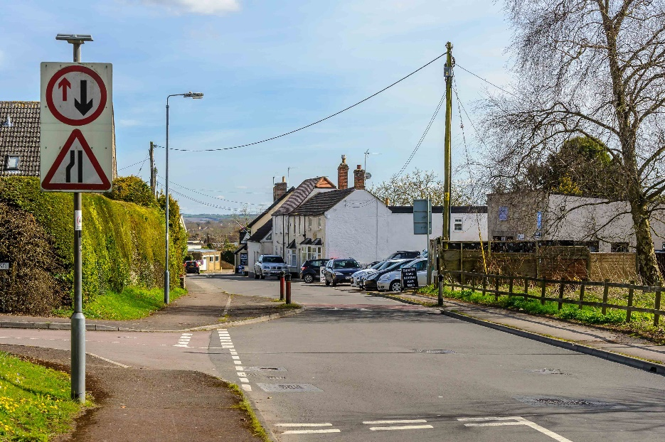
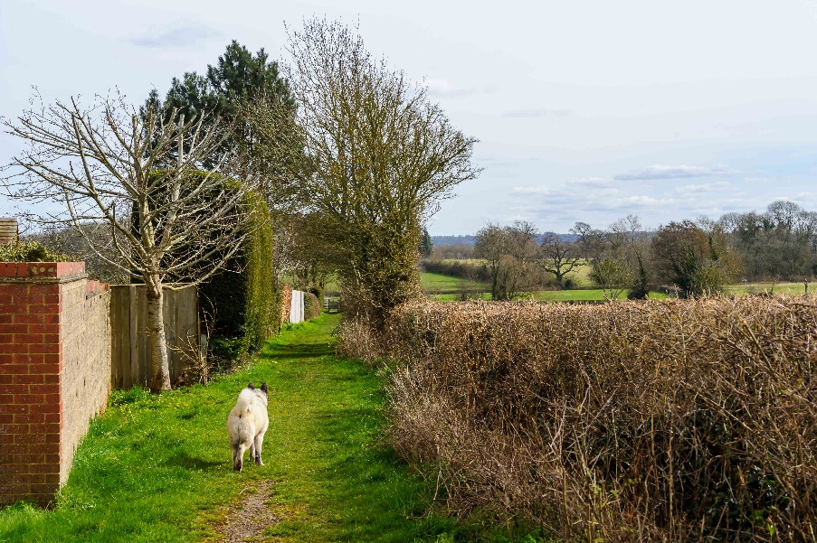
© Andrew Collett

LM4 – Local Views

The Neighbourhood Plan identifies Important Views on the Policies Map. Development proposals should demonstrate how they have taken account of the Important Views. In particular, development proposals should set out details on how they take into account the important views by way of building layouts, built form, height, mass, scale, building line, plot size, elevational design, materials, streetscape and rooflines.

5.16 The policy seeks to ensure that developers respect the identified important local views in the Parish. It establishes key criteria of existing features against which individual applications can be assessed. The criteria are, by necessity, of a generic nature and there are likely to be site specific issues that will need to be addressed on a site by site basis. The policy refines Wiltshire Core Policy 57 by identifying local views that form an essential part of the character of the Parish.

5.17 The selection of important views has been defined in the LMP Views Report which forms part of the evidence base. The policy does not rule out any form of development, but requires its building layouts, built form, height, mass, scale, building line, plot size, elevational design, materials, streetscape and rooflines to have given full consideration to the nature of important views, and that the development will not obstruct or punctuate important views in such a way that would undermine the contribution they make to defining the character of the Parish.

© Andrew Collett

LM5 – Local Green Spaces

The Neighbourhood Plan designates the following locations as Local Green Spaces, as shown on the Policies Map:

- The Field behind the Sun Inn;
- The Recreation Field on Chestnut Springs;
- The Community Field adjacent to the Parish Hall.

New development will not be permitted on land designated as Local Green Space except in very special circumstances.

5.18 The policy identifies three important open spaces for designation as Local Green Spaces in line with §99 of the NPPF. The separate Local Green Spaces Report, included in the evidence base, demonstrates how each space is considered to meet the tests of §100 of the NPPF.

5.19 The designation has the policy effect of the equivalence of the Green Belt when determining planning applications located within a designated Local Green Space. Hence the policy resists all development proposals unless there are very special circumstances as set out in §101 of the NPPF, to justify why consent should be granted.

© Mike Sharp

LM6 – Local Shops and Businesses

The Neighbourhood Plan defines the main business areas on the Policies Maps as detailed below:

Lydiard Millicent

- Lydiard Stud;
- Lydiard Garage Site;
- John Toomers & Sons Ltd;

Lydiard Green

- Bagbury Park;

Greenhill & Greatfield

- Blackfords Yard.
- Greatfield Nurseries & Garden Centre;

Development proposals that seek to retain or expand existing businesses in the established main business areas in the Parish will be supported, provided they conform to other policies of the Neighbourhood Plan and of the development plan.

Development proposals for new shops or businesses will be supported in accordance with other policies of the Neighbourhood Plan and of the development plan.

5.20 The policy seeks to encourage the development of new employment at existing established sites in the Parish and defines where these are located, giving local effect to Wiltshire Core Policy 34. The introduction of new shops and businesses should be dealt with in accordance with other Neighbourhood Plan policies and of the development plan, specifically Wiltshire Core Policy 34.

5.21 The settlement of Lydiard Millicent has three separate business areas situated at Lydiard Stud and the Lydiard Garage Site on The Street, as well as the John Toomers & Sons Ltd Site on Stone Lane. Lydiard Green has one business areas situated at Bagbury Park. Greatfield and Greenhill have one each, Greatfield Nurseries & Garden Centre, and Blackfords Yard. Each of these sites hosts a variety of small businesses that contribute to the local economy. This is supplemented throughout the Parish by small home businesses and homeworkers. The policy therefore seeks to remain supportive of small businesses as a valued contribution to its local economy and supports their expansion, subject to conformity with other policies of the Neighbourhood Plan and of the development plan.

5.22 Additionally, the village does not have a local shop and relies on neighbouring parishes for such services. Therefore, it is also supportive of the introduction of new shops within the parameters set out in Wiltshire Core Policy 34.

LM7 – Community Facilities

The Neighbourhood Plan defines the following properties as community facilities:

- All Saints, Church Place, Lydiard Millicent, Swindon SN5 3LS
- The Parish Hall, 1 The Butts, Lydiard Millicent, Swindon SN5 3LR
- Lydiard Millicent Church of England Primary School, 5 The Butts, Lydiard Millicent, Swindon SN5 3LR
- Lydiard Millicent Preschool, The Butts, Lydiard Millicent, Swindon SN5 3LR
- The Sun Inn, The Street, Lydiard Millicent, Swindon SN5 3LU

Proposals that will result in either the loss of, or cause significant harm to, a defined facility will be resisted, unless it can be clearly demonstrated that the operation of the facility, is no longer financially viable. Development proposals to sustain or extend the viable use of existing community facilities and the development of new facilities will be supported.

5.23 The policy identifies community facilities that will be protected from unnecessary loss in accordance with Wiltshire Core Strategy Policy 49.

5.24 The Neighbourhood Plan group have been collecting evidence on community facilities that are valued by the community and offer a valuable resource to support the local community. The purpose of this policy is therefore to secure these assets in the long term for the benefit of the people of Lydiard Millicent and to apply the test of viability to give them added protection.

LM8 – Movement Routes

The Neighbourhood Plan identifies the existing Movement Routes as shown on the Policies Map. The Routes comprises a variety of footpaths and bridleways.

Development proposals that lie within the broad location of these Routes will be required to align their connectivity requirements with its objectives, so that it contributes to its successful formation and maintenance.

Save for householder development and other minor developments, all new development should ensure safe access to existing Routes that, in turn and, wherever possible, take available opportunities to improve and extend Movement Routes in order to provider better connectivity throughout the Parish.

5.25 This policy defines a network of movement routes for protection, and to identify improvements to the existing infrastructure with a view to encouraging more people to walk or cycle more often for their daily journeys to school, to work and for trips to local services in general conformity with NPPF paragraph 35 and reflects the Wiltshire Core Policy 48 in improving access to services for implementation in this Parish.

5.26 There is recognition that whilst existing footpaths provide pedestrian access to most areas in the parish, there is no safe link with footpaths to the neighbouring Swindon services and facilities. The village lacks a shop and therefore there is currently no safe alternative means of transport to the nearest shop , or convenience store in Purton or West Swindon, and therefore these journeys are mostly undertaken by car. The Joint Strategic Assessment for Royal Wootton Bassett and Cricklade Community Area 2013 – 2015 also recognises that the community have expressed concern about vehicle speeds and states: “The area has a very high car ownership level with 51.5% commuting to work by car, compared to only 3.6% using public transport despite the close proximity to Swindon as the major employment centre.”

5.27 Similarly, there are no cycle paths and roads are narrow and congested, leading to a common concern in the parish of road safety. This requires efforts to encourage travel by means other than the car. Therefore, there needs to be good and safe routes for pedestrians and cyclists.

5.28 The close proximity to Swindon, and the use of nearby services and facilities in Swindon, means that the key is continuity. The policy therefore seeks to address these issues. Swindon already has an established path network and the Movement Routes report indicates where improvements in Lydiard Millicent can create opportunities to link with this established network.

LM9 – Developer Contributions

Where appropriate and directly related to new development, enhancements to Movement Routes will be in accordance with the opportunities identified in the Movement Routes Report and agreed with the Parish Council. These will be secured by way of planning conditions, Section 106 contributions or Community Infrastructure Levy contributions as appropriate.

5.29 Where improvements to Movement Routes, identified in Policy LM8, are required, contributions will be sought through S106 agreements, subject to compliance with the Community Infrastructure Regulations 2010 (as amended), or via planning conditions or CIL as appropriate and will be used to part-fund these and lever in match funding from other sources where possible.
6. Implementation

6.1 The Neighbourhood Plan will be implemented through Wiltshire Council’s consideration and determination of planning applications for development in the Parish.

Development Management

6.2 The Council will use a combination of the Local Plan and this Neighbourhood Plan policies to inform and determine its planning application decisions. The Parish Council is a statutory consultee on planning applications made in the Parish and it will be made aware of any future planning applications or alterations to those applications by the planning authority. It will seek to ensure that the Neighbourhood Plan policies have been identified and applied correctly by applicants and by officers in their decision reports.

6.3 Where necessary, the Parish Council may seek to persuade the Secretary of State to call-in a planning application that it considers is in conflict with the Neighbourhood Plan but which the planning authority has deemed to consent. Similarly, it may also seek to persuade the Secretary of State to recover an appeal of a refused application, where the conflict with one or more Neighbourhood Plan policies has been important in the reasons for refusal. In both cases, the Parish Council will do so if it considers matters of national policy significance (for neighbourhood planning) are raised.

Local Infrastructure Improvements

6.4 Although the scale of development likely to be consented in the Parish during the plan period is likely to be very limited, there may be opportunities through S106 agreements (or through the Community Infrastructure Levy) to secure financial contributions to invest in improving local infrastructure. Should an opportunity arise, the Parish Council will review the evidence base and community consultations for the neighbourhood plan to inform its view in liaising with Wiltshire Council.

Other Non-Planning Matters

6.5 During the process of preparing the Neighbourhood Plan, there have been many ideas for improving or addressing current problems in the village and Parish that lie outside the scope of the land use planning system to control. The Parish Council has noted these issues and will take them forward through its day-to-day business and in partnership with the local community and relevant parties.

POLICIES MAP & INSET

