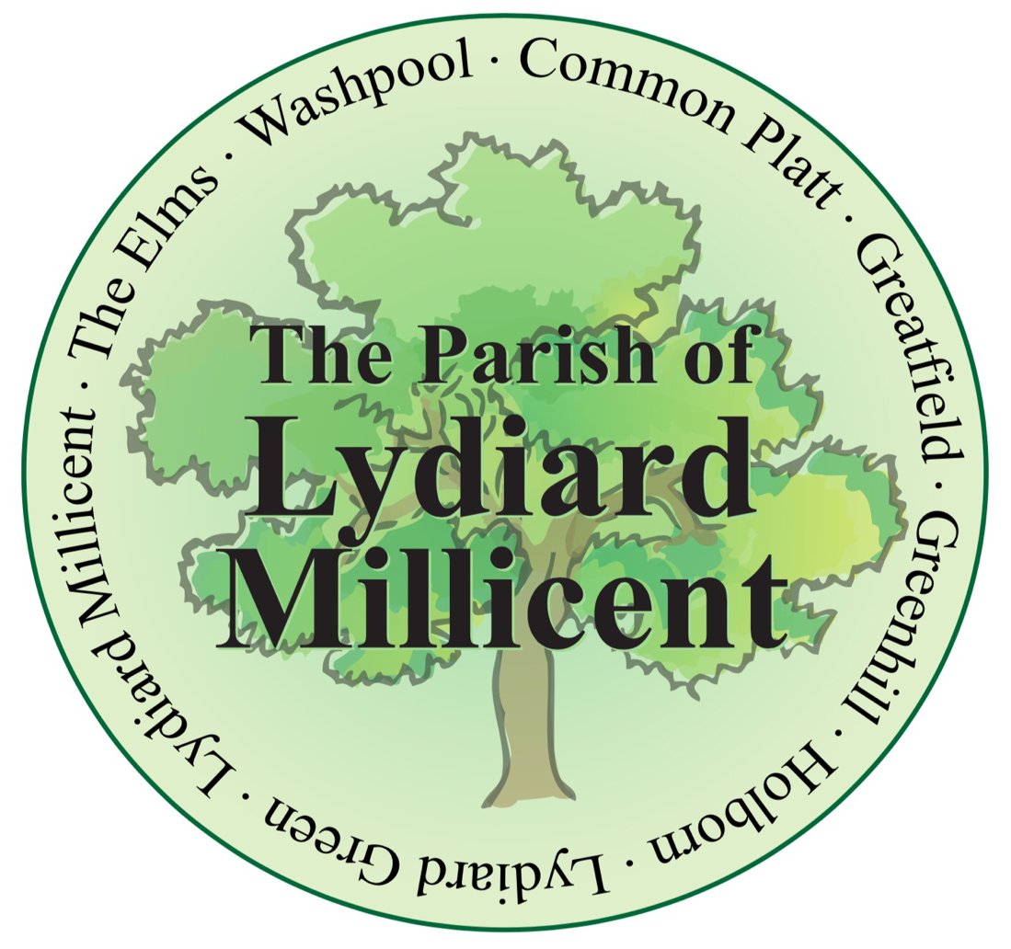
Lydiard Millicent
Parish
Neighbourhood Plan

September 2017
Draft Version
30th September 2017

Table of Contents

1. Neighbourhood Planning in context 1
2. The Plan Area 1
3. Neighbourhood Plan: Process and Development 2
4. Context 4
5. Residents Aspirations 4
6. Community Infrastructure Levy 5
7. Monitoring and Review 6
8. Evidence 6
9 Relationship to the Wiltshire Core Strategy 7
10 Plan wide objectives 8
11 Transport 9
12 Environment 13
13 Facilities 17
14 Housing and Development 18

1. Neighbourhood Planning in context
Neighbourhood Plans aim to give communities the opportunity to shape their environment and have more influence over planning decisions taken which affect them. They are developed from within the community, but provided they achieve necessary legislative milestones, they become “made” (completed) and are used by the Local Planning Authority in determining planning applications and making policy. Neighbourhood Plans must be prepared in accordance with the Local Planning Authority’s Core Strategy, in this case the Wiltshire Core Strategy, adopted in January 2015.
Neighbourhood Plans must also follow the National Planning Policy Framework 2012 which sets out the structure for the planning of sustainable development. The Wiltshire Core Strategy, adopted 20 January 2015, is the strategic plan for Wiltshire, and provides both generic and place-based policies to guide development. The Wiltshire Core Strategy provides the local context for the neighbourhood plan whose policies and proposals must be in general conformity with its policies.

2. The Plan Area
The Lydiard Millicent Neighbourhood Plan covers the whole of the Lydiard Millicent Parish, situated in the north east corner of Wiltshire. The Lydiard Millicent Parish Neighbourhood Area is in the southern part of the Royal Wootton Bassett and Cricklade Community Area. Lydiard Millicent Parish lies directly to the west of Swindon with the parish of Lydiard Tregoz to the south and Purton parish to the north.
Originally it was part of the Wiltshire Council pilot project North East Wiltshire – Villages (NEW-V) neighbourhood plan covering the towns of Royal Wootton Bassett and Cricklade and the surrounding villages of Purton, Lyneham and Bradenstoke, Broad Town, Clyffe Pypard, Lydiard Millicent, Lydiard Tregoz and Tockenham. However due to the two towns and some parishes deciding to do their own neighbourhood plans and Lydiard Millicent Parish becoming non-contiguous with the three remaining parishes of Broad Town, Clyffe Pypard, and Tockenham, Lydiard Millicent Parish decided to proceed with the Lydiard Millicent Parish Neighbourhood plan.
The neighbourhood area is that within the Lydiard Millicent Parish boundary (see map). This historic parish is characterised by its rural nature, high quality environment, and, contains Lydiard Millicent village and a group of smaller hamlet-like settlements. The Area is looking for limited development to help sustain the existing viable communities. Lydiard Millicent Parish Neighbourhood Plan Area also contains two conservation areas.
Due to the size of Lydiard Millicent Parish and its population there is no major employment nor housing development within the parish, however, due to its proximity to Swindon, Cricklade and Royal Wootton Bassett, these are catered for within these areas. As such the neighbourhood area sees a high level of out-commuting, particularly to Swindon, and in the main has a dormitory function relying on services at these large centres.
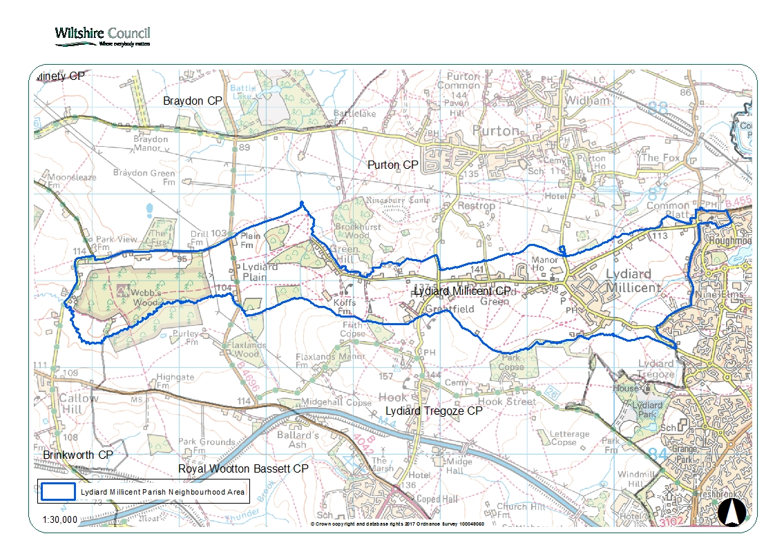

3. Neighbourhood Plan: Process and Development
The process of developing the NEW-V Neighbourhood Plan began in May 2012 following the provisional setting up of a Steering Group via the Area Board, however Lydiard Millicent Parish Council took the decision to prepare its own Plan during the summer of 2016. The Steering Group for the Lydiard Millicent Parish Neighbourhood Plan is comprised of representatives from the Parish Council and parishioners.
This group has met regularly to progress the Neighbourhood Plan, and the individual representatives have had responsibility for acting as a conduit between the Parish Council and the Neighbourhood Planning process. The Steering Group meetings have been open to public attendance and meeting details have been made available on the Lydiard Millicent Parish Council website.
At key points in the process the Steering Group members have reported back to the Parish Council as they form the ‘relevant body’ for purposes of section 61G(2) of the Town and County Planning Act 1990, for example when seeking neighbourhood area designation, when seeking approval to consult on the draft plan. The approval of the Parish Council will also be required to submit the plan to Wiltshire Council for formal consultation at a later date.

In preparing the neighbourhood plan the steering group have responsibility for ensuring that the submitted draft plan meets the basic conditions established in regulations. These are:
- the plan has had appropriate regard to national policy;
- the plan contributes to the achievement of sustainable development;
- the plan is in general conformity with strategic local policy;
- the plan is compatible with EU regulations.
Extensive public consultation has been carried out to obtain the views of residents and other stakeholders. An event was held on the 9th November 2013 in the Lydiard Millicent Parish Hall to explain the process of Neighbourhood Planning and to gather views on the priorities for the future of the area. At the same time an online and paper-based questionnaire was widely publicised which allowed the collection of a large amount of data on the aspirations of stakeholders (Details of these events are provided in the separate Statement of Consultation, to be finalised).
Following the public engagement event and the questionnaire, Issues Reports were produced, which collated and analysed all the information collected, identifying the positives and where change was needed. This data formed an important source of both qualitative and quantitative information which has underpinned the direction and vision of the Neighbourhood Plan. Within each Issue Report, the relevant national and local planning policies were also highlighted for each topic, to guide the group as to how to address issues whilst remaining in conformity with these policies.
The Issues Reports then drove the development of options for policy-making, where the Parish Council/Neighbourhood Plan Steering group worked on how best to address issues, in terms of preserving and enhancing those aspects which were identified by residents/stakeholders as positive, and improving the negative features. This work was carried out by means of a Strengths, Weaknesses, Opportunities and Threats analysis (SWOT), examining each option in detail. Those options which came out the strongest, and were in conformity with planning policy were developed into draft Neighbourhood Plan policies.
A further pre- consultation event was held on 22nd June 2017 to show parishioners the latest version of the draft plan. A questionnaire was given out at the meeting and sent to parishioners who could not attend together with a copy of the plan. A sign-in sheet collected 60 names although not all attendees signed. It is estimated that between 80-90 people attended. The comments and suggestions have been included in the latest version where possible, and confirmed the previous consultations.

4. Context
In 2005 the Parish published a Parish Plan which was very well supported with nearly 41% of households in the parish replying to the Parish Plan Questionnaire. The top two issues identified by the parishioners were: to maintain the Rural Buffer Zone that then existed between our parish, Swindon and other local communities and to maintain the existing boundary with Swindon. In Spring 2011 an Updated Parish Plan was issued. This time just under 40% of parishioners returned the associated questionnaire, of those respondents 95% wanted a buffer zone between the village of Lydiard Millicent and Swindon and the maintenance of a separate identity for the village.
Both Parish Plans indicated the very strong resistance, by a village mentioned in the Doomsday Book, with over 1,000 years as an independent community in North Wiltshire, to being absorbed into the ever growing Borough of Swindon. These sentiments in the main stem from around 30 years ago when the parish lost approximately a quarter of its area to Swindon including the hamlet of Shaw and there has since been unrelenting pressure to build houses for Swindon. When Wiltshire Council proposed a Neighbourhood Plan which could enable the type and extent of any housing developments in the parish to be controlled by the parish, residents seized the opportunity. The parish has a significant number of elderly people living in large houses, they would like to “downsize” but remain in the village with their friends; unfortunately, the availability of suitable accommodation is extremely limited The results of the Neighbourhood Plan consultation include proposals for a very modest housing development to enable some of our older residents to down size and stay within the parish and for younger residents with their roots in our community to continue to live here.
As identified in Wiltshire Council Core Strategy [CP1, 4.16, 4.17 ], major employment and housing development in the wider area will be concentrated in the larger centres of Cricklade, Royal Wootton Bassett and Swindon.

5. Residents Aspirations
A number of themes have come out across the Lydiard Millicent Parish in terms of aspirations, including:
- Traffic and transport: improvements in public transport, road safety, public rights of way and traffic management.
- Development and housing: limited growth based on development which is in keeping with the existing settlements in terms of scale, design and location.
- Open Space: improvement in the quality and quantity of open space available to residents for informal leisure/recreation, children’s’ play and sports
- Education, Services and Facilities: for residents to be able to obtain the services and facilities they need, either within their community or nearby.
These themes have been used by Lydiard Millicent Parish Steering Group to set the parishes’ vision, aims and objectives, overall of which was that the community wished to see the distinctive characteristics, of the area, maintained and enhanced and to preserve the “village feel” of the settlements. This included a desire to resist the encroachment of development between surrounding settlements. This was particularly true in relation to those boundaries abutting Swindon and Royal Wootton Bassett.
The policies in a Neighbourhood Plan must relate to the use or development of land. Policies cannot relate to general aspirations such as ‘an improvement to broadband speed’ or ‘a reduction in the volume and speed of traffic’. Therefore, not all aspects of these themes can be dealt with in a Neighbourhood Plan because they do not all relate to the use or development of land. Those that fall within the criteria have been developed into land use policies that promote sustainable development.
The overarching vision for the Lydiard Millicent Parish Neighbourhood Plan was:
- To protect and enhance the individual, separate identity of the many historic rural settlements within its area. The beauty and intrinsic value of the countryside should be protected and the gradual, persistent erosion of the separation between villages within the neighbourhood plan area should be prevented.
- Any development within line with the Wiltshire Core Strategy should be managed and located to avoid coalescence with neighbouring villages and to enable improvements in road safety.
- It is important to protect the health, safety and well-being of these rural communities whilst maintaining the quality of life and integrity of this living environment

6. Community Infrastructure Levy
The Community Infrastructure Levy (CIL) is a charge that local authorities in England and Wales can put on new development in their area to raise funds to help deliver the infrastructure necessary to support development.
Wiltshire Council became a Charging Authority in May 2015. All new eligible development will be required to pay CIL. Where a neighbourhood plan has been ‘made’ the parish council will receive the enhanced percentage of the CIL receipts received in their parish to be used to provide infrastructure needed to support development. At a parish level this could be to upgrade a parish hall to make it more widely available or contribute towards improvements to the pedestrian/cycle network/recreational facilities.
As part of the neighbourhood planning process, Lydiard Millicent Parish has identified the following infrastructure projects which could be supported by CIL.
- Footpaths between Holborn and the Lydiard Millicent Village, at Lydiard Green and in Stone Lane
- Development of village green and play area in the community field next to the Parish Hall
- Upgrading of existing play areas
As stated above planning polices in the neighbourhood plan must relate to the development and use of land. However, the neighbourhood plan does provide an opportunity to identify the priorities within a parish reflecting some of the concerns and aspirations identified through consultation not directly related to land use but which provide a valued service or facility within the parish.Alongside CIL, certain planning obligations can still be sought for on-site infrastructure. For further information on both CIL and planning obligations please refer to Wiltshire council website.

7. Monitoring and Review
Once ‘made’ the Neighbourhood Plan becomes part of the Development Plan for Wiltshire and will be used to guide decision making in the neighbourhood area in relation to individual planning applications.
Compliance with the Neighbourhood Plan will be monitored by the Steering Group, and will report annually to the Parish Meeting, to ensure that it remains relevant and up to date, triggering a review as and when necessary. A review of the Neighbourhood Plan could also be triggered by a significant change in national or local strategic policy.

8. Evidence
The following documents have been used as sources of information in the preparation of this Neighbourhood Plan:
Lydiard Millicent Parish Plan, 2005
2011 Census
Lydiard Millicent Parish Plan Update 2011
National Planning Policy Framework, 2012
Wiltshire Council Housing Needs Survey Jan 2013
Results of the Lydiard Millicent Parish Council Housing Questionnaire 2013
Lydiard Millicent Postcards of the Future Survey 2013 (Common Places)
Lydiard Millicent Draft Issues Report Oct 2013 (Common Places)
Wiltshire Core Strategy, January 2015
NEW-V Statement of Early Consultation, January 2015
Wiltshire Housing Land Supply Statement, April 2016 (published November 2016)

9 Relationship to other Policies
The plan period has been set to coincide with the current Wiltshire Core Strategy plan period until 2026.
The issue of protecting the distinct character and identity of settlements is recognised in the Royal Wootton Bassett and Cricklade Area Strategy section of the Wiltshire Core Strategy. The Area Strategy states that given the proximity of Swindon to the community area, planning for this area needs to be managed holistically to ensure development at Swindon is as balanced and sustainable as possible while also affording appropriate protection to rural areas which may face unplanned development pressure. It also states that the open countryside should be maintained to protect the character and identity of the area. The proposed vision develops this strategy locally and is in general conformity with over-arching area strategy in the Wiltshire Core Strategy.
The Neighbourhood Plan once made, will become part of the development plan for Wiltshire alongside the Wiltshire Core Strategy. Therefore the policies of the Wiltshire Core Strategy also apply to the neighbourhood area and work alongside the policies of this plan. For example the environment section of the vision will augment Core Policy 50 (biodiversity and geodiversity), Core Policy 51 (landscape) and Core Policy 52 (Green Infrastructure). The transport section will complement Core Policy 61 (transport and new development), Core Policy 64 (demand management) and Core Policy 65 (movement of goods). The Neighbourhood Plan adds details to the Wiltshire Core Strategy policies and supplements the existing policy to better reflect local circumstances.
The Wiltshire Core Strategy policies view Lydiard Millicent as a small village where development is unscheduled.
The National Planning Policy Framework under Plan-making para 150 encourages sustainable development and the Lydiard Millicent Parish Neighbourhood Plan follows this policy.

10 Plan wide objectives
The vision for the Lydiard Millicent Parish neighbourhood area seeks to inspire through challenging yet deliverable objectives. The overriding aim for the vision is that those who live, work or play in the neighbourhood value their quality of life, have respect for the land, for nature, and for each other, and have time to invest in their family, friends and community.
The above vision is to be delivered across four functional areas, made up of transport, environment, facilities and development and housing.
The objectives reflect that all development should consider how it can contribute to delivering the key outcomes, no matter how small that contribution is.
- To protect and enhance the individual, separate identity of the many historic rural settlements within its area.
- The beauty and intrinsic value of the countryside should be protected and the gradual, persistent erosion of the separation between villages within the neighbourhood plan area discouraged.
- Development should be managed and located to avoid coalescence with neighbouring villages and to enable improvements in road safety.

11 Transport

Aims:
- To manage and improve publicly available car parking provision in the Parish, and alleviate the problems associated with on-road parking.
- To manage road use and speeds through traffic management and calming measures that improve safety for pedestrians, cyclists, and other road users, and which prevent main roads becoming barriers to movement and communication within the Parish.
- To improve and extend pavements, paths and dedicated cycle-ways within Lydiard Millicent Parish to encourage more people to walk and cycle safely both between amenities and between villages.
Parking, particularly in relation to the school, was raised by many residents and there is a strong desire to develop car parking in the centre of Lydiard Millicent village to support Parish Hall ,Church and school. Residents also want to ensure adequate parking is provided in new development so that existing parking problems are not exacerbated, and to improve local pedestrian and cycling links.
The Parish Council has bought a paddock next to the Parish Hall and has obtained Planning Permission from Wiltshire Council to build a car park. Plans have been drawn up but at present the cost of construction exceeds the funds available to the Parish Council and the project is on hold. The footpath in Lydiard Green has recently been lengthened, but will still have a significant gap. Similarly, the pavement in The Street has gaps which forces parents and children into the road, and, finally the road between Park Lane and the Holborn cottages has only a partial grass verge. Developer funding for new or missing sections of footpaths will be actively sought by the Parish and Wiltshire Council.
Road safety is a concern for many Lydiard Millicent Parish residents, who would like to see a reduction in traffic (especially HGVs) through the parish, and traffic management and traffic calming measures in place. Safety, speeding and erosion of the grass verges are all issues. Residents would like to see road traffic congestion and speed reduced. They would like to see HGV vehicles redirected away from the most sensitive locations.
As development in the surrounding areas increases, including the development of Ridgeway Farm, local rural roads are being used as ‘rat runs’ to avoid congestion on the strategic road network. These persistent traffic volumes and speeds are having a negative impact on Lydiard Millicent Parish’s cohesion and traffic safety. It is recognised that the policies of the neighbourhood plan alone cannot address these wider problems. However, a wider overarching understanding of the breadth and scale of the issues involved could result in positive action on the local road network to divert traffic away from the most sensitive areas or unblock points of congestion of the strategic road network which would reduce the amount of traffic seeking alternatives.

Residents want movement within the village, without roads becoming barriers, and they want to see the quality of life maintained. They would like to be able to walk, or cycle safety within the village and to neighbouring villages and amenities. They would like to encourage more residents to walk to school. Residents would like to see improved pavements and cycleways. Improvements and expansion of pavements and cycleways would help to alleviate some of the issues surrounding parking near the school (see LM1A).
Road condition and maintenance in Lydiard Millicent Parish is considered a priority. Residents have expressed concern about the deterioration of roads because of increased volumes of traffic, and a failure to maintain their condition and road markings.
Residents would like to see proposals for development assessed to identify the potential traffic/transport implications and steps taken to mitigate negative impacts, through improvements to roads and traffic management.
Residents have said they would like to see new pavements in Lydiard Green and The Street; grass verges for pedestrians and a footbridge in Holborn.
They have also said they would like to see Mini-roundabouts at the junction of Stone Lane with the C70 in Common Platt and at the junction of the C70 and the B4553 (Casa Paulo) to cope with increased traffic from the Ridgeway Farm and Tadpole Farm housing development, and traffic calming on the C70 between Common Platt and Washpool.
Traffic-generating developments should contribute to CIL and produce traffic/ transport assessments.
Bus services are important to Lydiard Millicent residents, who would like to see buses and bus stops made wheelchair accessible where possible.
The maintenance and enhancement of the rights of way network should be supported.
There is support for the Steering Group to work with the Royal Wootton Bassett and Cricklade Area Board to establish a sub-group of the existing Community Area Transport Group to consider the overriding concerns about the levels of through traffic in the local area which is being fuelled by growth at Swindon, Royal Wootton Bassett, Chippenham and the wider area.
Policies in the Wiltshire Core Strategy promote sustainable forms of transport and transport assessments, protect the transport network and seek to reduce reliance on the private car (Core Policies 60-66)
The National Planning Policy Framework requires local authorities to set local residential and non- residential parking standards and protect the local road network (paragraphs 39-41). Wiltshire Council have done this through their Local Transport Plan 3.

Lydiard Millicent Policy 1A: Car parking
The provision of additional car parking in the centre of Lydiard Millicent village to support the Parish Hall, the village school, the Parish Church and other community organisations will be supported subject to historic environment, road safety and residential amenity concerns being met. The quantity of car parking provided will be in accordance with the latest Wiltshire Council car parking standards
Where change of use of existing publicly available car parking areas is suggested equivalent and equally accessible parking must be provided as a replacement.
Where possible, new development should seek to respond to opportunities to provide safe and convenient off street parking for community buildings.
Any new, expanded, or change of use of commercial or any residential development must be completely self-sufficient in terms of off-road parking, which means—
- Development proposals will only be supported if they include the maximum level of off-road parking consistent with the standards set out in the Wiltshire Core Strategy,
- Developments that reduce the amount of off-street parking currently available will only be supported if they make enforceable provision for off-street parking nearby,
- Parking spaces will need to be made available in perpetuity.
Any development should be planned, designed and implemented to provide adequately for necessary access by service vehicles and cars but—
- Without encouraging use of cars in circumstances when walking, cycling or public transport would be a more environmentally responsible choice; and
- Without hindering people using those modes of travel.
Where appropriate and practicable, developments should make provision for:
- measures to improve public transport provision, make it more easily accessible and increase its use;
- measures to improve the safety of pedestrians and cyclists and to make the use of those modes of travel more convenient;
- suitable levels of off-street parking for the development proposed and off-street manoeuvring space for the vehicles likely to service the proposed use.

Lydiard Millicent Policy 1B: Road safety and public rights of way
Maintenance and improvements to pedestrian and cycle networks within Lydiard Millicent Parish and connecting Lydiard Millicent to other villages and settlements are a priority. New development must maintain and enhance existing pedestrian and cycle networks.
Where possible, new development should seek to respond to opportunities to provide new and improved safe and convenient pedestrian and cycle routes.
Any proposal for development must be accompanied by an assessment of the potential traffic and transport implications, and take steps to mitigate negative impacts, through improvements to roads and traffic management.

Where an application would result in on-street parking or need for on-street manoeuvring space in accordance with the above, this should be accompanied by adequate information to demonstrate that this will not result in unacceptable highways safety issues, and that it will not adversely affect the amenity of residents, dominate the street scene or harm the character of the immediate area

12 Environment
Aims:
- The protection and enhancement of the separate and distinctive identity and character of Lydiard Millicent Parish as a historic Wiltshire Village and Parish, and the historical environment and landscape setting, is of utmost importance. This protection of all parts of the Parish, and in particular the centre of the Lydiard Millicent Village, is of primary concern.
- To prevent any coalescence between Lydiard Millicent Village and settlements, and the surrounding villages in North Wiltshire, by the maintenance and enhancement of the existing open spaces, and green pastures.
- To conserve and enhance local biodiversity
The potential influence, and infringement, of Swindon is most significant to the east of the Parish. Ribbon development is seen along roads in most areas of the Parish, and there is a diversity of land uses, from residential to light industrial, service sector including several garden centres, retail uses, equestrian and farmland, and areas of woodland and hedgerow – some historic. There are a number of important small woods in our more rural areas, particularly in Greenhill, where bluebells grow, which are cherished and should be maintained.
However, beyond the landscape immediately visible from the main roads, there are diverse landscape elements and locations of historical interest.
There are two Conservation Areas in the parish, one of which, centred around the Parish Church, protects the views from, and to, the All Saints Church, and the Parish Hall.
The other is in the adjoining hamlet of Lydiard Green, and both are also conserved under current Wiltshire Core Strategy guidelines, for historical architectural purposes. The Sun Inn, in The Street, is a listed building that has developed particular importance as the social centre to the village over the years. The Parish Hall and the Church have many activities throughout the week.
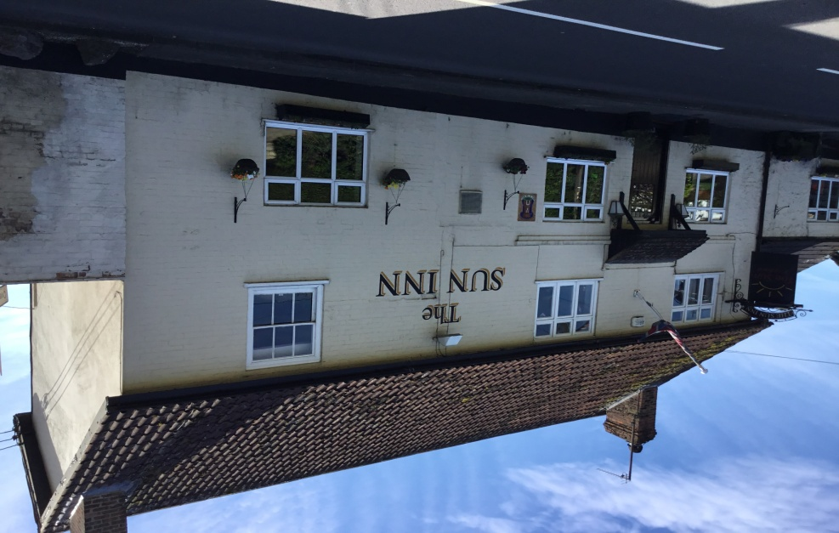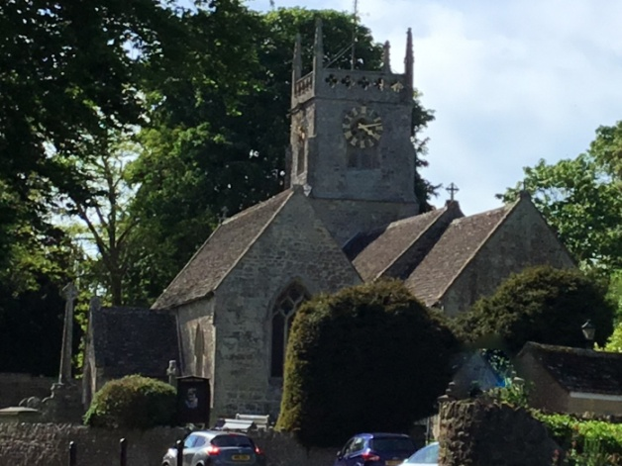 SUN INN. THE CHURCH

Residents of Lydiard Millicent Parish appreciate the open space within and around their communities. There is recognition of the value of those spaces and a strong desire for the protection of the countryside around the village and hamlets.
Many residents suggest that a central village green could be a positive focal point for Lydiard Millicent village and should be actively considered. The P.C. own the field adjacent to the Parish Hall, which has Planning Approval for a car park, and could be developed as a multi-purpose facility.
The Parish suffers a rat-run from vehicles from areas north and west travelling to and from Swindon, most prominently at commuting times. Any development along this route needs to be carefully considered, with additional parking, and pedestrian safety, born in mind, especially near the access to the village Primary School in The Butts.
Many areas in the village, and most of the hamlets in the Parish have no pavements. Whilst this is to be expected in a rural community, it does pose a danger to pedestrian use, where and when traffic is heavy, as many of the roads are narrow.
Particular importance is given to the open views from Holborn and the western side of the village towards Lydiard House and Park and the County Wildlife Site that adjoins it.
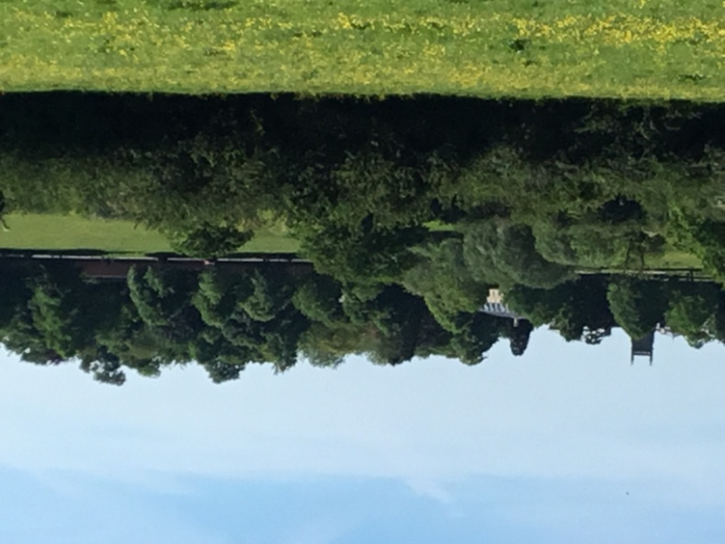
A tributary of the River Ray, the brook running from Lydiard Park to Holborn and Washpool, is a wildlife haven. These areas around Holborn and around the the S.W. edge of the Parish on the boundary with Swindon, have, at times, been prone to severe flooding, which must be borne in mind if any development is proposed. (NPPF 100)
Deer are often seen in the fields towards Lydiard Tregoz church, around Holborn, in the Greenhill area, and in many more parts of the parish.
Several areas in the parish, adjacent to fields and hedgerows, are feeding areas for bats, especially Pippistrelle. They can often be seen around the Recreation Field. One house between the village and Lydiard Green has a purpose built bat ‘loft’.
Foxes often traverse the gardens in the Chestnut Springs area, and in other more rural roads and areas of the Parish.
The pond near the Vicarage has protected newts.
There is shown to be a strong desire to maintain the existing green field space, especially to the east of the parish, which adjoins Swindon., as documented in the Parish Plan and Parish Plan Update. Development in this area will be seen to lead towards the coalescence of the Village with the Borough of Swindon, and should be appropriately managed.
In order to enhance the sense of place and identity, it is essential that the open space between the village and Swindon, formerly part of the Rural Buffer Zone, is retained. Development, which threatens the separate setting of the village, will be strongly challenged.
There are many views, which should be protected. These particularly include –
- Opposite the Washpool turning, across to Lydiard Mansion and St Mary’s church, where the parkland and adjoining county wildlife reserve is outstandingly beautiful.
- The view from the top of Greenhill overlooking Bradon Forest, Lydiard Plain and Webb’s Wood on Wood Lane.
- Stone Lane towards Purton.
- The south-east areas of the Parish looking across to the Marlborough Downs above Swindon.
These establish the context and setting of the Village and Parish, and need protection from development, as mentioned above.
It is also important to maintain the Swindon-built Millennium Path, running through this Parish, from Lydiard Park, through Holborn and Common Platt, across Stone Lane and into Purton.
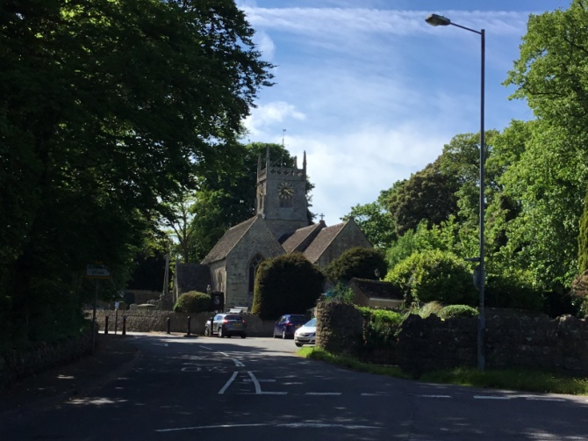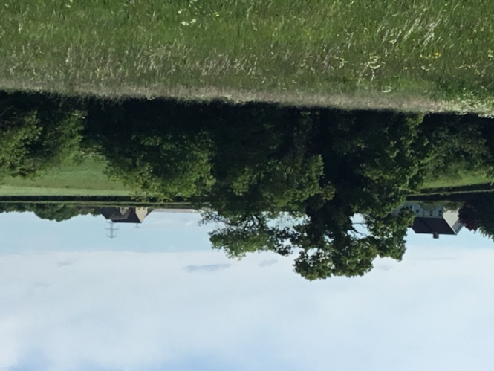 THE STREET TOWARDS THE CHURCH FROM STONE LANE TOWARDS PURTON
Wiltshire Core Strategy Policy 50 already seeks to protect biodiversity and geo-diversity and will be applied to all proposals for new development in the plan area. Wiltshire Core Strategy Policy 51 recognises that the principal pressure on the landscape arising from new development is erosion of the separate identity, character, visual and functional amenity of settlements and their setting, and impacts on the open countryside.
Lydiard Millicent Policy 2C New development to retain and enhance existing green infrastructure
- New development proposals to demonstrate how any development will protect and enhance features of nature conservation and geological value.
- Landowners to maintain hedges, ditches and watercourses

Lydiard Millicent Policy 2B Maintain and enhance existing open green spaces and pastures
- Consider introduction of cycle paths and further roadside footways where possible.
- Maintain existing features of nature conservation and geological value.
- The landscape setting of Lydiard Millicent Parish is to be protected by this policy to prevent the persistent erosion of the separation between the village and the Borough of Swindon.

Lydiard Millicent Policy 2A Development proposals should be sensitive to the Parish, settlement identity and defining characteristics of the local area, and demonstrate how they would maintain the quality of the local built and natural environment.
- Care taken to protect and enhance the historical environment.
- Maintain and enhance existing open green spaces and pasture.
- Retain existing hedgerows and outstanding trees
- Encourage more safe play areas to be created.
- Consider further footpaths to aid pedestrian access and movement.
- Consider introduction of cycle paths where possible.
- Maintain existing features of nature conservation and geological value.
- Key local landscapes and recreational amenities to be protected and enhanced.

Wiltshire Core Strategy Policy 52 already seeks to protect green space in Wiltshire and will be applied to all proposals for new development in the plan area.NPPF, paragraph 17, already acknowledges that it is important to take account of the different roles which supports thriving rural communities and character of different areas and to recognise the intrinsic character and beauty of the countryside,.
13 Facilities
Aims:
- Support the development of retail opportunities in the village
- To make provision for the play/sports needs of older children and teenagers
Lydiard Millicent Policy 3A: Class A3 (restaurants and Cafes) and A4 (Drinking Establishments) uses should be protected from conversion to residential accommodation in order to protect the vitality and viability of Lydiard Millicent and increase its self-containment.
The development of retail opportunities, either via new or existing premises, will be supported provided any traffic/transport effects are mitigated, the building is in keeping with the Lydiard Millicent street scene and residential amenity is safeguarded. Any retail development should be located centrally to ensure pedestrian access and enhance commercial viability. Development within the Conservation Area will be required to be sympathetically designed and of a high quality.

The village Post Office and store closed some years ago as a result of Post Office reviews and the competition from convenience stores in Purton and Shaw. There is some demand in Lydiard Millicent for a village shop and post office. There is good support for local restaurants and pubs and a desire to resist their conversion to other uses
Green space, including the sports ground and playground, are valued by Lydiard Millicent Parish residents who would like to see more facilities and opportunities for older children in the parish.
The school has strong support from the parish, though road safety in this area was expressed as a concern by many residents.
Lydiard Millicent Policy 3B: Lydiard Millicent Parish Hall and play areas are important community resources which will be protected from development.
Residential development within the parish will be expected to contribute towards the ongoing maintenance and enhancement of the play areas. Specifically, the development of an outdoor multi-sports play area for older children at an appropriate location will be supported, provided the amenity of surrounding residents is taken into consideration. There is a suitable area on the parish sports field where a multi-sport facility could be constructed.
Continued support for the Parish Hall which is well used as a community resource

Residential dw

14 Housing and Development

Aims:
- To protect and enhance the individual, separate identity of the many historic rural settlements within its area of Lydiard Millicent Parish. The beauty and intrinsic value of the countryside should be protected and any development should be located to avoid the gradual, persistent erosion of the separation between Lydiard Millicent Village and surrounding villages within the neighbourhood plan area and with Swindon.
- Development should be managed and located to enable improvements in road safety and introduce reduced traffic speeds both within and between villages to protect the rural character of country lanes.
- To promote limited development within the built area of Lydiard Millicent Village as infill.
- It is important to protect the health, safety and wellbeing of these rural communities whilst maintaining the quality of life and integrity of this living environment

The community in Lydiard Millicent Village has its own identity and wishes to remain a separate village. Residents felt it was important to encourage a mix of ages within the village.
Limited residential development in Lydiard Millicent Parish should be of small scale and reflect the needs of the community as set out in both the Wiltshire Council and Parish Council Housing Needs Survey. (See Evidence) It is essential that development makes provision for the needs of families and young people by providing a range of dwelling sizes and styles, in keeping with the character of the area.
Some very modest development may be appropriate to respond to local needs and to contribute to the vitality of the rural community.
There is a desire for high quality, environmentally sensitive, small scale development to provide housing to accommodate the older population and young people/families who wish to remain in the area. This is in accordance with the Wiltshire Council Core Strategy for Small Villages and in line with the Wiltshire Council Housing Needs Survey and the Lydiard Millicent Parish Council Neighbourhood Plan Questionnaire. This development was felt to be best accommodated within the existing built up area of the habitations avoiding greenfield sites.
Any development must promote good design which reflects the key characteristics of the historic settlements in the area to retain and enhance the individual identity of the Parish. Key characteristics relate to both the relationship between buildings and the materials used.
Key points:
Good design is encouraged, development conforms to the local character and is locally distinctive.
Development is supported where it respects local character and promotes the distinctiveness of the parish through the use of appropriate scale, design and materials
The distinct character and vitality of the parish is maintained
Open space between the village, the hamlets and Swindon is encouraged
The integrity of the local built environment is maintained
Good design helps to provide a sense of place, creates or reinforces local distinctiveness, promotes community cohesiveness and social well-being. The Wiltshire Core Strategy recognises that development needs to be carefully planned to ensure that valuable features and characteristics are protected and enhanced. Core policy 51- Ensuring High Quality Design and Place Shaping applies to all development in Wiltshire and seeks to make sure development responds to local distinctiveness by drawing on local context. The key characteristics described will supplement the implementation of core policy 51 in the plan area.
Objectives.
The provision of the housing need is met
Infill,( as defined by Wiltshire Core Strategy ),is encouraged where it is in keeping with the character of the village
New development offers a range of house types
The development of low cost, smaller dwellings well related to the services and amenities of the village are promoted to meet the needs of 1st time buyers and older people
New development is constructed to the Lifetime homes standard
Design of new development is resilient to the effects of climate change
The rural nature of the village is maintained
The green, open undeveloped space around the settlement areas is protected

Properties should be:
- Located within the existing built up areas.
- Generally comprise not more than a small group of house, of no more than 10 dwellings, that is infill. Sites larger than this would not be appropriate in scale to this rural location with limited facilities.
- Within easy and safe walking distance of parish facilities such as The Parish Hall ,the school, the Church, the Sun Inn and main housing areas.
- On a bus route.
- With a clear access on to a road with good safety record and minimal history of speeding, and have adequate off road parking or garaging.
- Connected to main drainage and full pressure water supply.

Lydiard Millicent Parish wishes to adopt these objectives as it seeks to promote good design, and encourages development that respects the existing character and form of settlement.

All policies included in the neighbourhood plan need to have regard to the Wiltshire Core Strategy and the National Planning Policy Framework. The Wiltshire Core Strategy policies view Lydiard Millicent Village as a small village where development is restricted.
Evidence referred to in the preparation of this section of the plan includes:
- Lydiard Millicent Parish Plan, 2005
- Lydiard Millicent Parish Plan Update 2011
- Lydiard Millicent Parish Council Housing Questionnaire 2013
- Results of the LMPC Housing questionnaire 2013
- Lydiard Millicent Postcards of the Future Survey 2013 (Common Places)
- Wiltshire Council Housing Needs Survey (April 2016)
Evidence in these documents was gathered in relation to the requirements for the NEW-V Neighbourhood Plan. It is felt that these responses are still valid even though we are now unable to continue with NEW-V and are completing our own plan.
Development in Lydiard Millicent Parish will be expected to demonstrate high quality design and be sensitive to the historic environment of the area. Development within the setting of listed buildings or in the Conservation Areas is expected to respect the local context, taking opportunities to sympathise with the street scene, such as lime-washed, rendered or other exteriors in keeping with existing older properties. Development in the centre of Lydiard Millicent village will be expected to make provision for a village green.
Lydiard Millicent Policy 4: Development and Housing
Limited residential development in Lydiard Millicent Parish should be of small scale and reflect the needs of the community as set out in both the Wiltshire Council and Parish Council Housing Needs Survey. It is essential that development makes provision for the needs of families and young people by providing a range of dwelling sizes and styles, in keeping with the character of the village.
Proposals should be:
- located within the existing built up area of the village, and
- generally comprise not more than a small group of house, that is generally infill. Sites larger than this would not be appropriate in scale to this rural location with limited facilities.
- Within easy and safe walking distance of parish facilities such as the Parish hall, the school, the Church, the Sun Inn and main housing areas.
- On a bus route (both to and from Swindon).
- With a clear access on to a road with a good safety record and minimal history of speeding; adequate off road parking or garaging.
- Connected to main drainage and full pressure water supply.

The Wiltshire Core Strategy supports housing development in settlements through core policies 1,2,19,and 48. It is these policies that will apply. The Wiltshire Core Strategy policies CP1/2 & CP19 view Lydiard Millicent Village as a small village (Core Strategy appendix F) in the countryside where only infill development within the built-up area of the settlement is permitted (CP2 paragraph 4.34 filling of a small gap within the village that is only large enough for not more than a few dwellings, generally only one dwelling).
It is acknowledged that Core Strategy (CP44) allows an exception site of affordable housing of up to 10 dwellings subject to where need can be identified and supported by a majority of the community.

