Alfriston School
Sports College
Penn Road, Knotty Green, Beaconsfield,
Buckinghamshire, HP9 2TS
Telephone: 01494 673740
Email: office@alfristonschool.com
ALFRISTON SCHOOL

ALFRISTON SCHOOL
Full time / Job Share PE / Forest School TEACHER Maternity Cover

POST TITLE - Teacher
SALARY GRADE - £24,859-£39,113 Main pay scale/upper pay scale (depending on experience) plus SEN 1 Allowance of £2,149 per annum (pro rata)

HOURS - Full time or a Part time job share – MATERNITY COVER (0.6 PE and/or 0.4 Forest School)
REQUIRED TO START: SEPTEMBER 2019 or as soon as possible after

Dear Applicant,
Thank you for showing an interest in the vacancy we have at Alfriston School. I hope after reading this information you feel able to apply for this post.
We are looking for an enthusiastic, versatile and motivated teacher of PE / Forest School to be able to deliver high quality teaching and learning across key stages 3, 4 and Post 16 to small groups of secondary aged girls with moderate learning difficulties and to take a shared pastoral responsibility for a group of 12 girls.
We currently anticipate that the timetable would cover PE three days a week, Tuesday, Wednesday and Thursday and Forest School Monday and Friday
Our school is an outstanding Special School Academy, and we are committed to ensure that all our pupils become the best that they can be, and they can enjoy and achieve in all that they do. Our teachers have a strong sense of commitment and use their excellent subject knowledge to provide interesting and creative lessons in which all pupils learn well. They have high expectations of their pupils and develop good supportive relationships within a positive learning atmosphere where the girls can thrive. We cater for a wide range of abilities up to and including GCSE standard.
We are looking for either an experienced or newly qualified PE and/or Forest School teacher who would like to join an established and successful department in our very special school. We need a talented teacher who is also a good team player and who can inspire and motivate girls with learning difficulties. You must have excellent subject knowledge and the passion to pass this on to the pupils you teach. We will support you in understanding and managing the special needs of our pupils and give you an invaluable insight and appreciation of the rewards to be gained from working in a school such as ours.

To apply:
Please complete the application form and write a letter of application (preferably word processed) addressing each of the points in the person specification.

Send the completed form, and letter of application to the school, either by post or to the following email address: office@alfristonschool.com

Closing Date:
The Closing Date for applications is midday Wednesday 3rd July 2019

Interview Date:
The Interview Date will be Wednesday 10th July 2019

If you require any further information please contact Mrs Sandra Rawlings, Office Manager on 01494 673740 or email office@alfristonschool.com.

Yours sincerely
Jinna Male

Jinna Male
Headteacher

ABOUT THE SCHOOL AND STAFF

Alfriston is an outstanding Special School with Sports College status for girls aged 11-19 with moderate learning difficulties and speech, language and communication difficulties, catering for 150 girls. We became an Academy on 1st March 2012. The school has been delivering high quality education since 1950. All the pupils have a statement of special educational need or education, health and care plan and are taught in small groups and with additional support. Our teaching staff are specialist subject teachers and are experienced in working with a range of special needs and abilities.

Pupils attend Alfriston from all over Buckinghamshire and some neighbouring counties. We also have weekly boarding provision for 20 pupils.

We consider the staff team as our most valuable resource. Training and development is a high priority in the school. There is also personal support given to staff to manage the diverse and challenging work needed to support pupils with significant special needs.

At present there are over 50 staff employed at the school working in the teaching, support, residential and administrative teams. We are proud of the excellent standard of education provided at Alfriston.

Our website is www.alfristonschool.com

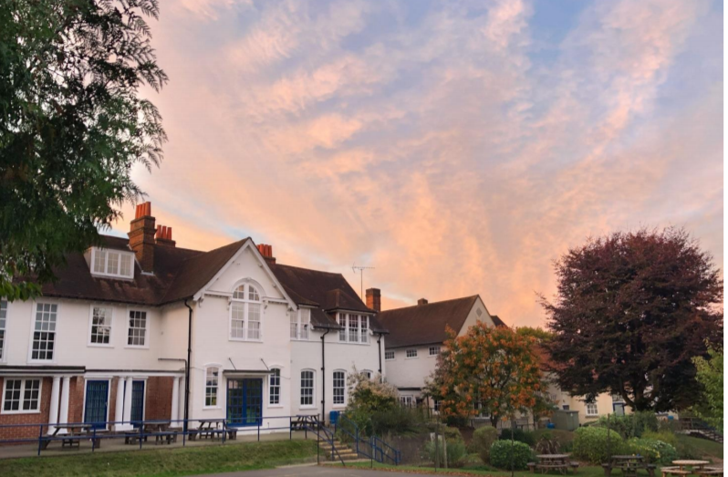

JOB DESCRIPTION
P/T PE AND SPORTS TEACHER (0.6)
P/T FOREST SCHOOL TEACHER (0.4)

Job Purpose
To teach pupils within the school with particular responsibility for the general education, pastoral care and welfare of the pupils in their class. This includes maintaining pupil records, assessment and liaison with parents and other professionals, and to carry out such duties as are reasonably assigned by the Headteacher

Employment Duties
This job description is to be performed in accordance with the provisions of the School Teachers’ Pay and Conditions Document and within the range of teachers’ duties as set out in that document.

Responsibilities
- To teach, according to their educational needs, pupils assigned to the class

- To monitor, assess and maintain records on pupils’ progress, academic and behavioural, and use these to inform planning and teaching

- To supervise the work of the SSA, delegate duties and to maintain an ordered classroom

- To maintain discipline in accordance with the school’s policy on behaviour

- To contribute to meetings, discussions and consultations necessary to co-ordinate the work within music and the school as a whole

- To promote equal opportunities within the school and to represent the school positively

- To demonstrate good practice and to be able to support and encourage teacher colleagues

PERSON SPECIFICATION
P/T PE AND SPORTS TEACHER (0.6)
P/T FOREST SCHOOL TEACHER (0.4)

Criteria | Desirable | Essential
Experience
Teaching in a mainstream or special school |  | Y
Working with children with special needs | Y
Qualifications and Training
Level 3 Forest School Leader Y*
Qualified Teacher Status |  | Y
Evidence of Continuing Professional Development | Y
Special needs qualification | Y
Knowledge and Skills
Able to teach Physical Education |  | Y**
Able to lead teams and individuals | Y
Able to use ICT to support teaching and learning |  | Y
Understanding of promoting positive relationships within the wider school community |  | Y
Understanding equality and diversity issues and implications for policy and practice |  | Y
Ability to drive the school minibus | Y
Personal Qualities
Highly developed interpersonal skills |  | Y
Ability to work under pressure and meet deadlines, accepting the flexibility to attend twilight and evening meetings as required |  | Y
Ability to successfully work in collaboration with colleague teachers |  | Y
Ability to relate to young people in a positive manner |  | Y
Willingness to constructively challenge the work of self and others to continually improve own and team performance |  | Y
To show loyalty and commitment to the school |  | Y
Y* Forest School role only
Y** PE role only

