Education, Health and Care Plans (EHCP)
What is an EHCP?
An EHC plan is a legal document that describes a child or young person’s special educational, health and social care needs. It explains the extra help that will be given to meet those needs and how that help will support the child or young person to achieve what they want to in their life. It will aid the teaching and support staff working with your child and will include:
- The views, interests and aspirations of the children and young people and their parent/carer
- An outline of the child or young person’s special educational need
- Outcomes covering education, health and social care
- The special educational provision needed to support the child or young person
- The name and type of current education setting
- Resources attached to the plan
- Personal budget information (if applicable)
The plan is a very detailed assessment of your child under the Children and Families Act 2014. It will include detailed reports about the child or young person from a number of people, including:
- Parents/carers
- The child/young person
- Teachers
- Educational practitioners
- Health practitioners
Before a plan is issued, the local authority will need to make an education, health and care needs assessment of the child. The plan will describe the child’s needs and the specialist help and provision required to meet those needs.
Education, health and care plans can be accessible for children and young people from 0-25 years of age, if the young person stays in some form of education or training. Students going to university will not be eligible for a plan.
What happens once the EHC plan has been prepared?
Once the plan is prepared the local authority must send the draft EHC plan (including any appendices) to the child’s parent or to the young people themselves and allow at least 15 days to give views and make comments on the content.
During this time, the local authority must make officers available for meetings with parents/carers or the young person on request if they wish to discuss the content of the draft EHC plan.
For more information on EHC plans
Visit: www.dfes.gov.uk
The SEN code of practice is available on the website.

Signed:
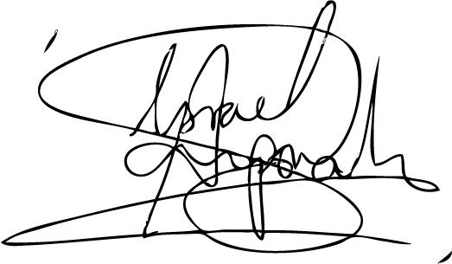

Date of review: 10th August 2020
Date of next review: 10th August 2021

