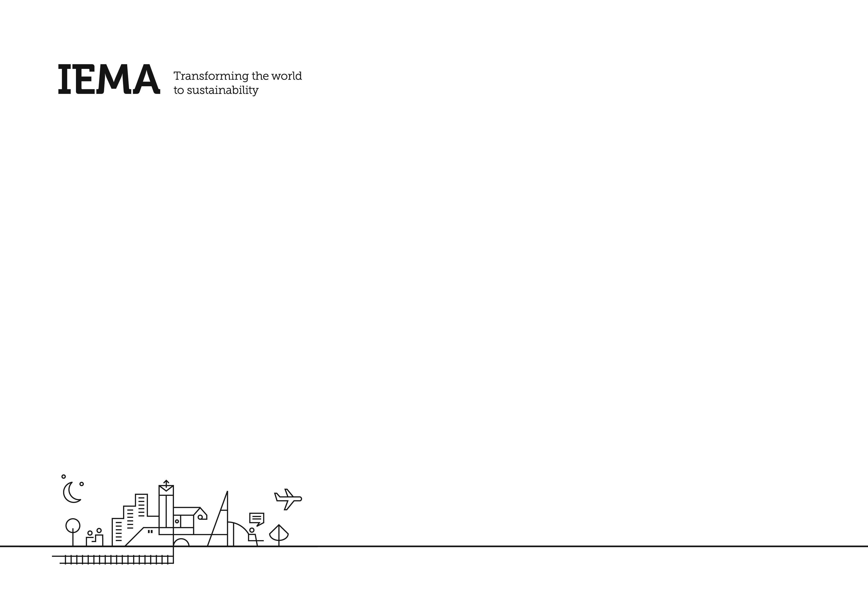
Continual Professional Development Record

Recording your CPD step-by-step

Maintaining a CPD record is a mandatory requirement for all IEMA professional membership grades. From Graduate to Fellow, all members have to declare they have taken part in relevant CPD activities each year in order to retain their membership. So, if your membership has a professional suffix, be sure to set your development goals and begin logging your CPD activities right away. See below for a reminder on our CPD requirements:

CPD Requirements:
- Set 2-4 personal development goals for the year ahead to meet your learning and development needs (these can be career goals or personal milestones).
- Aim to log at least 30 hours of related CPD each year that keeps your knowledge current and your development on track.
- Describe the value recevied from participating in the listed activities (e.g., How have you put your learning into practice? What do you now know as a result of this activity? Has it moved you closer to achieving your goals?)
- Provide an overall Reflection on the progress made towards your goals (e.g., Did you achieve them? What worked well? What did not? What may you do differently next year?)

Step 1: Identify your goals
The first and most crucial step in your annual CPD cycle is recognising what you want to achieve in the short and long term. Setting ambitious yet realistic targets for building knowledge, skills and your network, will guide what activities you get involved with. Ask yourself what areas of the Skills Map you need to strengthen. What areas of your role prove tricky, but you know you need to overcome? How will you build your professional profile in the next 12 months? These questions will help you build your plan of action. Take some time to really think about what you want to achieve and log that using this form.

Steps 2 and 3: Record your CPD activities
Logging your learning gives you an opportunity to reflect on what you have gained, learned, and achieved by doing your CPD activities. It also gives you the chance to think about how you can practically apply your new knowledge, and even stimulates what learning you’ll do next. Remember professional development activities are not restricted to formal classroom training courses. You can do CPD at any time through day-to-day activities like reading, coaching and mentoring, experiential learning, networking, dialling into webinars, attending conferences and getting involved in research. Use the IEMA CPD Form to record each CPD activity you do. The form’s fields will prompt you to log the right details and help you reflect and evaluate on how each activity benefits your career.

Step 3 (Continued): Record your work activity (Specialist Registers only)
Your status on one of IEMA’s Specialist Registers – Environmental Auditing, Environmental Impact Assessment and Energy Savings Opportunity Scheme (ESOS) – depends on you demonstrating that you're continuing to be active in relation to your specialisation. Use this section to list the relevant work you have been doing as it relates to your Specialist Register membership.

Step 4: Reflect and declare
Reflection is as much a part of the learning process as doing the activity itself. It helps you think about what you’ve learned, and what you’ll do differently in future. Take some time to consider the progress you’ve made towards your overall goals. What did the activities you got involved in contribute to your career? Did those activities help you to achieve your goals? Would you choose a different profile of activities for your next year of CPD to ensure you stay on track and continue to see results?

Once you have completed your form, send it in to us at info@iema.net.

About you
Name |  | Email Address
Membership Number |  | Membership Grade (including Specialist Register if applicable)
Job Title |  | Primary Work Area
Location (if in the UK) |  | Location (if outside the UK)

Step 1: Identify your goals
What are your goals? What skills and knowledge do you need to develop in order to help you achieve them? You should try to set yourself both short and longer term goals.
Learning and Development Goals:  These can include career goals, membership goals or could include a specific personal or workplace milestone on you or your employer’s journey to sustainability |  | Type of Goal | For membership Goals only, which grade do you want to achieve? | When do you want to achieve it? | Primary topic your goal relates to | How will you achieve your goal?  Remember development activities are not restricted to formal training courses, and may occur through day-to-day activities, including coaching and mentoring, experiential learning, networking, webinars, conferences, research, and reading.
1 |  | Choose an item. | Choose an item. |  | Choose an item.
2 |  | Choose an item. | Choose an item. |  | Choose an item.
3 |  | Choose an item. | Choose an item. |  | Choose an item.

Steps 2 and 3: Record your CPD activities and evaluate your results
Date | Type of Activity | Description of Activity  Developing Yourself/Developing Others/Work Activities | Main Competency the activity relates to | Level of work the activity relates to | Lessons Learnt  What have your learned from undertaking this activity? | Benefits Gained  What will you do differently? How has the activity benefitted your work practices? | Number of hours per activity
Click or tap to enter a date. | Choose an item. |  | Choose an item. | Choose an item.
Click or tap to enter a date. | Choose an item. |  | Choose an item. | Choose an item.
Click or tap to enter a date. | Choose an item. |  | Choose an item. | Choose an item.
Click or tap to enter a date. | Choose an item. |  | Choose an item. | Choose an item.
Click or tap to enter a date. | Choose an item. |  | Choose an item. | Choose an item.
Click or tap to enter a date. | Choose an item. |  | Choose an item. | Choose an item.
Click or tap to enter a date. | Choose an item. |  | Choose an item. | Choose an item.
Total number of hours:

Step 4: Reflection and Declaration
Identify your principal learning lessons.
Reflect on the activities you have described in this submission to identify:
- The progress you have made towards your goals
- The nature of activities that you get most learning and development value from
- What you will do differently next year to continue to progress towards your objectives

Declaration
The information I have provided is a true and accurate record of my Continuing Professional Development (CPD)
Name: | Date:

By submitting this information, you agree with the points laid out in IEMA’s Privacy Policy regarding the collection of personal data

Step 3 (Continued): Record work activity for Specialist Registers only
Date(s) work was undertaken | Number of days onsite  Numeric, i.e., 1, 2, 3 | Number of days offsite  Numeric, i.e., 1, 2, 3 | Role in Project/Audit  - L = Lead Auditor, Sole Auditor  - A = Auditor; under supervision of Lead Auditor  - TP = Training Provider  - PM = Project Manager  - O = Other | Supervised  Yes / No | Number in team  Numeric, i.e., 1, 2, 3 | Description of:  - CPD activity  - ESOS competency if applicable  - Training received  - Training provided | Verification of third party:  - Company Name  - Website  - Industry / Sector
Example:  20-21 June 2017 | 2 | 1 | L | No | 2 | Conducted a full Initial Environmental Review of a garage. | Name of company, company website, industry sector.
 |  |  | Choose an item. | Choose an item.
 |  |  | Choose an item. | Choose an item.
 |  |  | Choose an item. | Choose an item.

