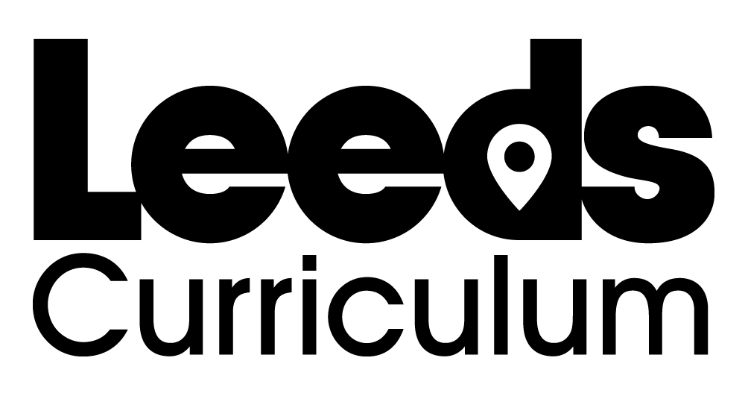
My Music Hall Character

What is your character’s name?

What is their act? How do they entertain the audience?

Draw a picture of your character’s costume.

Teachers notes
Literacy links:
Many music hall acts used alliteration to make their acts sound more exciting e.g. ‘Miniature Marie’ or ‘Daisy and Dots’.
Other acts used exotic language or place names to make their acts sound more unusual and intriguing e.g. ‘Les Bons Bons’ or ‘Zehini and Son, the Great Parisian Acrobats’.
The Chairman would use a great array of adjectives to introduce each act; a good way to expand pupils’ vocabulary.
Have a look at http://www.leodis.net/playbills/ for images of historic playbills at City Varieties and examples of real music hall acts.

