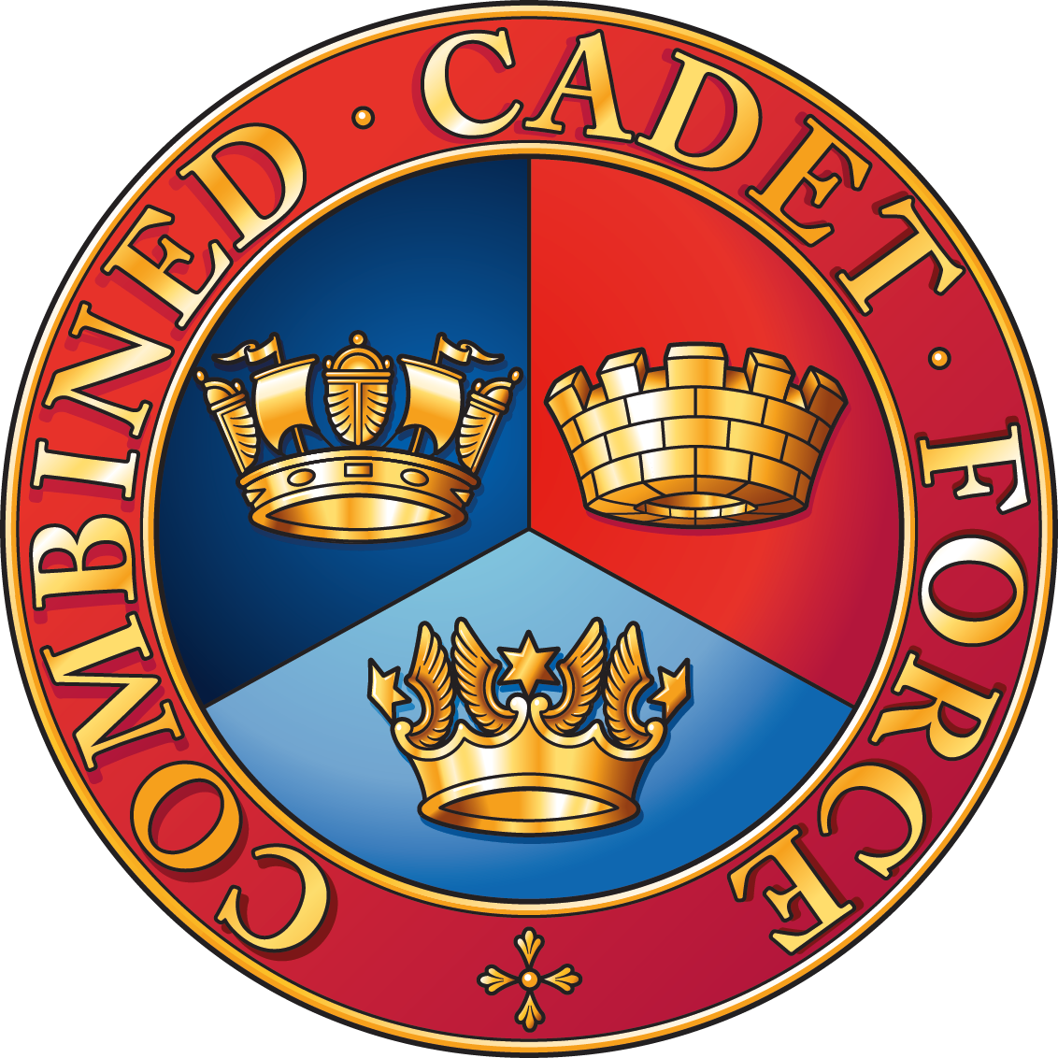

Consent form

Name of cadet ____________________________________________

I give consent for my/my child’s image to be submitted to the Combined Cadet Force Association Photographic Competition.
I understand that submitted images may be used in CCF publications and the CCF website, as well as for future promotion of this competition. Please note that websites can be viewed throughout the world and not just in the United Kingdom.

CCFA Policy
If the photograph is used, we will avoid naming the child - so we will not use children’s full names alongside their photographs in the CCF’s own printed publications, or on our website. However, children’s first names may be used, where they cannot be linked to individuals in the photograph.
Declaration: I have read and understood the CCFA policy. My decision on whether to give consent will remain valid for future competitions run by CCFA, unless I notify the CCFA to the contrary in writing.
Name: _________________________________________ (Parent/Guardian if under 18)
Signed: __________________________________________(Parent/Guardian if under 18)
Date: _________________
e-mail address_________________________________

