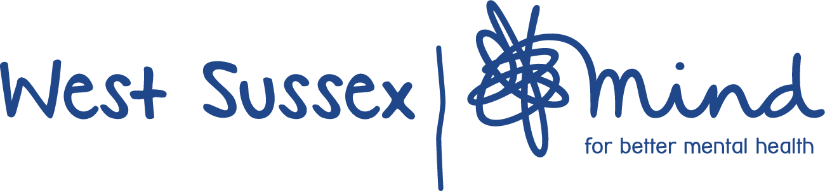
Brief for Equality, Diversity & Inclusion Pledge development Consultant and Facilitator
1. Background
In early 2021 West Sussex Mind started a piece of work to focus our attention on Equality, Diversity and Inclusion. Two working groups were set up, one to look at the Trustee Board and one at the wider organisation. Both of these working groups have now put together a plan for the next year. The idea for the pledge came from wider staff working group and is one of our priorities for 2021/22. Our Board Diversity and Equality, Diversity & Inclusion Action plans can be shared for information on request.
2. What we are looking for
West Sussex Mind are looking for proposals from organisations/individuals that are interested in working with us to create an equality, diversity and inclusion pledge. The pledge will be the end result of a facilitated development programme which challenges staff to explore their views and behaviours and agree the actions that we commit to take as individuals and as an organisation to bring change.
We feel that the process of creating the pledge is as important, if not more so than the pledge itself, especially in terms of engaging staff and challenging ourselves and each other in a safe space to understand prejudice and bias. To ensure the pledge is kept as a live document we intend to link it to our staff competencies/behaviours and annual appraisal process and ensure each staff member has an EDI target each year as part of their development.
We are, therefore looking for proposals to facilitate the following:
Phase 1 – Focus groups – September 2021
- 2 x half day development sessions - with staff/volunteers including trustees – Up to 20 individuals in each group – Via zoom
The purpose of the staff/volunteer development sessions will be to provide space for discussion and reflection around their understanding of and what equality, diversity and inclusion means to individuals in the context of their work and our organisation and to gather thoughts and ideas around what is important and should be included in an organisational pledge around this.
- 2 x focus groups (2hrs maximum) with people who use our services – Up to 10 individuals in each group with WSX Mind staff to support – In person or via zoom
The purpose of the service user focus groups will be to provide space for discussion and reflection around what equality, diversity and inclusion means to individuals in the context of their mental health and experience of our organisation and work and to gather thoughts and ideas around what is important and should be included in an organisational pledge around this.
Consultant to write up all output from these 4 sessions.
Phase 2 – Staff conference – October 2021
On 20-10-21 we plan to have an in person staff/volunteer conference (venue to be arranged – Probably around 100 people) – We would like to spend 2 hour morning slot at conference – Feeding in work and ideas from September focus groups/workshops, getting conference participants to have discussions and work on developing these ideas with intention that can then use material to develop pledge – Could involve some of individuals from our EDI working group in doing this – Want consultant to plan out this 2 hr session – Lead facilitation of this and then write up output from conference session and then draft a proposed pledge for WSX Mind.
Consultant expected to: | West Sussex Mind will:
- Plan & develop content staff/volunteer workshops and service user focus groups in consultation with WSX Mind link person  - Lead/deliver workshops/focus groups & conference content  - Write up out-puts from all focus groups/workshops/conference as per agreed timescales and also from these after conference to pull together and draft proposed pledge | - Provide link person to liaise with around delivery and agreeing programme/content etc  - Book venues/provide zoom links  - Provide technical support for zoom workshops (member of staff to support running of session)  - Publicise and recruit participants for workshops/focus groups  - Provide staff to support service user focus sessions

3. Our requirements
If you feel you can submit a proposal that meets the areas outlined in the overview section we would like you to submit a proposal containing the following information:
- Your proposed approach to delivering programme outlined in 2.
- Your experience and approach to providing similar EDI workshops/consultancy for other clients
- How many days work you estimate for undertaking this work and your breakdown of fees/daily rates and any other costs you envisage
- Two references from other clients who we could approach prior to contracting.
Proposals should be submitted by Friday 11th June 2021 by email to: katie.glover@westsussexmind.org
If you wish to speak to someone prior to submitting a bid – please can you also email
We will evaluate proposals using the following criteria:
- Experience and track record in delivering similar programmes
- Ideas to engage and challenge staff in the development of our pledge
- Cost effectiveness
- Capacity for innovation and value

