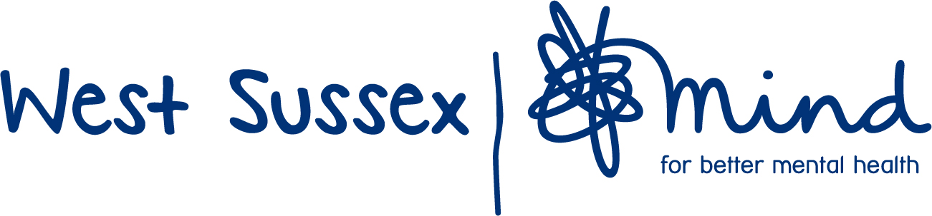

Volunteer Role Profile

Role title: | General assistant volunteer – activities & events
Name of Project: | Communities in Mind – Bognor & Chichester
Name of Supervisor: | Joanna Bulis (Service Manager) or Julia Dendle (Coordinator)
Main purpose: | As Covid-19 conditions allow and under strict guidelines in accordance with internal and external policies and protocols:  - To assist and support staff to deliver a variety of activities to enhance the experience of service users and help support their mental health and wellbeing.  - To help at events and engage with the public to raise awareness about mental health.
Location of role: | Bognor or Chichester areas by agreement, at different venues (e.g. Laburnum Centre, Bognor or Bassil Shippham Centre, Chichester)
Times/Days volunteer required: | On either or both days, by agreement, depending on your availability:  Tuesdays in Bognor, 12.30 – 15.30  Wednesdays in Chichester, 12.30 – 15.30  Occasionally, by prior agreement, on other days and times, to support the needs of the service and wider organization, e.g. for an information day event at the weekend
Responsibilities / Specific tasks: | All volunteering work for WS Mind to be carried out within our policy guidelines and procedures, and following any government guidelines and specifications in relation to the Covid-19 pandemic:  Purchase refreshments for the activity or event, if required.  Help set up & organize the room and environment for an activity.  Help clean the room, furniture, and equipment in line with Covid-19 and WS Mind guidelines and risk assessment.  Help set up information stand, banners, publicity materials etc.  Help distribute leaflets.  Help prepare and clear up refreshments, if applicable.  Meet and greet service users and direct or accompany to allocated room.  Interact with service users and assist them to engage in the activity or event.  Assist with, and occasionally take the lead in, the running of the session, under supervision of paid staff.  Assist with tidying up, washing up and putting things away, and ensure the room/area is put back as found.  Any other reasonable tasks required to ensure the session is delivered safely and for the benefit of services users.
Skills needed:  Qualities needed: | Good communication skills  Ability to carry out some gentle lifting and moving tasks, such as moving chairs and tables  Willingness to carry out a range of practical tasks to support service users.  Positive attitude and enthusiasm  Patience and understanding  Empathy
Qualifications needed: | No qualifications required  An understanding of mental health issues an advantage
Training provided: | WSM induction and training relevant to the role, especially concerning: Safeguarding, Health and Safety, Confidentiality, Data Protection and Professional Boundaries, Mental Health Awareness.
DBS check needed (Y or N): | Yes - enhanced
Benefits to the volunteer: | Opportunity to use your skills to support people with mental health needs.  Experience will be useful for future volunteering or work opportunities.  We will provide constructive feedback and a testimonial/report at the end of your volunteering time with us.
Any other info: | For this role, we would like a regular commitment of at least 6 months and ideally 12 months, at times and days to be agreed with supervisors.  For example: three sessions per month in one location; once a month in both areas; two sessions per month in each area.  This sort of commitment provides continuity for our service users and supports the staff team and the organization to plan efficiently, enabling us to deliver high quality services.

