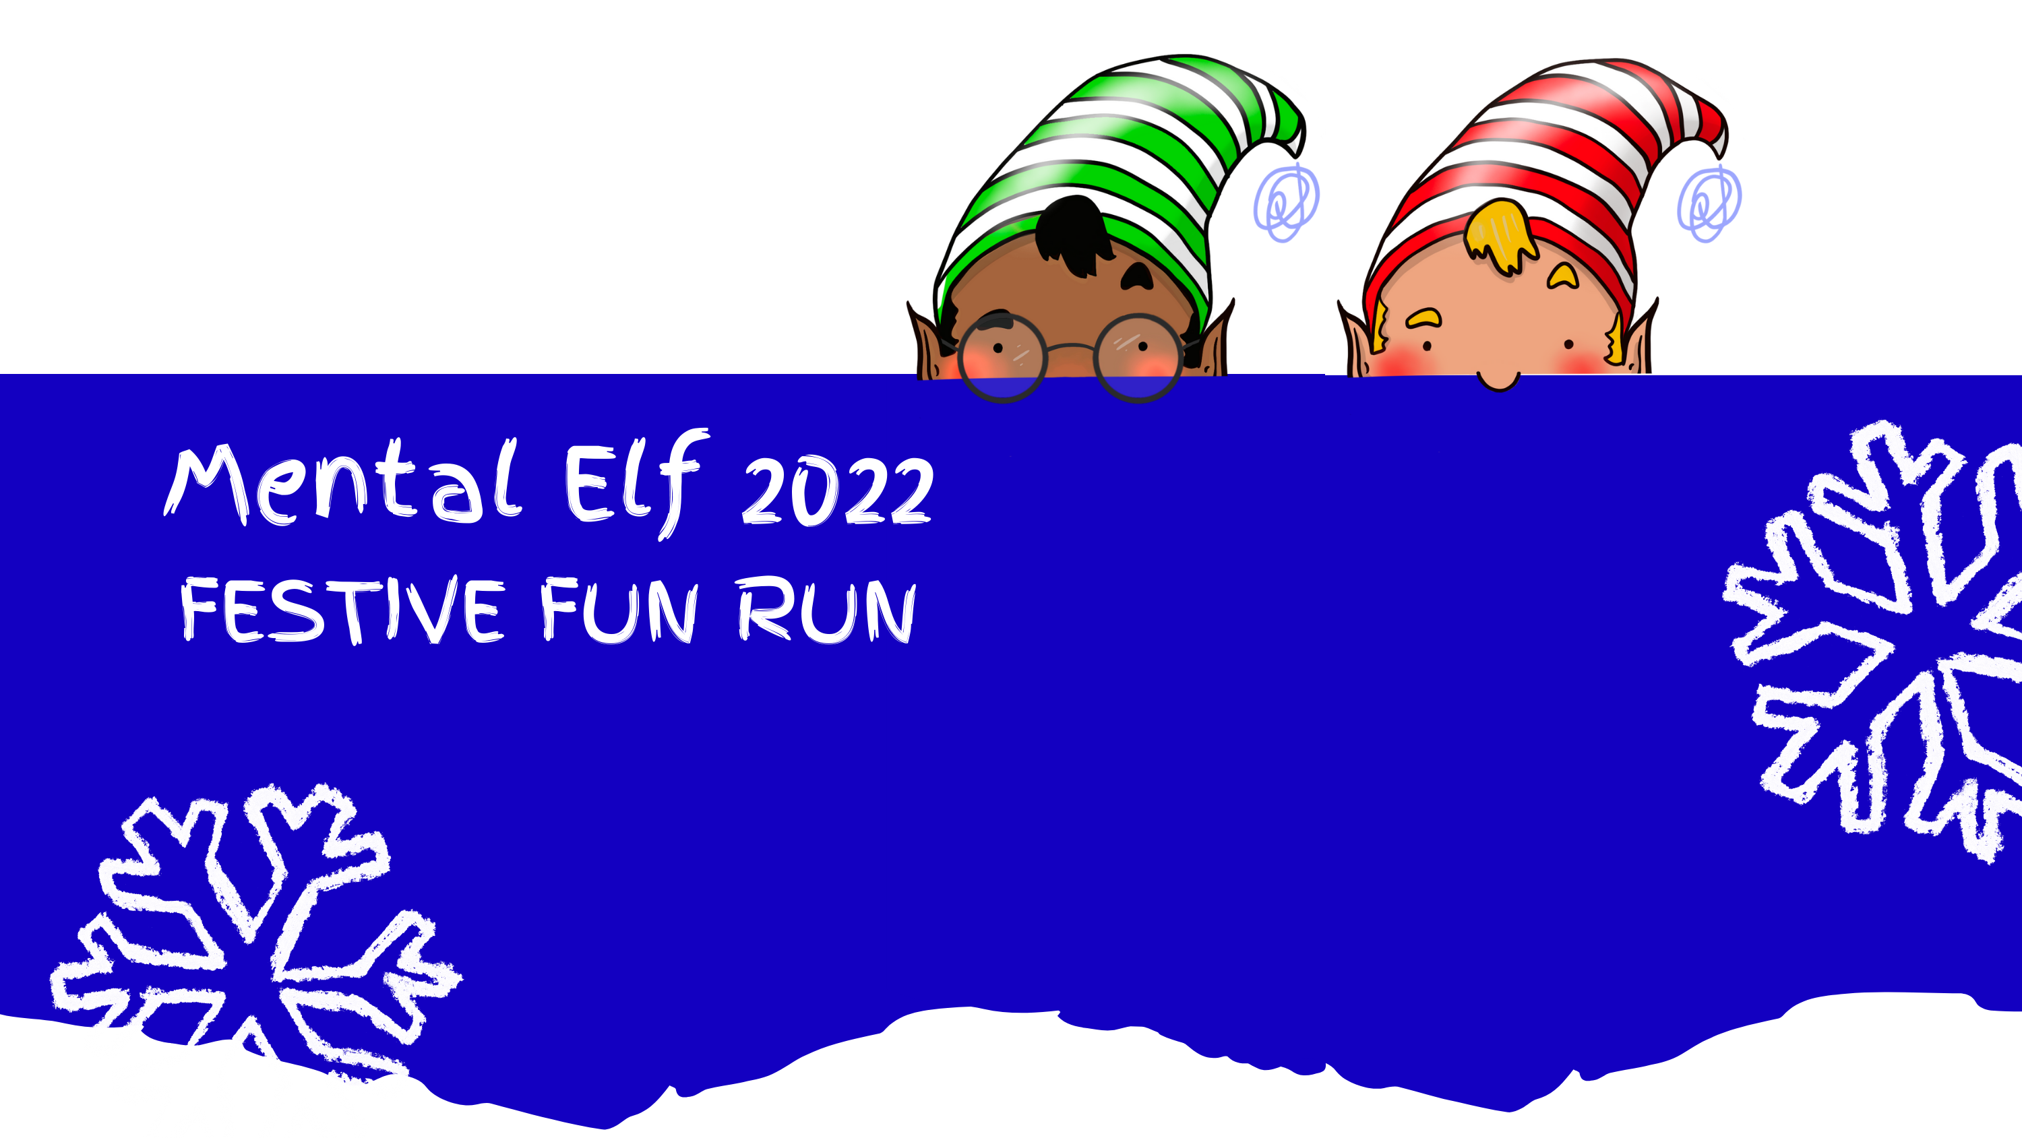
Mental Elf Festive Fun Run- Sunday 27th November 2022

Name ______________________________________________
Address ______________________________________________

Full name (Please print) | Home address (Please print)  Rather than your work address (this is essential for Gift Aid) | Postcode | Donation Amount (£) | Date paid | Gift Aid?*  Please tick

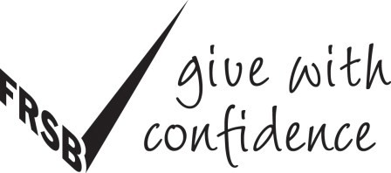
By ticking the box you have agreed that you are a UK Income or Capital Gains taxpayer, and that you want Mind to reclaim tax on your donation detailed, given on the date shown. You understand that you must pay an amount of Income Tax and/or Capital Gains Tax in the tax year at least equal to the amount of tax that all the charities and Community Amateur Sports Clubs you donate to, will reclaim on my gifts for that tax year. You understand that other taxes such as VAT and Council Tax do not qualify.
By adding Gift Aid to your donation, it means that for every £1 you give, the Inland Revenue will give Mind an extra 25p and it doesn’t cost you a penny!

Full name (Please print) | Home address (Please print)  Rather than your work address (this is essential for Gift Aid) | Postcode | Donation Amount (£) | Date paid | Gift Aid? *  Please tick

Cheques should be made payable to West Sussex Mind. Once you’ve completed your fundraising, please collect all your donations and send them /drop them into to the address below with your sponsorship forms:

West Sussex Mind
The Gateway
8-10 Durrington Lane
Worthing
BN13 2QG

If you have any questions regarding fundraising please contact Community Fundraising and Communications Manager Debbie Watkins
Telephone: 01903 277000 email:debbie.watkins@westsussexmind.org Registered Charity Number: 1155918 Company Number: 8884776

