Manager of Therapeutic Services (Female*)

£38,885 pro rata per year
22.5 hours per week
(To include Mondays and Wednesdays - additional hours sometimes available depending on funding)

This post is only open to female applicants as being female is deemed to be a genuine occupational requirement under Schedule 9, Paragraph 1 of the Equality Act 2010.

Dear Applicant

Thank you for your interest in working for RISE and the role of Fundraising & Engagement Manager.

This is your application pack and it will update you on what RISE as an organisation is all about and how you can apply for this role. I hope you will find the information interesting and that it will make you want to be a member of the team.

The application form and Equalities form are included in a separate document.

Please return your application via email to recruitment@riseuk.org.uk by 19 August 2021. During our shortlisting process we anonymise applications; therefore, please do not change the format of the application from word format. PDF format will not be accepted. Please quote the reference number and the job title on the subject of the email.

For those who would prefer to handwrite their application, the application form can be printed from the website and returned via post to:

RISE
PO Box 889
Brighton
BN2 1GH

Please quote the reference number and the job title on the envelope and allow delivery time before the closing date.

The closing date is 19 August 2021 with interviews scheduled for 26 August 2021.
We look forward to receiving your application form and hope the successful candidate will be able to join us as soon as possible.

The following information is provided:

- Organisation Summary
- Working with the expertise at RISE
- Sustainability of RISE
- Plans for the future
- Equality and Diversity
- Data Protection Act 1988
- RISE values
- Benefits of Working for RISE
- The recruitment process
- Job Description
- Person Specification
- Privacy Statement
- Application Form

Organisation Summary

RISE started out twenty-six years ago as the Brighton Women’s Refuge Project, a small, self-funded women’s charity set up to provide a crisis response to those ‘battered women’ (sic) escaping violent intimate partners. We have evolved to become a medium sized charity with a strong reputation and brand, updated in 2007 to become RISE, which stands for Refuge, Information, Support and Education. Our vision is ‘Freedom from Abuse and Violence’ and to this end we work with women, their families and those identifying as LGBTQ+. As part of the women’s movement from inception we are a longstanding member of the Women’s Aid Federation for England, where the RISE CEO is the Vice Chair.

You can find more about us here on our website and here in our latest Annual Report

We take a strengths based, person-centred approach to work with survivors and victims of domestic abuse across our comprehensive range of services which include helpline, casework, workshops and groups, and therapy. We have a strong track-record of developing innovative, responsive services for women, children and LGBTQ+ people, much of it in partnership with key local as well as national funders including National Lottery.
Core to our mission is combating the causes and consequences of violence and abuse as part of a national and international movement by women and girls for women and girls. We have a feminist campaigning and activism deep in our history and have a strong local and regional presence as well as good connections with other women led organisations, including Lewes Ladies FC who are leading Equality FC, Brighton Women’s Centre, Brighton Oasis and the local Violence Against Women and Girls Forum. We are deeply embedded in the Brighton and Hove Community with a strong supporter and volunteer base working with us on our events such as our iconic 8k Women’s race and through community based projects such as Ask Me.

RISE has an established digital presence and a strong social media following:@riseuk and RISEUK facebook.

Working with the expertise at RISE

Having a long history of offering crisis and community services to high risk and other clients, RISE has considerable expertise, policies and procedures that underpin our safe and effective practice when working with survivors. These include safeguarding adults and children policies and procedures compliant with the Pan Sussex Child and Adult Safeguarding; effective risk assessment, case and safety management policies and procedures along with robust clinical governance and complaints frameworks.

The RISE CEO is a member of the Child Safeguarding Partnership and expert RISE staff deliver training to public and voluntary sector colleagues on safeguarding and domestic violence. We have in-house expertise on stalking and harassment; cyber-crime, harmful practices; LGBTQ+; as well as child to parent violence. We also have expertise in ‘harmful cultural practices’, FGM and other religious and cultural harms. We work closely with national bodies such as Southall Black Sisters, Women’s Aid, Safelives, Galop, Paladin and Surviving Economic Abuse to sustain best practice in our specialist field.

However, having recently lost our contract to deliver the risk-led, crisis service for Brighton and Hove to a generic national large charity, we are returning to the original / newly reinvigorated ethos, policies and procedures that underpin our re-visioning of RISE informed by our communities and survivors.

RISE have adopted a needs-led, strengths-based, women-centred approach to casework based on the Women’s Aid VOICES model. Whilst we always take appropriate regard for risk and safety we are centrally committed to fully responding to survivors’ needs and the change in our circumstances enables greater freedom to be fully person-centred and strengths-based, which we know works best for long-term, sustainable recovery.

Likewise, our Trauma-informed policy and procedures that underpin all our work ensure that these key principles are deeply embedded for all staff, community members and survivors. They include feeling safe, trustworthiness/transparency, peer support, collaboration & mutuality, empowerment, voice & choice, cultural, historical and gendered issues.
RISE has an open and transparent dialogue about the issue of power throughout the organisation and beyond. We are interested in calling out and challenging the parallel processes that happen for the majority of domestic abuse services and our re-focusing in on listening primarily to our communities and mobilising their voices, skills, actions and networks is a response to this. We draw inspiration from frameworks such as Ecofeminism, Communitarian feminism and anti-racism narratives to critique the patriarchal structures in order to give back voice and power to those on the margins. These frameworks were developed by grass-roots, activist, marginalised communities in order to challenge the status quo.

RISE has an environmental policy to ensure our environmental footprint is kept to a minimum – we are now applying environmental impact assessments to all our large events and are looking to improve on this.

Sustainability of RISE

RISE’s 5-year strategic plan (2019-24) outlines our key objective to become a by and for organisation – by and for survivors of domestic abuse; by and for the communities we serve. Below are the headlines of our strategic plan:
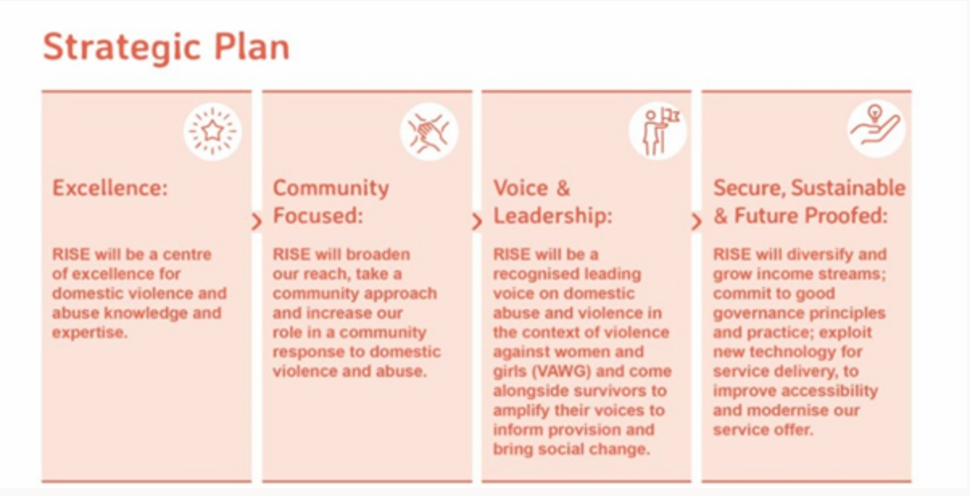
We are clear that we want to shift the balance from contract income; which restricts our flexibility and responsiveness to the wants and needs of our communities and those we serve towards more unrestricted funding so we are able to open up to new possibilities and opportunities brought by the community, as well as committing to our ethos of being a learning organisation that advances the national dialogue about the future of our sector.

Plans for the Future

Having now established our digital and regular giving more firmly we plan to strengthen this income source through a new donor development plan. Alongside this the Board have committed to support the development of corporate giving.
We have invested in developing our Helpline and we want to enable it to continue. We will be bidding for funds to sustain the Helpline Coordinator role, to recruit and retain volunteers and to improve our helpline offer by adding more online resources and Live Chat.
In 2021 we will be launching a new training platform which will be used internally and also for provision of both self-directed learning and more formal courses. This will enable RISE to provide community–focussed learning opportunities as well as professional training through an online portal to raise awareness and generate a new income stream.
We are committed to growing our work with mothers, babies, children and young people and growing our housing support offer.

Equality and Diversity

Our equalities and diversity policy and procedures ensure that RISE works to eliminate discrimination, advance equality of opportunity, foster good relations between groups, promote, and protect human rights in its service provision and as an employer along the criteria of protected characteristics. Due to the remit of RISE to provide services to vulnerable people and in accordance with the legal framework set out within the Equality Act (2010) Section 9, the recruitment to some posts may be restricted by a protected characteristic if it is a genuine occupational requirement. Most posts at RISE will be female only as we provide female only services. This will require those that are not female to follow the requirements of our services to enable female only safe space. RISE also have an effective equalities working group overseeing a comprehensive workplan; for example, we recently trained all staff on understanding on unconscious bias and how to develop best practice for full accessibility for marginalised groups.

RISE is committed to promoting fairness and eliminating discrimination within its practices. As part of the recruitment process the name, contact details, the details of referees and the page with the Equalities form will be all removed from your application and your application will be given an application number before forwarding on to the shortlisting stage. At least two people will individually score the application. The candidates who have the highest combined score above a set level will be selected for interview.

Data Protection Act 1988.

Please note that your application form will be stored securely, and the information you have provided will not be disclosed to any outside agency unless we are obliged to do so. Forms from successful applicants will be used as a basis for the personnel record. Forms from unsuccessful applicants will be destroyed after six months. Those applicants who have consented for their details to be held on file for future vacancies will be considered for other roles during the six-month period.

RISE’s values

Respect
‘Places esteem upon the individual, their processes, and resources. Effectively communicates positive regard through verbal and non-verbal messages which reinforce an individual’s self-worth, strengths, choices and freedoms.’

Independence
‘Fostering a sense of personal responsibility in people giving them the confidence to make their own decisions and to live their lives free from control

Safety
‘Understands, promotes and models practice which places priority upon the physical and emotional safety of the self and others, having the ability to recognise and challenge unsafe practice effectively and appropriately.

Equality
‘Places priority upon understanding and challenging the prejudices of the self, others, organisations and institutions in order to ensure that services meet the needs of all individuals regardless of gender, age, race, culture, religion, education, sexual orientation, class and ethnicity.

Benefits of working for RISE:

- An employer contribution of 3% into our stakeholder pension scheme via Standard Life (on condition that you remain enrolled in the pension scheme and contribute a minimum of 5% of your salary)
- Generous annual leave of 27 days rising to 29 days after 5 years plus bank holidays (pro rata if part-time)
- Training and Learning Opportunities
- Free tea and coffee
- Eye test and a contribution towards glasses if required for work.
- Employee Assistance Programme (Health Assured is our provider)
- Flexible working alongside RISE’s priorities to ensure well-being at work.
- Trauma Focussed wellbeing support.

The Recruitment Process

At RISE we are committed to providing the best possible recruitment service and experience to candidates. We commit to:

- treating you in a polite, helpful and friendly manner at all times.
- Information that you provide will be treated as confidential and will be seen only by those involved in the recruitment process.

- We will remove all personal information from your application to ensure that the short listing panel are not aware of whose application they are assessing. All staff will have undergone recent unconscious bias training.

- We will ask you to complete an equal opportunities questionnaire – this information is only used for monitoring purposes.

- We will endeavour to make any reasonable adjustments to the selection process (application form, interview or training) to enable individuals to participate equally as requested by candidates

- If you are selected to progress to the next stage you will be advised as soon as possible.

- We will aim to give you at least one week’s notice prior to interview, or we will make it clear in the job advertisement when the interviews will be held.

- We provide the questions you will asked at the interview 20 minutes before the interview to help you prepare.

- We will not contact your referees unless you give your permission. We will however need to obtain two satisfactory work references as a condition of any employment offer.

- A decision will be made as soon as possible after interviews and you will be informed, normally within 1 week.

- Unsuccessful interviewees will be offered feedback if requested.

We look forward to receiving your completed application form and wish you success.

