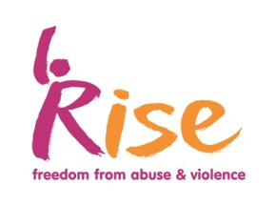
Equality Monitoring Form
Rise is committed to promoting fairness and eliminating discrimination within its practices. The information given will be stored anonymously and confidentially in accordance with the Data Protection Act (1998). It will be used for statistical and monitoring purposes only. This form will be removed from your application BEFORE entering the shortlisting process to prevent discrimination.

What gender are you?
Male
Female
Transgender
Other
Declined to answer

Which age group do you fit?
Under 18
18 – 24 years
25 – 34 years
35 – 44 years
45 – 54 years
55 – 60 years
65+ years
Declined to answer

How would you describe your sexual orientation?
Heterosexual
Lesbian
Gay man
Bisexual
Don’t know
Other
Declined to answer

Do you consider yourself disabled?
If yes, in what way?
No disability
Physical
Learning Difficulties
Mental Health
Other
Don’t know
Declined to answer
Please state more details…

What is your ethnicity?
A | White
 | White British
 | White other
 | Gypsy / Traveler
B | Asian
 | Asian British
 | Indian
 | Pakistani
 | Bangladeshi
 | Other Asian background
C | Black or Black British
 | Black British
 | Caribbean
 | African
 | Other Black background
D | Mixed
 | White and black Caribbean
 | White and black African
 | White and Asian
E | Other mixed background
 | Arab
 | Chinese
 | Other ethnic group
 | Please state:
 | Don’t know
 | Declined to answer

What is your religion or faith?
No religion
Buddhist
Christian (all denominations)
Hindu
Jewish
Muslim
Sikh
Other
Declined to answer
Don’t know

