IBD Patient Survey findings for [insert hospital name] now available

We’re delighted to announce positive findings from the IBD Benchmarking Tool for our hospital treating people with Inflammatory Bowel Disease (IBD) – of which Crohn’s Disease and Colitis are the two main forms.

Thank you to those who took part in the IBD Patient Survey and to all our patients. We welcome your ongoing feedback to help us continually improve.

Through the IBD Patient Survey, conducted as part of the IBD Benchmarking Tool, our patients highlighted:
- [Insert IBD Patient Survey findings – example below]

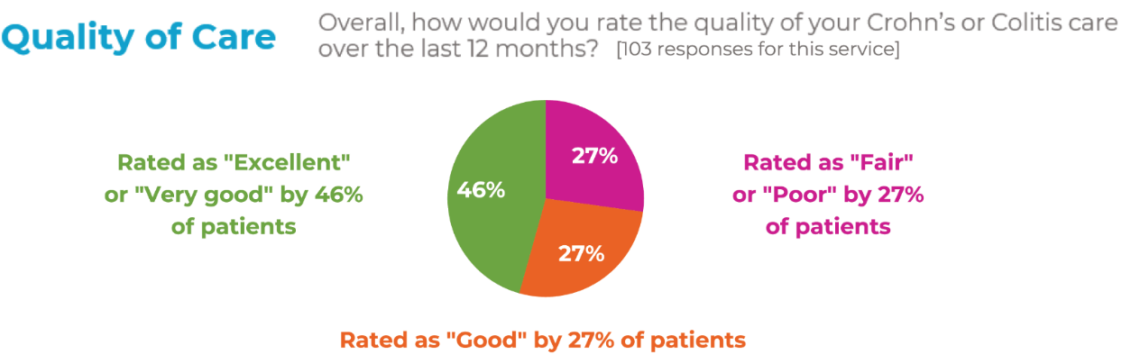

The IBD Patient Survey was responded to by over 10,000 patients using IBD services across the UK and aims to assess how services are doing in a number of key areas of patient care.

Members of the IBD team also assessed how the hospital provides for our patients against a series of IBD Standards, which define high-quality care for everyone in the UK living with Crohn’s or Colitis.

We are making a number of specific improvements to our IBD service in line with the IBD Standards as part of our ongoing Quality Improvement.

[Insert link to newsletter or web article with more details – text deliberately short for the purposes of this flyer/poster]

The full report is available online at ibduk.org.

Look out for the next IBD Patient Survey in 2021 so we can further improve our IBD service with your input. [Add further details on how patients can be involved in your Quality Improvement processes as appropriate]

