

**IBD Standards and Benchmarking: Service Communications Toolkit**

Tools and resources to promote your IBD Benchmarking Tool results

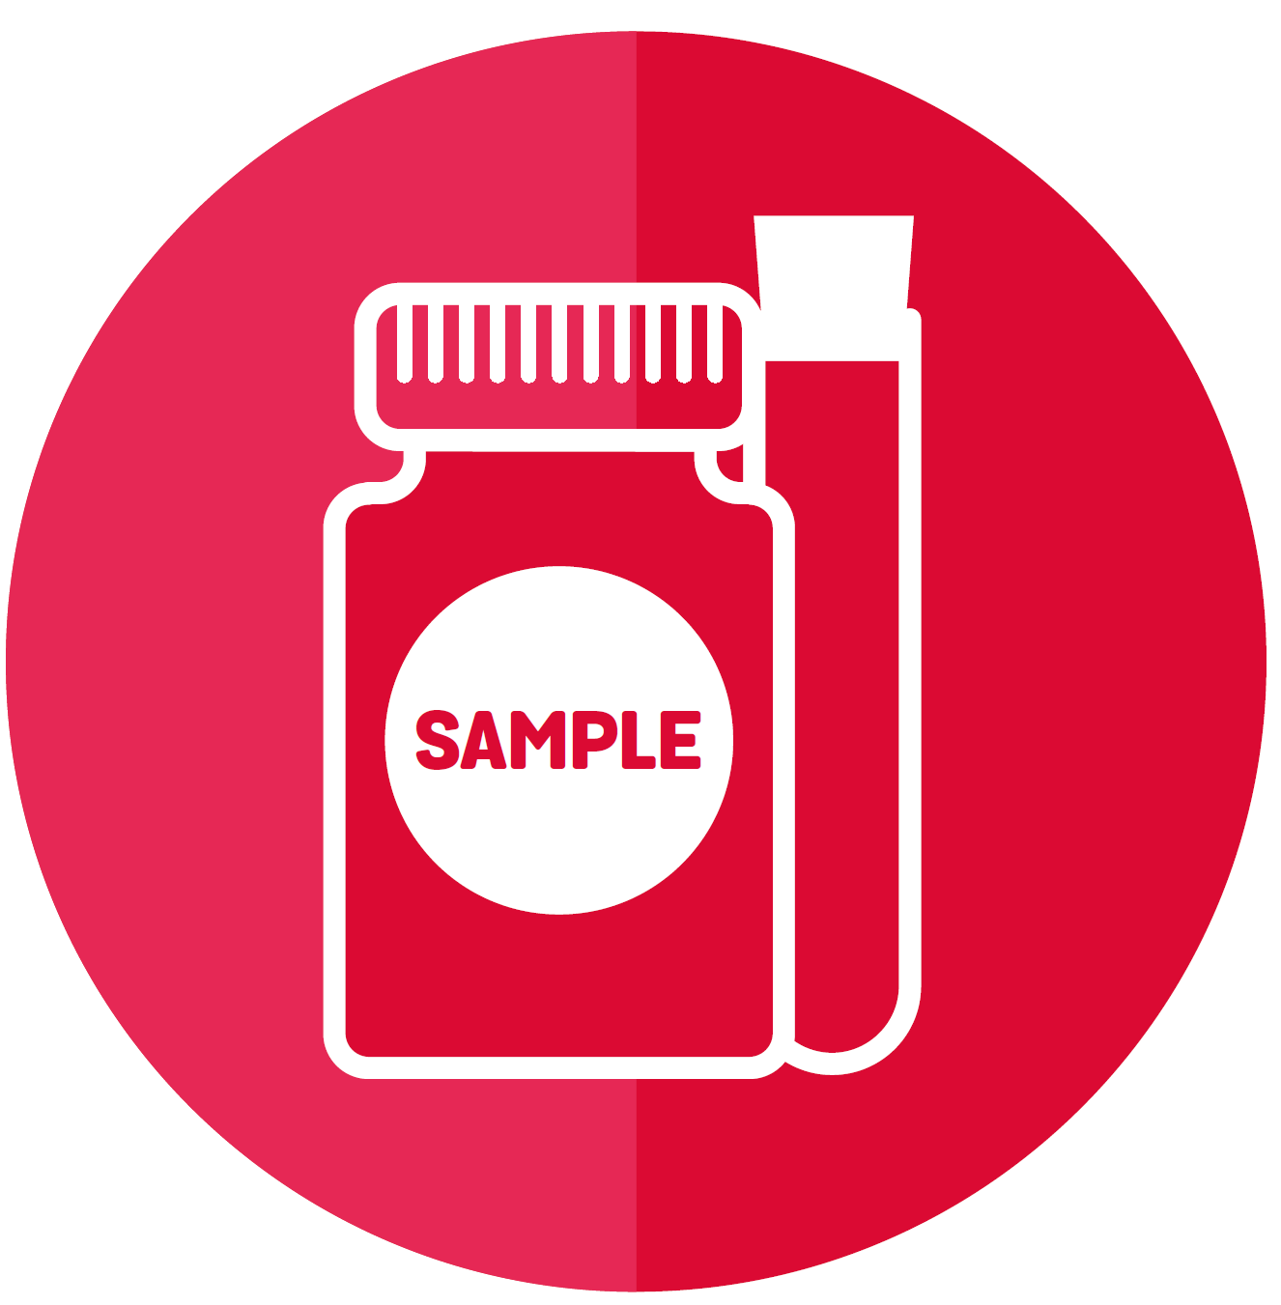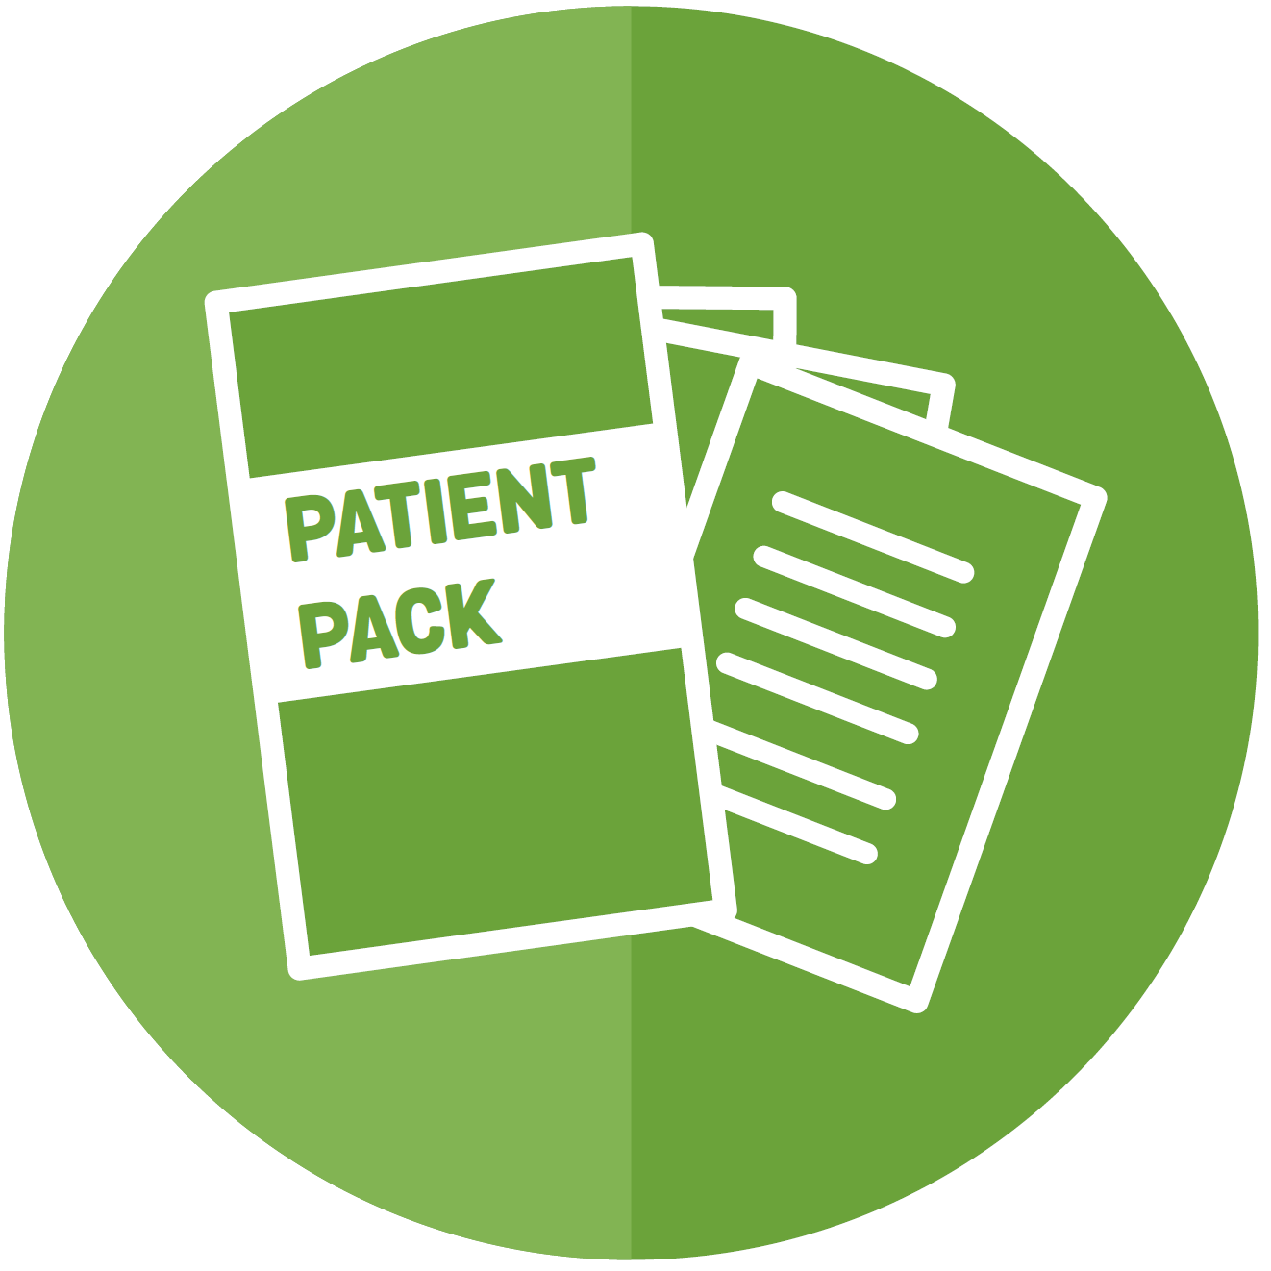

|  |  |
| --- | --- |
| [**www.ibduk.org**](http://www.ibduk.org) | **Published by IBD UK, March 2020** |

|  |
| --- |
| **What is this toolkit?** |

This toolkit provides all you need to communicate your service’s results from the

IBD Benchmarking Tool 2019/2020 – a new way to assess how well services across

the UK are providing care against the 2019 IBD Standards. This includes the Service

Self-Assessment completed by your IBD team and the results of an IBD Patient Survey

completed by those using your IBD service.

**This toolkit is intended to help you to share the results for your service with**

**your Stakeholders, including hospital press teams.**

The information in this toolkit will help you to communicate about the IBD Standards

and your results to patients, healthcare colleagues within your hospital, hospital

management and the local population.

The toolkit will help you deliver:

* **External communications**
  + **achieving positive stories in the media about your IBD service**
  + **sharing results with patients**
  + **providing content for your social media platforms and stakeholder newsletters**
  + **equipping you to respond to questions and queries**
* **Internal communications**
  + **sharing your results with NHS leaders, managers, clinical champions and colleagues**
  + **gaining support from these key stakeholders and others**
  + **delivering on Quality Improvement**
  + **engaging in future IBD Benchmarking**

|  |
| --- |
| **What are the IBD Standards and why do they matter?** |

The 2019 IBD Standards define what high-quality care for people with Crohn’s and Colitis should look like. They are a framework of statements, collaboratively produced by patients and professionals, and launched by IBD UK – a partnership of patient and professional organisations working together for everyone affected by Inflammatory Bowel Disease.

The IBD Standards say what high-quality, personalised care should look like at every point of the patient journey – from first symptoms, to treatment and ongoing care – and how IBD services need to be organised.

The IBD Benchmarking Tool – made up of the Service Self-Assessment and the IBD Patient Survey - aims to address variations in the quality and consistency of care people with Crohn’s and Colitis currently receive in the UK.

Over 10,000 patients in 99% of IBD services across the UK completed the IBD Patient Survey and 72% of services completed the self-assessment. The combination of patient views and comparison against the IBD Standards provides a powerful and unique opportunity to push up standards of care for everyone with IBD.

IBD UK recognises that services across the UK are working hard to deliver consistent, high-quality care for people living with Crohn's and Colitis. While variations currently exist, the IBD Benchmarking Tool aims to helpservices to **identify where resources should be directed in ongoing Quality Improvement**, and to help show commitment to your patients’ views and needs, ensuring your patients benefit from a high-quality service.

IBD UK believes in an open, transparent approach to sharing successes while recognising where services need to focus on improvement, helping to build a strong relationship with patients who use IBD services. IBD UK believes that a partnership approach is fundamental for IBD services across the UK to meet the IBD Standards – everybody needs to be involved to make a difference.

|  |
| --- |
| **Table of contents** |

|  |  |
| --- | --- |
| **Contents** | **Page** |
| 1. **A guide to your IBD Benchmarking Tool reports** | **3** |
| 1. **How to use this toolkit** | **4** |
| 1. **Engaging colleagues and stakeholders** | **4** |
| 1. **Key dates: raising awareness of your results with the media** | **6** |
| 1. **Ideas for headlines** | **6** |
| 1. **Social media** | **7** |
| **Appendix: overview of resources available** | **8** |

|  |
| --- |
| **1. A guide to your IBD Benchmarking Tool reports** |

There are three types of reports you may receive as a result of your participation in the IBD Benchmarking Tool.

1. 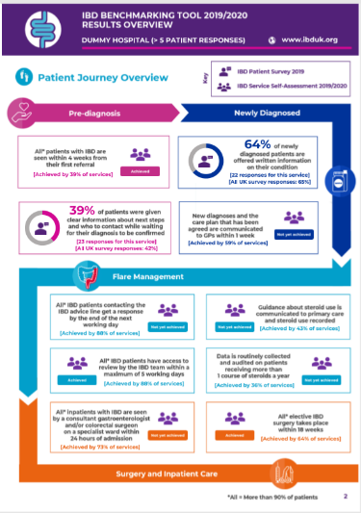**Results Overview:** an overview of the Service Self-Assessment and IBD Patient Survey responses across the patient pathway for your service – the key in the report shows which results are from the IBD Service Self-Assessment and which are from the IBD Patient Survey
2. **Patient Survey Report:** a detailed report of the IBD Patient Survey responses for your service
3. **Service Deep Dive Report:** a comprehensive report including:

* All responses from your self-assessment, with grading achieved and related IBD Patient Survey results
* How your service performance compares to the UK and UK country average
* **Ideas for next steps and Quality Improvement**

The Results Overview and Patient Survey Reports are public and will be published on the IBD UK website. Your individual Service Deep Dive Report will only be available to you via your IBD Benchmarking Tool link to log-in and view online, together with your Visual Dashboard.

***Please note:*** *you will only receive Results Overview and Service Deep Dive Reports if you completed the Service Self-Assessment; and a Patient Survey Report will only be produced where more than five patients from your service responded to the IBD Patient Survey.*

**Using the IBD Benchmarking Tool online**

* You will be provided with a reminder of your link to access the tool
* You will be able to view your Service Deep Dive Report, via the "Reports" tab
* You can also see a visual dashboard showing your service’s results grouped into four domains: Access, Patient Empowerment, Quality and Coordinated Care
* This enables you to make side-by-side overview comparisons with your service’s IBD Patient Survey results, the UK country average and UK average
* This function is available via the “Results” and “Comparison” tabs

|  |
| --- |
| **2. How to use this toolkit** |

This toolkit provides a range of ideas and suggestions for how you can communicate your results and raise the profile of your hospital and the successes of the IBD service.

There are several ways this toolkit can help you to communicate your results:

* Use the **template briefing email for hospital stakeholders** and the **stakeholder presentation** to highlight the success of the service – and **prompt a conversation on Quality Improvement**. You can also use these materials to gain support for external communications activity you may wish to deliver around the IBD Benchmarking results
* Adapt the **template media materials:** **template press release**, and **Q&A** and plan outreach to the media, making use of the **ideas for headlines** below
* Update patients on the results of the Benchmarking using the **template patient information** and/or develop the **template flyer for patients** to include findings from your **Results Overview Report**. You may also want to share the **Results Overview Report** itself
* Update other stakeholders, whether colleagues or external parties, using the **template newsletter**

|  |
| --- |
| **3. Engaging colleagues and stakeholders** |

**The IBD Benchmarking Tool reports show a representation of your IBD service – and highlight areas for improvement. The publication of the local reports is an opportunity to prompt and support ongoing conversations with NHS Managers, Quality Improvement Leaders and Medical Directors making the case for greater investment, prioritisation and transformation of your IBD service.**

1. **Engage the IBD team and wider IBD service**

* Use the **stakeholder presentation** in a meeting to ensure your results are

understood and discussed as a team and explain what the reports show

* Use the **stakeholder presentation**, the **template media materials**, and

ideas from this **toolkit** to discuss and agree a communications

plan with the press office and IBD team – and how to involve them as

spokespeople

* Adapt the **template newsletter** and include the perspective of those managing

the IBD service to highlight the significance of the findings to management

and other colleagues – **including an action plan for Quality Improvement**

1. **Engage hospital management and leadership**

* Use the **stakeholder presentation** to engage senior hospital managers and leaders with the results and your Quality Improvement plans, taking this opportunity to discuss resources and funding and support from the Chair, Board and wider stakeholders
* When planning to deliver a **stakeholder presentation**, consider how the results relate to other things happening locally in the hospital to further demonstrate the value of additional funding and resources for your IBD service. This could be within the context of other good news or in relation to national policy drivers such as GIRFT, NHS Rightcare, Modernising Patient Pathways or Value-Based Healthcare; or results from the IBD Registry
* Suggest that your Chief Executive covers the IBD Benchmarking results in any regular communications they dispatch, for example in a regular hospital blog or monthly brief email to stakeholders. You could adapt the **template newsletter** article for these uses. The hospital communications/press team will be able to help you with this
* As well as your usual distribution list, you may wish to consider sending a copy of the newsletter to other stakeholders, such as GPs and CCGs

1. **Raise the profile within the hospital**

* Adapt the **template newsletter** with screen-grabbed highlights from your reports (a ‘how to’ is provided in the social media section) and post it up on staff notice-boards and areas of high footfall
* Request that an article is included in the Trust-wide staff newsletter and any other internal communications that circulate beyond the hospital – adapt the **template newsletter** for this
* Hold an open day for the service. This is an opportunity for your Chief Executive to highlight the good work the IBD service is doing and engage colleagues, hospital stakeholders, and patients. You could also invite local media and get some photographs. World IBD Day on 19th March could be a nice hook to do this

1. **Engage with patients**

* The **Results Overview Report** is a visual snapshot of how

your service is doing. Make the most of this and display a

print-out in clinics, with copy from the **template patient**

**information** and/or **template flyer for patients** alongside this to

explain the project

* Organise a meeting with your patient panel to discuss the

results in more detail – they may have some ideas and can

support with communicating to your wider patient population

* Wherever possible in face-to-face contact or via

emails/letters, encourage patients and your patient panels

to consider taking part in your Quality Improvement plans

* Take some of the ideas from the **social media guidance**

section of the toolkit to reach patients, or from the raising

awareness of your results with the media section

**What next**

* IBD teams are being invited to apply to attend **Quality Improvement workshops**, to be held by IBD UK from Autumn 2020
* **A Quality Improvement toolkit**, which will feature templates, case studies and podcasts is soon to be launched by IBD UK, hosted at [**ibduk.org/resources-for-IBD-services**](http://www.ibduk.org/resources-for-IBD-services)
* IBD UK recommend both quick wins and pursuing longer-term goals in Quality Improvement. For example, services can improve access to patient information and signposting to patient organisations relatively quickly and easily, while business cases for additional team roles will take longer to implement. Sharing resources and ideas can also save time and effort, whether through the IBD UK website and toolkit or through buddying with another service or regional networking

|  |
| --- |
| **4. Key dates: raising awareness of your results with the media** |

**Planning your media outreach**

The key stages for IBD Benchmarking are shown below. You may wish to plan external communications activity for implementation at the earliest possible stage, as the coverage you achieve can help to engage internal stakeholders to help with further improvements to the service.

**Wednesday 11th March: reports available**

* The Results Overview and Patient Survey Reports will be publicly available on the IBD UK website (but not publicised widely)
* Your Service Deep Dive Report and Visual Dashboard will be available to you via your IBD Benchmarking Tool link

**Wednesday 18th March: reports publicised**

* We will be publicising the release of reports via a letter to CEOs and an email to patients

**June: national report release**

* We will be publicising the release of the national report – analysing the results for the entire UK
* While this provides an opportunity to conduct further communications activity, we encourage you to begin communicating the results for your hospital from 18th March onwards

**In addition to the toolkit materials available, you may also want to direct journalists to the Crohn’s & Colitis UK website for more background information on these conditions:** [**www.crohnsandcolitis.org.uk/about-crohns-and-colitis**](http://www.crohnsandcolitis.org.uk/about-crohns-and-colitis)

|  |
| --- |
| **5. Ideas for headlines** |

The best way to make the most of your service’s IBD Benchmarking Tool results is to

review your hospital’s reports so you understand the data and can find headlines and

story angles from the statistics that stand out the most.

Of course, these headlines are important for sharing results with the media but can also

help capture the attention of colleagues and patients in other communications activities.

While we recommend that you lead with the good news and the areas you have excelled in, it is important to be transparent and give a message about continued improvement and areas that the service needs to focus on as well.

|  |  |
| --- | --- |
| **Headline / story angle** | **Where you can find the data** |
| **IBD service achieves impressive 'quality of care' score – say local patients** | ***Results Overview***  Page one |
| **Waiting times and ‘quick response’ IBD service applauded by patients** | ***IBD Patient Survey Report***  Q1.1, Q1.2, Q2.7, Q3.2, Q3.3, Q3.4, Q4.5, Q5.3 |
| **Access to specialist and holistic care praised by new patient survey** | ***IBD Patient Survey Report***  Q2.1, Q2.2, Q4.3, Q4.7, Q5.4, Q5.6, Q5.9, Q5.10, Q5.11, Q5.12, Q6.1, Q6.3 |
| **Patients applaud information provided by local IBD service** | ***IBD Patient Survey Report***  Q1.4, Q2.3, Q2.4, Q2.6, Q2.8, Q4.6, Q4.8, Q5.1, Q5.5, Q5.7, Q5.13, Q5.14 |
| **IBD services scores highly on patient-centred care** | ***IBD Patient Survey Report***  Q2.5, Q5.8 |
| **IBD patients praise well-coordinated care between GP and hospital gastroenterologist** | ***IBD Patient Survey Report***  Q6.2 |
| **6. Social media** | |

This section of the toolkit is designed to give you a few ideas to communicate your hospital's IBD Benchmarking Tool results on your social media channels.

While you may find these ideas helpful, the more of your own creativity you can add to this the better!

**Share posts from IBD UK partners**

From Wednesday 18th March onwards, IBD UK and IBD UK member organisations,

including national charity Crohn's & Colitis UK, will begin to publicise the IBD

Standards and Benchmarking on their social channels.

Please follow and share this content if you can. You can find us at:

* twitter.com/IBDUKTeam
* facebook.com/crohnsandcolitisuk
* twitter.com/CrohnsColitisUK
* instagram.com/crohnsandcolitisuk/

**Share highlights from your report**

To demonstrate the successes of your IBD service, why not capture some of the best individual images/graphs from your Results Overview or Patient Survey Report and share these on social media? You can prepare these posts now and share them on your social channels from Wednesday 18 March onwards.

All you need to do is:

1. Choose the images/graphs you want to share
2. Use the snipping tool on your computer to 'cut these' out on your screen
3. Save these down as image files (eg JPGs or PNGs)
4. Schedule social media posts highlighting the good news!



Here are some example posts you may find helpful:

"Pleased to share **#IBDBenchmarkingTool** results showing our Inflammatory Bowel Disease (IBD) service is above the national average for [insert detail] [insert link to report] **#IBDStandards**"

"XX% of our patients rated the IBD service "excellent" or "very good" in IBD Benchmarking [insert detail] [insert link to report] [insert hashtag]"

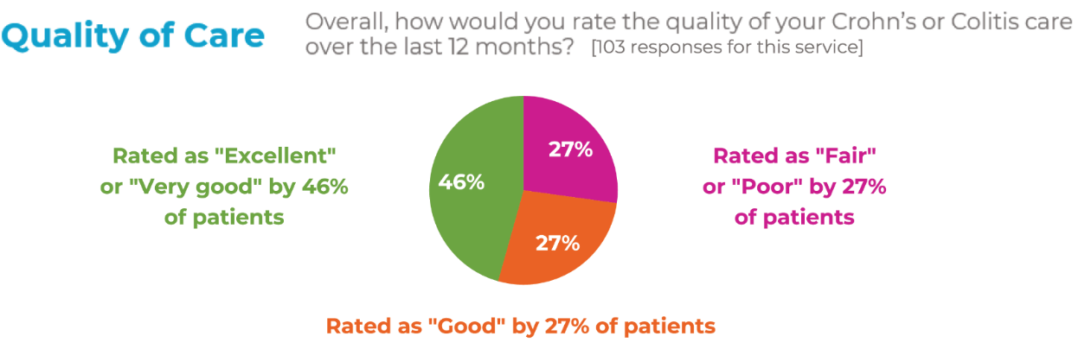

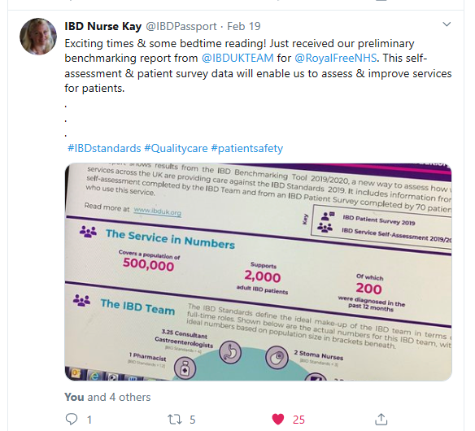

**Blog/vlog about the IBD Benchmarking Tool**

Re-purpose the newsletter content included in this toolkit to use as a blog. Or get creative and record a short video blog (vlog) asking members of your IBD team about the positive IBD Benchmarking Tool findings and what they want to do next to further improve the service. You could also get patients or your patient panel involved in blogs and vlogs.

You might like to ask them:

* What are you most pleased about in your service's IBD Benchmarking Tool reports?
* Are you pleased that patients are reporting a positive experience with the service?
* How important is it that patients are involved in the development of the IBD service?
* In what areas do you want to further improve the service?

**Hashtags, Tagging and Links**

In order to gain a greater reach and spread awareness far and wide we

suggest you use **#IBDStandards** on your Twitter and Instagram posts.

Other hashtags to consider using are: **#Colitis #Crohns**

**#IBDBenchmarkingTool**

You can also link to the IBD UK website where the reports can be found.

Simply add [**ibduk.org/services-map**](http://www.ibduk.org/services-map) to the end of your posts.

Tag us in your posts so we can see them – please use **@IBDUKTeam** and

**@CrohnsColitisUK** on Twitter and **@CrohnsandColitisUK** on Facebook and

Instagram.

|  |
| --- |
| **Appendix: overview of resources available** |

|  |
| --- |
| **IBD Benchmarking Tool reports** |
| *Note: These are not available within the toolkit. The Results Overview and Patient Survey Reports will be publicly available online at* [***ibduk.org***](https://crohnsandcolitisuk-my.sharepoint.com/personal/sophie_bassil_crohnsandcolitis_org_uk/Documents/Downloads/Toolkit%20v2%20-%20clean/Third%20draft%20-%20clean/ibduk.org)*whereas the Service Deep Dive Report is only available to you when you log-in to the IBD Benchmarking Tool.*   * Results Overview Report * Patient Survey Report * Service Deep Dive Report |
| **Stakeholder materials** |
| *Click on each relevant file embedded below to open the file up in a new window*   * Stakeholder presentation * Template newsletter * Template patient information * Template flyer for patients * Template briefing email for hospital stakeholders     ***Note:*** *to open the Stakeholder Presentation in ‘edit’ mode please right-click the icon above, click ‘Presentation Object’, and then click ‘edit’* |
| **Media materials** |
| *Click on each relevant file embedded below to open the file up in a new window*   * Template press release * Q&A * Key messages |