Neonatal mortality in the UK
- In 2017 in the UK, 1,267 babies who were born after 24 weeks’ gestation died in their first 28 days of life.¹
- Neonatal mortality rates in England and Wales from 1985-2018 (graph below)²

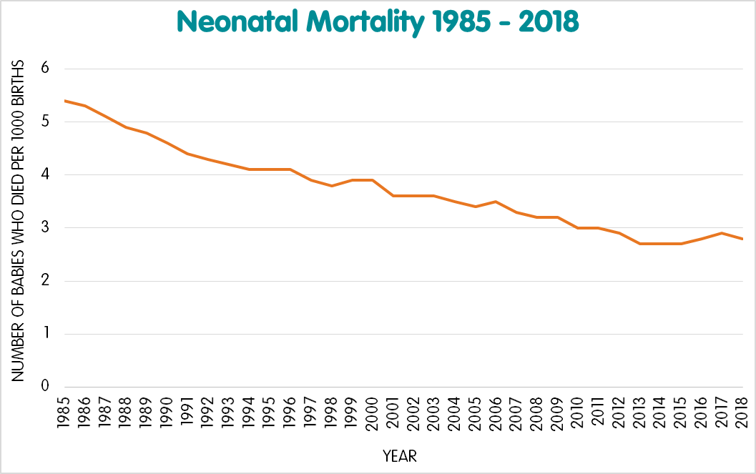

Why do some babies in the UK die soon after birth?
- In 2017, 41 per cent of babies who died in their first 28 days of life died due to complications in the neonatal period; this was the largest cause of death.¹
- 36 per cent of babies died due to medical conditions identified in the womb or at birth (congenital anomalies).¹
- 12 per cent of deaths were due to babies being born extremely early.¹
- In 2017 more babies born to mothers living in the most deprived areas died in the neonatal period when compared to mothers who lived in less deprived areas.¹
- Also, more babies born to mothers aged under 20 and over 40 died, when compared to other age groups.¹
- Babies born to Black or Black British parents had a 67 per cent increased risk of neonatal death compared to babies of white ethnicity.¹
- Babies born to Asian or Asian British parents had a 72 per cent increased risk of neonatal death compared to babies of white ethnicity.¹
- Neonatal mortality rates in babies whose mothers are of white ethnicity have decreased between 2015-2017, whereas babies born to mothers of Asian, Asian British, Black and Black British ethnicity have increased between 2015-2017.¹
- Smoking during pregnancy can lead to many complications for the baby. The baby is at higher risk of being born prematurely, of being born with a low birth weight, and also at a higher risk of death.³
- In 2017, 19 per cent of mothers of babies who were stillborn or who died in the neonatal period smoked throughout their pregnancy.¹
- Obesity during pregnancy has also been associated with increased neonatal death rates.⁴
What are the survival rates for babies born premature?
- The following survival rates have been calculated from the number of live births and neonatal deaths (before 28 days after birth) at each gestation (point of pregnancy) in 2017.¹

Gestation at birth (weeks) | Per cent of babies who survived (2017 data)
22-23 | 29.6
24-27 | 85.5
28-31 | 96.9
32-36 | 99.5
37-41 | 99.9
42+ | 99.9

References
- MBRRACE-UK. 2019 report on 2017 data. Perinatal mortality surveillance report. Retrieved from: https://www.npeu.ox.ac.uk/downloads/files/mbrrace-uk/reports/MBRRACE-UK%20Perinatal%20Mortality%20Surveillance%20Report%20for%20Births%20in%202017%20-%20FINAL%20Revised.pdf
- ONS (2019, data from 2018). Deaths registered in England and Wales: 2018. Retrieved from:
https://www.ons.gov.uk/peoplepopulationandcommunity/birthsdeathsandmarriages/deaths/bulletins/deathsregistrationsummarytables/2018
- NICE guidance: Smoking: stopping in pregnancy and after childbirth. Retrieved from:
https://www.nice.org.uk/guidance/ph26/chapter/2-Public-health-need-and-practice
- NICE guidance: weight management before, during and after pregnancy

https://www.nice.org.uk/guidance/ph27/chapter/2-Public-health-need-and-practice

