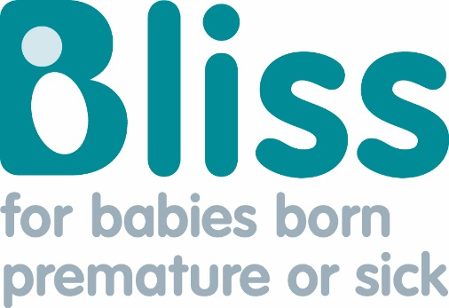
This document provides references for each stat on the Bliss website pages: ‘Statistics about neonatal care’, ‘Prematurity statistics in the UK’, ‘Statistics for babies admitted to neonatal units at full term’, ‘Neonatal mortality in the UK’ and ‘The global picture’.

Statistics about neonatal care
How many babies receive neonatal care?
- Every year, over 100,000 babies are cared for in a neonatal unit in the UK.^{1,3}
- 1 in 7 babies born in the UK each year are admitted onto neonatal units.^{1,2,3}

How many babies are admitted to neonatal care each year in England, Scotland and Wales?

- In 2016, of the 100,762 babies who received neonatal care in England, Scotland and Wales, only 1.2 per cent were born before 25 weeks.¹

Gestation of baby at birth | Number of babies | Percentage of the total number of babies admitted on to a neonatal unit
Total | 100,762 | 100%
Before 25 weeks | 1,189 | 1.2%
26-32 weeks | 10,283 | 10.2%
33-36 weeks | 26,758 | 26.6%
After 37 weeks (Full term) | 62,427 | 62%
Missing data | 105 | 0.1%
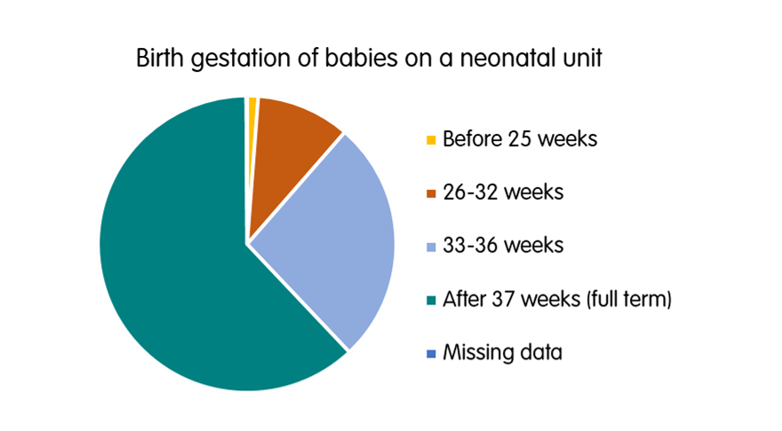

- Only 1.7 per cent of babies born alive in England, Scotland and Wales are part of multiple births.^{4,5,6}
- 11.2 per cent of babies who received neonatal care in England, Scotland and Wales were from a multiple pregnancy.¹
How many babies are admitted to neonatal care each year in Northern Ireland?
- According to the Northern Irish public health agency, NICORE, 1,851 babies were born needing neonatal care in 2015.²
Gestation of baby at birth | Number of babies | Percentage of the total number of babies admitted on to a neonatal unit
Total | 1,851 | 100%
Before 28 weeks | 48 | 2.6%
28- 31 weeks | 202 | 10.9%
32- 33 weeks | 222 | 12%
34 - 36 weeks | 485 | 26.2%
37 weeks onwards (Full term) | 894 | 48.3%
Missing data | 0 | 0%

How long will a baby typically spend on a neonatal unit?
- The average length of a stay in neonatal care in England and Wales is seven days – however this includes figures for both premature and full term babies.¹
- The average length of stay for a baby born between 28 to 31 weeks, in England, Scotland or Wales is 44 days.¹
Gestation of baby at birth | Average length of stay (days) | Average age at discharge (gestational age in weeks)
Before and up to 27 weeks | 92 | 39.4
28-31 weeks | 44 | 36.4
32-36 weeks | 12 | 36.6
More than 37 weeks | 4 | 40.3
Average | 7 | 38.6

Transfers – how many babies are moved to a different hospital during their time in neonatal care?
- According to the National Neonatal Audit Programme, ten per cent of babies in neonatal care experience at least one transfer. Of the 95,222 babies included in their data in 2015, there were 14,308 transfers in total involving 9,523 babies.⁷

References
- NDAU. (2017). NDAU 2016 report. Retrieved from:
https://www.imperial.ac.uk/media/imperial-college/medicine/dept-medicine/infectious-diseases/neonatology/NDAU-2016-Report-v1.1-(002).pdf
- NICORE. (2016). Neonatal care in Northern Ireland, 2015. Retrieved from:
https://www.qub.ac.uk/schools/SchoolofNursingandMidwifery/FileStore/Filetoupload,777901,en.pdf
- ONS. (2016) Births in England and Wales by Characteristics of Birth, 2016. Retrieved from:
https://www.ons.gov.uk/file?uri=/peoplepopulationandcommunity/birthsdeathsandmarriages/livebirths/datasets/birthcharacteristicsinenglandandwales/2016/birthcharacteristicsworkbook2016.xls
- ONS. (2017). Births in England and Wales by Characteristics of Birth, 2017. Retrieved from:
https://www.ons.gov.uk/peoplepopulationandcommunity/birthsdeathsandmarriages/livebirths/datasets/birthcharacteristicsinenglandandwales
- TAMBA: Key statistics on Multiple Births. Retrieved from:
https://www.tamba.org.uk/document.doc?id=782
- ISD, (2016). Births in Scottish Hospitals: Year ending March 2015. Retrieved from: http://www.isdscotland.org/Health-Topics/Maternity-and-Births/Publications/data-tables.asp
- NNAP 2016. National Neonatal Audit Programme 2016 Annual Report on 2015 data. Retrieved from: http://www.rcpch.ac.uk/system/files/protected/page/NNAP%202016%20Annual%20Report%20on%202015%20data%20-%20For%20NNAP%20website.pdf

Prematurity statistics in the UK
- We estimate that around 60,000 babies are born prematurely in the UK every year. This means that 1 in every 13 babies born in the UK will be born premature (before 37 weeks of pregnancy).^{1,2,3}

References
- ISD, (2016). Births in Scottish Hospitals: Year ending March 2015. Retrieved from:
https://www.isdscotland.org/Health-Topics/Maternity-and-Births/Publications/data-tables.asp
- Public Health Agency, Northern Ireland Child Health System, Children’s Health in Northern Ireland, December 2017. Retrieved from:
http://www.publichealth.hscni.net/sites/default/files/RUAG%20Childrens%20Health%20in%20NI%20-%202016-17%20-%20FINAL%20-%20Dec%202017.pdf
- ONS. (2017). Births in England and Wales by Characteristics of Birth, 2017. Retrieved from:
https://www.ons.gov.uk/peoplepopulationandcommunity/birthsdeathsandmarriages/livebirths/datasets/birthcharacteristicsinenglandandwales

Statistics for babies admitted to neonatal units at full term
How many babies are admitted to neonatal units at full term?
- Around 60 per cent of babies admitted to neonatal care are born at full term, i.e. at 37 weeks’ gestation or above.¹
Why are babies admitted to neonatal care at full term?
- The five most common reasons why full term babies need to be cared for on a neonatal unit:
- Respiratory conditions (about 25 per cent of all term admissions)¹
- Infection (about 18 per cent of all admissions)²
- Hypoglycaemia - this is where a baby has low levels of glucose in their blood (almost 12 per cent of all admissions)¹
- Jaundice (around 6 per cent of all term admissions)¹
  - 81 per cent of these babies received phototherapy¹
  - 33 per cent received intravenous fluids¹
  - 1.6 per cent received a blood transfusion¹
- Asphyxia (HIE) (around 2.5 per cent of all term admissions)²

References
- NDAU. (2017). NDAU 2016 report. Retrieved from:
https://www.imperial.ac.uk/media/imperial-college/medicine/dept-medicine/infectious-diseases/neonatology/NDAU-2016-Report-v1.1-(002).pdf
- NHS improvement (2017): Reducing harm leading to avoidable admission of full-term babies into neonatal units. Retrieved from:
https://improvement.nhs.uk/documents/764/Reducing_term_admissions_final.pdf
- Battersby et al (2017). Term admissions to neonatal units in England: a role for transitional care? A retrospective cohort study. BMJ Open. Retrieved from:
https://bmjopen.bmj.com/content/7/5/e016050.full?ijkey=dRMIpMjzNnIbfV1&keytype=ref

Neonatal mortality in the UK
- In 2017 in the UK, 1,267 babies who were born after 24 weeks’ gestation died in their first 28 days of life.¹
- Neonatal mortality rates in England and Wales from 1985-2018 (graph below)²

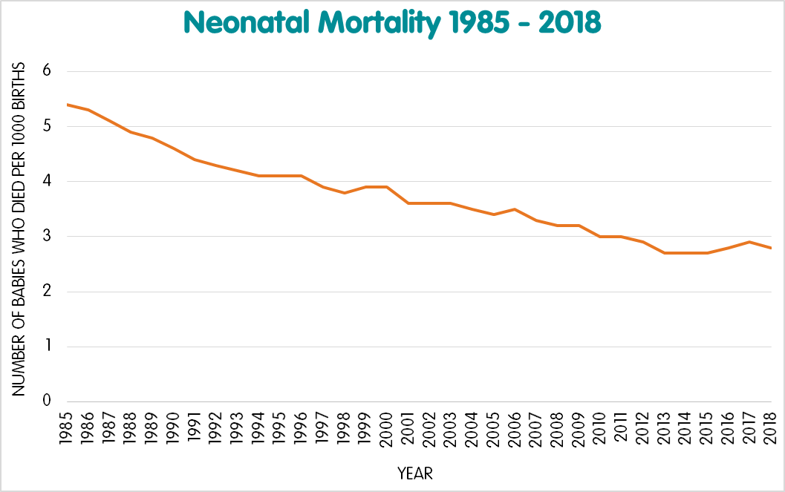

Why do some babies in the UK die soon after birth?
- In 2017, 41 per cent of babies who died in their first 28 days of life died due to complications in the neonatal period; this was the largest cause of death.¹
- 36 per cent of babies died due to medical conditions identified in the womb or at birth (congenital anomalies).¹
- 12 per cent of deaths were due to babies being born extremely early.¹
- In 2017 more babies born to mothers living in the most deprived areas died in the neonatal period when compared to mothers who lived in less deprived areas.¹
- Also, more babies born to mothers aged under 20 and over 40 died, when compared to other age groups.¹
- Babies born to Black or Black British parents had a 67 per cent increased risk of neonatal death compared to babies of white ethnicity.¹
- Babies born to Asian or Asian British parents had a 72 per cent increased risk of neonatal death compared to babies of white ethnicity.¹
- Neonatal mortality rates in babies whose mothers are of white ethnicity have decreased between 2015-2017, whereas babies born to mothers of Asian, Asian British, Black and Black British ethnicity have increased between 2015-2017.¹
- Smoking during pregnancy can lead to many complications for the baby. The baby is at higher risk of being born prematurely, of being born with a low birth weight, and also at a higher risk of death.³
- In 2017, 19 per cent of mothers of babies who were stillborn or who died in the neonatal period smoked throughout their pregnancy.¹
- Obesity during pregnancy has also been associated with increased neonatal death rates.⁴

What are the survival rates for babies born premature?
- The following survival rates have been calculated from the number of live births and neonatal deaths (before 28 days after birth) at each gestation (point of pregnancy) in 2017.¹

Gestation at birth (weeks) | Per cent of babies who survived (2017 data)
22-23 | 29.6
24-27 | 85.5
28-31 | 96.9
32-36 | 99.5
37-41 | 99.9
42+ | 99.9

References
- MBRRACE-UK. 2019 report on 2017 data. Perinatal mortality surveillance report. Retrieved from: https://www.npeu.ox.ac.uk/downloads/files/mbrrace-uk/reports/MBRRACE-UK%20Perinatal%20Mortality%20Surveillance%20Report%20for%20Births%20in%202017%20-%20FINAL%20Revised.pdf
- ONS (2019, data from 2018). Deaths registered in England and Wales: 2018. Retrieved from:
https://www.ons.gov.uk/peoplepopulationandcommunity/birthsdeathsandmarriages/deaths/bulletins/deathsregistrationsummarytables/2018
- NICE guidance: Smoking: stopping in pregnancy and after childbirth. Retrieved from:
https://www.nice.org.uk/guidance/ph26/chapter/2-Public-health-need-and-practice
- NICE guidance: weight management before, during and after pregnancy

https://www.nice.org.uk/guidance/ph27/chapter/2-Public-health-need-and-practice

The global picture
- 1 million children die each year from the complication of premature birth, and globally, it’s a leading cause of death in children under 5.^{1,2}
Premature birth
- Around the world 15 million babies are born prematurely every year.¹
- 60 per cent of these births take place in Africa and South Asia.¹
- The three countries with the highest rate of preterm birth are (the numbers below are the numbers of babies who were born premature out of 100 babies born alive)¹:
- Malawi- 18.1
- Comoros- 16.7
- Congo- 16.7
Neonatal mortality – the number of babies who die within their first 28 days of life
- The country with the highest neonatal mortality rate in the world is Pakistan, at a rate of 44.2 per 1,000 live births.³
- Other countries with high rates of neonatal mortality are in Sub-Saharan Africa and South Asia. These include Central African Republic, South Sudan, Afghanistan and Somalia.³
- Countries with the lowest rates include Japan (0.9 per 1,000 live births), and Iceland (1 per 1,000 live births).³
- The UK ranks well globally, however, whilst the rate of neonatal mortality has improved since 1990, latest figures stand at 2.6 per 1,000 live births.³

References
- World Health Organisation, fact sheet on preterm birth. Retrieved from:
https://www.who.int/en/news-room/fact-sheets/detail/preterm-birth
- Liu et al (2016). Global, regional, and national causes of under-5 mortality in 2000-15: an updated systematic analysis with implications for the Sustainable Development Goals. The Lancet. Retrieved from:
https://www.ncbi.nlm.nih.gov/pmc/articles/PMC5161777/
- Levels and Trends in Child Mortality. United Nations Inter-Agency Group for Child Mortality Estimation. Report (2018 on 2017 data). Retrieved from:
https://data.unicef.org/resources/levels-and-trends-in-child-mortality/
Also reported by The World Bank:
https://data.worldbank.org/indicator/SH.DYN.NMRT?year_high_desc=false

