ADDRESSOGRAPH

Hospital Logo

Passing a Nasogastric Tube (NGT) Competencies for Parents / Carers on Neonatal Unit and Transitional care
A separate sheet is needed for each care giver.
When Parents sign they are confirming they have been given training, practised with supervision, accept responsibility and feel competent to pass a Nasogastric feeding tube.
Statement of Competency:  Please sign and date when education, assessment and competence have been achieved. | Parent Signature / Date | Nurse signature / Designation / Date
I (Parent / Carer) have observed a NGT being passed.
I am aware of the Health and Safety risks i.e: potential for tube to be passed in to the lungs, associated with this way of feeding
- It has been explained to me what to do if baby vomits, gags, changes colour or there feels to be an obstruction whilst passing the NGT.
I understand the importance of infection control with regards to
- clean area to set up equipment
- clean equipment
- wash hands with soap and water and dry thoroughly prior to procedure
- Disposal of used equipment
Procedure to Pass NGT:
With clean hands take the new NGT and measure length of tube to be inserted.
The tube length should be estimated before insertion. Place tip of tube at tip of nose, extend tube to earlobe, and then to xiphisternum (bottom of breast bone). This is known as the NEX measurement (See picture overleaf).
Swaddle baby securely into a safe comfortable position, ensuring hands are within the swaddle to prevent grabbing at the tube.
Pass the NGT through the nostril and slowly proceed into the stomach (alternating nostrils with each new tube)
ALERT Remove the tube immediately if the baby changes colour or breathing pattern or if the tube appears in the mouth
Aspirate secretions and test for acidity with pH indicator paper
If no aspirate is obtained try to place your baby on his/her side. This may move the position of the tube in the stomach, and aspirate again.
If still no aspirate obtained do not feed using the tube. Seek advice from the Neonatal Outreach Nurse or the Neonatal Unit
If pH paper shows <6, secure tube with tape, making a note of the length of tube at the nostril, in centimetres.
I have the contact details of:
Neonatal Outreach Nurse: …………………………….
Neonatal / Transitional Care unit: ...............................................................................
Open Access area:……………………………………

Picture showing points of where to measure nasogastric tube prior to passing.

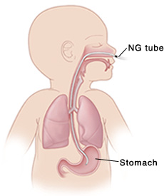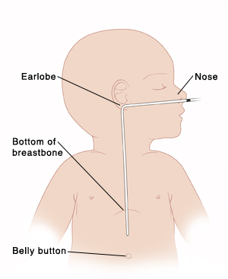
RECORD OF PRACTICE – PASSING A NASO-GASTRIC TUBE

Please ensure assessments are carried out over a period of time to ensure parents are consistently competent. This can be carried out in the home. The number of tubes passed will be dependent on each parent/care giver’s individual need and nursing staff need to assess this.

Date | Staff signature and designation | Comments

I have received training and consider myself safe and able to undertake all the above criteria and accept responsibility for passing a NGT tube for my baby.

Name of Parent / Carer …………………………………… Signature ……………………………….

Date ……………

