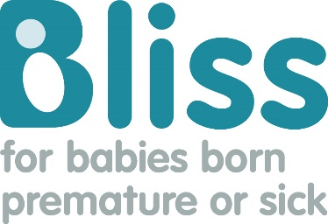

Bliss fundraising press pack
Sharing your story, event or fundraiser is a great way to increase donations and help get the word out there about what you are doing for Bliss.
Journalists hear from lots of fundraisers every day. Here are our top tips for helping your story to stand out from the crowd.
Press releases
A press release is the most effective way to get a story to journalists.
You can use the template on p4 of this document to help you write your own. There is also a sample of a press release on p3 so you can see what the final press release is meant to look like.
Don’t forget:
- Keep the press release short – one page is the perfect length.
- Copy the press release into the body of an email. If you send the press release as an attachment, journalists are less likely to open it.
- Include at least two or three photos as an attachment to go with the story.
- Always include your contact details on the press release so the journalist is able to get in touch with you.
- Be sure to check your email and phone regularly after you send out the press release in case a journalist gets in touch.
- Call the newspaper or radio station to find out who covers local events or charity fundraising. Ask for their contact details so you can send the press release to them directly.
- If it is a daily paper, try to call between 11.00am and 3.30pm. If it is a weekly paper, do not call the day before it is published (e.g. If the paper comes out on a Friday, do not call on a Thursday) as they will be too busy to talk to you.

Photography
It is always a good idea to include photos with your press release. Be sure to seek permission from the people in the photo or the parents of anyone under the age of 18 before you send their photo to the media.
Don’t forget:
- Avoid sending blurry, heavily filtered or poor quality photos (see examples below).
- Take landscape photos – ideally on a digital camera.
- If you have had a premature or sick baby yourself, send a few photos of you and your baby in hospital and you and your baby now to help illustrate your journey.

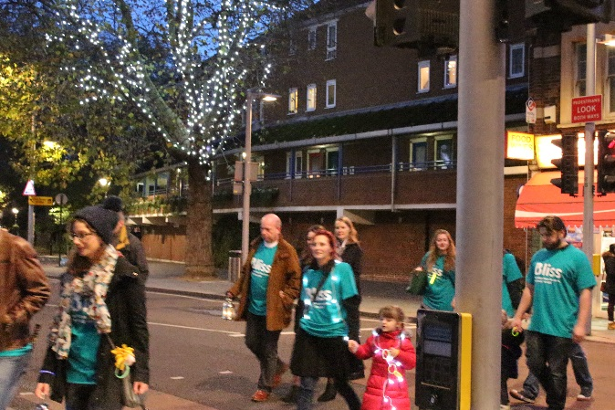
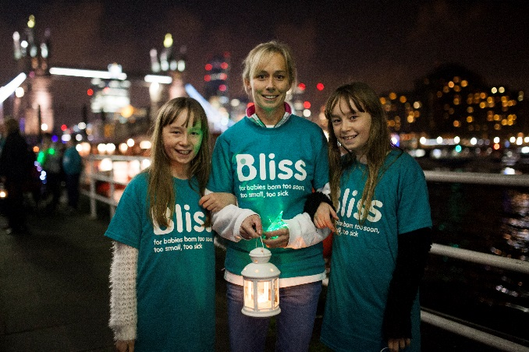

In this photo, the subjects are blurry, there is an obstruction in the foreground and the background isn’t very good
In this photo, the subjects can be seen clearly, they are smiling, you can see the Bliss logo and the background is great.

If you need any more help or advice, please contact the media team by emailing: media@bliss.org.uk

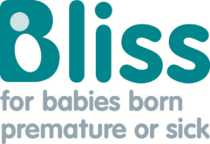
Sample press release

Cardiff mum does 200 mile trek to raise money for premature and sick babies

For immediate release
Contact: Jane Smith, 0111 222 33 45, jane@sample.com (available weekdays after 1.00pm)
A mum from Cardiff is raising money for the premature and sick baby charity Bliss by walking 200 miles across Wales in June.
Jane Smith, 32, is fundraising after her own experience of being helped by the charity. Jane’s daughter – Sarah– was born at just 26 weeks, weighing a tiny 755g.
Jane said: “I still remember just how terrifying it was to be separated from Sarah for those 35 hours. She was so small and fragile and we worried about what was going to happen to her.
“Sarah battled jaundice, a hole in her heart and suspected meningitis. Whenever we took a step forward, we took two back but were eventually able to go home.”
Sarah spent a total of 17 weeks in neonatal care. She is now a happy and healthy three year old who enjoys playing with her brother, Sam.
Now Jane is going to walk 200 miles across the Brecon Beacons to raise money for the charity that supported her through the challenging time while Sarah was in hospital. So far she has raised £200.
Jane said: “Bliss supported us in so many ways while we were in hospital. Their leaflets and website provided clear information about neonatal care. A Bliss Champion visited our unit every week and spoke to us about what we were going through. I also called their helpline when I was worried about going home and they were so reassuring. I know that the charity also invests in life changing research and helps train health care professionals to care for babies in the best way possible. They also work with politicians to ensure that investment is made into neonatal care. It is a charity close to our hearts.”
To support Jane visit: www.examplegiving.com/Jane
ENDS

Notes to editors
One in eight babies are born needing neonatal care in the UK every year.
Bliss is the UK’s leading charity for babies born premature or sick.
Bliss champions the right for every baby born premature or sick to receive the best care. We achieve this by empowering families, influencing policy and practice, and enabling life-changing research. Visit bliss.org.uk for more information.
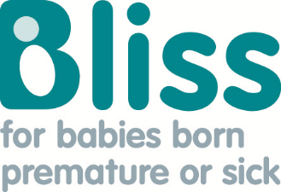
[Insert name of town/ area] [Insert relationship to baby] does [Insert fundraiser/ event] to raise money for premature and sick babies

For immediate release
Contact: [insert your contact details and the best time to reach you]
A [relationship to baby] from [town/ area] is raising money for the premature and sick baby charity Bliss by [fundraiser/ event].
[Your full name], [age], is fundraising after [his/ her] own experience of being helped by the charity. [baby’s name] was born at just [number] weeks, weighing [weight].
[Your name] said: [add two or three paragraphs describing your experience and how you felt].
[Baby’s name] spent a total of [number] [days/ weeks/ months] in neonatal care at [insert hospital].
Now [your name] is going to [insert event/ fundraiser] to raise money for the charity that supported [him/ her] while [baby’s name] was in hospital. So far [he/ she] has raised [insert fundraising total].
[Your name] said: [Your reason for supporting Bliss]
To support [Your name] visit: [Add link to your fundraising page].

ENDS

Notes to editors
One in eight babies are born needing neonatal care in the UK every year.
Bliss is the UK’s leading charity for babies born premature or sick.
Bliss champions the right for every baby born premature or sick to receive the best care. We achieve this by empowering families, influencing policy and practice, and enabling life-changing research. Visit bliss.org.uk for more information.

