How Will Melting Ice Affect Your School and Town?

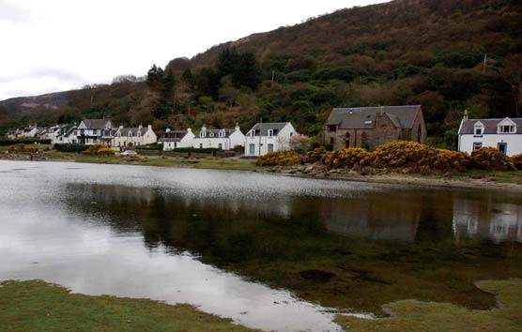

© Simon Oakes

What would happen to your town (or a seaside town you are a familiar with) if the sea rose by a metre? Or by five metres, if some of the ice in Greenland and Antarctica begins to melt more quickly, due to global warming.

Scientists think that world sea-level could rise by more than half a metre this century. Sea water is getting warmer and expanding. Polar ice is melting and adding more water to the oceans.

The rise will be even greater if polar ice starts to melt more quickly – especially in South East England, where the land is sinking too.

Researching the possible changes ahead

We are going to think about how a sea-level rise of (i) one metre and (ii) five metres could have impacts on our own local community and the physical environment around our school.

If there is clearly no local threat to your school and town, then you will need to study a nearby coastal settlement instead. For instance, if you live in an upland area of Yorkshire, you may have been to Whitby or Scarborough. These seaside towns are clearly at risk of sea-level rise.

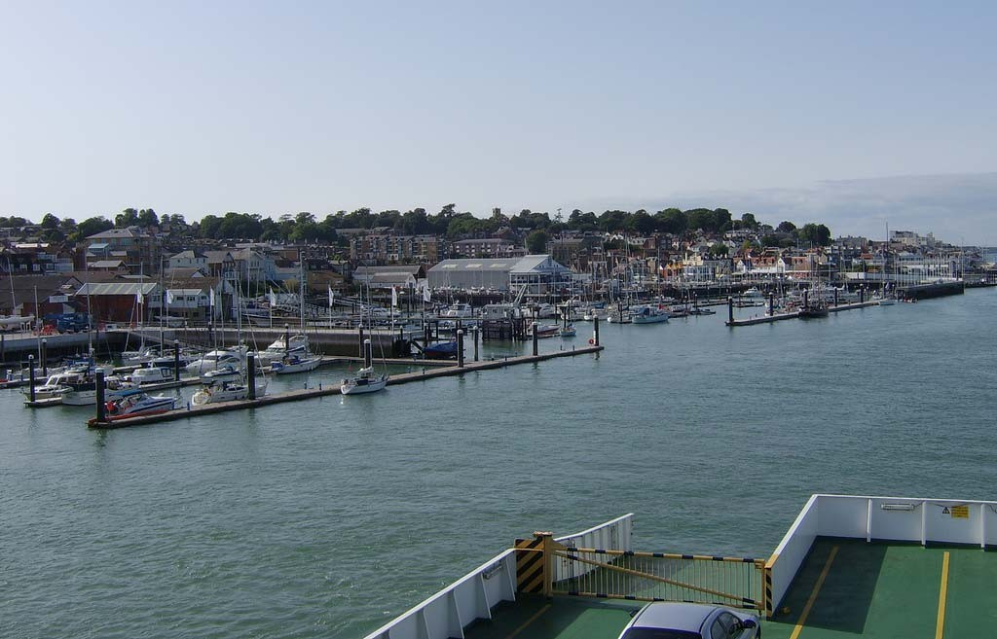Data sources

O O

OO

Ordnance Survey maps of the area you are researching should be looked at first of all. What is at risk? Look for places that are just 1 metre or 5 metres above sea level. Identify the land uses that are most threatened. You can make your own map showing the areas that would be lost if the sea-level rises.

If your school has access to Google Earth, this can also help you identify the areas close to the current sea-level.

The Environment Agency website will show if there is already a flood risk that could be exacerbated by sea-level rise (enter
your postcode where indicated):
www.environment-agency.gov.uk/subjects/flood/

The Solent and Isle of Wight region:
a major threat of sea-level rise is found here due to sinking ground
as well as possible polar ice melting

© www.flickr.com/photos/chuffy/242401705/sizes/l/
Taking it further

You can also think about some of the following ideas:
- What products may no longer be sold in local shops due to changes occurring in the regions where these products are made and grown?
- Think of places like Venice or Australia’s Great Barrier Reef – how might holiday destinations for some local people, family and friends change?
- Might more refugees need to come and live in our town if their own countries become uninhabitable due to a big sea-level rise? Bangladesh is highly threatened, for instance.

Getting started

Work in groups. Each group should be given an OS map of the area around the school (or an alternative sea-side place) to help them identify areas or activities they think could be particularly at risk.

There is a grid to fill in on the next page. There is also a poster to complete that your teacher will give you a copy of to work with.

In another lesson, the groups could perhaps produce a PowerPoint presentation of their findings. Or a spokesperson for each group could make a presentation to the whole class.

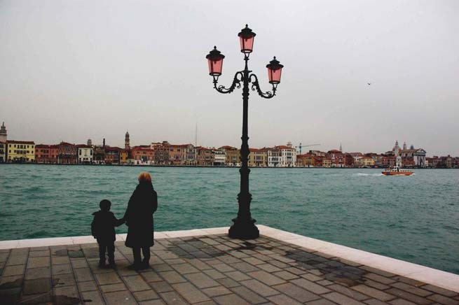© Simon Oakes
Venice: will it remain a popular holiday destination for British people if the world’s ice keeps melting?

The local impact of sea-level rise on:
Possible impacts
What would happen if sea level rose by (i) one metre (ii) five metres?
Names of the districts or streets that would be most badly affected

Homes on low-lying ground
(i)

(ii)

Businesses, shops and industries
(i)

(ii)

Hospitals, schools, stations and other services

(i)

(ii)

The physical environment (animals, trees, plants, beaches, dunes, etc.)

Landmarks, monuments, irreplaceable heritage sites
(i) (ii) (i)
(i)

(ii)
Other things you have spotted
(ii)

