The Conservative and Unionist Party Manifesto 2017

Forward, Together
Our Plan for a Stronger Britain and a Prosperous Future

Easy Read

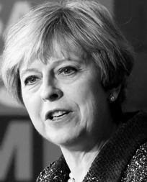
This is Theresa May
She is our Prime Minister

This is what she said

"The next five years are the most challenging that Britain has faced in my lifetime.

Brexit will define us: our place in the world, our economic security and our future prosperity.

So now more than ever, Britain needs a strong and stable government to get the best Brexit deal for our country and its people.

Now more than ever, Britain needs strong and stable leadership to make the most of the opportunities Brexit brings for hardworking families.

Now more than ever, Britain needs a clear plan.

This manifesto, Forward, Together: Our Plan for a Stronger Britain and a Prosperous Future will meet the great challenges of our time, beyond Brexit.

With this plan and with a strong hand through Brexit, we will build a stronger, fairer, more prosperous Britain, for all of us."
Disclaimer
This Easy Read document is a short version of key points.

Please see the original document for more detailed information.

You may need help with this.


5 Big Challenges

The need for a strong economy

Brexit and the changing world

Enduring social divisions

An ageing society

Fast changing technology.

1. A Strong Economy That Works
For Everyone

Theresa May’s Conservatives will deliver

- A strong economy

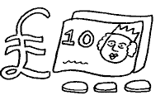 | This will be built on good public finances.
 | Lower taxes.
 | Better regulation
 | And free trade deals with countires around the world.

- A new deal for working people

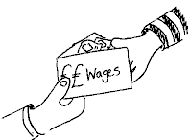 | To give them a decent living wage
 | And new rights and protections in the workplace.

- Governance of public companies

 | This will be built on new rules for when a company takes over antother company.
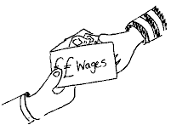 | Looking into executive pay
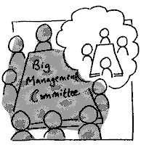 | And getting workers to be part of company boards.

- Growth across the country

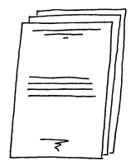 | This will be through our modern industrial strategy

Investment in infrastructure

 |  | Road
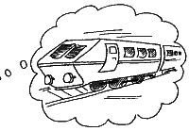 |  | Rail
 |  | Airports
 |  | And broadband
 | Investment in skills
 | And research and development.

- Cheaper energy costs

 | This will happen after a new and fair look into the cost of energy.

- Wealthy towns and cities

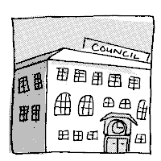 | Making sure we have government offices and national museums all over the UK

2. A Strong and United Nation in a Changing World

Theresa May’s Conservatives will deliver

- The best deal for Britain

We will get the best deal we can as we leave the European Union.
This will be done with a smooth and orderly Brexit.

- A strong and stable Union

 | There will not be a Scottish referendum at this time.

- A United Kingdom Shared Prosperity Fund

Money we get back from leaving the EU (European Union) will be spent on all 4 nations.
The 4 nations are England, Scotland, Wales and Northern Ireland.

- Global leadership on development

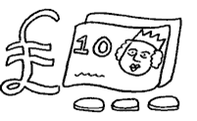 | This will be done by spending 0.7 per cent of our national income
 | And with new rules on how to spend it.

- Strong defence

 | By meeting our NATO target of at least 2 per cent of GDP
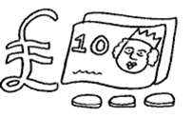 | And increase spending by at least half a per cent more than inflation every year.

NATO means North Atlantic Treaty Organisation.
This is a military agreement of 28 countries.

GDP means Gross Domestic Product.
It measures the total value of all goods made and services provided during a set length of time.
- Security from crime and terrorism

 | We will have a new national police force to deal with serious crime.
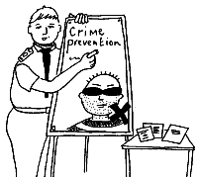 | A stronger response to white collar crime.  This is a non-violent crime  It is a way to get money  For example: Fraud
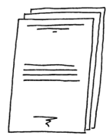 | A world-leading counter-terrorism strategy.

3. The World’s Great Meritocracy

Meritocracy means you will have a fair chance to get as far as you can with your skills and hard work.
It is not about how much money you have or your social status.

Theresa May’s Conservatives will deliver

- More good school places

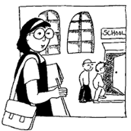 | End the ban on selective schools
 | Ask universities and free schools to help run state schools.
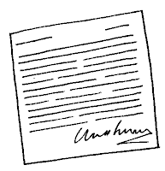 | Change unfair rules so new Catholic schools can open

- World class technical education

 | New institutes of technology  They will have the same freedoms that make our universities great.

- A government not afraid to confront unfairness

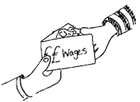 | Look at the pay gap between men and women
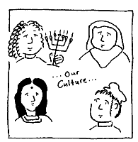 | The unfairness because of where you are from, your religion or gender
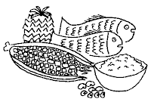 | Provide a free school breakfast for every child in Primary school
 | The stigma of mental health
 | And disability discrimination.

- Protections for victims of domestic abuse in law

A new landmark Domestic Violence and Abuse Bill.

- Fairer markets for consumers

 | Cut the cost of living
 | Put a price cap in place to stop energy customers from getting large rises in bills.

- Control migration

 | They will lower the level of migration from 273,000 people a year to tens of thousands.

Migration means people coming from outside of Britain to live, work and study here.

4. A Restored Contract between the Old and Young

Theresa May’s Conservatives will deliver

- Good public finances

 | This will be done by better money management.
 | And a balanced budget by the middle of the next decade.

- Annual increases in the state pension

 | This is through a new Double Lock  It will start in 2020.

Double Lock means that pensions will go up in line with the earnings that pay for them.
Or in line with inflation.
This is decided on the highest amount.

- Respect and safety in old age

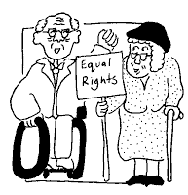 | A long-term solution for elderly care to protect peoples savings.
 | The poorest pensioners will continue to get help with their bills.

- Great healthcare

They will give the NHS (National Health Service)

 | More money
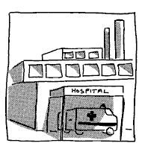 | Better buildings
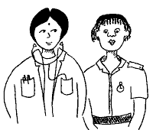 | And more nurses, midwives, doctors, carers and other health professionals.
- Homes for all

 | This will include a new type of fixed-term council housing.  It will be linked to a new Right to Buy plan.
 | We will provide specialist housing where it is needed.  This could be housing for older people

- Great childcare

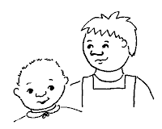 | There will be thousands of new nursery places a year.

5. Success and Security in a Digital Age

Theresa May’s Conservatives will deliver

- The world’s most dynamic digital economy

Help digital businesses get the money, skills and people they need to succeed.

- Safety for people’s data online

There will be a new data protection law.

- Safety for children online

New rights to make social media companies delete information about young people as they turn 18.

- Digital government and public services

 | To use data and digital technology to change school choices, local services and issues like planning and social care.

- New rules for the digital economy

 | This will be supported by a national ruling and an international partnership.

- Security online

 | There will be a lot of money spent on cyber security and stronger cyber standards for government and public services.

Conclusion

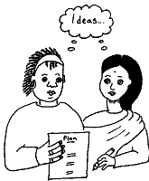 | This is our plan for a stronger Britain and a successful future.

This is what we see for the future

 | A nation united

 | Shared opportunities

 | Safe, vibrant and sustainable communities

A Great Meritocracy

 | This is where everyone,  in every part of our country,  is given the chance to go wherever their skills will take them.

This is a period of great national change

 | We will only reach our goals if we have strong and stable leadership.

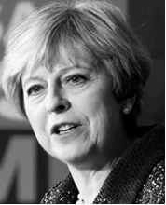 | Theresa May and her team will get the best possible deal with the European Union.

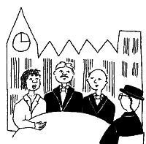 | They will plan a course to a new global future.

 | Now is the time to show our strength as a nation and the character of our united people.

 | We shall succeed, if we go forward, together.

Conservatives
Promoted by Alan Mabbutt on behalf of the Conservative Party, both at 4 Matthew Parker Street, London, SW1H 9HQ.

