Teaching Assistant (Senior School) Job Description

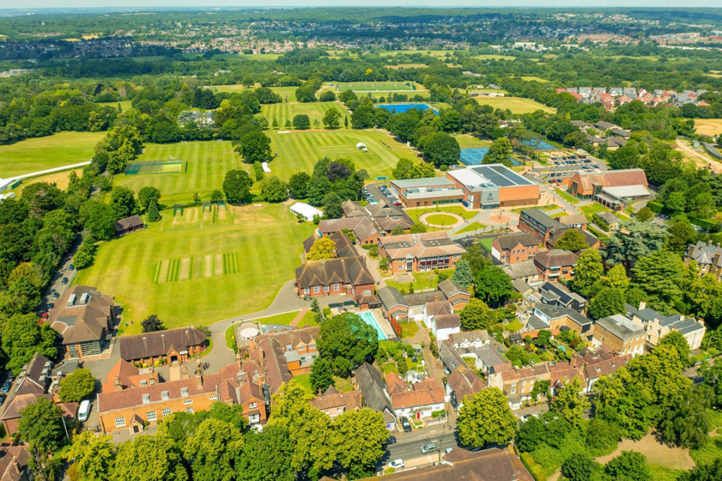

Introduction

Chigwell School seeks to appoint an experienced and enthusiastic teaching assistant to work across the Senior school. This is an excellent opportunity to join a highly successful school and supportive team, and to further develop your career within a thriving independent school environment. The role involves working alongside teaching staff and the SENDCo to deliver high-quality support through one-to-one interventions, in class assistance and where appropriate leading small group sessions. This is a permanent position, available on either a full-time or part-time basis, with a start date as soon as possible during the Autumn Term.

Background

Founded in 1629 by Samuel Harsnett, the son of a Colchester baker who went on to become Archbishop of York, Chigwell School stands on its original site with the original school building still in use. However, whilst Chigwell of today is conscious of its long-standing history, it is a forward-looking, ambitious, coeducational independent school of 990 pupils aged four to eighteen. It enjoys excellent facilities, a dedicated staff, bright and hardworking pupils, and a site of 100 acres.

Chigwell School is located in the picturesque village of Chigwell just over ten miles from central London and on the Central Line. The extensive, beautiful grounds are close to the edge of Epping Forest and it is rare for a school to have so much space and yet be so close to the centre of the capital. Most pupils are day pupils but in the Sixth Form there is a small community of international boarders, roughly thirty from sixteen countries, and these live in four small boarding houses.

As well as being an academic school, Chigwell has the reputation for providing a rich and full education, with plenty of opportunities for all pupils who are enthusiastic, co-operative and able. Chigwell is a caring and friendly school, with a close sense of community, not least between colleagues. As the Good Schools Guide reports: Academically, pupils are put through their paces but it all seems to be done in such a civilised and pleasant manner that you are more likely to hear pupils talk about opportunities and prospects than pressure and stress. “Anyone who wants to do well here, will do well” said one student, “and I can’t think of a nicer place to succeed.” Founded in 1629 by Samuel Harsnett, the son of a Colchester baker who went on to become Archbishop of York, Chigwell School, which is at the centre of the community, has been preparing pupils to make their mark on the world for nearly four centuries.

Whilst the Chigwell of today remains proud of its unique heritage, it is a place of innovation where pupils are well prepared to contribute positively to the community, inspire change for the better and continue learning throughout their lives.
Chigwell has seen many changes since its foundation, including becoming fully co-educational in 1997, establishing the Pre Prep in 2013 and building a state-of-the-art Sixth Form Centre in 2016. Grounded in tradition but preparing pupils for the future, Chigwell is now a large school of 1,060 boys and girls aged 4-18 years, where every individual is known and cherished.
Through the wide range of academic and co-curricular opportunities available to them, each pupil becomes the very best they can be: independent in spirit, adventurous in approach and empathetic in their treatment of others. This allows Chigwellians to forge their own paths to success and realise the words of the school motto: find a way or make a way.
Uniquely positioned on a 100-acre site in the picturesque village of Chigwell, the school benefits from the leafy surroundings of Epping Forest whilst being just 20 minutes away from the City of London on the central line. An enchanting vista through the treeline offers stunning views of the City skyline, giving pupils the rare benefit of having so much space so close to the centre of the Capital.
Chapel is at the heart of the School and although Chigwell follows the Christian tradition, pupils draw on a breadth of spirituality afforded by a vibrant and diverse community.

Vision, Mission and Values

Vision﻿
To inspire pupils to fulfil their potential and forge their own path to success.

﻿﻿Mission
Chigwell is a nurturing community. We strive to ensure that everyone is the very best they can be; independent in spirit, adventurous in approach and empathetic in how they treat others. Since 1629, pupils have been empowered with a deep respect for lifelong learning, ensuring they are ready to make their positive mark around the world.

Values
As well as representing what makes Chigwell distinct, the values also fuel the vision, as the school cultivates young people who will become inspiring role models for others.

Happiness First
Creating a nurturing space where happiness underpins achievements and drives everyone forward.
Courageous and Resilient
Seizing every opportunity and having the confidence to embrace them wholeheartedly.
Innovative Approach
Adapting and evolving, influencing the changing world.
Community of Kindness
Supporting and collaborating with each other, making a positive contribution to the community.
Lifelong Learning
Cultivating curiosity, keeping the passion for learning alive beyond the school gates.

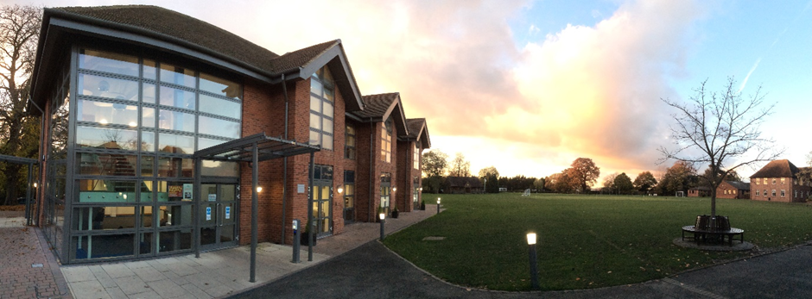

The School

Pre-Prep

Sitting at the very heart of the school site, the Pre-Prep is a safe and nurturing community where the youngest Chigwellians begin their educational journey. Pupils and staff benefit from a state-of-the-art and purpose-built building, with a spacious assembly hall, library and teaching and playing areas designed specifically for ages 4-7 years. The school day is structured to provide a balanced mix of academic, physical and creative experiences. Whilst the National Curriculum forms the basis of all programmes of study, it is adapted to extend and meet the needs of Chigwellians, and significant emphasis is placed on learning outside the classroom. Pupils take part in many educational opportunities, including visits to museums, theatres and workshops, as well as benefiting from enrichment activities in school, such as themed days, visits by speakers, musical workshops and other performances.

Junior School

Pupils transition seamlessly to the Junior School at 7 years old, benefitting from small class sizes and considerable individual attention. The creative and broad curriculum seeks to make children independent in approach and curious about the world around them whilst embedding key skills within all subject areas.

From the age of 7, children do drama in the purpose-built drama centre, with their plays and assemblies in the theatre itself, and they learn their music in the Walde Music School, performing in choirs, ensembles and orchestras from an early stage. Art, Design and Technology is a particular strength, taught in the Art Centre and with regular exhibitions of the children’s work. Science is taught in the Science labs and ICT is both integrated into all teaching and taught as a separate subject in the ICT labs. Sport and PE are taught by specialist teachers and coaches, with two games afternoons and regular fixtures every week.

Pupils are also expected to develop wider interests and the wide-ranging programme of after school clubs and activities is second to none. From board games, to Korfball, to Stock Market club to Astronomy club to sporting and musical and drama activities, every child can taste a variety of activities to see what suits them best.

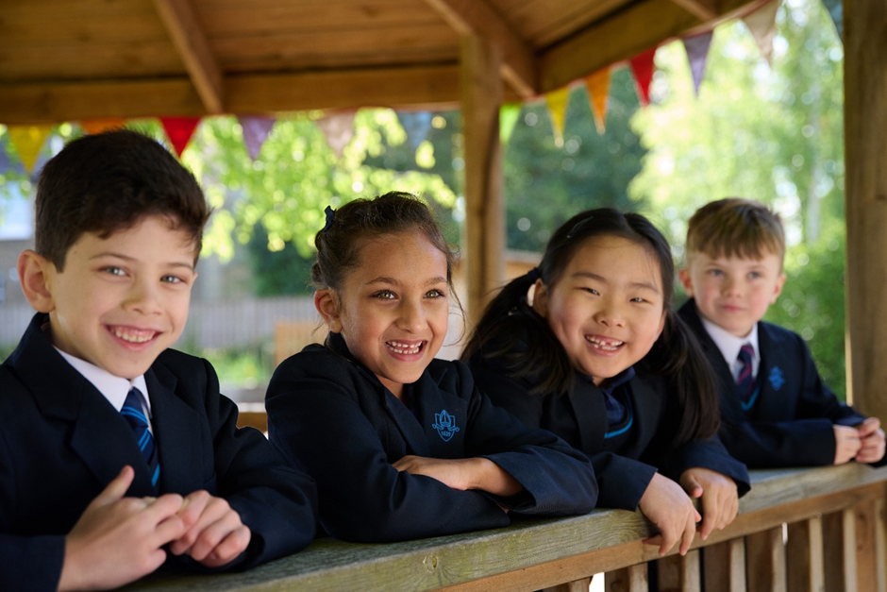

Senior School

Pupils follow the senior school curriculum from the start of Year 7 but pastorally Year 7 and 8 operate as a discrete unit. In Year 9, pupils become part of one of the four senior school day houses (Caswalls’, Lambourne, Penn’s and Swallow’s) and these are a focus for co-curricular activities and pastoral care. As pupils’ development accelerates both emotionally and academically, they are prepared to successfully pass public exams, embrace university life and make career choices through the rich combination of a broad and balanced curriculum, variety of co-curricular opportunities and breadth of pastoral support.
Once they reach Year 10, pupils take a core of GCSEs consisting of English Language, English Literature, Maths, at least one foreign language, the sciences (with the vast majority taking triple science) and three other additional subjects. Pupils meet in their house groups each day and will get to know students of all ages. There are a whole host of extra-curricular competitions and activities through the house system, and all are encouraged to participate. Each house has a housemaster or housemistress at its head who has a team of supporting tutors. Every pupil has a house tutor who oversees all aspects of their education, welfare and progress and is the first point of contact for parents.

Sixth Form

Students in the Sixth Form at Chigwell benefit from the exclusive use of the purpose-built Risham Sarao Sixth Form Centre which opened in 2016. The facility is a hub for learning, with six classrooms, study and social spaces and a centre for university and career advice, as well as a coffee shop. Sixth formers also make good use of the specialist facilities around the school and play an active role in the school community, leading by example and shouldering considerable responsibility. Students can pursue three or four A levels selected from a broad academic range, as well as an Extended Project Qualification (EPQ). Those with a GCSE profile commensurate with an Oxbridge application are offered support sessions, as are those considering medicine, veterinary science or dentistry. In Year 12, every student participates in an academic enrichment programme for one lesson a week, aimed at broadening and deepening their intellectual experience. Courses include Medical Ethics, Financial Analysis and a History of Western Art amongst others. The vast majority of Chigwell leavers go on to Russell Group universities or the equivalent, with some gaining places at prestigious universities overseas. A small but growing number also take up degree-level apprenticeships. The Chigwell careers programme follows the eight Gatsby Benchmarks and a mixture of school-based sessions. External speakers, events and employer interactions ensures that students receive a well-rounded careers education.

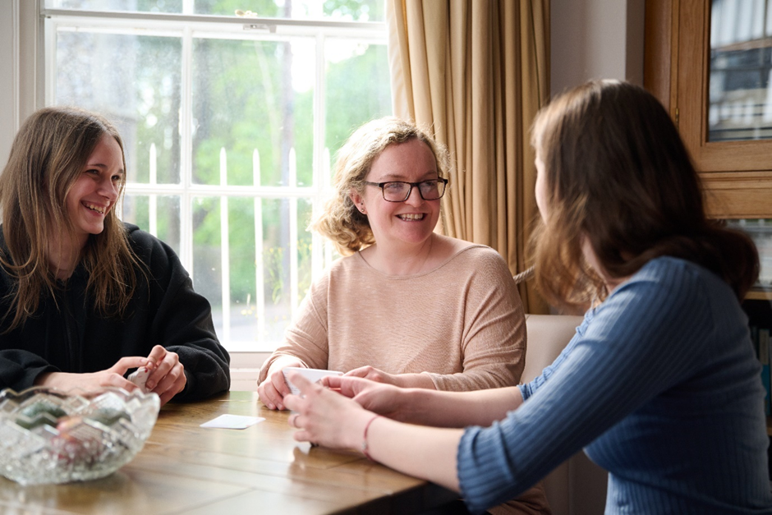

Boarding

Chigwell offers four extended family-style houses (two for girls and two for boys) for 28 international boarders aged 16-18 years. Boarders are well-integrated into school life and well-prepared for both their A Levels and successful entry into British universities. Boarding is a mature community where pupils from around the world benefit from close friendships and cultural exchange.



The Chapel

Chigwell is of Anglican foundation and the Chapel, dedicated in 1924, acts as a focus of thought and inspiration for a diverse community representing all the major world faiths and those who have no faith.

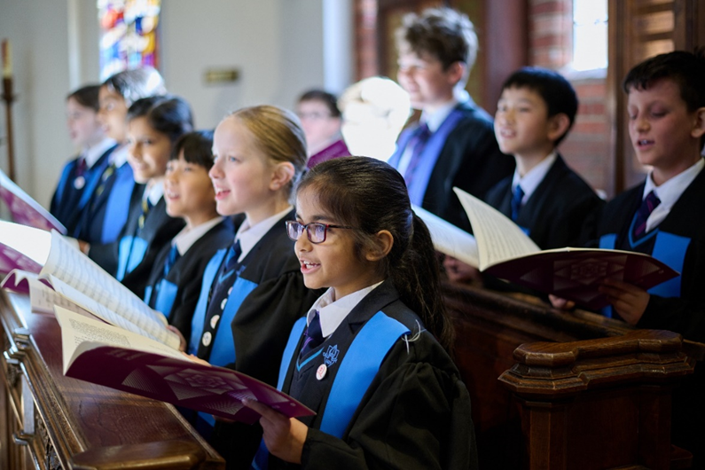

Co-Curricular

A particular feature of Chigwell is the breadth of opportunities offered beyond the classroom. Outdoor learning begins in the Pre Prep and continues throughout the school, from the thriving Scout Troop through to the pupils embarking on their Duke of Edinburgh Scheme Gold Award. Pupils enjoy PE lessons and games afternoons, with a full programme of external fixtures as well as sports tours on offer. The excellent sports facilities include a floodlit AstroTurf, nine tennis/ netball courts, nine football pitches, a new 3G floodlit pitch and indoor and outdoor cricket nets. This provision is due to be substantially enhanced by the new eco-friendly Sports and Wellbeing Centre which will have a six-lane indoor swimming pool, five court multipurpose sports hall, climbing wall, gym and studios and a café.

Drama is key to developing creativity and the inter-personal skills so essential to modern life and at Chigwell pupils are introduced to a range of material from Ancient Greece to Shakespeare to modern texts. With its own state-of-the art 150-seat theatre, Chigwell offers pupils the opportunity to participate in a range of productions as actors, stage designers, lighting and sound specialists and make up and costume designers as well as a host of other roles.

There is a wide range of musical opportunities for pupils of all ages, with several hundred pupils taking private instrumental and singing lessons and participating in ensembles, choirs and orchestras. A regular programme of concerts ensures every pupil has the opportunity to perform during the year, including at events taking place in the local community.

Pupils are encouraged to express their individuality, feelings and thoughts using a mixture of materials and variety of traditional and contemporary tools in Art and Design. The Department regularly hosts exhibitions in the airy gallery and offers a broad enrichment programme, encompassing practical workshops, trips and talks by visiting speakers.

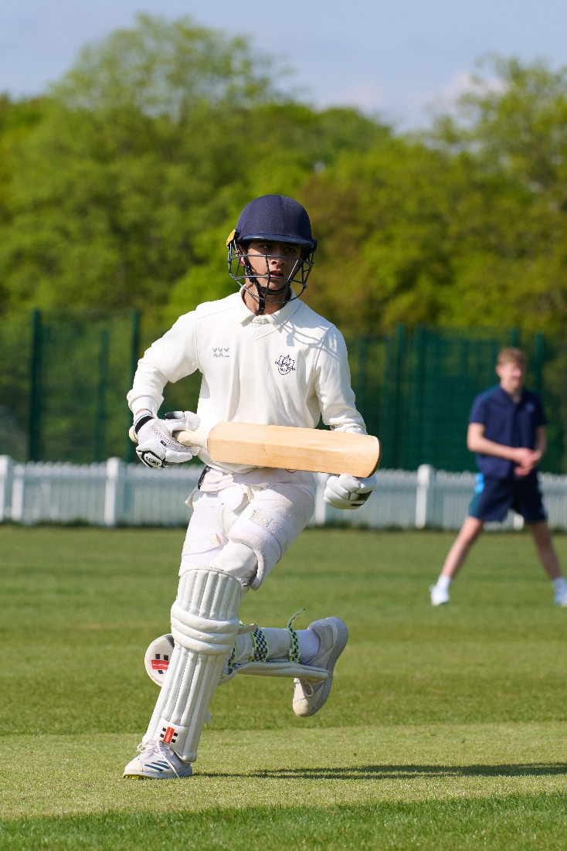

Outreach and Community Partnerships

Working with the wider community has always been part of Chigwell’s DNA and preparation for making a contribution to the world begins when pupils are at school. They are encouraged to work with the local and wider community through voluntary roles at local scout and brownie groups, the Epping Conservation Centre, Chigwell Riding Trust and relevant local charities. Staff share their expertise with local school children, running mock interviews for sixth formers, music classes for local secondary and primary pupils and through a strong relationship with the London Academy of Excellence in Tottenham which it helped to establish. School facilities are also regularly used for events to benefit pupils from other local schools and community groups.

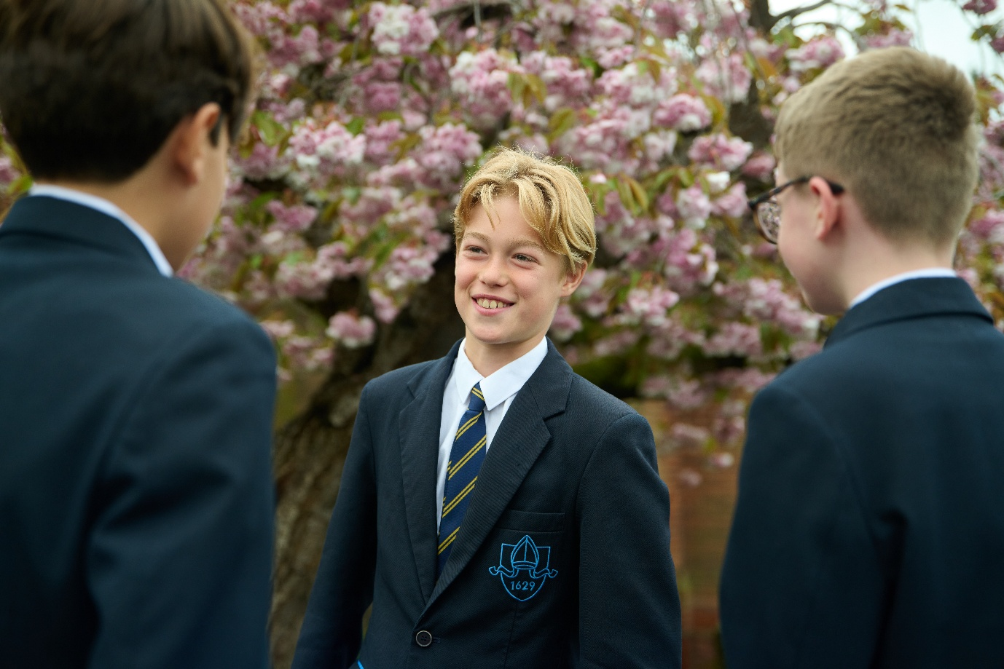

The Role

The purpose of the role is to support pupils’ learning ensuring that they make appropriate progress and support class teachers to raise attainment. The key tasks and responsibilities are:

Teaching and learning
- Work alongside the teaching staff in the Senior School to assist in the educational and social development of pupils under the direction and guidance of the Head, SENDCo and class teachers
- Provide support for individual pupils and groups, under the direction of teachers, as identified by the Learning Support register, inside and outside the classroom, enabling them to attain their full potential
- Work with small groups of children, as identified by class teachers, inside and outside the classroom, focussing on set learning objectives
- Under the direction of a teacher, prepare and deliver learning activities with individual pupils and groups
- Be prepared to introduce tasks, monitor pupils work and use a range of strategies to support learning
- Support the organisation of the learning environment including the production of differentiated materials where appropriate
- Support students with emotional or behavioural problems and help to develop their social skills
- Take initiative within lessons to support individual pupils who may appear to be struggling with a concept or task
- Teach new concepts as agreed with the SENDCo
- Support more able pupils with extension ideas and challenges, as directed by class teachers
- Liaise closely with class teachers in order to keep informed about planning and learning objectives
- Promote and support the inclusion of all pupils, including those with specific needs, both in learning activities and within the classroom
- Keep records of small group or individual support, detailing pupil progress or any problems and share this diary with class teacher and SENDCo as required
- Provide detailed verbal and written feedback on lesson content, pupil responses to learning activities and pupil behaviour, to teachers and pupils and parents when requested by the SENDCo.
- Participate in a programme of support for pupils either at lunchtime, before or after school, as required
- Keep records of small group or individual support, detailing pupil progress or any problems and share this diary with class teacher and SENDCo as required
Other duties
- Liaise with the SENDCo, to discuss children’s progress, to plan and review current support and to contribute to records of pupil progress and achievements
- Support class teachers in tasks that support teaching
- Promote the welfare of children and support the school in safeguarding children though relevant policies and procedures
General
- Set a good example in terms of dress, punctuality and attendance
- Contribute to the overall ethos, work and aims of the school acting as a role model and setting high expectations.
- Participate in training, other learning activities and performance development as required
- Attend and participate in relevant meetings as required
- Take part in the school’s performance management system
- Be aware of and comply with policies and procedures relating to child protection, equal opportunities, health and safety, confidentiality and data protection reporting all concerns to an appropriate person.
- Appreciate and support the roles of other professionals
- Promote equality as an integral part of the role and to treat everyone with fairness and dignity.
- Recognise that health and safety is a responsibility of every employee, to take reasonable care of self and others and to comply with the school’s Health and Safety policy and any school-specific procedures / rules that apply to this role.

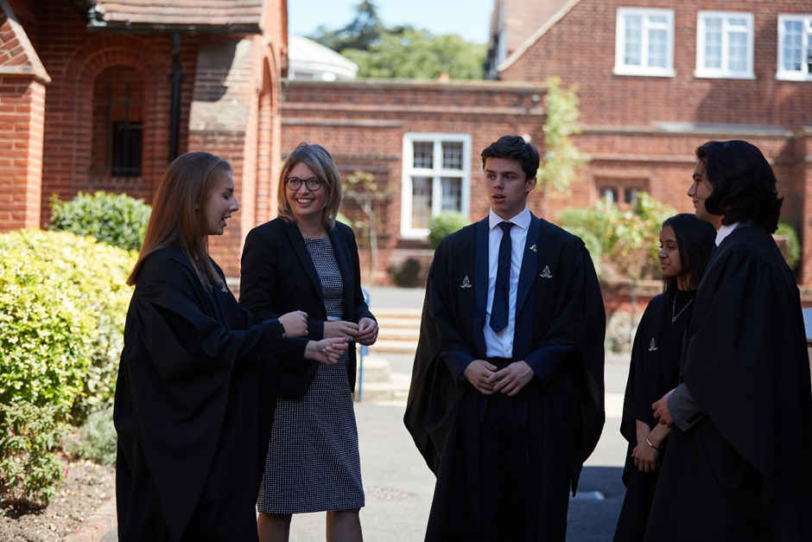

Person Specification
Requirement | Essential or Desirable
Qualifications / Education / Training:  - A good GCSE pass in English and Maths is essential  - Hold relevant qualifications at a level equivalent to at least NQF Level 3.  - Meet the Teaching Assistant Standards and or HLTA standards or equivalent qualifications or experience  - Training and experience in delivering a range of interventions to small groups of pupils  - Evidence of continuing professional development | Essential  Essential  Essential  Essential  Essential
Experience:  - Recent experience in a similar role in another maintained or independent school  - Experience in supporting pupils across Key Stages three- five  - Experience supporting pupils with a a range of needs including SEN, EAL or behavioural difficulties.  - Experience supporting pupils with Educational, health and care plans.  - Experience in applying a range of learning and teaching strategies  - Experience in working with pupils who have Specific Learning Difficulties, for example Dyslexia, and an understanding of teaching Study Skills in preparation for exams  - Experience of monitoring an evaluating impact of teaching sessions  - Effective classroom management  - Knowledge of SEND Code of Practice and EHCPs | Essential  Essential  Essential  Essential  Essential  Essential  Desirable  Desirable  Desirable  Desirable
Skills and Knowledge  - A good knowledge of the current NC requirements of the subjects  - The ability to adapt to different environments within the school and to the needs of different children  - Awareness of how pupils with SEND learn, the factors which affect progress and how to motivate them.  - An understanding of commitment to inclusive education.  - The ability to work with any age group across the school.  - The ability to establish and maintain effective working relationships  - Ability to work constructively as part of a team, understanding classroom roles and responsibilities and your own position within these  - Ability to accept guidance and direction from teachers.  - Ability to relate well to children and adults  - Ability to inspire, motivate and encourage young people  - Ability to adapt sessions appropriately dependent on the needs of young people  - Ability to maintain a high standard of teaching which ensures all students are actively engaged in their learning and make excellent progress  - Sound ICT skills to support learning and maintain electronic information systems  - Willingness to undertake training to develop job related skills to support good practice  - Commitment to the protection and safe guarding of children and young people  - Awareness of the need to show respect to all children and adults within the school | Essential  Essential  Essential  Essential  Essential  Essential  Essential  Essential  Essential  Essential  Essential  Essential  Essential  Essential  Essential  Essential

Salary

The salary on offer is competitive.

Benefits

Chigwell School is a very happy place to work and the School provides a supportive working environment. There is a well-developed programme of professional development. Pupils are enthusiastic, well-behaved and eager to learn, and colleagues are supportive, dedicated and get on well together. There is a strong sense of community.

Other benefits of working at Chigwell School include:

- A competitive salary and generous holiday entitlement  - Strong commitment to professional development  - Membership of the Pension Scheme  - Generous fee remission for eligible children  - Personal Accident Cover and Death in Service  - Employee Assistance Support Programme  - Free access to a GP helpline to provide round-the-clock GP assistance  - Complimentary lunch and tea, and break time refreshments during term time  - Use of the Sport and Wellness Centre facilities outside of the school day  - Free parking on site and cycle racks  - Wellbeing and Medical Centre on site  - Use of School Library  - A beautiful working environment – 100-acre site, beautifully landscaped with a number of listed buildings  - Good transport links by tube (Central Line), road and local bus route and free shuttle bus to the tube station before and after school  - A supportive community of highly motivated students and staff | 

How to apply

Applicants should complete the application form that can be accessed from our website https://www.chigwell-school.org/vacancies/ and email it to the Human Resources Manager at hr@chigwell-school.org
Applications will be considered upon receipt therefore early applications are encouraged. Candidates will be contacted by telephone or email to attend an interview if required. The School reserves the right to interview and appoint prior to the closing date.
The School is an equal opportunities employer and welcomes a diverse pool of candidates.
Chigwell School is committed to safeguarding and promoting the welfare of children and young people and expects all staff and volunteers to share this commitment. Applicants must be willing to undergo child protection screening including checks with past employers and DBS.

